Electric charge-generation properties of a supercapacitor-like electroactive laminate in response to mechanical and humidity stimulit

Table of Contents
Table of Contents 2
List of publications 4
Authorʼs contribution 5
List of abbreviations 6
1. Carbon-polymer-ionic liquid electroactive polymer laminates 7
1.1 Introduction 7
1.2 Applications for the IEAPs 8
1.2.1 IEAP as a supercapacitor 8
1.2.2 IEAP as an actuator 9
1.2.3 IEAP as a motion sensor 10
1.3 Carbonaceous IEAPs as motion sensors 12
1.3.1 IEAPs as sensors for stimuli other than mechanical 13
1.4 Humidity-sensitivity of the IEAPs 13
1.5 From sensors to energy-harvesters 14
1.5.1 Energy harvesting in micro-scale 14
1.5.2 The current role of supercapacitors in energy-harvesting 15
1.5.3 IEAP as an energy harvester 16
1.6 Ambient humidity as an energy source 16
2. Motivation 18
3. Structure of the work 19
4. Concept for charge generation by IEAPs 20
4.1 Considerations for the design of IEAP sensor material 20
4.2 The choice of materials 20
4.2.1 CDC as an electrode material 20
4.2.2 Ionic liquid as an electrolyte 22
4.2.3 Polymeric separator and binder 23
4.3 Proposed working principle 24
4.3.1 Mechanoelectrical transduction 26
4.3.2 Hygroelectrical transduction 26
5. Fabrication of IEAPs 28
5.1 “Direct assembly” (Type I) 28
5.2 Layer-by-layer casting (Type II) 29
5.3 Comparison table 32
6. IEAPs as motion sensors 33
6.1 Characterization of the iEAP motion sensors by homogenous bending 33
6.2 Design of measurement rigs 34
6.2.1 Test rig A 34
6.2.2 Test rig B 35
6.2.3 Validation of the homogeneity of the material 37
6.2.4 ’Snap-through’ motion 37
6.3 Transient response of IEAP Type II 38
6.3.1 Experimental set-up 38
6.3.2 Results 39
6.4 Motion-sensing properties of IEAP Type I 40
6.4.1 Experiment set-up 40
6.4.2 Results 42
6.5 Working principle of the IEAP motion sensor 45
6.6 Characteristics of carbon-based IEAP as motion sensor 46
7. The influence of ambient humidity on the electrical parameters of IEAP 49
7.1 Introduction 49
7.2 Origins for the humidity-related impedance changes 49
7.3 Experimental 50
7.4 Electrical impedance of the IEAP at different relative humidities 51
7.5 Equivalent circuit fitting 53
7.6 Results and discussion 54
8. An IEAP as a humidity sensor 57
8.1 Introduction 57
8.2 Experimental 58
8.3 Transient response to humidity gradient 59
8.3.1 Open-circuit voltage 59
8.3.2 Cyclic stability 64
9. Energy harvesting 65
9.1 IEAP as a mechanoelectrical energy harvester 65
9.2 The concept for cyclic hygroenergy harvesting 65
Conclusions 68
References 70

List of publications
Publications included in this thesis:
- Must, I., Kaasik, F., Põldsalu, I., Johanson, U., Punning, A., & Aabloo, A. (2012). A carbide-derived carbon laminate used as a mechanoelectrical sensor. Carbon, 50(2), 535-541.
- Must, I., Anton, M., Viidalepp, E., Põldsalu, I., Punning, A., & Aabloo, A. (2013). Mechanoelectrical impedance of a carbide-derived carbon-based laminate motion sensor at large bending deflections. Smart Materials and Structures, 22(10), 104015.
- Must, I., Johanson, U., Kaasik, F., Põldsalu, I., Punning, A., & Aabloo, A. (2013). Charging supercapacitor-like laminate with ambient moisture: from humidity sensor to energy harvester. Phys. Chem. Chem. Phys. 15, 9605-9614.
- Indrek Must, Veiko Vunder, Friedrich Kaasik, Inga Põldsalu, Urmas Johanson, Andres Punning and Alvo AablooIonic liquid-based actuators working in air: the effect of ambient humidity. Submitted to Sensors & Actuators: B. Chemical
Other publications relevant to the field, not included in this thesis:
- Must, I.; Kruusamäe, K.; Johanson, U.; Tamm, T.; Punning, A.; Aabloo, A. (2011). Characterisation of electromechanically active polymers using electrochemical impedance spectroscopy. Lecture Notes on Impedance Spectroscopy: Measurement, Modeling and Applications, Kanoun, O. (Ed.), CRC press, 113 - 121
- Temmer, R., Must, I., Kaasik, F., Aabloo, A., & Tamm, T. (2012). Combined chemical and electrochemical synthesis methods for metal-free polypyrrole actuators. Sensors and Actuators B: Chemical, 166, 411-418.
- Must, I., Anton, M., Kruusmaa, M., & Aabloo, A. (2009, March). Linear modeling of elongated bending EAP actuator at large deformations. In The 16th International Symposium on: Smart Structures and Materials & Nondestructive Evaluation and Health Monitoring (pp. 728723-728723). International Society for Optics and Photonics.
- Must, I., Kaasik, F., Põldsalu, I., Johanson, U., Punning, A., & Aabloo, A. (2012, April). Carbon-polymer-ionic liquid composite as a motion sensor. In SPIE Smart Structures and Materials+ Nondestructive Evaluation and Health Monitoring (pp. 834019-834019). International Society for Optics and Photonics.
- Must, I., Johanson, U., Kaasik, F., Põldsalu, I., Punning, A., & Aabloo, A. (2013, July). An ionic liquid-based actuator as a humidity sensor. In Advanced Intelligent Mechatronics (AIM), 2013 IEEE/ASME International Conference on (pp. 1498-1503). IEEE.
- Kaasik, F., Torop, J., Must, I., Soolo, E., Põldsalu, I., Peikolainen, A. L., ... & Aabloo, A. (2012, March). Ionic EAP transducers with amorphous nanoporous carbon electrodes. In Proceedings of SPIE (Vol. 8340, p. 83400V).

Authorʼs contribution
Paper I: Author constructed the measurement set-up, performed all experimentation and data processing, and was responsible for writing the paper.
Paper II: Author collaborated in preparing of the samples, performed all experimentation and data processing, and was responsible for writing the paper. Author supervised E. Viidalepp in the construction of the used measurement device.
Paper III: Author initiated the study, prepared the measurement apparatus, conducted all measurements and data analysis, and was responsible for writing the paper.
Paper IV: Author collaborated in preparation of the measurement apparatus and conduction of the experiments, conducted all data analysis, and was responsible for writing the paper.

List of abbreviations
B₄C-CDC
BF₄⁻
CDC
CNT
EMI
EMIBF₄
EMITFS
IEAP
IL
IPMC
NI
PVdF-HFP
RH
SWCNT
TiC-CDC

Carbon-polymer-ionic liquid electroactive polymer laminates

Introduction
The rapidly growing field of soft robotics and flexible electronics has stimulated the interest on the development of novel electroactive and stimulus-responsive materials.^{1, 2} Compared to conventional robotics and semiconductor-based electronics, which primarily engage electron transport and magnetic fields in engineered structures, the development of soft systems is more focused on biologically inspired approaches that often incorporate ionic currents in their operation and rely on the counteraction between electronically and ionically conductive materials.³ In addition, the materials for soft robotics and flexible electronics are often multifunctional, e.g. they can perform simultaneously as structural and functional elements in a system.
The work at hand explores the properties of a soft thin symmetrical three-layered laminate, which consists of a microporous polymeric membrane in-between two carbonaceous electrodes. The membrane and the electrodes are swollen by an appropriate electrolyte, commonly from the class of ionic liquids. Therefore, this laminate is referred to as an Ionic ElectroActive Polymer (IEAP). The electrodes are electronically conductive, whereas the membrane conducts only ions. The incorporation of ionic liquid as an electrolyte allows the long-term use of such IEAPs in air, thereby creating new fields of application for the systems based on ionic conduction, as long-term operation in air cannot be achieved by the use of more conventional, solvent-based electrolytes.
A number of devices from rather distinct fields of application share essentially the same structure given above. The applications of particular interest for IEAP currently are:
- Flexible supercapacitors
- Electromechanical actuators (often called as artificial muscles)
- Motion sensors
- Energy harvesters
The abovementioned devices are distinguished mainly in the particular choice of materials rather than in the construction principles. In all applications for IEAPs, the degree of interaction between the ionic species and electronically conductive electrode is of particular importance. A good match between the porosity distribution of the electrode material and the sizes of the ions must be made to achieve an optimized device. The properties of the IEAPs can be tuned by the proper choice of electrolyte and changing the precursors and synthesis process parameters of carbon electrodes. In addition, the choice of polymeric separator and binder also influences its ionic conduction and in turn also its electroactive properties.
Although multifunctional devices can be achieved by deliberate optimization, multifunctional properties of the IEAPs are currently only scarcely recognized. Consequently, the investigation of the IEAPs has been distinguished by the field of application.

State-of-the-art applications for IEAPs

IEAP as a supercapacitor
In supercapacitors the electric double-layer formed on the surfaces of high surface-area electrodes is used for storage of electric energy. Supercapacitors are commonly characterized by their high current and power density. The electrochemical system composed out of high surface-area carbon electrodes and electrolyte in-between having notably high capacitance at low voltage was first constructed by Becker et al. from General Electric Co. in 1957⁴ and commercialized first in 1978 by NEC.⁵ Conventional supercapacitors are sealed systems, which use volatile organic electrolytes; for example, such as acetonitrile or propylene carbonate containing tetraethylammonium tetrafluoroborate salt. Ionic liquids are promising electrolytes for the supercapacitors especially due to their high electrochemical window (>4 V); however, only in dry conditions.⁶
Recently, there has been a growing interest in the development of flexible, bendable, twistable, foldable or creasable supercapacitors with an aim of developing power storage element for portable and wearable electronic devices.^{7, 8} Unlike the conventional sealed supercapacitors, which behave as standalone monofunctional units, flexible supercapacitors can also perform as structural components, therefore reducing the weight and volume of portable electronics or energy storage units.⁹⁻¹² Ionic liquids have also been considered as electrolytes for flexible supercapacitors due to their nonvolatility.^{13, 14} Flexible supercapacitors as well as bending actuators are often constructed as thin laminate sheets, while flexible supercapacitors in a weaveable fiber form have recently become increasingly popular.^{8, 15} A large number of prospective fields of application for the flexible supercapacitors presumes the ability for operation in air, as complete exclusion of water absorption becomes increasingly difficult in long term use.
The supercapacitors are attractive also for the use in micro-scale devices; therefore, methods for integrating supercapacitors with microelectronics and microelectromechanical systems (MEMS) fabrication process are sought for. Contrarily to the conventional supercapacitors, which are characterized by their gravimetric specific capacitance in respect to the mass of their electrode material, the most relevant criteria for the micro-supercapacitors are their areal energy and power densities, as the mass of their active electrode material is often negligibly small compared to their total weight. Another reason is that the capacitance of a single electrode does not always scale up with its thickness. ¹⁶ For example, areal specific capacitance of 80 mF cm⁻² has been reported on a 28-µm electrospun CNT electrode,¹⁷ while a nanoscale-thickness graphene electrode reaches 80.7 μF cm⁻² in capacitance.¹⁸

IEAP as an actuator
In 1992, Oguro et al., Shahinpoor et al. and Sadeghipour et al. almost simultaneously constructed an electromechanical actuator based on fluoropolymer-copolymer membranes containing anionic moieties. The ionic polymer was first coated with compliant electronically conductive noble metal electrodes; thus, the resulting IEAP material is often called an ionic polymer-metal composite (IPMC). The working principle of IPMCs is straightforward – the mobile cations in the ionic polymer membrane together with their water solvation shells are drawn towards negatively charged electrode by applying electric potential difference between the metal electrodes. The resulting pressure difference between the opposite sides of the ionic polymer membrane emerges volumetric effects and causes bending of the IPMC.^{19, 20} The large dependence on hydration level makes the in-air use of solvent-based IEAP complicated.
Conjugated polymers – polymers with electronically conductive backbone due to π-conjugation – are perspective alternative electrode materials for ionic actuators, which have been developed since the early 1990s.²¹ Volumetric changes in the conductive polymer electrodes are obtained by entrance or expulsion of mobile counter-ions, driven by reversible electrochemical oxidation or reduction of the conjugated polymer.²²
In 1999, Baughman et al. demonstrated electrically induced actuation of a three-layered laminate with single-walled carbon nanotube electrodes in an aqueous electrolyte.²³ The bending phenomenon was explained by quantum chemical effects in the carbon, resulting in elongation of the single-walled nanotubes.
In the beginning of 2000s, ionic liquid was conceived as a promising electrolyte to construct actuators operable in air. Ionic liquid was demonstrated as a suitable electrolyte for conductive polymer-based IEAP actuators in 2002 by Lu et al.²⁴ In 2005, an actuator with “bucky gel” – a highly viscous composite of carbon nanotube and ionic liquid – electrodes was presented by Fukushima et al.²⁵ Subsequently, the electrically induced volumetric effects were demonstrated on various types of activated carbons such as carbide-derived carbon²⁶, carbon aerogel²⁷, and graphene.²⁸ IEAP actuators with carbonaceous electrodes are characterized by considerably large capacitance (120 F/g^{29, 30}) and high cyclic energy-storage efficiency (84%³⁰). Concurrently, the expansion of high specific surface area activated carbon supercapacitor electrodes in its charged state³¹ is also conceived as one of the failure mechanisms of supercapacitors.³²
The IEAP actuators are often constructed as cantilevers undergoing bending motion^{23, 25}, but linear length change of either individual electrodes³³ or the whole laminate²⁶ has also been employed.
Simple control over bipolar actuation by only controlling electric potential or current applied between the electrodes, large displacement amplitudes in cantilevered mode, low elastic modulus, and, most importantly, drastically lower working voltages compared to piezoelectric or dielectric elastomer actuators has motivated an extensive interest toward development ionic electromechanical actuators.

IEAP as a motion sensor
It is known that many types of energy conversion devices work in either direction. For example, a piezoelectric pressure sensor that generates voltage in response to mechanical input can be operated as well as an actuator by applying voltage from an external power source. In IEAP laminates, electrically induced motion of ions in the electrolyte is prosperously engaged in energy storage as a supercapacitor and, as an inseparable accompanying effect, in generation of mechanical work as an actuator. There exists also a counter-effect – formation of electric potential difference or electric current between the electrodes as a result of motion of ions in the electrolyte. Many types of IEAPs have been demonstrated to generate voltage or electric current as a result of mechanical stimuli, i.e. they are capable of detecting motion. Motion sensors often share construction and optimization principles with actuators, because the sensor elements are, by default, expected to be operable intermittently as actuators, as currently required. Therefore – an IEAP optimized for actuation functions, as a general rule, also as motion sensors, thereby expressing the multifunctional nature of the IEAPs.
Mechanoelectrical transduction has been previously comprehensively studied in case of IEAPs with inert metal (therefore, this type of laminate is referred to as ionic polymer-metal composite – IPMC) electrodes³⁴. Mechanoelectrical transduction of the IPMCs was conceived almost simultaneously with its actuation property.³⁵ However, the mechanism governing the sensing phenomenon in case of IPMCs is still under debate, therefore considerably complicating its optimization.^{36, 37} The major competing fundamental explanations for the charge-generation phenomenon are: (a) pressure-driven flow of diluent in the ionic polymer membrane due to mechanical bending creates an effective dipole in the pressure gradient direction due to orientation of cations and anions in the ionic polymer clusters;³⁸ (b) The pressure difference exerted by mechanical bending causes a flow of solvent together with mobile cations, therefore creating a net charge imbalance;³⁹ (c) More recently, it has been suggested that the electric double-layer at the electrode-electrolyte boundary gets disrupted by a flow of electrolyte and solvent, giving a rise to streaming potential.^{36, 37, 40}
Two of the abovementioned theories – (a) and (b) – explain the charge-generation phenomenon with the specific morphology and ionic structure of the ionic polymer membrane, while the role of the electrodes is of secondary matter. These theories apply on an ionic system where one ionic species (SO₃⁻ anions in case of Nafion) is fixed to the polymeric backbone and the counter-ion (Li⁺, Na⁺, etc.) associates to the fixed ionic groups. Vice versa, the explanation (c) underlines the importance of the electrode material and predicts a stronger sensorial response from a laminate with higher specific surface area electrodes.
The charge-generation phenomenon is well-characterized for IPMCs with a single mobile ionic group. Simultaneously, ionic liquids have been used as an alternative solvent and electrolyte for the IPMC sensors and actuators⁴¹, while the use of ionic liquid is primarily motivated by its stable in-air operation capability. In the case of an ionic polymer membrane that is swollen in an ionic liquid, both cations and anions are the mobile ionic species, in turn requesting the need of this to be reflected in the proposed working mechanism. Mechanoelectrical transduction of IPMCs with ionic liquid electrolyte has been investigated with the purpose of verification of the streaming potential hypothesis.^{37, 42}
The shape of an IEAP in cantilever configuration changes when electric charge is injected to them from an external source, and they generate electric charge when the cantilever is bent with an external force. It is, however, possible to find IEAP-based devices in such configurations that work exclusively in a single direction. For example, linear actuation in an IEAP laminate can be registered in thickness direction²⁶ due to the (anisometric) expansion of the charged carbonaceous electrodes⁴³. From a theoretical point of view, an IEAP in such configuration could not be used as a pressure sensor, because equal pressure and strain is exerted on both of the electrodes in a mirror-image symmetric device. Vice versa, it is possible to construct IEAP motion sensors in such configurations, where its actuating capability is constrained – for example, an IEAP motion sensor in a pipe form, not having considerable actuation property in case of such device geometry, has been demonstrated.⁴⁴ Regardless of this, it has been underlined that iEAPs are capable of sensing also deformations other than bending, such as shear or compression.^{36, 42} This phenomenon is explained with streaming potential or current as the underlying physical mechanism for sensorial response, but the determination of the polarity of the measured electric potential or current has to date not been explained.
It can be concluded that the choice of appropriate electrode material is of equal importance with the membrane in the construction of iEAP motion sensors. In addition to the inert noble metal electrodes such as platinum, also faradaic conductive polymer⁴⁵⁻⁴⁹ and likewise faradaic ruthenium dioxide^{37, 42} electrodes have been used in the construction of motion sensors.
Mechanoelectrical transduction of iEAPs with carbonaceous electrodes has previously attracted only occasional interest. The current status of the research on motion-sensing parameters of carbonaceous IEAPs is covered separately in the next section.

Carbonaceous IEAPs as motion sensors
The sensorial response of IEAPs with carbonaceous electrodes has previously been reported only in few papers. Baughman et al. predicted, without experimental verification at the time, mechanoelectrical effect in an IEAP with carbon nanotube electrodes in 1999.²³ Kamamichi et al. have fabricated carbon nanotube-based IEAPs, which yield up to 0.1 mV in response to motion, by printing the electrode material on a cast PVdF-ionic liquid membrane.¹¹¹ Sensorial property of IEAPs with bucky-gel electrodes has also been mentioned, without experimental investigation, by Ghamsari et al. ¹¹² Akle et al. stated in 2012 that IEAPs with high-surface area (such as carbon nanotube-based) electrodes “do not operate properly as sensors” due to predicable complications in the signal-conditioning circuitry.⁴² Otsuki et al. have constructed a bending speed-independent deformation sensor based on a non-specified solid polymer membrane and non-specified carbon electrodes, yielding output voltages of up to 350 mV.¹¹³
Carbon-based ionic sensors have also been constructed in other forms than laminates. Mirfakhrai, Baughman, et al. have used carbon nanotube yarns for measurement of tensile stresses.¹¹⁴ However, this sensor works by measuring electric current between a biased yarn and a reference electrode. The sensorial effect is explained by the increase of the surface area of the yarns due to a tensile force. Formally, this kind of sensor does not belong to the class of IEAPs, because no polymer is involved in its construction, but its supercapacitor-like structure suggests similarity to the IEAPs in its working principle.
In this work, the following aspects are under concern in the investigation of IEAP motion sensors:
- The use of carbide-derived carbon with a high specific surface area and tailored porosity distribution as an electrode material for improvement of IEAP motion sensors
- Investigation of motion sensor properties of IEAP constructed both with and without incorporation of ionic polymer
The mechanoelectrical measurements involved characterization of the IEAP response to different curvature changes and characterization of the frequency-response to a sinusoidal bending with constant change in curvature.

IEAPs as sensors for stimuli other than mechanical
There are only few attempts found in the literature on using IEAP technology for measuring stimuli other than mechanical pressure. In 2012, Bakhoum et al. proposed a miniature supercapacitor for measuring humidity inside electronic components or composite materials. The supercapacitor constructed from activated carbon electrodes and potassium hydroxide electrodes was claimed to have the highest sensitivity with respect to size among all known types of moisture sensors.⁵⁰ However, this proposed humidity-sensing mechanism does not incorporate any generation of electric charge.

Humidity-sensitivity of the IEAPs
Many of the potential applications for IEAPs, especially if used as actuators, assume their ability for operation in an environment with a variable RH level. Ambient humidity is an important parameter that determines the performance of IPMC actuators in air.⁵¹ This is also expected, as its working mechanism is based on electro-osmosis of water-solvated ions. The use of IPMC motion sensors in air has been demonstrated; however, the sensing signal is dependent on the hydration level⁵².
Space, which is an exceptional environment due to its inconsiderable ambient humidity content, is one of the promising fields of use for IEAPs.⁵³ On the contrary, a number of other potential fields of application for IIEAP actuators, such as haptic feedback devices, presume reliable operation at the full range of RH levels. To date, the IEAPs as energy-storage elements are often characterized in an inert gas atmosphere, such as in a glovebox, which excludes the effects of ambient humidity, but makes it difficult to predict the behavior of IEAPs in a real application. Encapsulation is one of the proposed solutions to overcome humidity-sensitivity; although, it does not offer protection in long-term.⁵⁴ The IEAP actuators and sensors are typically characterized in ambient air at a constant temperature, often without specifying the RH level. The knowledge on the behavior of ionic liquid-based electrochemical systems based on double layer-adsorption working in air at the full range of RH is of crucial importance for devices irrespective of the field of application – actuation, sensing, energy storage and harvesting.
The effect of ambient humidity on the performance of IEAP actuators or sensors with ionic liquid electrolyte is seldom discussed, as ionic liquids are considered stable in ambient conditions. In a real electrochemical device working in air, ionic liquid cannot be considered as a solvent-free electrolyte. Recently, the investigation of physicochemical properties of water-IL mixtures has attracted much interest⁵⁵⁻⁵⁸. A change in RH level can cause a drift in the electromechanical parameters of the actuators and sensors, which in turn raises the need for considering the RH level as an important input parameter for control algorithms. Consequently, the characterization and modelling of the effect of RH level on the properties of the IEAPs is justified.

From sensors to energy-harvesters
Vibration, humidity and pressure, which are common byproducts of industrial processes (such as thermal power station or motor traffic) or accompany with various natural phenomena, offer virtually unlimited source for harvestable energy. The energy harvested from the surrounding environment is considered as ‘green’ and ‘renewable’. Today, these power sources are often not widely utilized due to lack of suitable energy-harvesting materials. Due to high cost of the energy-harvesting materials and comparably low power density, ambient environment is currently not considered as replacement for nuclear or thermal energy. However, the energy harvesters in micro-scale are of particular interest for portable devices.

Energy harvesting in micro-scale
Energy harvesting in micro-scale (below milliwatt-level per one device) offers increasing interest especially due to the following issues:
- The electronic components have become more energy-efficient. For example, the power consumption of a low-cost 32-bit microprocessor with Cortex-M4 RISC architecture goes down to 90 µA/MHz⁵⁹. The low power-consumption level suggests that electrochemical batteries, which are, to date, the only profitable energy sources for portable electronics, could be completely replaced by energy harvesting elements, which can draw the required amount of energy directly from the ambient environment.⁶⁰
- There is an increasing interest in developing mobile or implantable sensor network nodes and other micro-/nanosystems operating in low duty-cycle regime.⁶⁰ As power is consumed only during short active cycles, the total power consumption is significantly decreased and even low-grade sources previously considered unprofitable can be used to harvest energy.
- There are a number of different sources of energy in the environment; most of them are irregular in time. A more reliable and efficient energy harvesting can be achieved by collecting energy from all available sources, therefore increasing the total power and minimizing the time period with no harvestable energy.
- Implantable (or wearable) medical electronic devices, which are often combined with lab-on-chip technology, are expected to be capable of autonomous operation during several years. The ability of harvesting energy in vivo is a considerable improvement in the field of medical electronics. Previously, energy harvesting from the energy of a heartbeat using ZnO thin films has been demonstrated by Li et al.⁶¹
- In terms of cost per unit power, the energy harvesting units are today, as a rule, not comparable to conventional (thermal) power stations. However, the advantages of energy harvesters emerge in small scale power generation units. For example, despite thermoelectric energy harvesting has intrinsically low efficiency (<10 %), it retains its efficiency even down at microwatt level, where the conventional generators are impractical.⁶²
Small-scale mechanical vibrational energy can be transferred directly into electric energy using piezoelectric ceramics (such as PZT) or soft polymers (such as PVdF in its crystalline β-form). Other proposed solutions include the use of electrostatic effect between a metal and a corona-polarized PTFE surface⁶³ or by means of triboelectric effect between PET and PDMS films⁶⁴

The current role of supercapacitors in energy-harvesting
The supercapacitors and IEAP actuators are charged from an external power source. An IEAP actuator can be brought towards its initial position by consuming the stored charge by short-circuiting the electrodes. A supercapacitor is discharged in a similar fashion, yet the stored electric charge is mostly consumed by some electronic device to perform useful work. Despite a large amount of the electric charge stored in an IEAP actuator is, in the current prototypes, not recycled and therefore wasted after every working cycle due to the lack of efficient electronics for this action, the supercapacitor-like actuator technology holds an advantage before, for example, actuators based on Joule heating – a large amount of the applied electric charge can in principle be recycled.
Previously, supercapacitor-like structures have been considered for use in energy harvesting applications essentially as intermediary or even main energy storage units.⁶⁵ The transient electric energy output of energy-harvesting materials, especially piezoelectric materials, is of irregular nature. The high voltage output spikes of a piezoelectric material is first rectified by using semiconductor electronics and consequently stored in a supercapacitor. After the terminal voltage in the capacitor has exceeded a threshold value, it is available for consuming. The recent work by Sun et al⁶⁶ is a representative example of the role of supercapacitor in piezoelectric energy harvesting systems today.
The output of thermoelectric generators is changing slowly in time, compared to the irregular transient signal of the piezoelectrics, but the voltage level is extremely low (10s of mV) and the internal resistance is orders of magnitudes lower than that of piezoelectric crystals. In such case, an external charge pump is used to boost the voltage to a suitable level for charging supercapacitor as an intermediary storage. The state-of-the-art commercially available step-up converter, such as LTC3108 from Linear Technology, can boost voltages up from levels as low as 20 mV and therefore allow harvesting energy from thermal gradients as low as 1ºC⁶⁷; however, at a low (<50%) efficiency.

IEAP as an energy harvester
From the class of IEAPs, energy-harvesting capability from mechanical vibrations has been widely explored in case of IEAPs. IPMC is applicable as a mechanoelectrical energy harvester in the frequency range <50 Hz, has an efficiency of less than 2 per cent, and generates instantaneous power up to 45 µW/cm³.⁶⁸ The IPMCs with water as a solvent are especially advantageous in underwater energy-harvesting from water flow and vibrations.⁶⁹⁻⁷¹ This is due to intrinsic water-compatibility of the IPMCs. Although the ionic liquid-based IEAPs are operable in air,⁷² in-air energy harvesting using IEAPs has attracted incomparably lower interest. A solution for harvesting wind energy by fluttering motion of leaf-shaped cantilevers is realized using polymer piezoelectrics.⁷³ This is generally due toroughly two times higher energy conversion efficiency of polymer piezoelectrics compared to the IPMCs.⁶⁸

Ambient humidity as an energy source
Ambient humidity is rarely considered as a source of electric energy in engineering solutions. On the contrary, the reversible sorption of ambient water by a nonhomogeneous material is a common actuation mechanism in the nature. For example, a pine cone opens as a result of dehydration of a layered structure with non-homogenous fiber orientation in different layers.⁷⁴ Therefore, ambient humidity holds a significant energetic potential.
It is well-known that asymmetric and reversible absorption of water by hygroscopic materials can be used for producing mechanical work. In its simplest way, this effect can be observed as curling of a sheet of paper due to moistening of one of its sides.⁷⁵ Recently, the research on soft biomimetic artificial structures using sorption of water for actuation has gained a rising interest with a perspective of developing shape-morphing structures for soft robotics applications.⁷⁶⁻⁷⁸ Inspired by the natural phenomena, water vapor has been recently successfully employed in energy harvesting by Ma et al.⁷⁹ However, in the work by Ma et al., humidity gradient was not converted directly to electric energy, but a fast and reversible, hydrolysis- and hydrogen-bonding-based actuation of a polypyrrole–polyol-borate polymer composite was converted to electric energy through incorporation of a layer of piezoelectric PVdF polymer.⁷⁹
Electrokinetic energy harvesters, which use streaming current as a power source, are perspective for small-scale energy harvesting⁸⁰, because in its simple implementation it does not require any special engineered materials and a working device can be fabricated simply as an integral part of microfluidic devices. The efficiency of a streaming current-based energy harvesting system is significantly increased (up to 3% have been measured) in case the electric double-layers on opposite walls overlap, which can be achieved at channel heights around 75 nm.⁸¹ However, fabrication of microchannels with nanoscale dimensions by lithographic methods is complicated. For that reason, microporous materials, such as ion-selective 50-nm nanopores have been suggested.⁸² All electrokinetic energy harvesters presume a pressure-driven water flow for operation. To date, only a very few solutions have been presented which use sorption or diffusion effects for flow generation. Water evaporation-driven energy harvester with construction inspired by the water transport in trees, but the mechanism of electric energy generation based on streaming current formed in a microfluidic channel with electrically charged walls has been investigated by Borno et al.⁸³ In addition, a straightforward solution for turning sorption effects in a hygroscopic PEDOT:PSS film into mechanical rotary or linear motion has been proposed by Okuzaki et al.^{84, 85}

Motivation
This research is focused on investigation of charge-generation properties of the IEAP laminates with high-surface area activated carbon electrodes. It is known from the prior art that the IPMCs have mechanoelectrical properties – they respond to mechanical stimuli by formation of voltage and current between the electrodes.^{34, 68} However, the working principle of IPMC motion sensors is to date explained by more than one competing theory, as it is explained in Section 1.2.3 above. The previous research has been focused on modelling of the motion of ions and solvent in the ionic polymer cluster network, while the significance of the surface area, porosity, and porosity distribution of the electrode material on the sensorial response has not been investigated thoroughly.
Activated carbon derived from metal carbides – that is, CDC – is remarkable for its high specific surface area and a tailored porosity distribution. Therefore, IEAP laminates with CDC-based electrodes are selected for investigation of sensorial properties.
IEAP motion sensor is a passive sensor that emits electric current in response to mechanical stimuli, which suggests its outlook also as an energy harvester. As it is underlined in Sections 1.2.5 and 1.4.3, the IEAP technology has to date only occasionally used to sense other types of stimuli than mechanical. High hygroscopicity of the IEAP, covered in Section 1.3 above, suggests that the IEAP laminate can respond to ambient humidity. The humidity-responsive IEAPs would find use in humidity sensing and even micro-scale energy harvesting. The materials capable of utilizing low-grade sources for energy harvesting offer large scientific and industrial interest.As the IEAPs are known to be hygroscopic, the characterization of the electrical response of the IEAP to humidity change would give valuable information on the behavior as actuators and also as in-air operable flexible supercapacitors. In general, the humidity-sensitivity would considerably broaden the field of application of the IEAPs.

Structure of the work
On this basis, paragraph 4 generalizes the IEAP’s charge-generation property, which applies also for other stimuli than mechanical strain.
The well-justified selection of the electrode material gives an opportunity to increase the sensitivity of the IEAP sensors. The design considerations are discussed in section 4.1. In this work, IEAPs prepared with carbon derived from metal carbides (CDC) with a tailored porosity distribution that matches well with the sizes of the ionic liquid ions was used as an active electrode material. The choice of materials for an IEAP is discussed in section 4.2 and the manufacturing process for the IEAPs investigated in this work is given in section 5.
In paragraph 5, motion-sensing properties of IEAPs are discussed. The mechanoelectrical properties of carbonaceous IEAPs as reviewed in section 1.3 and investigated experimentally on the IEAP with carbide-derived carbon electrodes with tailored porosity distribution in sections 6.1- 6.4. The main results are given in section 6.5 and evaluated in sections 6.5-6.6.
The IEAPs are often constructed out of highly hygroscopic materials. Therefore, a hypothesis can be proposed that sorption of water by an IEAP laminate can result in generation of a macroscopic electric charge. First of all, the knowledge on the change in electrical properties of the IEAP in different humidity levels is necessary. This is done in section 6. The sections 7.1-7.2 discuss the humidity-sensitivity of the IEAP constituents and the humidity-sensitivity of the used IEAP is investigated experimentally by impedance spectroscopy in sections 7.3-7.6. The IEAPs response to humidity gradient is investigated experimentally in section 8.
The extensive response of the IEAP to ambient humidity gradient suggested that the IEAP could be employed even in energy harvesting, as suggested in section 8. Section 9.1 characterizes the IEAP as an energy-harvester. Previously, ambient humidity has not been considered as an energy source because of lack of suitable energy-harvesting materials; however, its energetic potential is discussed in section Error! Reference source not found.. The concept of hygroelectrical energy harvesting is introduced and the results of the energy-harvesting experiment are given in section 9.2. In this work, for the first time, ambient humidity gradient is converted directly, without intermediary conversion into mechanical energy, into electric energy. Additionally, for the first time, storage of harvested energy into the same energy-harvesting material is demonstrated.

Concept for charge generation by IEAPs

Considerations for the design of IEAP sensor material
In the selection of materials for the IEAP working solely as a supercapacitor, it is obvious that accessibility of the carbon surface area must be optimized for both anions and cations.⁸⁶ For IEAPs as actuators, it is generally accepted that higher ionic conductivity of the polymeric membrane incorporated with an electrolyte increases the response speed, while the generated strain depends (a) on the interaction between the ionic moieties and (b) capacitance of the electrodes, which in turn determines the absolute amount of transported charge.^{43, 87-91} Taking into consideration that the actuation property is related to the difference in the sizes of the oppositely-charged ions, it may be that lower ionic conductivity can result in a higher strain-generation capability.
As a hypothesis, the sensorial response of IEAP can be enhanced by selecting a combination of ionic liquid and a porous matrix so that the mobility of cations and anions in this matrix is, contrarily to the optimization criteria for the supercapacitors, purposely dissimilar. Unequal mobility can be achieved by (a) tailoring the relation between the porosity distribution of the microporous electrode and the sizes of the ionic liquid ions, (b) tailoring the interaction between electrolyte ions and ionic polymer membrane and (c) by selective hydration of hydrophilic ionic groups.

The choice of materials

CDC as an electrode material
CDC is obtained by chlorination of metal carbide (SiC, TiC, B₄C, Mo₂C, VC, etc.) precursors at high temperature (400…1200ºC) and in an oxygen-free atmosphere. During the chlorination process, the metal atoms are selectively extracted from the crystalline precursors, while the original shape and volume are exactly preserved. The properties of the CDC are highly dependent on the chlorination temperature and the choice of precursor, as the distribution of carbon atoms in the carbide precursor lattice is different. Furthermore, the CDC is subject to post-synthesis annealing typically with H₂ or NH₃, which is necessary for the removal of chloride residues, but the surface area and structure of CDC can be also affected during annealing. The unique possibility of tuning the porosity in sub-ångstrom accuracy in the nanometer-range, its high specific surface area (1000-2000 m² g⁻¹), and chemical inertness makes CDC attractive for use as supercapacitor or lithium battery electrodes, in capacitive desalination, and as gas storage medium. CDC is formed on the surface of the precursors and it is therefore possible to accurately control the thickness of the resulting CDC layer; however, structural variations can arise in the thickness direction. Bulk CDC is usually produced from fine carbide powder; therefore, the resulting CDC is also in powder form. CDC is fabricable by lithographic methods, which makes it distinctive in the field of high-surface area carbons, as it opens a possibility to produce electrochemical devices with CDC electrodes in micro- or nanoscale.⁹²⁻⁹⁴
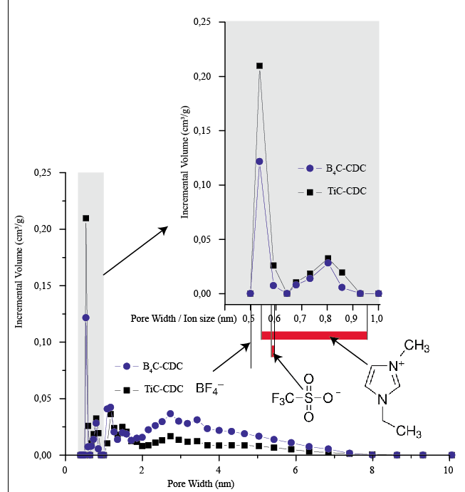
Figure 1. The porosity distribution of the CDCs used in this work in comparison with the lateral sizes of the ionic liquid ions used in this work.
The advantages of CDC listed above motivated the selection of CDC as an electrode material for the IEAP sensors. The choice was motivated also by the finding that motion-sensing properties of IEAP with CDC electrodes had not been characterized before in the literature. Two different CDCs, derived from boron carbide (with rhombohedral crystal structure) or titanium carbide (with cubic crystal structure), were used in this work. The resulting CDC is referred to as B₄C-CDC or TiC-CDC accordingly to the precursor for the CDC synthesis. This nomenclature has been suggested by Presser at al.⁹³ B₄C-CDC was produced by Y-Carbon Inc. and TiC-CDC by Skeleton Technologies. The porosity distributions, given in Figure 1, of the CDCs were measured using nitrogen adsorption method at the boiling temperature of nitrogen. The size distribution of pores below 2 nm is rather similar between B₄C-CDC and TiC-CDC, with the exception of a more pronounced peak at 0.54 nm in case of TiC-CDC. The peak at 0.54 nm pore size is clearly distinguished in case of both CDCs. The pore distribution of B₄C-CDC is considerably wider – the amount of pores in the range of 2…8 nm is demonstrably higher than in case of TiC-CDC. A wider porosity distribution can be advantageous, as it enables faster ion transport between bulk electrolyte and the smaller range of micropores. It has been experimentally confirmed that both anions and cations of an EMIMTFSI ionic liquid enter and exit the pores of an TiC-CDC during charging and discharging.⁹⁵

Ionic liquid as an electrolyte
The negligible vapor pressure has attracted ionic liquid to be used as a favorable electrolyte for electrochemical devices that are operated in air. Ionic liquids are often classified as hydrophilic or hydrophobic. In this work, two hydrophilic ionic liquids – EMITFS and EMIBF₄ – were considered for investigation of the mechanoelectrical effect. The use of EMIBF₄ is, however, not recommended for applications used in high-humidity conditions due to hydrolysis of BF₄ ions⁹⁶; therefore, EMITFS as one of the most hydrophilic ionic liquids has been selected as an ionic liquid for investigation of humidity-related effects of IEAPs. The sorption capacity, rate and difficulty to reach equilibrium humidity
In case of majority of the ionic liquids currently available, the cations are larger than anions. The ionic liquids used in this study – EMIBF₄ and EMITFS – also followed this tendency. Both of the ionic liquids had 1-ethyl-3-methylimidazolium cations, which are slightly oblong-shaped and have lateral dimensions between 0.53–0.95 nm based on quantum chemical calculations. The size of spherical tetrafluoroborate and trifluoromethanesulphonate anions are 0.47 and 0.58 nm, respectively. For the given dimensions, Van der Waals diameters are shown. Therefore, by comparing the effective sizes of the ions with the porosity distribution of the CDC, it can be expected that the mobility of cations and anions of these ionic liquids is unequal in the CDC.
It is not correct to assume that the ionic liquid consists entirely of ions. For reference, the effective ionic concentration of pure BMIBF₄ and BMITFS ionic liquids are 0.64 and 0.57 of their respective molar concentrations.⁹⁷ Therefore, pure ionic liquid could be considered as a system, where some ionic liquid ion pairs act as a solvent. What is more, in a real electrochemical system operating in air, the absorbed water acts as an additional solvent.⁹⁸
The hydrophilicity of ionic liquids is determined, as a rule, by its anions, especially if the anions have high charge-per-volume ratio.⁵⁸ The TFS⁻ anion is highly hydrophilic due to its sulphonate group. The imidazolioum-based cations are considered hydrophobic; thereby the hydrophobicity increases with the length of its hydrocarbon chains. Therefore, EMI⁺ cation is the least hydrophobic cation from the group of imidazolium-based cations.⁵⁵ In addition, the positive charge of the EMI⁺ cation is located specifically on the imidazolium ring, which makes the total charge distribution over the EMI⁺ cation anisotropic and causes its specific adsorption orientation.⁹⁹ Therefore, it can be assumed that (a) also the EMI⁺ cations can also bind water molecules and (b) the equilibrium orientation of EMI⁺ cations can be different at various sorption degrees.

Polymeric separator and binder
The ionic liquid-incorporated polymeric membrane has a strong influence on the performance of the IEAPs, as the morphology and ionic moieties in the polymer determine the ion transport characteristics.
Extensive swelling of ionic polymers in hydrophilic ionic liquids⁷² and the resulting higher ionic conductivity¹⁰⁰ has led to a wide use of IL-intergrated ionic polymer electrolytes as membranes in various electrochemical devices.^{101, 102} Nafion – a tetrafluoroethylene based fluoropolymer-copolymer – is widely employed as separator materials for IEAP actuators and sensors. The perfluorovinyl side-chains of Nafion are terminated with anionic sulphonic acid groups, which are highly hydrophilic – Nafion can absorb as much as 22 wt% of water.¹⁰³ Incorporation of a large amount of water or hydrophilic ionic liquid creates a cluster channel network into Nafion, thus providing a path for the mobile ions to be dislocated. A highly swollen Nafion network conducts both cations and anions. As illustrated in Figure 2A, the cluster network in Nafion that is swollen only in an EMITFS ionic liquid consists of EMI⁺ cations that are bound with the sulphonic acid groups of Nafion, and free ionic liquid that is acting as a solvent. The addition of water (depited in Figure 2B) causes the hydration of strongly hydrophilic functional groups - sulphonic acid groups of Nafion and TFS⁻ anions. As a consequence, the ionic liquid ions become more mobile and could be dislocated by the water diffusing through the cluster channels, as depicted in Figure 2C. The diffusion coefficient for cations and anions of an ionic liquid in an ionic polymer matrix is an intricate topic – it has been demonstrated that in low water content, cations are essentially faster due to formation of triple-ion complexes with two anions and a cation, while at high water content, the mobility of cations is constrained by the interactions with ionic moieties of ionic polymer.¹⁰⁴
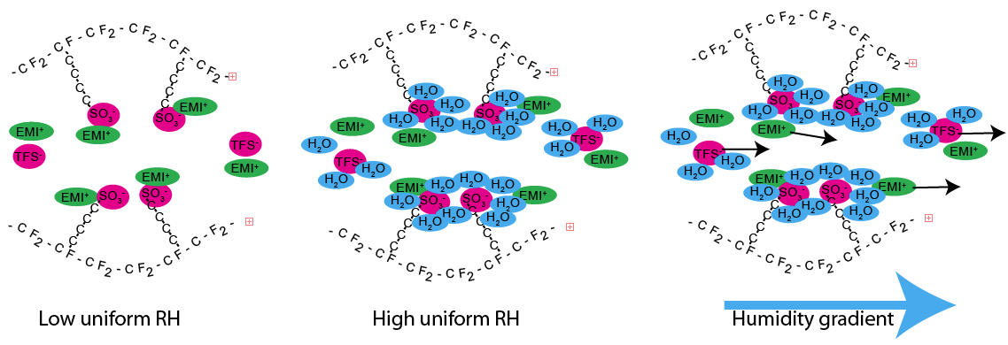
Figure 2. (A) Cluster network in Nafion incorporated with ionic liquid. (B) Hydration of the ions. (C) Dislocation of the ions due to humidity gradient.
The choice of polymers is not limited with ionic polymers – ionic liquids have been successfully incorporated into non-ionic polymers such as PVDF(HFP).^{25, 29, 105} A more recent approach in the development of polymer electrolytes for IEAPs is the synthesis of self-assembled nanostructured sulphonated block copolymers with well-connected ionic channels, which allow fast and organized motion of ionic liquid.⁸⁷ Another approach in obtaining solid (structural) electrolytes suitable for the IEAPs is the synthesis of polymerized ionic liquids.¹⁰⁶

Proposed working principle
The formation of electric charge between the IEAP electrodes due to either mechanical bending (covered in paragraph 6) of the laminate or establishment of a humidity gradient across the laminate (covered in paragraphs 8-9) is caused by similar underlying physical processes. Therefore, the charge generation mechanism is covered jointly.
The carbonaceous electrodes of the IEAPs used in this work are assumed to be ideally polarizable, i.e. there is no charge transfer across the electrode-electrolyte interface. Whenever an electrode is brought into contact with an electrolyte, two accompanying phenomena occur: (a) Reorientation of electrolyte ions, which can also cause reorientation of solvent molecules; and (b) redistribution of electrons in the electrode surface for balancing of the charge.¹⁰⁷ As a result, the charges accumulate on the boundary, forming a so-called electrochemical double-layer.
The current work is concerned on the formation of electric potential difference and electric current between the opposite electrodes of a symmetrical IEAP laminate. Voltage or electric current could not be registered if the whole, ideally symmetrical IEAP laminate undergoes the same transient course of pressure, temperature, moisture content etc., because symmetric physical processes take place in both of the opposing electrodes and the sign of potential difference is therefore not defined. Therefore, a deduction can be made that only unsymmetrical processes in the opposite electrodes can result in formation of electric charge. Nevertheless, charge-generation by applying equal mechanical strain on both electrodes of an apparently symmetrical IEAP has been reported in numerous cases in the literature.^{36, 42} In such cases, no attention has been paid on the premise of the need for unsymmetrical electrodes. However, fabrication of a completely symmetrical IEAP is technically impossible; therefore, the electrodes of an apparently symmetrical IEAP always have slightly different total surface areas.
A different approach for charge-generation by an IEAP is by exposing the opposite electrodes of a virtually symmetrical laminate to different conditions. In the current work, mechanical pressure and water concentration gradient are considered as the causes for the formation of electric potential difference and electric current.
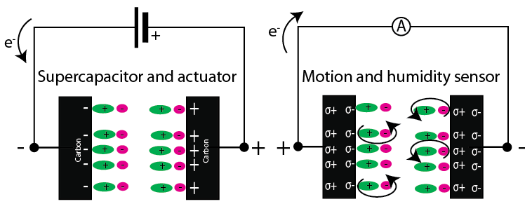
Figure 3. The polarity of voltage on terminals and the corresponding structure of the first two ion layers in case of an IEAP as (A) supercapacitor or actuator, and as (B) motion or humidity sensor.
An important aspect in the explanation of the sensorial properties of the IEAPs is the polarity of the induced electric charge. In case an IEAP is used as a supercapacitor or an actuator, injection of electrons from an external power source causes a formation of an electrochemical double-layer on the electrode-electrolyte boundary. Electrons are injected to (an electrode with negative potential) or taken from (an electrode with positive potential) an electrode, while the charge is balanced by a specific reorientation and dislocation of the electrolyte ions (Error! Reference source not found.A). If an IEAP is used as a sensor, the originally symmetrical double-layers present on the opposite electrodes undergo unsymmetrical processes are rearranged in unequal fashion. Therefore, the difference in the charge distribution in the electrodes also becomes unequal. In case of the electrodes that are not connected via an electronically conductive medium such as a workload, a current-measurement resistor, or an accidental short-circuited spot in the laminate, the total number of electrons in each electrode is not changed. Instead, the cause for generation of voltage and electric current is a shifted electron density within a single electrode. In other words, when the IEAP is charged as a result of mechanical stress or ambient humidity, an electrode with more electrons getting involved in the charge-balancing in the double-layer obtains positive relative potential difference with respect to the opposite electrode, and vice versa. When the electrodes are connected into an electric circuit, electric current can be registered between the electrodes (Error! Reference source not found.B).

Mechanoelectrical transduction
Mechanical bending of an IEAP laminate induces compressive stress in the electrode at the concave side and tensile stress in the electrode at the convex side of the IEAP laminate; therefore, dissimilar conditions for the opposite electrodes are straightforwardly achieved. It is expected that bending induces an unidirectional pressure-driven flow of the electrolyte in a microporous electrode and a swollen polymer matrix. Formation of electric current or potential between the electrodes can be achieved when the mobility of differently-charged ions is unlike in the given porous structure. The different mobility can be caused by (a) matching the porosity distribution of the electrode with the sizes of the ions in the electrolyte; or (b) tailoring the interaction between the electrolyte ions by chemical modification of the electrode or swollen polymer matrix. In this work, the enhancement of mechanoelectric effect is expected by the use of a carbonaceous electrode with a specific porosity distribution, which causes unequal mobility of the electrolyte ions.
In addition to appropriate ionic conductivity, high flexibility of the IEAP laminate is an essential concern when considered as a mechanoelectrical transducer.

Hygroelectrical transduction
As a hypothesis, reorientation of the mobile ions, which is necessary for generation of electric charge, could also be achieved merely by hydration of the hygroscopic constituents of the laminate. Hygroscopic ions can collect water molecules into their solvation shell, therefore increasing the effective volume of the ion and also the structure of an equilibrium double-layer at the electrode-electrolyte interface. Therefore, high hygroscopicity of the constituents is the primary concern for the IEAP operated as a hygroelectrical transducer.
For hygroelectrical transducer, a particular match between the porosity distribution of the electrode material and the electrolyte is needed; therefore, the optimization criteria for the design of hygroelectrical transducer are in agreement with the ones for mechanoelectric transducer. It is therefore expected that a material with good mechanoelectrical properties also works well as a hygroelectric transducer.
An important qualitative difference in hygroelectric transduction compared to mechanical bending is the possibility for long-term conservation of perturbations in the double-layer. It is obvious that an IEAP laminate can be bent only up to its maximum possible final curvature at a time; therefore, the maximum amount of generated charge in one bending is strictly limited. After a sufficient time of waiting, the perturbations in the double-layer have disappeared and the bent position now corresponds to a newly achieved stable state. In contrast, a constant humidity gradient can be conserved during a virtually unlimited time, which suggests that the generated charge could be preserved for a longer time period compared to a charge generated due to a strain gradient. In addition, during a long-time conservation of a humidity gradient, also continuous diffusion of water and water-solvated ions through the IEAP can start to occur. In turn, a considerably higher amount of charge per one cycle can be generated by applying a humidity gradient rather than a strain gradient.

Fabrication of IEAPs
In this work, two different types of IEAPs with tailored properties were chosen for investigation of mechanoelectrical and hygroelectrical properties. These IEAPs differ from each other in the selection of materials and manufacturing method.

“Direct assembly” (Type I)
‘Direct assembly’ method was first used to fabricate IEAPs by Akle et al. in 2007¹⁰⁸ and it was further developed by Palmre et al.¹⁰⁹ This method is especially suitable for preparing IEAPs with separators purchased in sheet form, e.g. Nafion. This material is hereinafter referred to as Type I.
A Nafion 117 ionomer membrane purchased from FuelCellStore.com was first cleaned by boiling in 1 M hydrochloric acid, washed by boiling in deionized water, and then ion-exchanged by immersing in LiClO₄ solution. At this phase, a majority of the anionic sulphonic acid groups in Nafion are bonded with Li⁺ cations. After subsequent removal of solvents in vacuum, the membrane was immersed in 1-ethyl-3-methylimidazolium trifluoromethanesulphonate (EMITFS) IL (Fluka, ≥99.0 %). During the immersion, the Li⁺ cations are substituted with EMI⁺ cations.
The electrode material was prepared by dispersing TiC-CDC powder (Skeleton Technologies) with 15 wt% Nafion solution in ethanol and water (1:1) (LIQUION® LQ-1115 1100EW; Ion Power, Inc). An ultrasonic probe (UP200S, Hielscher) was used to promote homogenization.
The dispersion was painted layer-by-layer directly on both sides of the previously IL-impregnated Nafion membrane using an airbrush. After application of electrode layers on both sides of the membrane, the volatile solvents were evaporated under an infrared lamp. Finally, the membrane was sandwiched between ~100 nm gold foils (Gold-Hammer) and fused together by hot-pressing under 3.5 MPa at 140 ºC for 5 s. Some extra Nafion solution was used to promote adhesion of the gold foil.
The total thickness of the finished IEAP laminate was 250-280 µm and the thickness of each electrode was around 30 µm. The cross-section of the prepared IEAP is shown using an optical microscope in A and using a scanning electron microscope in B.
Figure 4 (A) Optical micrograph of an IEAP Type I cut slantwise. (B) Scanning electron micrograph of the cross-section of the IEAP Type I.
The finished laminate is highly flexible – it can be easily bent to radii below 3 mm without delamination, cracking of the electrodes, or discontinuation of the gold current collector, as shown in Figure 5A. The material is, however, slightly viscous – the neutral position shifts after bending to high curvatures, as seen in Figure 5B.
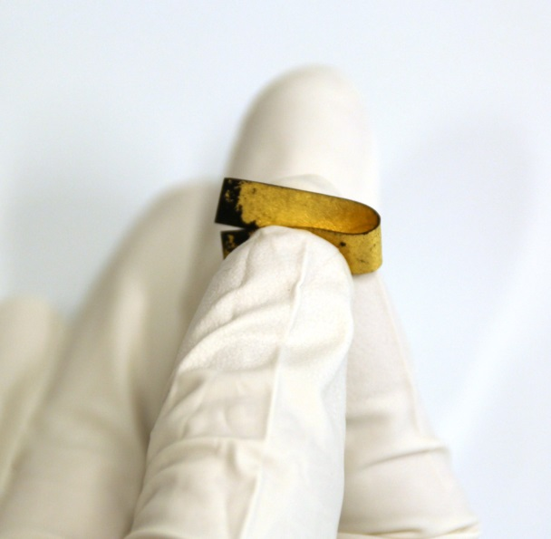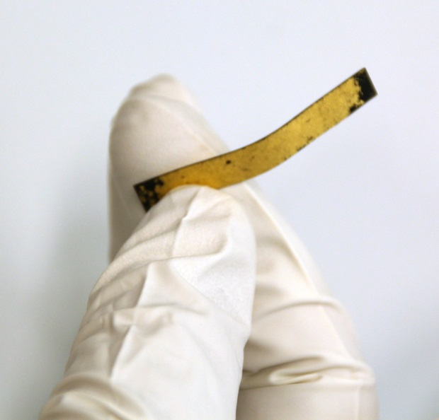
Figure 5. Flexibility of the IEAP laminate

Layer-by-layer casting (Type II)
Layer-by-layer casting of ionic EAPs was developed by Fukushima et al. in 2005²⁵ and it is further developed by []. This method involves complete dissolving of the polymer precursor in an appropriate solvent; therefore, the polymer precursors can be acquired in any form such as in pellets. Fabrication of an IEAP by this method is straightforward: The electrode and separator layers are prepared by casting on a flat surface. All three layers are subsequently incorporated into a three-layer composite by hot-pressing. This material is hereinafter referred to as Type II.
1-Ethyl-3-methylimidazolium tetrafluoroborate (EMImBF4), polyvinylidene fluoride-co-hexafluoropropylene (PVdF(HFP)), 4-methyl-2-pentanone (MP) and propylene carbonate (PC) were purchased from Sigma-Aldrich Co. and dimethylacetamide (DMAc) from Fluka. B₄C-derived CDC powder, precursor of the actuator electrodes, was produced by Y-Carbon Inc. All reagents were used as received and without any further purification.
The electrode suspension was prepared as follows. First, PVF-HFP pellets were dissolved in DMAc. EMImBF₄ and B₄C-CDC powder were mixed in DMAc and treated in an ultrasonic bath for 30 min. After that, the polymer mixture was added to the CDC-IL suspension, stirred on a magnetic stirrer for 5 min, sonicated again for 20 min, and decanted into a polytetrafluoroethylene (PTFE) mold. The finished electrode contains B₄C-CDC, EMImBF₄, and PVF-HFP in the ratio of 50:26:24 wt.%, respectively.
The separator was prepared from an EMImBF₄ and PVF-HFP solution (1/1 wt). The IL was added to the polymer solution, sonicated for 25 min, and then poured into a PTFE mold. MP and PC were used as solvents for the separator layer production. Finally, the electrode films and the separator film were assembled by hot-pressing at 75 °C and a pressure of 3.5 MPa for 10 s.
In this method, an important aspect is that the microporous structure of the ionic liquid-incorporated polymeric separator is formed during the casting process; therefore, the choice of the ratio between ionic liquid and polymer is of great importance in determining the ionic conductivity of the polymeric membrane.
The carbon/polymer/IL ratio in the electrode is the most critical parameter influencing the properties of the finished laminate – it determines the conductance as well as the flexibility of the electrode material.
Scanning electron micrograph given in Figure 6A shows that the finished laminate has 220-µm electrodes and a 30-µm membrane. Figure 6B gives a close-up to the electrode-membrane interface. The membrane has a directional structure, which is most likely caused by flowing under high temperature during hot-pressing. Figure 6D gives a more detailed close-up to the membrane. The electrode structure given in Figure 6C illustrates the individual 1-5-µm carbon grains connected by the polymer matrix.
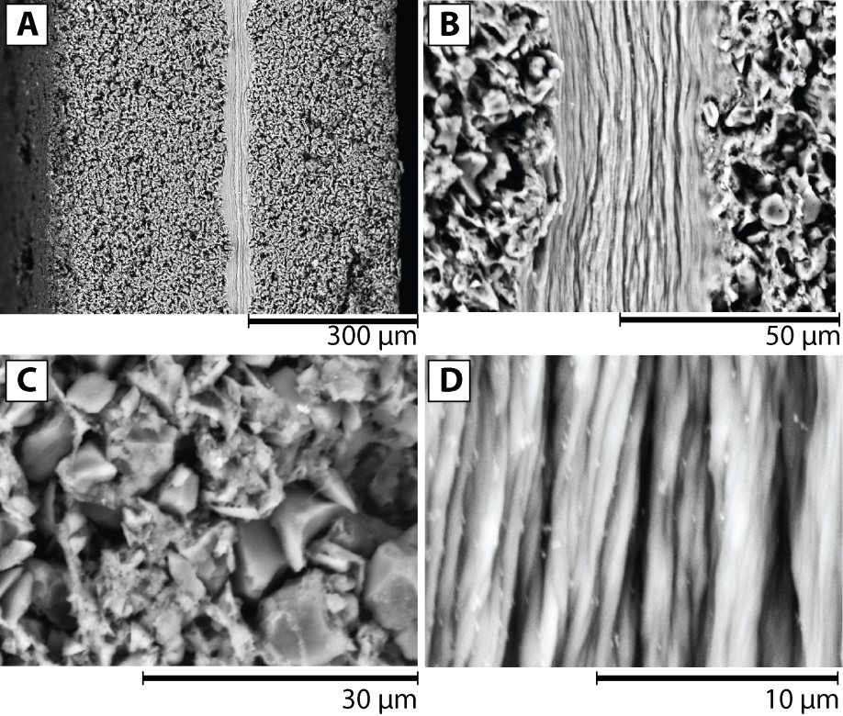.
Figure 6. Scanning electron micrographs of (A) the cross-section of the IEAP; (B) the electrode-membrane interface; (C) the morphology of the electrode; and (D) the morphology of the membrane. Adapted from ¹¹⁰.
The laminate prepared by layer-by-layer casting is also highly flexible. The scanning electron micrographs given in Figure 7AB show the same spot on the laminate cross-section before and after bending to 10³ m⁻¹. A fractured spot on the IEAP given in Figure 7C illustrates the role of the separator – although the carbonaceous electrodes have been cracked, the thin polymeric separator still holds the two parts together despite that it has been significantly stretched out.

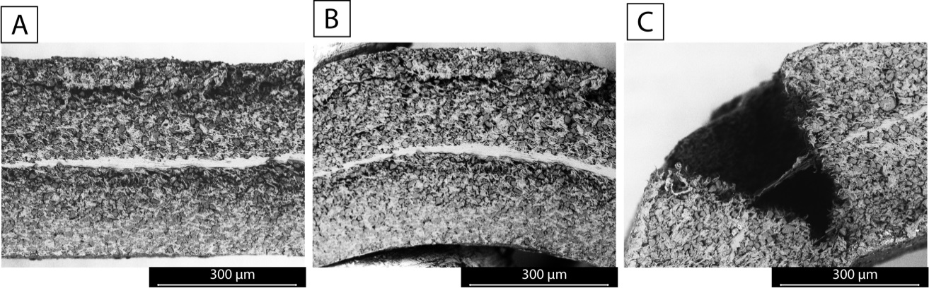
Figure 7. The flexibility of the IEAP Type II. An initially straight piece of IEAP (A) is bent to a curvature of 10³ m⁻¹ (B). (C): A fractured spot on an IEAP.

Comparison table
Table 1. The comparison between the laminates Type I and II.
 | Type I | Type II
Electrode material | TiC-CDC | B₄C-CDC
Polymer | Nafion | PVdF(HFP)
Electrolyte | EMITFS | EMIBF₄
Current collector | 130 nm Au | -
Electrode thickness (each) | 220 µm | 30 µm
Separator layer thickness | 30 µm | 190 µm
Relative thickness of the electrodes to the total thickness | 94 % | 24 %
Electrode resistance | <1 Ω/square | 28 Ω/square
Cross-electrode impedance module at 1 Hz | 28 Ω cm² (at 53% RH) | 66 Ω cm²

IEAPs as motion sensors

Characterization of the iEAP motion sensors by homogenous bending
The sensor properties of the IEAPs are, by default, measured in a cantilever configuration, because also their actuation properties are measured typically in the same configuration. In this way, a multifunctional device, simultaneously having sensorial and actuation capability, is achieved.
An unloaded actuator in a cantilever configuration can bend homogenously in response to the electrical charge input, on the premise that the electronic conductivity of the electrode is sufficiently high for fast electric signal propagation across an individual electrode, i.e. there is no significant voltage drop along the electrode. Such condition has been achieved, for example, in case of IEAP with gold current collectors on top of the electrodes (type I). Therefore, the whole free part (the part which can freely bend without obstructions, i.e. it is not clamped between the electric terminals) of the IEAP always has a homogenous curvature. The characterization of the sensorial properties of the same material is more complicated, as it is difficult to bend the IEAP homogenously in time. Homogenous bending of the IEAP is advisable for two reasons:
1) When the IEAP is bent homogenously, the measured data represents essentially the material properties, not the peculiarities of a particular device configuration. The mechanoelectrical parameters measured by homogenous bending can be afterwards used to predict the output of sensors in non-homogenous bending configurations.
2) This configuration corresponds to a potentially typical use of IEAP motion sensors in real applications; e.g. by coupling the motion-sensing IEAP to an IEAP acting as an actuator, it can give feedback corresponding to the actuation speed and magnitude to a controller.^{115, 116}
From a contrasting point of view, there are also a number of perspective biomimetic applications for the IEAP sensors in non-homogenous bending configurations – e.g. hair flow sensors^{117, 118} or tactile sensors¹¹⁶. Air flow has been previously used to induce actuation in characterization of IPMC sensors.¹¹⁹
A large number of papers on the mechanoelectrical transduction apply external force on the free end of the cantilevered actuator in perpendicular to the initial position.^{39, 45, 49, 52, 120-122} In this way, the material under investigation can be bent in a virtually unlimited frequency range, but the maximum achievable bending deflection is limited. Biddiss et al.¹²³ have used a measurement configuration, where one end of the cantilever was fixed to a rotating platform. By doing so, the deflection amplitude is increased at the cost of decreased frequency range, but the bending curvature is still nonhomogeneous at high bending angles.
To date, several techniques have been developed for the measurement of sensors at constant curvatures. The most straightforward solution is fitting the IEAP sheet to the surfaces of cylindrical objects with different diameters^{124, 125} or sliding the IEAP on the surface of a test block between sections with different curvatures ¹¹³. However, continuous and smooth change in the curvature could not be achieved using these two methods.

Design of measurement rigs
In this work, two versions of measurement rigs were constructed for the investigation of sensorial properties of the soft IEAP laminates. They were both characterized by the ability for achievement of homogenous and continuous bending profiles.
Both of the rigs assume the homogeneity of the laminate under test in at least its lateral (length) direction, i.e. the bending stiffness must be constant in all parts of the laminate. Bending stiffness of a laminate is dependent on the total laminate thickness, the ratio between the thicknesses of different layers, and the elastic moduli of the different layers separately – therefore, these parameters are also expected to be constant. With this assumption, it is possible to achieve uniform bending curvatures simply by holding the opposing end points of the laminate in an appropriate position and pointing to an appropriate direction, as depicted in Figure 8A.

Test rig A
The first test rig was constructed by fixing the laminate under test between two steel bands. The laminate with a length L was rigidly fixed to the steel bands only from its opposite ends, so that it is straight when the steel bands are also straight. The steel bands were then turned into a circle, as shown in Figure 8BC. The bending curvature of the steel bands can be continuously changed. The free part (L_{f}) of the IEAP laminate follows exactly the uniform curvature of the steel bands.
This test rig enables fast (full bending cycle in <5 s), stepless and well-defined change in IEAP curvature, but the achievable curvatures are limited between 20 and 60 m⁻¹. Consequently, the laminate could be bent only in a single direction, while the straight position could also not be achieved.
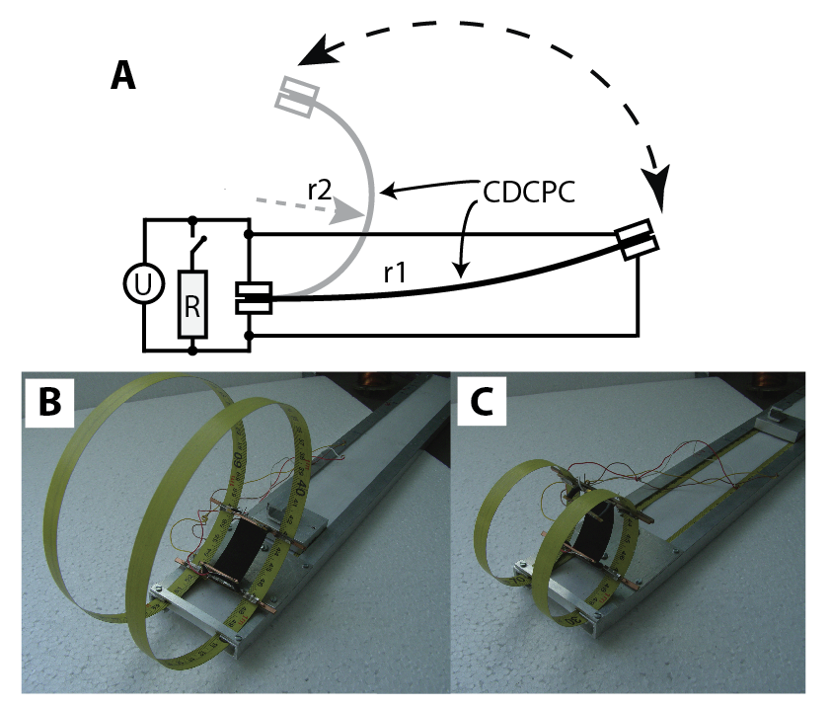
Figure 8. (A) The measurement set-up. (BC)Test rig A at two positions with different curvatures.

Test rig B
The restrictions in the test rig A were overcome with the construction of a second test rig with a novel bending geometry. The geometric model used in the construction was able to constrain a fixed-length (L_{f}) piece of IEAP to an arc shape of any radius larger than L_{f}/2π, i.e. up to a position where the end points of the laminate come together. The geometry involves two identical oval-like closed-curve patterns in contact with each other without slipping, as depicted in Figure 9. The contact point between the shapes at the bending angle (2α) is at the point (x(α),y(α)) according to the Equation (1).
 | $$\left\{\begin{aligned}\text{x}\left(\text{α}\right)\text{=}{\text{sinc(α)}}^{\text{2}} \\ \text{y}\left(\text{α}\right)\text{=}\frac{\text{1-sinc(2α)}}{\text{α}}\end{aligned}\right.$$ | (1)
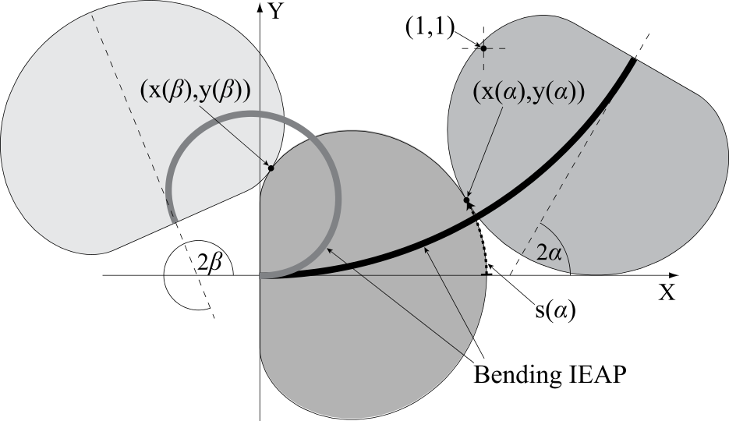
Figure 9. Geometry for homogenous bending of constant-length samples.
The oval-shaped wheels were constructed in the form of noncircular gearwheels in order to assure the motion without slipping.
Although the bending geometry enables, in principle, the achievement of bending angles (2α) up to ±360º, such bending angles could not be achieved in a real system, because some of the laminate must be fixed between the measurement terminals. In the constructed device, bending angles (2α) up to ±228º were achieved. What is more, a sinusoidal transient course of the bending angle was achieved.
The highest bending frequency of the device was 3 Hz. The usable frequency range for some types of IEAP motion sensors can reach over 33 Hz,¹²⁶ although at very low bending deflections. In this work, the IEAP’s ability of measuring extremely high bending deflections at moderate frequency range was investigated. Such conditions correspond to the IEAPs applied in haptic feedback systems or as feedback sensors for the same material acting as an actuator.
Figure 10. Photograph of the test rig B.

Validation of the homogeneity of the material
Homogeneity of the material under test was presumed in case of both of the constructed measurement rigs. The validity of this assumption was verified by photographing the rig with an IEAP attached at different positions and subsequently fitting the line corresponding to the IEAP cross-section with a circle. Figure 11 confirms that the free part of the IEAP has an uniform curvature and therefore it is also sufficiently homogenous in its length direction.
Figure 11. Material homogeneity is proven by fitting a circle over the cross-section of an IEAP that is fixed to the test rig B.

’Snap-through’ motion
In a transition moment between convex and concave shape of the laminate during bending, a ’snap-through’ motion occurs in the case if the free length of the laminate is even slightly different from the distance between the fixing clamps in a straight position. A snap-through motion in IEAPs has also been previously used to achieve bistable actuator¹²⁷, energy-harvesting ⁷⁰ and motion-sensing⁴⁴ systems. Figure 12 depicts a transient output voltage of the IEAP motion sensor (type I) attached to a test rig B so that the free length is slightly longer than the distance between the fixing clamps. During the transition between convex and concave shape of the laminate, a fast buckling motion occurs. The buckling motion can be easily observed in the transient voltage, which indicates a good sensitivity of the IEAP motion sensor at high frequencies.
Figure 12. Snap-through motion occurring in case of an incorrectly attached sample.

Transient response of IEAP Type II

Experimental set-up
The transient response of the IEAP motion sensor to steep bending was characterized using test rig A, which allows achievement of bending curvatures in the range of 20…60 m⁻¹.
The experiments were performed in the following order:
- Holding the laminate in still position at curvature of 20 m⁻¹ (radius R0 in Figure 13A) for at least 500 s for achievement of equilibrium conditions;
- Steep bending of the laminate to a different curvature (radii R1-R3 in Figure 13A);
- Holding the laminate at its new curvature for 500 s;
- Returning the laminate steeply to its initial curvature;
- Holding the laminate in still position for another 500 s.
During the whole experiment, electric current or voltage was registered. Open-circuit voltage was measured by connecting the measurement terminals to a National Instruments’ PCI-6036E analog input DAQ with an SCC-AI06 analog input module. Electric current was measured as a voltage drop over a 5 Ω resistor connected between the measurement terminals. The same DAQ set-up was used for the measurement of open-circuit voltage and electric current.

Results
Transient course of open-circuit voltage depicted in Figure 13F and short-circuit current depicted on Figure 13G are both characterized by formation of a sharp peak immediately after steep bending and by slow diminishing of the signal to zero in 100 s. Initially, the electrode that was stretched out during bending obtains positive potential with respect to the electrode that was compressed. After 100 s, a course of voltage with opposite polarity was registered. The sign of the potential, however, switches always at approximately 100 s after bending, independent of the bending amplitude. After approximately 500 s, the potential returns to its initial value. The laminate generates open-circuit voltage with a peak value of 7.6 µV/m⁻¹ and electric current with a peak value of 0.60 µA/m⁻¹/cm².
Electric charge generated in each bending cycle was obtained by integrating the generated current in time, as depicted in Figure 13F. The laminate is able to generate 1.8 µC/m⁻¹/cm² of electric charge.
The peak voltage and electric current are nearly proportional to the change in laminate curvature, as depicted in Figure 13BC. Peak current registered at 10 times slower bending speed yields 30% lower peak value, as depicted in Figure 13C. The electric charge generated in each bending cycle, depicted in Figure 13C, is independent of bending speed.

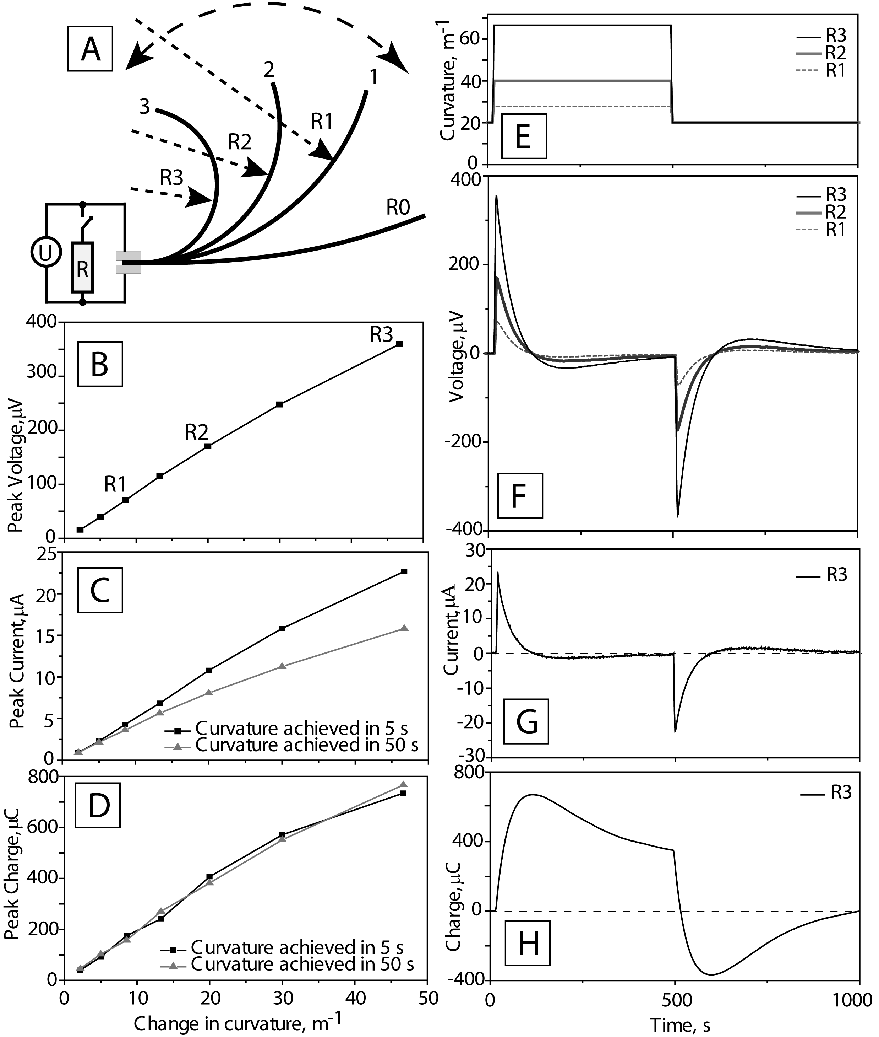
Figure 13. (A) Set-up of voltage and current measurements. (B) Peak voltage value versus final curvature. (C) Peak current value at two bending velocities. (D) Calculated charge values of previous. Transient signals: (E) applied curvatures. (F) Corresponding open-circuit voltages. (G) Course of short-circuit current. (H) Calculated charge of previous

Motion-sensing properties of IEAP Type I

Experiment set-up
Dynamic motion-sensing properties of the IEAP Type I was investigated using test rig B, as it provides sinusoidal bending profile in time and a wider frequency range. The material was bent at the maximum bending amplitude – from -121 to 121 m⁻¹.
The output of the laminate material under test is registered using the National Instruments’ PCI-6036E DAQ board. The bias current of conventional operational amplifiers can eventually charge the supercapacitor-like test objects; therefore, a preamplifier with low input bias current is needed. A Burr-Brown INA 116 instrumentation amplifier with a bias current of <3 fA was selected as a preamplifier.
Figure 14. Schematic of the experimental set-up
Electric current was measured as a voltage drop over a shunt resistor R connected between the electrodes, as depicted in figure 3 (A). The value of the shunt resistor was chosen accordingly to the typical series resistance of the investigated piece of IEAP. If the value of current-measurement resistor matches with the series resistance of the current source (an IEAP), the energy dissipated on the measurement resistor is the highest and the measurements are don at the highest level of accuracy. (Please see Figure 32. The peak current and dissipated power of an IEAP Type II at various load resistances. Adapted from ¹¹⁰.Figure 32 in the section 9.1 below, which gives the output current and power at various load resistances for one particular piece of IEAP.) The actual value of the shunt resistor was 10 or 5 Ω accordingly to the investigated sample. The same amplifier set-up functions as an ammeter or voltmeter, depending on the state of the switch S connecting the shunt resistor.
The peak-to-peak values and phase shifts of voltage (U_{pp}) and electric current (I_{pp}) are determined by fitting the measured signal with the sine parameters using a differential evolution algorithm implemented in National Instruments’ LabView enviroment.
A typical set of transient signals measured at 0.2 Hz bending frequency are shown in Figure 15. The input curvature follows a sinusoidal course. The transient profiles of open-circuit voltage and electric current are also sinusoidal, but their phases lag curvature by 30º at this specific bending frequency. The amount of generated electric charge is determined by integrating the measured electric current in time, as illustrated with a gray area in Figure 15.
Figure 15 A typical course of transient voltage and electric current of IEAP Type II measured at 0.2 Hz bending frequency. Average generated charge and peak-to-peak values of voltage (U_{pp}) and electric current (I_{pp}) are extracted fromthe signals.

The size-dependence of the IEAP motion sensor output was investigated by measuring the IEAPs of constant length (42 mm), but of different widths (3, 6, 9, 12 mm). In order to ensure the homogeneity of the parameters of the different samples, the same piece of laminate was cut narrower. The free part of the laminate (the distance between the fixing clamps) was 33 mm; therefore, 21% of the IEAP sheet was rigidly fixed and was not bent, while still being electrically connected and acting as a supercapacitor.
The experiments were performed at room temperature and at 30±5% RH.

Results
The transient course of open-circuit voltage after steep bending of IEAP Type I is, in similar to the IEAP type II discussed in the paragraph 6.3.2, characterized by a sharp peak immediately after bending, as depicted in Figure 16A. The subsequent course of open-circuit voltage was notably different – the voltage decreased rapidly, but did not cross its initial (zero) value in the investigated time span.
The significant attenuation of the transient voltage is also expressed in the frequency-dependence of the peak-to-peak voltage value, as depicted in Figure 16B. A one order of magnitude decrease in bending frequency results in a roughly 12% decrease in the peak-to-peak voltage.
More importantly, the peak-to-peak voltage shows a considerable and irregular dependence on the laminate surface area. This is especially pronounced in the case of the narrowest (3 mm in width) measured sample. This dependence is most likely caused by non-homogenous surface conductivity due to random discontinuities in the gold current collector. Figure 16C illustrates that a twice larger laminate sheet results in by an approximately 6.0% higher peak-to-peak voltage.
The phase angle between curvature and open-circuit voltage does not have a pronounced dependence on the laminate area. Open-circuit voltage leads curvature change by approximately 25º at 1 mHz and it decreases towards zero with increased frequency, as illustrated in Figure 16D.
Figure 16 (A) Transient courses of voltage after a change of curvature from 121 to 121 m⁻¹ in 0.5 and 5 s. (B) The peak-to-peak voltagefrequency response of the samples. (C) The peak-to-peak voltages as a function of sensor area. (D) The phase shift of voltage
Generated electric current is registered as a voltage drop over a 10 Ω resistor; therefore, the measured current does not correspond to a real short-circuit condition. However, the value of the resistance is in the same order as the internal resistance of the laminate.
Similarly to the material Type I, the transient course of current in the case of material Type II is characterized by decay to zero, as depicted in Figure 17A. The gold current collector on the material Type II reduces the time needed for discharge of the electric charge generated by bending by a factor of 10 – from 100 to 10 s.
Figure 17B demonstrates that the frequency response of peak-to-peak electric current is strongly dependent on frequency, as expected. Theoretically, all parts of the laminate undergoing homogenous bending motion should give a proportional increase to the total current. Figure 17C confirms that the peak-to-peak current is proportional to the laminate area especially at lower frequencies.
At the frequency <10 mHz, the phase of electric current depicted in Figure 17D leads input curvature by nearly 90º, which corresponds to a capacitor-like behavior. The phase difference drops drastically at higher frequencies.
Figure 17. (A) Transient courses of electric current after a change of curvature from 121 to 121 m⁻¹ in 0.5 and 5 s. (B) The peak-to-peak voltage frequency response of the samples. (C) The peak-to-peak voltages as a function of sensor area. (D) The phase shift of electric current.
In the transient analysis provided in section 6.3.2, it was confirmed that the electric charge generated in each bending cycle is independent of the bending speed. In case of continuous cyclic bending, the electric charge generated in each cycle generally decreases with increased frequency, as illustrated in Figure 18A. At the same time, Figure 18B proves that a more intensive bending (bending at a higher curvature change rate) generates more charge per time. At 3 Hz, the laminate can generate up to 12 µC s⁻¹ cm⁻², as demonstrated in Figure 18C.
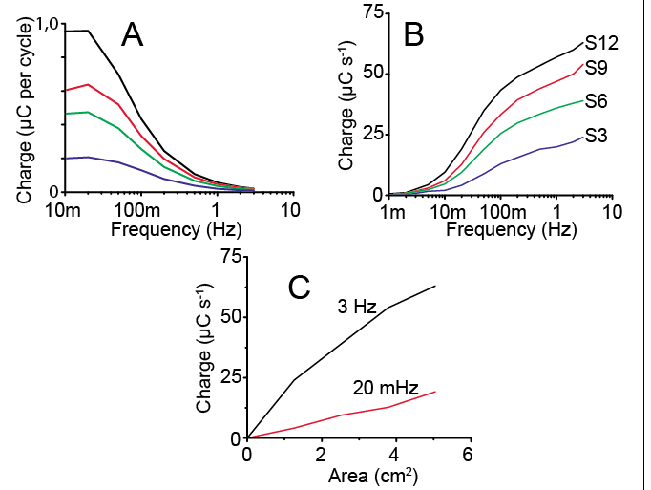
Figure 18. (A) Generated charge per full bending cycle. (B) The generated time-averaged charge. (C) The values for charge at different frequencies as a function of the laminate area

Working principle of the IEAP motion sensor
The evolution of the measured open-circuit voltage (Figure 19A) is explained as follows. Initially (Figure 19B), the IEAP is in equilibrium condition, i.e. the double-layers on the opposite electrodes are equally charged and the voltage between the electrodes is correspondingly zero. After steep formations of strain and hydraulic pressure gradient, the ions in the double-layer are quickly reoriented (Figure 19C). Simultaneously, flow of ionic liquid is induced. As significant amount of anions are fixed in the CDC pores, negative potential is formed on the compressed electrode. During the reorientation and dislocation of the ions, the double-layer is charged. After diminishing of the hydraulic pressure gradient, the ions in the double-layer reorientate again towards minimum energy. The subsequent behavior of open-circuit voltage is considerably different in case of investigated materials I and II. In case of material II, the voltage diminished to zero after 100 s (Figure 19D). This point corresponds to the state where the double-layer is the most disturbed from its initial structure. Subsequently, the relaxation becomes the prevalent process and hence a course of voltage with opposite polarity is registered (Figure 19E). In case of material I, the generated voltage decreased more slowly and did not cross the zero value. Finally (Figure 19F), the double-layers in the opposite electrodes have reached a new equilibrium.
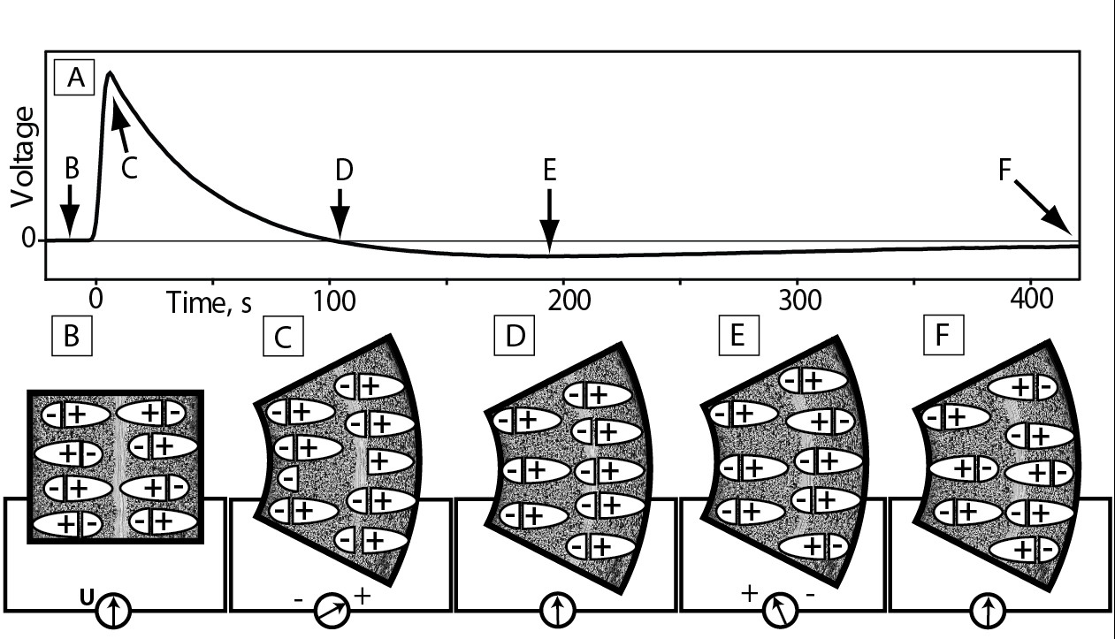
Figure 19 (A) The couurse of open-circuit voltage and (B-F) the schematic explaination for the formation of the measured voltage.

Characteristics of carbon-based IEAP as motion sensor
The results of the experiments clearly demonstrate the considerable influence of the manufacturing process and the chosen materials on the mechanoelectrical properties of the IEAPs.
In this work, IEAPs with carbide-derived carbon electrodes are found to operate successfully as motion sensors. Additionally, motion-sensing property has been successfully demonstrated in case of an IEAP with non-ionic polymer separator (that is, Type II).
The transient course of voltage generated by the investigated IEAP laminates after a steep bending motion is characterized by significant attenuation. The output voltage of the laminate Type II drops 20% from the peak value in 10 s, while the voltage on laminate Type I drops as much as 41…48% from the peak value in the same time span. Attenuation of output voltage is known also in the case of other carbon-based IEAP motion sensors. Otsuki et al.¹¹³ have observed a similar, but less attenuated (attenuation ca 15% of the peak value after 10 s) response in case of a laminate with ionic liquid impregnated polymer membrane and carbon electrodes.
The investigated IEAP sensors produce open-circuit voltages comparable with the values previously reported by Kamamichi et al.¹¹¹ and Otsuki et al.¹¹³ Peak output voltage is found to be proportional to the bending magnitude (Figure 13B); therefore, it is possible to measure the magnitude of motion the IEAP is subjected to. On the other hand, the large attenuation of the transient signal makes it difficult to measure frequent consecutive deformations. Attenuation is also the cause for nonlinear frequency-response of the IEAP motion sensors at a constant bending magnitude (Figure 16B). In addition, open-circuit voltage is sensitive to the material inhomogeneity. In principle, all parts of the laminate undergoing same bending motion should generate the same voltage. However, the smaller piece of IEAP generated voltage that is considerably smaller than generated by a larger piece, as demonstrated in Figure 16B. Despite of substantial differences in the construction method and the composition between the IEAPs of Type I and II, their normalized peak voltages were close in value: when the curvature of IEAP is changed in 5 s, the IEAP type I generated 4.5 µV m¹, while the IEAP type II yielded 7.6 µV m¹ of peak voltage.
Electric current and charge are shown to have considerable advantages in motion sensing. The peak value of electric current is proportional to the bending magnitude, as given in Figure 13C, but is dependent on bending speed, as expected. Every part of the material that is bent uniformly should contribute to the total current and charge in proportion to its area. A linear dependence of the peak current on the laminate area is verified in case of IEAP type I, as shown in Figure 17C. As expected, the frequency-response of electric current is highly nonlinear. Figure 17B confirms that the current peak value rises with increased frequency up to the highest measured frequency – 3 Hz. At the same time, the phase difference between electric current and mechanical bending also decreases with increased frequency, as demonstrated in Figure 17D.
It is demonstrated that it is possible to measure the magnitude of bending by integrating the generated current, as depicted in Figure 13D. Calculation of total generated charge is found to provide most accurate motion feedback. The exceptionally high sensitivity in charge-sensing mode has also been confirmed in the case of IPMC transducers¹²⁸.
The value of charge obtained by this method does not depend on bending speed, which enables accurate measurement of the magnitude of motion. The magnitudes of generated charge were significantly different in case of different IEAPs – the IEAP of Type I yielded 1.7 mC m¹ m⁻² of charge, normalized against the change in curvature and the laminate area, while the IEAP of type II generated as much as 20 mC m¹ m⁻² of charge. A large, 12-fold difference in the charge-generation capacity can be explained by the amount of active material per laminate area – the thickness of the electrodes of the EAP type I was 30 µm, while the IEAP type II had 220- µm electrodes. That is, the laminate of Type II has roughly 7.3 times more active carbon material for the same surface area, which obviously gives a rise to an increased charge-generation capacity.
The generated charge provides accurate feedback only if the transient bending profile consists of short bending cycles followed by longer stationary positions. The estimation of magnitude of motion is more difficult in case of periodic bending. It is shown in Figure 18A that the amount of electric charge generated in each bending cycle decreases with increased frequency. This is caused by the time needed to collect the generated charge from the IEAP, which is approximately 10 s in case of the material type I, as given in Figure 17A.
The transient courses of voltage and electric current after a steep bending develop as a result of two factors: a) The transient course of electric double-layer charging due to the applied pressure gradient through the IEAP. b) The time needed for discharging of the generated charge by a current-measurement device. In the process of current measurement, the IEAP can be seen as a supercapacitor that is charged by a mechanical stimulus. The discharge circuit for such supercapacitor consists of a series of internal resistance of the IEAP supercapacitor, a distributed electrode resistance, and a current-measurement resistor.
The results also demonstrate a large effect of distributed electrode resistance on the mechanoelectrical parameters of the IEAP motion sensor. In case of IEAP Type I, the electrode resistance is <1 Ω/square due to the high conductivity of its gold current collector. The magnitude of electrical impedance of the electrode of IEAP Type II, which is substantially of resistive in nature¹²⁹Error! Reference source not found., is 28 Ω/square at 1 Hz. In case of the IEAP Type II, the transient courses of voltage and electric current were very similar, which refers to inefficient extraction of the generated charge. In case of IEAP type I, a majority of the generated charge was removed in 10 s as depicted in Figure 17A, which indicates the advantage of the current collector in motion sensing.

The influence of ambient humidity on the electrical parameters of IEAP

Introduction
In the experimental part of this paragraph, humidity-dependence of an IEAP Type I is investigated using electrochemical impedance spectroscopy. The impedance data was fitted with a suitably-chosen equivalent electrical circuit and the shift of the equivalent circuit parameters was correlated with the change in ambient RH. The impedance measurement and electromechanical characterization results reveal a number of advantages, but also deficiencies of the increased water content of the laminate.

Origins for the humidity-related impedance changes
The reason for the impedance change is a drift in material properties due to ambient humidity, which is reversibly absorbed by the IEAP material. The IEAPs used in this work are composed out of highly hygroscopic materials – Nafion, carbide-derived carbon, and a hydrophilic ionic liquid. All constituents from this list have previously individually been proposed for humidity sensing.
The high water sorption capacity of ionic polymer Nafion is caused by its hydrophilic ionic sulphonate groups. Pure Nafion can absorb water as much as 22% of its weight¹⁰³, while the calculations indicate that each sulphonate group in Nafion can coordinate up to 23 water molecules¹³⁰. The hydration of Nafion changes both its physical and electrical properties. The performance of IPMC actuators in air is directly related to the water desorption kinetics⁵⁴ – dehydration of Nafion decreases the performance of IPMCs at low RH due to decrease in ionic mobility. In turn, an IPMC-like electrochemical system has been applied as a humidity sensor, where the humidity value is extracted by measuring impedance between the electrodes¹³¹. There exist also other approaches for applying Nafion for humidity sensing – e.g. measuring the weight change by quartz crystal microbalance.¹³²
Carbide-derived carbons are synthesized by chlorination of metal carbides at high temperatures in an inert atmosphere. In principle, this synthesis method produces the carbon with comparably lower amount of carboxyl, carbonyl, or hydroxyl functional groups⁹⁴. However, upon the first exposure to air or in the process of post-activation, the dangling carbon bonds formed in the synthesis procedure are quickly functionalized¹³³. This determines the hydrophilicity of CDC.
The third hydrophilic constituent in the IEAP is the ionic liquid. Water sorption changes almost all physicochemical parameters of ionic liquids. As a rule of thumb, water content increases its conductivity and decreases its viscosity^{58, 98, 134, 135}. The high affinity towards sorption of vapors and low vapor pressure enables the use of ionic liquids as active elements in amperometric¹³⁶ or quartz crystal microbalance-based¹³⁷ sensors.

Experimental
The impact of ambient RH was investigated by placing the IEAP laminate of Type I in a container with a controlled RH value, as depicted on Figure 20. Electric impedance between the IEAP electrodes was measured using PARSTAT 2273 potentiostat in a two-electrode mode. The 3-cm² piece of the IEAP laminate was fixed between the measurement terminals made of gold. 10 mV RMS signals were used in the measurements.
The IEAP laminate was held in an environment of constant humidity for at least three hours before the measurements for achievement of equilibrium water content. Air convection in the chamber was promoted using an air agitator. During the impedance measurements, the air agitator was turned off. A Rotronic HC2 temperature and humidity sensor was used as a reference for the RH value. All experiments were conducted at the room temperature (24±1 ºC).
Humidity chambers with five fixed humidity points were constructed. The lowest humidity (0⁺⁴% RH was generated by using calcium chloride (CaCl₂) as absorbent, and the highest humidity value (100₋₄% RH) settled over a bath of distilled water. The fixed RH values of 23±2, 53±2, and 75±2% RH were generated by using saturated solutions of potassium acetate (CH₃CO₂K), magnesium nitrate (Mg(NO₃)₂), and sodium chloride (NaCl), respectively.¹³⁸ All chemicals used for stabilization of the humidity level were of technical grade.

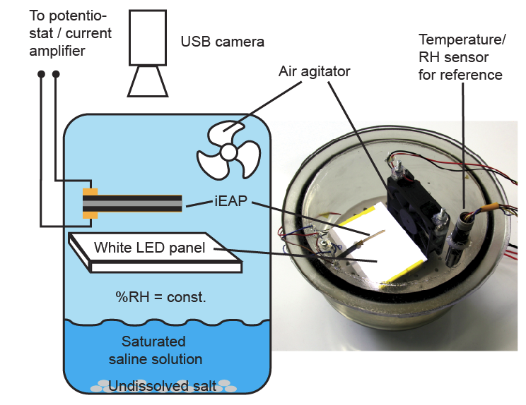
Figure 20. The measurement set-up for impedance measurements.

Electrical impedance of the IEAP at different relative humidities
The Nyquist plot of the measured impedance is given in Figure 21A and Bode plot is given in Figure 21BC. The impedance of the IEAP changes drastically with a changed RH level. The most significant difference is the shift of the real part towards higher values when the RH level is decreased. The impedances measured at >53% RH change only little, while the laminate is more sensitive to the variation in the RH value in the region of low (<53%) RH.
In a high-RH environment the Nyquist plot has a characteristic arc-shape at high frequencies (>100 Hz), while this is not clearly distinguishable at low RH level.
The phase between voltage and current is the largest at the lowest RH, indicating the most supercapacitor-like behavior.
Figure 21. (A) Nyquist and (B-C) Bode plots of the IEAP laminate’s electrical impedance

Equivalent circuit fitting
Equivalent circuit analysis was needed to understand the changes in impedance. In this work, an equivalent circuit given in Figure 23A was selected for fitting. A similar equivalent circuit has previously been used in the modelling of an IEAP actuator with bucky gel electrodes by Takeuchi et al.¹³⁹
The equient circuit given in Figure 23A consists of three blocks connected in series. A resistance R_{s} represents charge transfer resistance, which is determined by the ionic conductivity of the ionic liquid-containing polymer membrane, between the electrodes. In addition, the electron-transfer resistance of the CDC also contributes to the magnitude of R_{s}, but the impact of the CDC conductivity is expected to be much smaller than the conductivity of the membrane in-between electrodes.
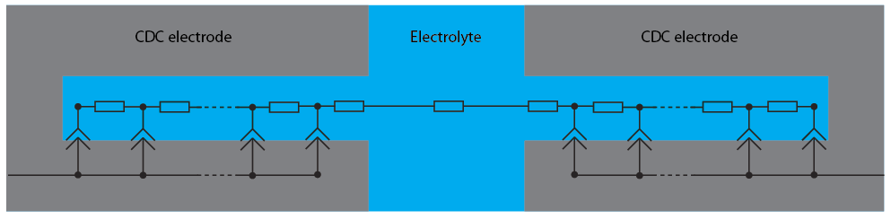
Figure 22. The distributed elements in a microporous activated carbon electrode.
Warburg element W with a mathematical form given by Equation (2) is a distributed element, which is used to describe an electrochemical system with anomalous diffusion. The pores in the CDC grains are described as finite transmission lines, as given in Figure 22. The boundary between the CDC and the ionic liquid electrolyte, i.e the double-layer region, is modelled as nonideal capacitors – constant phase elements. As the mobility of ions inside the pores is considerably constrained, i.e. it needs significantly more energy and time to charge the double-layer deep in the pores, a transmission line is formed. A Warburg impedance Z_{w} is described by three parameters – a proportional parameter W_{r}; a frequency-dependent parameter T_{w}; and an exponent W_{c}, which is a measure for non-ideality.
 | $$Z_{w}=W_{r}\frac{cth[{(iT_{w}w)}^{w_{p}}]}{{(iT_{w}w)}^{w_{p}}}$$ | (2)
The last block, which consists of by a parallel connection of resistance R_{p} and a constant phase element CPE_{p}, represents contact impedances between the CDC grains within each electrode and also the impedance between the electrode and the measurement terminals.
The ionic diffusion constrained by the transmission line effect in the CDC micropores can be presented as a characteristic frequency w_{d} given by Equation (3).
 | $$w_{d}=\frac{1}{T_{w}}$$ | (3)
The impedance spectra given in Figure 21 were fitted with the equivalent circuit given in Figure 23A. The best-fit value for the 7 parameters describing the proposed equivalent circuit were extracted for different humidity values.

Results and discussion
The Figure 23B demonstrates that a relatively good fit is achieved for all measured impedances.
Figure 23C illustrates that the ionic conductivity of the ionic liquid-swollen polymeric membrane decreases drastically with increased humidity content. This is also expected, because the conductivity of ionic liquid-water mixtures increases with increased water content up to more than 10 times until a peak value. The maximum conductivity of the ionic liquid-water mixtures is achieved at a range of 3-10 moles of water per mole of ionic liquid.⁹⁸ The conductivity of bulk water-free EMITFS is 0.398 S m⁻¹ at 298 K¹⁴⁰, while the conductivity of the EMITFS-water mixture increases from 1.345 to 3.927 S m⁻¹ at 298 K when the molar fraction of EMITFS is decreased from 0.8 to 0.2.¹⁴¹ In the current results, the resistance decreased as much as 13 times, from 41.1 to 3.17 Ω, with increasing RH level.
The magnitude of the distributed resistance – W_{r} – was equal in the RH levels of 75 and 100%, while it increased 10-fold, from 1.90 to 21.2 Ω, in the dry environment, as given in Figure 23E. This emphasizes a significantly constrained ionic mobility in the dry environment.
The exponent of distributed CPE in the double-layer (equal to 2*W_{p}) given in Figure 23G was in the range of 0.91…0.95 in all of the RHs except in the most hydrated condition. Therefore, the carbon-electrolyte boundary is capacitive in nature, with a slight deviation from an ideal capacitor (where 2*W_{p} = 1).
The contact impedance has effect only at high (>25 Hz) frequencies, as the CPE is shorted by a low-ohm (1-5 Ω according to Figure 23D) resistance at lower frequencies. Also, the contact impedance is significant in dry environment, as the magnitude of CPE_{p}-T drops 4.4 times with increased RH. In addition, the CPE_{p}-P is equal to 0.53 at the lowest RH (Figure 23G), which refers that in addition to electronic current, there is also a significant amount of ionic current between the different parts of a single electrode.
Figure 23 (A) The equivalent circuit used in the modeling of the IEAP laminate. (B) Nyquist plots of impedance with the fitted curves. (C-G) Best fit parameters of equivalent circuit at different RH levels. (H) Characteristic frequency ωt at different RH levels.
The impedance measurements results suggest that it is possible to measure the RH value over the laminate by registering impedance. In Figure 24, the possibility of measuring RH value by registering the phase difference between applied voltage and measured current is demonstrated. The phase change is approximately linear, and more importantly, the magnitude of phase change is large, which enables measurements of the RH value with high accuracy. The measurement of the RH value by registering the impedance of the same material is advantageous, because the signal directly corresponds to the momentary humidity content of the laminate, which can have a different transient course than the RH value measured using an additional humidity sensor based on a different active material with different sorption characteristics.
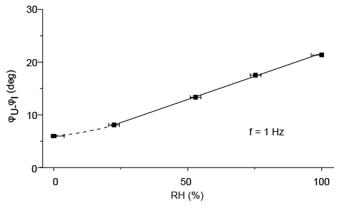
Figure 24. The extraction of the RH value by measuring the phase angle at 1 Hz.

The absorbed water influences the electrical properties of the laminate and the RH level should therefore be considered as an input parameter for control algorithms of the IEAP actuators and the factor influencing the charge storage capacity of the IEAPs as flexible supercapacitors.
In addition to the electrical properties, also mechanical properties of the IEAP change considerably. Investigation of the relation between the mechanical properties and the RH level is out of the scope of this work.

An IEAP as a humidity sensor

Introduction
As demonstrated in the paragraph 7, the impedance of the IEAP laminate is highly dependent on the ambient RH value. It is possible to determine the RH value around the IEAP laminate by measuring its electrical impedance. This is an advantageous and unique additional feature for the IEAPs primarily engaged either as an actuator or a supercapacitor, but the use of such laminate primarily as an impedance-based humidity sensor is impractical due to the relative complexity of the three-layered laminate and a wide choice of highly-developed competitive (e.g. resistive, capacitive, or quartz crystal microbalance-based) humidity sensor technologies.
In addition to the change in impedance, which is an expected result in case of an IEAP as a highly hygroscopic material, the humidity-sensitivity of the IEAP laminate has been found to concurrently express itself in an additional way, which is not predicted from the prior comprehension over the IEAP laminates. The newly found sensing phenomenon reveals itself in the formation of voltage and electric current between the IEAP electrodes, when the opposite electrodes of an IEAP laminate are exposed to the environments with different RH levels. In other words, a humidity gradient across the IEAP results in the formation of a macroscopic electric charge. Concurrently, also volumetric effects arise; i.e. the side of laminate exposed to a higher RH expands and the cantilevered laminate bends towards the drier environment. The bipartite response of the IEAP laminate is demonstrated in Figure 25.
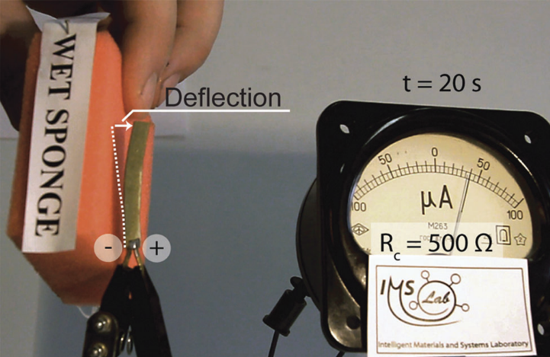
Figure 25. Demonstration of the humidity response of a cantilevered piece of IEAP Type I.

Experimental
The water sorption-induced charge-generation properties were characterized by exposing the opposite sides of the IEAP Type I laminate to different ambient RH values. The IEAP laminate was fixed between epoxy plates with ‘windows’, as illustrated in Figure 26A. The ‘windows’ in the plates with an IEAP between them were exposed to the humidity chambers with controlled RH values. Before the experiments, the humidity content in the IEAP was equilibrated by exposing the opposite sides to humidity chambers with equal RHs, as illustrated in Figure 26C. Subsequently, one humidity chamber was quickly (in ∼1 s) replaced with a humidity chamber with a different RH level, as depicted on Figure 26D, consequently establishing a RH gradient across the IEAP. All humidity chambers were equipped with air agitators, which ensured the preservation of constant RH in the chambers and also accelerated the water sorption or desorption.
The constant RH level in the humidity chambers were established by the use of saturated saline solutions in similar to the experiments described in section 7.3.
The voltage and electric current were registered using a National Instruments PCI-6036E DAQ board. The bias current of the PCI-6036E DAQ board with its front-end analog input modules from the SCC-AI series was found to be too high for measurement of open-circuit potential on supercapacitor-like systems, as the supercapacitor under test was charged by the current originating from the measurement device in the long run. Therefore, a Burr-Brown INA116 instrumentation amplifier with an extremely low input bias current was used as a preamplifier.
Electric current was measured as a voltage drop over a low-ohm resistor, as depicted in Figure 26B. The same amplifier set-up was used as an ammeter or a voltmeter, depending on the state of the switch S connecting the shunt resistor. The actual value of the shunt resistor – 10 Ω – was equivalent to the value of series resistance R_{s} at medium RH level, as given in Figure 24 for a similar IEAP with a comparable size. Matching of the internal resistance R_{s} with the value of the shunt resistor R_{c} assured that the power dissipated on the shunt resistor R_{c} was the highest.
Figure 26. (A) Fixing of an IEAP between epoxy plates with ‘windows’. (B) The set-up for electrical measurements. (C-D) The experimental set-up for varying RH gradient between an IEAP.

Transient response to humidity gradient

Open-circuit voltage
The transient course of open-circuit voltage after a sudden formation of a RH gradient across the IEAP reveals two different processes with different time constants, as depicted in Figure 27. Immediately after formation of humidity gradient, the voltage rises steeply and gains its peak or ‘knee’ after 100-500 s. After this, the voltage continues to increase further and achieves its final peak after as long as 2.2 h.
Figure 27 Transient course of the open-circuit voltage after exposing an initially dry electrode to 50% RH.
The process with a shorter time constant corresponds to water sorption or desorption processes occurring in this particular electrode, above which the RH was changed. Concurrently, also water diffusion through the IEAP slowly starts to occur. After the time of a first peak or a ’knee’ value in 100-500 s, water diffusion across the IEAP becomes the primary mechanism for the increasing voltage.
Synchronously to the rise of open-circuit voltage across the laminate, also volumetric effects emerge. Figure 28 illustrates the course of open-circuit voltage in comparison with the deflection of a cantilevered IEAP as a response to a RH increase above one of the electrodes. In this experiment, the IEAP laminate was not fixed between the rigid plates, which enabled measurement of the bending motion using a laser displacement meter, but in turn complicated the estimation of the humidity gradient magnitude across the IEAP. It can be noticed that the open-circuit voltage is clearly more sensitive to the change (both to increase and decrease) in the RH above the laminate. The bending of the laminate reflects the strain of all parts of the laminate; therefore, it is obvious that the diffusion of sorbed water through the electrode needs significant amount of time. On the contrary, sorption of water by even the topmost layer of a single electrode can be registered by measuring the voltage difference between the electrodes. The IEAP humidity sensor also has a ’memory’ – it is possible to determine the history of applied RH gradient by measuring voltage after the humidity gradient has disappeared.
Figure 28. Simultaneous deflection of the cantilevered IEAP laminate and formationof an open-circuit voltage between the electrodes after creation of a humiditydifference between the electrodes.
The transient course of voltage is characterized by a steep rise of voltage immediately after the formation of RH gradient, gaining its peak value in 100-500 s. As expected, the peak or ‘knee’ value is dependent on the RH gradient, as illustrated in Figure 29A. Figure 29B shows the peak values of open-circuit voltages measured in experiments with various combinations of initial equilibrium RH values and induced RH gradients. In case the peak value was not formed (as illustrated, for example, in Figure 29A for a combination of initial RH of 0% and ΔRH of 23%), the open-circuit value after 500 s is given. It can be observed that smaller RH gradients yield proportionally larger open-circuit voltages. In addition, the RH increase yields larger peak values, as absorption process is generally faster than desorption.
Figure 29 Fig. 5 (A) Transient course of the voltage after initially dry electrodes wereexposed to different levels of humidity. (B) Peak values of open-circuit voltage forall tested combinations of initial humidity and humidity gradients.
The transient course of electric current after the formation of RH gradient is characterized by a steep peak and a subsequent decay. Figure 30A shows that the level of electric current has dropped to the electrical noise level after 150 s. The peak value of electric current is roughly proportional to the change in RH level, as illustrated in Figure 30C, on the assumption of equal initial humidity. At the same time, the slope between peak value of current and change in RH is strongly dependent on the initial RH level. Interestingly, the generated values of electric charge, calculated in Figure 30B for transient courses given in Figure 30A, do not follow the same trend with peak current – the RH gradient of 100% yielded roughly the same amount of charge as gradient of 75%.
In the conducted experiments, the laminate was returned to initial, homogenous RH after 300 s. The repeated change in RH caused a second peak of electric current to be formed; only the direction of current was reversed this time. The peak values are given in Figure 30D for all investigated combinations of initial RHs and RH gradients. It can be noticed that the peak corresponding to the return to initial conditions does not follow the same pattern with initial disturbance of RH level – Figure 30A illustrates that the highest peak is formed when one side of the initially dry laminate is exposed to the highest RH, but the return to initial conditions yields the lowest peak value.
Figure 30 (A) Transient response of the electric current to humidity change.(B) Generated and stored charge as a function of time. (C) Peak values of theelectric current at various combinations of initial humidity and humiditygradients. (D) Peak values of the electric current upon returning the laminateto the initial humidity levels.

Cyclic stability
The electrical output of IEAP laminate in response to ambient humidity gradient has a high cyclic stability. In the cycling experiment, the laminate was placed between humidity chambers with 0 and 53% RH and the humidity gradient was reversed after every minute. After 1000 cycles, the course of open-circuit voltage was nearly indistinguishable from the initial value. The charge generated in each cycle, however, showed a small decrease – the 1000th cycle yielded 92% of the charge generated in the first cycle.
Figure 31. (A) Output current of the laminate during the cycling test. (B) Variation of the generated charge in consecutive cycles.

Energy harvesting

IEAP as a mechanoelectrical energy harvester
In the paragraph 6 of the current work, charge generation capability of the IEAP was investigated. The highest transient electric power generated by mechanical bending has been found to be 0.4 nW cm⁻² in case of an impedance-matched load, as depicted in Figure 32. This power level is evidently too low to be considered for energy harvesting. However, contrarily to e.g. piezoresistive sensors, the IEAP motion sensors are still advantageous, as they do not need any power from the measurement equipment.
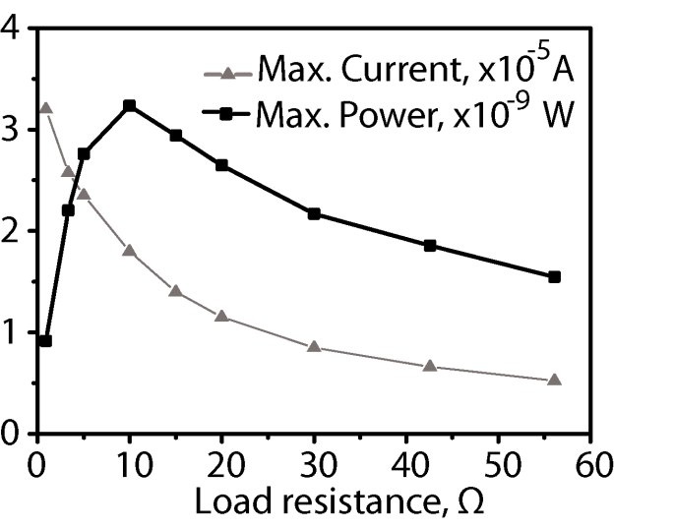
Figure 32. The peak current and dissipated power of an IEAP Type II at various load resistances. Adapted from ¹¹⁰.

The concept for cyclic hygroenergy harvesting
The voltage and electric current generation from ambient humidity gradient by the use of an IEAP material is discussed in the paragraph 8.3. In the following paragraph, the feasibility and characteristics of an IEAP as hygroelectric energy harvester is discussed.
The highest current and therefore charge generation density takes place directly after the change of RH. In principle, the highest momentary charge output of 1500 C m⁻² h⁻¹ or 3300 C kg⁻¹ h⁻¹ was registered; although, at the lowest voltage (<1 mV), which is impractical to be used to power electronic devices. At this point, supercapacitor properties of the IEAP are turned into advantage in energy harvesting. As described in paragraph 8.3.1, the open-circuit voltage on an IEAP increases when the laminate is held between environments with different RHs. The IEAP is able to produce small amounts of charge from water diffusion through the laminate. This amount of charge is too low to be collected by any external power conditioning circuitry. However, the IEAP is able to store a significant amount of generated energy in the very same material, where the energy was generated. The charging can take place at any rate, therefore enabling harvesting energy from sources previously considered as unavailable.
The whole amount of energy collected into the IEAP during a long (hours to days) time span can be extracted on demand at very high rate. This energy-consumption profile matches with wireless sensor network nodes operating at low-duty-cycle mode. Figure 33 describes the use of IEAP as an energy harvester. The IEAP is held between humidity chambers with different RHs during more than 2 hours, until the open-circuit voltage achieved its peak value. Subsequently, the IEAP was discharged on a 10-Ω load R_{c} by connecting it between the IEAP electrodes via switch S. Only 30 s was needed to fully discharge the IEAP. More importantly, the peak current of 23 A m⁻² was registered, which corresponds to a power density of 2.0 W m⁻². This current level is as much as 31 times more than the highest peak current registered in continuous mode directly after the rapid change of RH gradient. The difference in power density is even more drastic – by the use of periodic charge-discharge cycle, the peak power density increased as much as three orders of magnitudes, from 2.1 mW m⁻² to 2.0 W m⁻².
The highest registered energy density of the hygroelectric energy harvester was 4.4 J m⁻². As a comparison, the same IEAP working purely as a supercapacitor with a nominal voltage of 3 V and capacitance of 270 F m⁻² can hold 810 C m⁻² of charge and has an energy density of 1215 J m⁻². Therefore, the laminate is able to collect up to 6% of the charge and 0.36% of the energy it is able to contain merely from ambient humidity.
The simultaneous energy-storage capability is an unique property among energy-harvesting materials. For a comparison, a metallized 17 µm thick film of crystalline PVdF is able to collect 0.5 J m⁻² of energy from human respiration in 20 minutes.⁶⁶ At the same time, the energy-harvesting material itself as a parallel plate capacitor with a relative permittivity ε_{r} = 11 can hold only 7.3 mJ m⁻² when charged to 10 V. The energy generated in each cycle has to be collected into external storage units for subsequent use. Therefore, our IEAP material can collect energy from merely a humidity gradient with a rate that is comparable to mechanical stimulus. Moreover, there is no need for external energy storage units, as the material itself can store a significant amount of energy.

Figure 33 (A) Energy-harvesting principle based on intermittent charging and discharging of the EDLC-like IEAP laminate.

Conclusions
The work at hand explores a distinctive characteristic of the IEAP laminates with high specific surface area CDC electrodes – the ability of responding to external stimuli by formation of electric charge between the electrodes. These IEAP laminates function concurrently also as supercapacitors and electromechanical actuators.
At first, the response of the laminate to mechanical bending was investigated on IEAPs with ionic liquid electrolyte and ionic or non-ionic polymer separator. The transient response of the IEAPs to a bending motion is characterized by formation of a sharp peak immediately after bending and slow diminishing of the generated voltage and electric current towards zero. The IEAP motion sensor has a strongly nonlinear frequency response. However, it is possible to determine the amount of deflection by measuring electric current between the electrodes.
The IEAP laminates are found to have remarkable sensitivity to ambient humidity. Impedance spectroscopy analysis revealed that the series resistance decreased as much as 13 times as a result of RH change above the laminate. This is caused by highly hygroscopic constituents of the investigated IEAPs.
Humidity-sensitivity of the IEAP is revealed also in its charge-generation capability. It was discovered that the IEAP laminate responds to a RH gradient by formation of electric current and voltage between its electrodes. Charge is formed both as a result of RH change and an unidirectional humidity gradient.The magnitude of generated charge is found to be more than an order of magnitude higher than as a result of mechanical bending. The high magnitude of generated charge suggests that the field of application for the IEAPs could be broadened towards hygroelectric energy harvesting. Therefore, IEAP technology can bring ambient humidity gradient among practical sources for harvesting electrical energy. Error! Reference source not found. gives a roadmap between applications and the underlying working mechanisms of IEAPs.
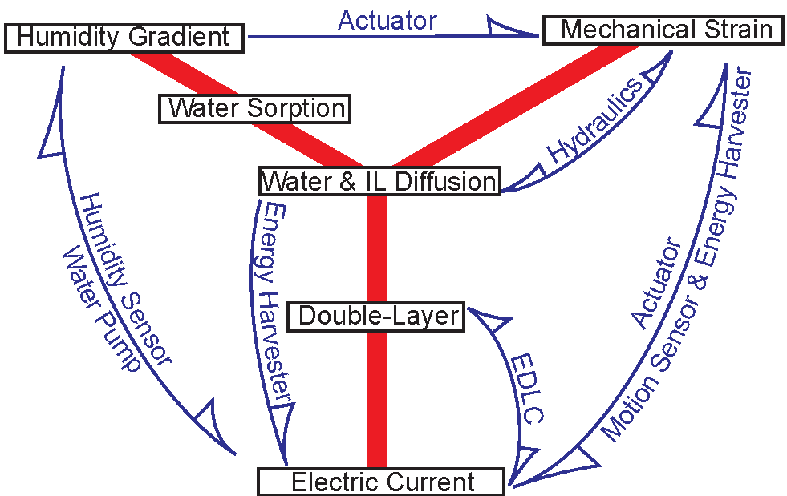
Figure 34. The roadmap for the applications for IEAPs.
Formation of electric charge can occur if the following conditions are met:
- Unequal conditions are applied to the opposite electrodes of a single laminate. In case of mechanoelectric transduction, the opposite electrodes undergo different mechanical stress; and in case of hygroelectric transduction, the different conditions are achieved by sorption of water.
- The mobility of cations and anions in the carbon and polymer matrix are unequal for achievement of a nonhomogeneous charge distribution. This is achieved by tailoring of the porosity parameters of the IEAP electrode and the morphology of the ionically conductive polymeric separator.
In hygroelectric energy harvesting, the supercapacitor-like properties of the IEAP are brought into use. An IEAP energy harvester can store the generated electric charge into itself, therefore serving concurrently as an energy harvester and a storage unit. This property enables collection of electric energy from the environment during a long time at a low rate, and to extract the collected energy at a high rate.

References
1 S. Kim, C. Laschi and B. Trimmer, Trends Biotechnol., 2013, .
2 T. Someya, Stretchable Electronics, John Wiley & Sons, 2012.
3 H. Koo and O. D. Velev, Biomicrofluidics, 2013, 7, 031501.
4 H. I. Becker, Low voltage electrolytic capacitor, 1957, .
5 J. Miller, Battery Energy Storage Technology, 2007, , 61.
6 E. F. François Béguin, Supercapacitors: Materials, Systems, and Applications, Wiley-VCH Verlag GmbH & Co. KGaA, Germany, 2013.
7 Y. Li, R. Torah, S. Beeby and J. Tudor, An all-inkjet printed flexible capacitor for wearable applications, IEEE, 2012.
8 J. Ren, W. Bai, G. Guan, Y. Zhang and H. Peng, Adv Mater, 2013, .
9 H. Cheng, Z. Dong, C. Hu, Y. Zhao, Y. Hu, L. Qu, N. Chen and L. Dai, Nanoscale, 2013, 5, 3428-3434.
10 Y. Fu, X. Cai, H. Wu, Z. Lv, S. Hou, M. Peng, X. Yu and D. Zou, Adv Mater, 2012, , n/a-n/a (DOI:10.1002/adma.201202930).
11 S. Lee, K. Choi, W. Choi, Y. H. Kwon, H. Jung, H. Shin and J. Y. Kim, Energy Environ.Sci., 2013, .
12 L. Hu and Y. Cui, Energy & Environmental Science, 2012, 5, 6423-6435.
13 D. Wei and T. W. Ng, Electrochemistry Communications, 2009, 11, 1996-1999.
14 M. F. El-Kady, V. Strong, S. Dubin and R. B. Kaner, Science, 2012, 335, 1326-1330.
15 X. Cai, M. Peng, X. Yu, Y. Fu and D. Zou, J.Mater.Chem.C, 2013, .
16 M. Beidaghi and Y. Gogotsi, Energy & Environmental Science, 2013, .
17 J. H. Kim, K. Nam, S. B. Ma and K. B. Kim, Carbon, 2006, 44, 1963-1968.
18 Z. Wu, K. Parvez, X. Feng and K. Müllen, Nature communications, 2013, 4.
19 Y. Bar-Cohen and Society of Photo-optical Instrumentation Engineers., Electroactive polymer (EAP) actuators as artificial muscles [electronic resource] : reality, potential, and challenges, SPIE, Bellingham, Wash. (1000 20th St. Bellingham WA 98225-6705 USA), 2004.
20 M. Shahinpoor and K. J. Kim, Smart Mater. Struct., 2001, 10, 819.
21 R. Baughman, L. Shacklette, R. Elsenbaumer, E. Plichta and C. Becht, in Conjugated Polymeric Materials: Opportunities in Electronics, Optoelectronics, and Molecular Electronics, ed. nonymous , Springer, 1990, p. 559-582.
22 E. Smela, Adv Mater, 2003, 15, 481-494.
23 R. H. Baughman, C. Cui, A. A. Zakhidov, Z. Iqbal, J. N. Barisci, G. M. Spinks, G. G. Wallace, A. Mazzoldi, D. De Rossi, A. G. Rinzler, O. Jaschinski, S. Roth and M. Kertesz, Science, 1999, 284, 1340-1344 (DOI:10.1126/science.284.5418.1340).
24 W. Lu, A. G. Fadeev, B. Qi, E. Smela, B. R. Mattes, J. Ding, G. M. Spinks, J. Mazurkiewicz, D. Zhou and G. G. Wallace, Science, 2002, 297, 983-987.
25 T. Fukushima, K. Asaka, A. Kosaka and T. Aida, Angewandte Chemie International Edition, 2005, 44, 2410-2413.
26 J. Torop, M. Arulepp, J. Leis, A. Punning, U. Johanson, V. Palmre and A. Aabloo, Materials, 2009, 3, 9-25.
27 V. Palmre, E. Lust, A. Janes, M. Koel, A. Peikolainen, J. Torop, U. Johanson and A. Aabloo, J.Mater.Chem., 2011, .
28 X. Xie, L. Qu, C. Zhou, Y. Li, J. Zhu, H. Bai, G. Shi and L. Dai, ACS Nano, 2010, 4, 6050-6054.
29 J. Torop, V. Palmre, M. Arulepp, T. Sugino, K. Asaka and A. Aabloo, Carbon, 2011, 49, 3113-3119 (DOI:10.1016/j.carbon.2011.03.034).
30 J. Torop, M. Arulepp, J. Leis, A. Punning, U. Johanson and A. Aabloo, Low voltage linear actuators based on carbide-derived carbon powder, International Society for Optics and Photonics, 2009.
31 M. Hahn, O. Barbieri, F. Campana, R. Kötz and R. Gallay, Applied physics A, 2006, 82, 633-638.
32 M. Hahn, R. Kötz, R. Gallay and A. Siggel, Electrochim. Acta, 2006, 52, 1709-1712.
33 M. Ghaffari, W. Kinsman, Y. Zhou, S. Murali, Q. Burlingame, M. Lin, R. Ruoff and Q. Zhang, Adv Mater, 2013, .
34 D. Pugal, K. Jung, A. Aabloo and K. J. Kim, Polym. Int., 2010, 59, 279-289.
35 K. Sadeghipour, R. Salomon and S. Neogi, Smart Mater. Struct., 1992, 1, 172.
36 U. Zangrilli and L. Weiland, Smart Mater. Struct., 2011, 20, 094013.
37 B. Kocer and L. M. Weiland, Smart Mater. Struct., 2013, 22, 035020.
38 S. Nemat-Nasser and J. Y. Li, J. Appl. Phys., 2000, 87, 3321-3331.
39 K. M. Newbury and D. J. Leo, Journal of Intelligent Material Systems and Structures, 2003, 14, 343-357 (DOI:10.1177/1045389X03034977).
40 F. Gao and L. M. Weiland, J. Appl. Phys., 2010, 108, 034910-034910-8.
41 M. D. Bennett and D. J. Leo, Sensors and Actuators A: Physical, 2004, 115, 79-90.
42 B. J. Akle, J Intell Mater Syst Struct, 2013, 24, 1123-1130.
43 F. Kaasik, T. Tamm, M. Hantel, E. Perre, A. Aabloo, E. Lust, M. Bazant and V. Presser, Electrochemistry Communications, 2013, .
44 L. Shen, Y. Cha, A. Shams and M. Porfiri, Smart Mater. Struct., 2013, 22, 105032.
45 Y. Wu, G. Alici, J. ?. ?. Madden, G. ?. Spinks and G. ?. Wallace, Advanced Functional Materials, 2007, 17, 3216-3222 (DOI:10.1002/adfm.200700060).
46 W. Takashima, T. Uesugi, M. Fukui, M. Kaneko and K. Kaneto, Synth. Met., 1997, 85, 1395-1396 (DOI:10.1016/S0379-6779(97)80289-5).
47 G. Alici, G. M. Spinks, J. D. Madden, Y. Wu and G. G. Wallace, Mechatronics, IEEE/ASME Transactions on, 2008, 13, 187-196.
48 T. Shoa, J. D. W. Madden, T. Mirfakhrai, G. Alici, G. M. Spinks and G. G. Wallace, Sensors and Actuators A: Physical, 2010, 161, 127-133 (DOI:10.1016/j.sna.2010.04.024).
49 S. John, G. Alici, G. M. Spinks, J. Madden and G. Wallace, Smart Mater. Struct., 2009, 18, 085007.
50 E. G. Bakhoum and M. H. M. Cheng, Components, Packaging and Manufacturing Technology, IEEE Transactions on, 2012, 2, 1151-1157.
51 K. Kikuchi and S. Tsuchitani, Effects of environmental humidity on electrical properties of ionic polymer-metal composite with ionic liquid, IEEE, 2009.
52 Z. Chen, X. Tan, A. Will and C. Ziel, Smart Mater. Struct., 2007, 16, 1477.
53 K. Krishen, Acta Astronaut., 2009, 64, 1160-1166.
54 S. J. Kim, I. T. Lee, H. Lee and Y. H. Kim, Smart Mater. Struct., 2006, 15, 1540.
55 J. Ranke, A. Othman, P. Fan and A. MÃ¼ller, International Journal of Molecular Sciences, 2009, 10, 1271-1289 (DOI:10.3390/ijms10031271).
56 Y. Cao, Y. Chen, X. Sun, Z. Zhang and T. Mu, Phys. Chem. Chem. Phys., 2012, 14, 12252-12262.
57 A. C. MacMillan, T. M. McIntire, J. A. Freites, D. J. Tobias and S. A. Nizkorodov, J Phys Chem B, 2012, 116, 11255-11265 (DOI:10.1021/jp305029n).
58 F. D. Francesco, N. Calisi, M. Creatini, B. Melai, P. Salvo and C. Chiappe, Green Chem., 2011, 13, 1712-1717.
59 ATSAM---e ARM-based Flash MCU SAM4L Series, Atmel, 2013.
60 Z. L. Wang and W. Wu, Angewandte Chemie International Edition, 2012, 51, 11700-11721.
61 Z. Li and Z. L. Wang, Adv Mater, 2011, 23, 84-89.
62 C. B. Vining, Nature Materials, 2009, 8, 83-85.
63 Q. Zhong, J. Zhong, B. Hu, Q. Hu, J. Zhou and Z. L. Wang, Energy Environ.Sci., 2013, 6, 1779-1784.
64 F. Fan, L. Lin, G. Zhu, W. Wu, R. Zhang and Z. L. Wang, Nano letters, 2012, 12, 3109-3114.
65 R. Vullers, R. van Schaijk, I. Doms, C. Van Hoof and R. Mertens, Solid-State Electronics, 2009, 53, 684-693.
66 C. Sun, J. Shi, D. J. Bayerl and X. Wang, Energy & Environmental Science, 2011, 4, 4508-4512.
67 LTC3108 Ultralow Voltage Step-Up Converter and Power Manager, Linear Technologies, 2013.
68 R. Tiwari and K. Kim, Smart Mater. Struct., 2013, 22, 015017.
69 M. Aureli, C. Prince, M. Porfiri and S. D. Peterson, Smart Mater. Struct., 2010, 19, 015003.
70 F. Cellini, Y. Cha and M. Porfiri, J Intell Mater Syst Struct, 2013, , 1045389X13508333.
71 Y. Cha, L. Shen and M. Porfiri, Smart Mater. Struct., 2013, 22, 055027.
72 M. D. Bennett, D. J. Leo, G. L. Wilkes, F. L. Beyer and T. W. Pechar, Polymer, 2006, 47, 6782-6796.
73 S. Li, J. Yuan and H. Lipson, J. Appl. Phys., 2011, 109, 026104.
74 E. Reyssat and L. Mahadevan, Journal of The Royal Society Interface, 2009, 6, 951-957.
75 E. Reyssat and L. Mahadevan, EPL (Europhysics Letters), 2011, 93, 54001.
76 D. P. Holmes, M. Roché, T. Sinha and H. A. Stone, Soft Matter, 2011, 7, 5188-5193.
77 Y. Ma, Y. Zhang, B. Wu, W. Sun, Z. Li and J. Sun, Angewandte Chemie, 2011, 123, 6378-6381.
78 S. Lee, J. H. Prosser, P. K. Purohit and D. Lee, ACS Macro Letters, 2013, 2, 960-965.
79 M. Ma, L. Guo, D. G. Anderson and R. Langer, Science, 2013, 339, 186-189 (DOI:10.1126/science.1230262).
80 Y. Yang and J. Liu, Micro/nanofluidics-enabled energy conversion and its implemented devices, Higher Education Press, co-published with Springer-Verlag GmbH, 2011.
81 van der Heyden, Frank HJ, D. J. Bonthuis, D. Stein, C. Meyer and C. Dekker, Nano letters, 2007, 7, 1022-1025.
82 C. Chang and R. Yang, Appl. Phys. Lett., 2011, 99, 083102-083102-3.
83 R. T. Borno, J. D. Steinmeyer and M. M. Maharbiz, Appl. Phys. Lett., 2009, 95, 013705-013705-3.
84 H. Okuzaki, T. Kuwabara and T. Kunugi, Polymer, 1997, 38, 5491-5492.
85 H. Okuzaki, K. Hosaka, H. Suzuki and T. Ito, React Funct Polym, (DOI:10.1016/j.reactfunctpolym.2012.10.013).
86 P. Simon, P. Taberna and F. Béguin, Supercapacitors: Materials, Systems, and Applications, , 131-165.
87 O. Kim, T. J. Shin and M. J. Park, Nature communications, 2013, 4.
88 S. Liu, W. Liu, Y. Liu, J. Lin, X. Zhou, M. J. Janik, R. H. Colby and Q. Zhang, Polym. Int., 2010, 59, 321-328.
89 Y. Liu, M. Ghaffari, R. Zhao, J. Lin, M. Lin and Q. Zhang, Macromolecules, 2012, 45, 5128-5133.
90 N. Terasawa, I. Takeuchi, K. Mukai and K. Asaka, Polymer, 2010, 51, 3372-3376.
91 M. M. Hantel, V. Presser, R. Kötz and Y. Gogotsi, Electrochemistry Communications, 2011, 13, 1221-1224 (DOI:10.1016/j.elecom.2011.08.039).
92 L. L. Zhang, Y. Gu and G. Zhao, J.Mater.Chem.A, 2013, .
93 V. Presser, M. Heon and Y. Gogotsi, Advanced Functional Materials, 2011, , n/a-n/a (DOI:10.1002/adfm.201002094).
94 L. Borchardt, M. Oschatz and S. Kaskel, Mater.Horiz., 2013, .
95 F. W. Richey, B. Dyatkin, Y. Gogotsi and Y. A. Elabd, J. Am. Chem. Soc., 2013, 135, 12818-12826.
96 M. G. Freire, C. M. S. S. Neves, I. M. Marrucho, J. A. P. Coutinho and A. M. Fernandes, The Journal of Physical Chemistry A, 2009, 114, 3744-3749.
97 H. Tokuda, S. Tsuzuki, Susan, Md Abu Bin Hasan, K. Hayamizu and M. Watanabe, The Journal of Physical Chemistry B, 2006, 110, 19593-19600.
98 O. Cabeza, S. García-Garabal, L. Segade, M. Domínguez-Pérez, E. Rilo and L. M. Varela, Ionic Liquids Theory, properties, new approaches, 2011, .
99 X. Zhang, L. Lu and Y. Cai, Langmuir, 2012, 28, 9593-9600 (DOI:10.1021/la301452d).
100 S. Sekhon, J. Park, E. Cho, Y. Yoon, C. Kim and W. Lee, Macromolecules, 2009, 42, 2054-2062.
101 M. J. Park, I. Choi, J. Hong and O. Kim, J Appl Polym Sci, 2013, .
102 B. J. Akle, M. D. Bennett and D. J. Leo, Sensors and Actuators A: Physical, 2006, 126, 173-181.
103 P. J. James, J. A. Elliott, T. J. McMaster, J. M. Newton, A. M. S. Elliott, S. Hanna and M. J. Miles, Hydration of Nafion® studied by AFM and X-ray scattering, Springer Netherlands, 2000.
104 J. Hou, Z. Zhang and L. A. Madsen, The Journal of Physical Chemistry B, 2011, 115, 4576-4582.
105 K. Mukai, K. Asaka, T. Sugino, K. Kiyohara, I. Takeuchi, N. Terasawa, D. N. Futaba, K. Hata, T. Fukushima and T. Aida, Adv Mater, 2009, 21, 1582-1585.
106 D. Mecerreyes, Progress in Polymer Science, 2011, 36, 1629-1648.
107 S. Trasatti and E. Lust, in Modern aspects of electrochemistry, ed. nonymous , Springer, 2002, p. 1-215.
108 B. J. Akle, M. D. Bennett, D. J. Leo, K. B. Wiles and J. E. McGrath, J. Mater. Sci., 2007, 42, 7031-7041.
109 V. Palmre, D. Brandell, U. Mäeorg, J. Torop, O. Volobujeva, A. Punning, U. Johanson, M. Kruusmaa and A. Aabloo, Nanoporous carbon-based electrodes for high strain ionomeric bending actuators, 2009.
110 I. Must, F. Kaasik, I. Põldsalu, U. Johanson, A. Punning and A. Aabloo, Carbon, 2012, 50, 535-541 (DOI:10.1016/j.carbon.2011.09.010).
111 N. Kamamichi, T. Maeba, M. Yamakita and T. Mukai, Adv. Rob., 2010, 24, 1471-1487 (DOI:10.1163/016918610X505585).
112 A. K. Ghamsari, Y. Jin and E. Woldesenbet, Smart Mater. Struct., 2012, 21, 045007.
113 M. Otsuki, T. Okuyama and M. Tanaka, Int. J. Appl. Electromagn. Mech., 2012, 39, 1063-1068 (DOI:10.3233/JAE-2012-1579).
114 T. Mirfakhrai, Jiyoung Oh, M. E. Kozlov, Shaoli Fang, Mei Zhang, R. H. Baughman and J. D. W. Madden, Mechatronics, IEEE/ASME Transactions on, 2011, 16, 90-97.
115 A. Hunt, Z. Chen, X. Tan and M. Kruusmaa, Feedback control of a coupled IPMC (ionic polymer-metal composite) sensor-actuator, ASME, 2009.
116 P. Brunetto, L. Fortuna, P. Giannone, S. Graziani and F. Pagano, Instrumentation and Measurement, IEEE Transactions on, 2010, 59, 1453-1462.
117 J. Tao and X. B. Yu, Smart Mater. Struct., 2012, 21, 113001.
118 J. Parcell, N. Aydemir, H. Devaraj, J. Travas-Sejdic, D. Williams and K. Aw, Smart Mater. Struct., 2013, 22, 112001.
119 C. Bonomo, L. Fortuna, P. Giannone and S. Graziani, Sensors and Actuators A: Physical, 2005, 123–124, 146-154 (DOI:10.1016/j.sna.2005.03.012).
120 K. Farinholt and D. J. Leo, Mech. Mater., 2004, 36, 421-433 (DOI:10.1016/S0167-6636(03)00069-3).
121 C. Bonomo, L. Fortuna, P. Giannone, S. Graziani and S. Strazzeri, Smart Mater. Struct., 2006, 15, 749.
122 B. Paola, L. Fortuna, P. Giannone, S. Graziani and S. Strazzeri, IPMCs as Vibration Sensors, 2008.
123 E. Biddiss and T. Chau, Med. Eng. Phys., 2006, 28, 568-578.
124 A. Punning, M. Kruusmaa and A. Aabloo, Sensors and Actuators A: Physical, 2007, 133, 200-209 (DOI:DOI: 10.1016/j.sna.2006.03.010).
125 M. Otsuki, T. Okuyama and M. Tanaka, Characterization of a curvature sensor using a solid polymer electrolyte, 2009.
126 D. L. Hung, X. Yang, G. Zhu, T. Ganley and X. Tan, Modeling of Ionic Polymer-Metal Composite beam dynamics and its validation using high-speed motion visualization, IEEE, 2010.
127 J. Jeon, T. Cheng and I. Oh, Sensors and Actuators A: Physical, 2010, 158, 300-305.
128 K. Farinholt and D. J. Leo, Mech. Mater., 2004, 36, 421-433.
129 K. Kruusamäe, A. Punning and A. Aabloo, Sensors, 2012, 12, 1950-1966.
130 L. M. Onishi, J. M. Prausnitz and J. Newman, J Phys Chem B, 2007, 111, 10166-10173 (DOI:10.1021/jp073242v).
131 F. Tailoka, D. Fray and R. Kumar, Solid State Ionics, 2003, 161, 267-277.
132 L. Sun and T. Okada, Anal. Chim. Acta, 2000, 421, 83-92.
133 S. Osswald, J. Chmiola and Y. Gogotsi, Carbon, 2012, 50, 4880-4886 (DOI:10.1016/j.carbon.2012.06.016).
134 E. Rilo, J. Vila, J. Pico, S. García-Garabal, L. Segade, L. M. Varela and O. Cabeza, Journal of Chemical & Engineering Data, 2009, 55, 639-644.
135 A. Jarosik, S. R. Krajewski, A. Lewandowski and P. Radzimski, Journal of Molecular Liquids, 2006, 123, 43-50 (DOI:10.1016/j.molliq.2005.06.001).
136 M. C. Buzzeo, C. Hardacre and R. G. Compton, Anal. Chem., 2004, 76, 4583-4588 (DOI:10.1021/ac040042w).
137 C. Liang, C. Yuan, R. J. Warmack, C. E. Barnes and S. Dai, Anal. Chem., 2002, 74, 2172-2176.
138 L. Greenspan, Journal of Research of the National Bureau of Standards, 1977, 81, 89-96.
139 I. Takeuchi, K. Asaka, K. Kiyohara, T. Sugino, K. Mukai and H. Randriamahazaka, Electrochemical Impedance Spectroscopy and Electromechanical Behavior of Bucky-Gel Actuators Containing Ionic Liquids, 2010.
140 Y. Yu, A. N. Soriano and M. Li, The Journal of Chemical Thermodynamics, 2009, 41, 103-108.
141 P. Lin, A. N. Soriano, R. B. Leron and M. Li, Exp. Therm. Fluid Sci., 2011, 35, 1107-1112.

