Novel model of viscoelasticity for IEAP actuators.
Veix, Punn, Alvo

Abstract tuleb alles siis kui conclusion on valmis.
The innovatory viscoelastic model of bending ionic electroactive polymer actuators allows modelling
1. Introduction
Already since the very first reports concerning the bending ionic electroactive polymer actuators, the researchers have described the „back-relaxation“ effect – an actuator excited with DC voltage, instead of holding its bent state, relaxes slowly back towards its initial shape. This behavior is commonly treated as a shortcoming of IEAP actuators, decreasing their ability to deliver a constant peak force to target, limiting their frequency range, and hindering their exact control. There have been several attempts to slower the rate of back-relaxation by choosing an opportune combination of separator, electrodes or mobile ions. Nevertheless, there is no report claiming that in the case of some IEAP material this holdback is completely eliminated.
Supposedly the phenomenon of back-relaxation is studied almost only in the case of „old-type“ ionic polymer-metal composites (IPMC). It is a wet ion exchange polymer membrane covered with thin metal electrodes on both sides. [X7] For typical IPMC with platinum electrodes, when a voltage is applied across the thickness direction, the electromechanical transduction occurs due to the motion of the cations along with the water molecules. As a result, one face of IPMC withers and shrinks and the opposite face protracts due to swelling with water and ions. This generates warping of the whole laminate. The resulting fast bending motion toward the cathode is followed by a slow relaxation towards the anode, while IPMC as the whole still remains bent. If now the input of this actuator is shorted, the actuator performs a sharp movement towards its initial state, but will usually outdistance. The steps of this process are depicted in Fig. 1. The speed of back-relaxation is reported being dependent on the type of polymer membrane, solvent, cations, etc. [X6]. It is commonly believed that the slow relaxation happens due to the water diffusion out of the strained polymer matrix. [X7] Most of the proposed electromechanical models describing the behavior of IPMC, just neglect the phenomenon of back-relaxation. [XXX] One of the few exceptions is presented by Bao et al. [X3], proposing the model of IPMC without and with the back-relaxation by adding a separate relaxation time constant. [X8] kirjeldab ka midagi.
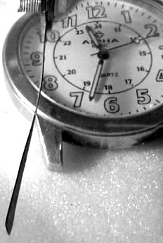 | 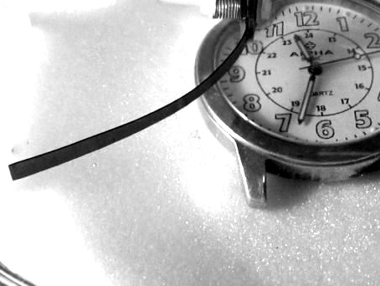 | 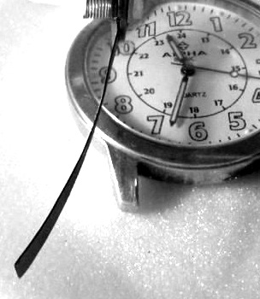 | 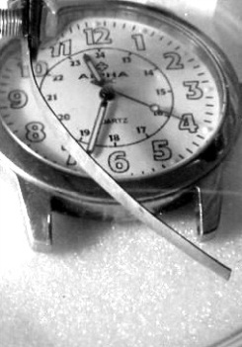
(a) | (b) | (c) | (d)
Figure 1. Actuation of IPMC. (a) – initial state; (b) – forward bending; (c) – back-relaxation with voltage still applied; (d)-opposite bending due to shorted input.
In recent years the range of IEAP materials has been significantly extended by means of materials used for electrodes, separator membrane, as well as the electrolyte. At first glance, all ionic EAPs seem similar in construction – two conducting electrodes separated by a polymer membrane, containing freely moving ions – but their actuation mechanisms can be significantly different. There haven’t appeared any definitive models or at least reports yet, describing the phenomenon of back-relaxation of IEAP actuators with electrodes based on carbon, or conductive polymers.
Experimenting with the IEAP actuators with carbon electrodes, we have noticed that similarly to the water-containing IPMC, virtually all of them exhibit back-relaxation, at least to some extent. It appears that by means of their transient spatial actuation and transient moment of force, the long-term behavior of all IEAP actuators is just similar. The back-relaxation is present regardless of the absence of the fluent liquid, and regardless of the membrane or electrode material.
The bending-relaxing behavior of the IEAP actuators resembles viscoelasticity, but seems working partly conforming, partly contra to the electrical excitation. For this behavior the constitutive models of viscoelasticity, consisting of linear combinations of springs and dampers, are inappropriate. There exist numerous models describing the material’s response in different loading conditions, e.g. Maxwell model, Kelvin-Voigt model, or combinations of both of them. [XX] All the models describe only the response of the material to the external load. Alas, neither of them involves any element causing the actual behavior of the IEAP actuators – lapsing against the load. The cause of this failure is the concept of the so-called canonic models of viscoelasticity [XX], where the load is external, and is applied to the whole system.
The objective of the current paper is describing the time-dependent correspondence between the transient input voltage and the shape of the IEAP actuators, taking into account also the back-relaxation. We ground to the scalable distributed model of IPMC, presented in [DM], and extend it to different IEAP materials. This approach describes the commonly uneven propagation of voltage along the IEAP material, and associates the voltage and charge carried over with the uneven flexure of the actuator. The experiments described in [DM] assume that the charge-flexure relation is simply linear, and leave off just when the phenomenon of back-relaxation becomes noticeable. The current paper associates our novel model of viscoelasticity with [DM]. The resulting electromechanical model of IEAP allows describing the shape or blocking force of the actuators over a long time. Its transient input signal is not limited in any way, due to the accordance to the Boltzmann superposition principle – each loading step makes independent contribution to the total loading history [ISBN: 1569903484].
This paper is organized as follows: Firstly, in Section 2 we show that the innovatory approach to an assembly of springs and dampers will result with PDE-s describing the truthful bending of the actuators forwards and backwards under a constant exciter. In Section 3 we demonstrate the capabilities of the proposed model of viscoelasticity with the response of a lumped model of a fictional IPMC. The thorough characterization of the mechanics of IEAP actuators given in Section 4 is inevitable for understanding the distributed electromechanical model introduced in Section 5. The verification of the model with the examples of three completely different IEAP materials is presented in Section 6. The discussion in Section 7 disputes about the further improvements of this representation.

2. The model of viscoelasticity with internal strain.
As mentioned hereinabove, in the canonic models of viscoelasticity the load is external, and is applied to the whole combination of springs and dampers. This configuration does not involve even any possibility to suppress the exciter. The situation changes completely, when the exciting factor is applied between the spring and damper, resembling something expanding-contracting between the elastic threads of the polymer molecules network. The viscoelastic scheme is depicted in Fig. 2. It consists of a damper in series with our new element - internal strain -, both in parallel with a lone spring. The internal strain is a vector of variation of the length of a non-elastic element. Hereinafter we associate it with the transient electrical charge q of the IEAP material, so for clarity we label the strain element with Q and portray with Q between arrows. When internal strain $ε_{q}$of the element Q is applied, the spring reacts momently, while the damper follows with time, tending towards the unstressed state of the spring. In brief, the input of our viscoelastic element is the strain $ε_{q}$, while the output is the strain of the spring $ε_{s}$. Currently, we only focus on the time dependency of the model designating the characterization of frequency response as future work.
Fig. 2. The model of viscoelasticity with internal strain.
The behavior of this viscoelastic model in different loading conditions is depicted in Fig. 3. We insist that there are no other external stresses or strains affecting the system besides${ ε}_{q}$, indicating that$σ_{Total}=0$. Initially the spring and damper are in their unstressed state: $σ_{d}=σ_{s}=0$ (A). The positive strain of Q draws the spring out (B) while the damper releases in time. This process continues regardless of the applied strain Q until the stress of spring is vanished (C). The removal of the strain Q results with the compression of the spring (D), followed by gradual dragging of the damper, until the stress of the spring is again zero (E). The negative strain of Q is depicted as its shortening (F) and compression of the spring. Similarly, the spring draws the damper longer until reaching the unstressed state (G). As seen in this figure, this system strives to gain its unstressed state with any stress Q.
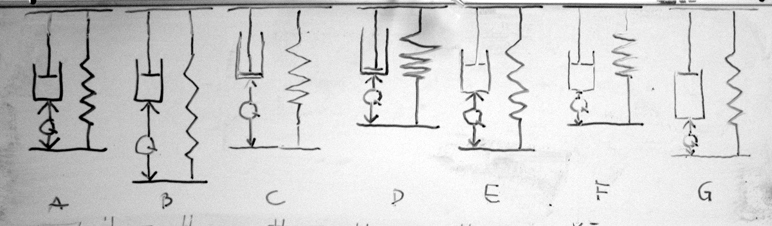
Fig. 3.
The definition of the model is summarized with four relations in (1).
$$\left\{\begin{aligned}{σ_{Total}=σ}_{D}\left(t\right)+σ_{S}(t)=0 \\ ε_{Total}=ε_{S}(t)=ε_{D}(t)+ε_{Q}(t) \\ σ_{S}(t)={Eε}_{S}(t) \\ σ_{D}(t)=η\frac{dε_{D}(t)}{dt}\end{aligned}\right.$$
where $E$and$η$ are modulus of elasticity of the spring and viscosity of the damper respectively. We see two equivalent solutions to this model: with respect to the input strain $ε_{Q}$ and with respect to its derivative, here we present both of them. The described relations in (1) can be arranged into differential equation for strain of damper.
$$η\frac{dε_{D}(t)}{dt}+{Eε}_{D}(t)+Eε_{Q}(t)=0.$$
The solution for $ε_{S}$ is found by bearing in mind $ε_{S}=ε_{D}+ε_{Q}$ and solving the first order linear differential equation for $ε_{D}$ with a homogenous initial condition $ε_{D}\left(0\right)=0.$
$$ε_{S}\left(t\right)=ε_{Q}\left(t\right)-\frac{E}{η} e^{-\frac{E}{η}t}\int_{0}^{t}{ε_{Q}\left(τ\right)e^{\frac{E}{η}τ}dτ}.$$
A different form of the equation is derived by combining (1) for strain of the spring directly
$${Eε}_{S}(t)+η\frac{d[ε_{S}\left(t\right)-ε_{Q}\left(t\right)]}{dt}=0$$
Solving (4) with $ε_{S}\left(0\right)=0$ gives
$$ε_{S}(t)=e^{-\frac{E}{η}t}\int_{0}^{t}{\left({\frac{d}{dξ}ε}_{Q}\left(ξ\right)\right)e^{\frac{E}{η}τ}dτ}$$
This form might be useful if the derivative of $ε_{Q}$ is known. By introducing the rate of relaxation $λ=\frac{E}{η}$ and expressing the input strain in terms of stress $ε_{Q}=\frac{σ_{Q}(t)}{E}$ both given forms are simplified to (7) and (8)
$$ε_{S}\left(t\right)=\frac{1}{E}\left[σ_{Q}\left(t\right)-λe^{-λt}\int_{0}^{t}{σ_{Q}(τ) e^{λτ}dτ}\right].$$
$$ε_{S}\left(t\right)={\frac{1}{E}e}^{-λt}\int_{0}^{t}{{\frac{d}{dξ}σ}_{Q}\left(ξ\right)e^{λτ}dτ}$$

3. Lumped model of IEAP with relaxation:
In order to demonstrate the capabilities of the proposed model of viscoelasticity and its correspondence to the superposition principle, we use a simple lumped model of IPMC presented e.g. in [Bao]. This concept couples the input voltage with transferred charge and the tip displacement of an IPMC actuator. It gives reasonable results in case of small displacements only and serves well to explain the complicated approach presented in the next sections of this paper. Here we just demonstrate the transient response of the model to a rectangular input signal without attempting to validate it with any real actuator.
The lumped model of IPMC is presented in Fig. 4A while the electrical signals as well as strains are depicted in Fig. 4B. The correspondence between the input voltage U_{in}(t) and charge q(t) is
ValemZZ
and the correspondence between the strain (or tip displacement) and charge is linear:
ε(t)=k*q(t) .
The transient charge q(t) (green in Fig 4B) corresponds to the rectangular pulse of input voltage U_{in}(t) (red in Fig. 4A). Two, according to (7) numerically modeled transient strain behaviors with different values of λ and convenient values of the coefficient k to fit the graphs into the picture, are presented in Fig X.
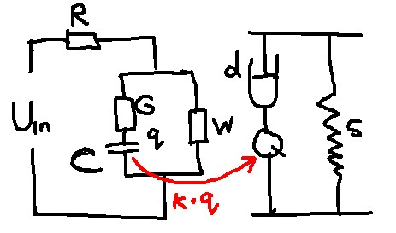
Fig. 4. Lumped model of IPMC.
Supposing that initially the system has been shorted for long time, the initial charge of C is zero: q(0)=0. As seen in Fig. 4., when voltage U_{in} is turned on, the strain ε(t) initially follows the charge q(t), in certain moment turns relatively suddenly back, then relaxes slowly with the speed determined by λ. When the voltage is switched off, the actuation towards the initial state again keeps the curve of charge followed by back-relaxation, but according to the superposition principle starts from the momentary values of strain and charge. Similar back-relaxing behavior of IPMC is described in numerous papers e.g. in [Bao, XX1,XX2,XX3].

4. Distributed bending moment of the actuator
Describing the bending IEAP actuators, it is convenient to observe only its short segment, for instance its tip. So far, lots of the publications follow this pattern and model the tip displacement in Cartesian coordinates, the blocking force of the tip, etc. [XX,XX]. They assume that the shape of the actuator is characterized with a single radius of curvature, and the strain of the actuator reflects directly the tip displacement. This unsophisticated concept can be true in the case of small unobstructed displacements only. As soon as the movement of the actuator is restricted, for instance by the gauge measuring the blocking force, its shape will deviate from circular, and the whole concept fails. The vectorial interpretation presented in this section is universal and serves as the first step in modeling the distributed bending moment of the actuators independently of their actual shape.
4.1. Characterization of the shape of the bending actuator
The vectorial notation of the shape of the actuators expresses its bending as a function of the distance from the input contacts along the sample. The curved line representing the shape of the actuator is divided into vectors of equal length as depicted in Fig. 5, assuming that within every vector the curvature is constant. The shape of the actuator is characterized by the matrix of angles of each vector with respect to the direction of the previous vector.
The image of the actuator is recorded by a camera and processed by some convenient image processing software. When the direction of the camera is set transverse to the actuator and the stage is illuminated from the background, the image of the actuator consists of a single contrast curved line which can be subjected to image processing software. Instead of a single image we can record a video footage to expose the time-dependent behavior of curvature. As an example, the graph given in Fig. 6 depicts the actuating-relaxing behavior of the actuator presented in Fig. 1.
The length and total number of the vectors is a trade-off between the accuracy of the result and the resolution of the camera. It is self-evident that more vectors represent a complicated shape better. However, as the width of the actuator is finite, but the recorded image consists of discrete pixels, the relative error of detecting the angle is reciprocal to the length of the vector. Siia veel midagi?

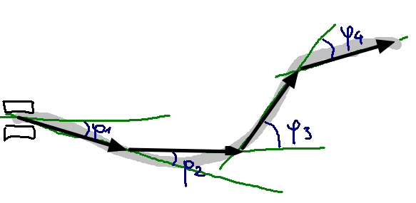  Fig. 5 Transformation to vector representation. | 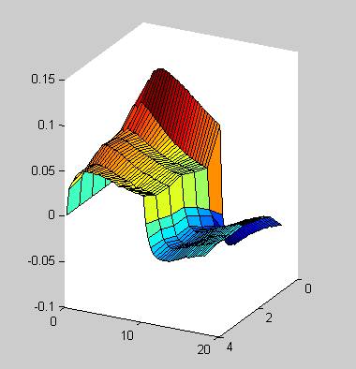  Fig. 6. Transient behavior of the actuator.  Kui saaks siia tagasivajumise ka?

4.2. Characterization of the bending moment of the bending actuator

In cantilever mode - fixed end attached to contacts, see Fig. X – the bending of the actuator is determined by the summarized moment of several components: the electrically induced bending moment $EIBM$, the moment $M_{w}$ caused by the weight of the actuator in the particular environment, and the internal bending moment${ M}_{r}$ countering $EIBM$ and $M_{w}$. When the sample is mounted edgewise, the component of $M_{w}$ in the plane of bending is zero. In the scope of the current paper, the mass and inertia of the actuator are neglected and we treat each time step as an independent static problem. According to the Euler-Bernoulli beam theory the correspondence between the curvature and corresponding bending moment is
dφds=M(s)EI ,
where $E$ is the modulus of elasticity and $I$ is the second moment of area.
The described methodic does not pose any restrictions to the shape of the actuator, it works as well when the sample is tapered or its cross-section differs from rectangular. When the cross-section of samples is a rectangle, the second moment of area is expressed as
$I={bh^{3}}/{12}$,
where $b$ and $h$ are width and height of the cross-section of the sample respectively. In that case an electrically induced bending moment of the time-dependent behavior of the sample depicted in Fig. 1. reflects its bending depicted in Fig. 6. in a different vertical scale.

5. Viscoelastic electromechanical model of IEAP actuators
5.1. Previous work
The concept of the distributed electromechanical model of IEAP actuators is introduced in [DM]. This approach declares that the bending of an IPMC actuator at any time and any point is caused by the charge carried over between the electrodes at that point by that time. The amount of charge is determined by the inhomogeneous transitory voltage that in turn is uneven due the electrical resistance of the electrodes. The electrical constituent of that model depicted in Fig. 10. resembles a sophisticated lossy RC transmission line. The conductivity of the electrodes of the IEAP material is represented by a series of resistances of the opposite electrodes Ra and Rb, while the capacitance C, and the loss parameters G form the impedance of the material.
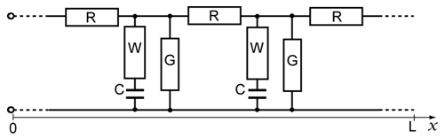
Fig. 10. IEAP resembling a lossy RC transmission line. Siia Cauer!
Although that paper emphasizes the flexure of the IPMC actuator is non-uniform in spatial and time domainand and that it is scalable by means of the the length of the actuator, it is contented with the simple proportional relation between the flexure and the charge, and discontinues just when the phenomenon of back-relaxation becomes noticeable. The objective of the current paper is to proceed from that stage of development.
One of the advantages of the approach of RC transmission line is the presence of the analytical solutions of its response to some specific input signals, particularly to the Heaviside step function. This enables easy comparison of the model with the real response of the actuator to the input voltage signal representing a flat step up. Moreover, it is possible to attach additional contacts to the surface of the actuator, and in this way validate the electrical parameters of the transmission line [XX, XX]. The propagation of voltage along this RC line is described by the following PDE:
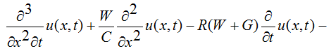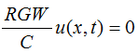. (V1)
It is a pseudo-parabolic PDE, similar to those describing e.g. diffusion in porous media or heating a rod with radiation and loss present. Fortunately, it is possible to solve it analytically for u(x,t) utilizing the method of separation of the variables [DM, RCGWLine]. Moreover, by applying the initial and boundary conditions – initially the line is discharged and its other end is open – the analytical expression describing the time-evolution of the voltage distribution on the line after applying a voltage step to its input is
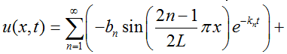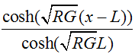 (V2)
where L is the length of the sample,
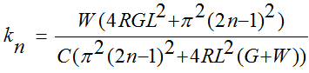 , and 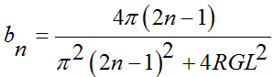.
As seen, the complicated time-evolution of the voltage distribution on the line is defined solely by the measurable parameters: by impedance of the material, by the length of the sample, and by time. Although the PDE describing the transient transferred charge is analogous to (V1), it is impossible to apply the boundary conditions and obtain the solution, similar to (V2). Instead, if initially the line is discharged, the charge is expressed via voltage as
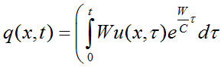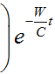 . (V3)
As an illustrative example, the transient behavior of voltage and charge of the actuator depicted in Fig. 1., are given in Fig. 11.
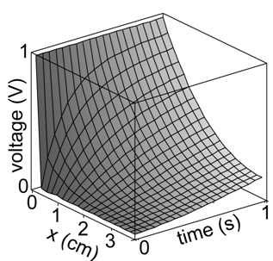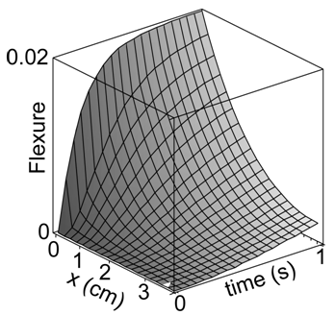
Fig. 11. A – voltage; B – charge q
5.2. Distributed viscoelastic electromechanical model of IEAP actuators.
The illustratory diagram of our viscoelastic electromechanical model of IEAP actuators is given in Fig. 12. It consists of infinite series of infinitesimally short lumped units, similar to those described in Section 3, while the conductive opposite electrodes of the IEAP material assure the electrical conductivity between the lumped units. Its electrical equivalent circuit is a lossy RC transmission line, described in the previous section, while the mechanical constituent stands of series of infinitesimally short hinged links. The buffers between the links are the models of viscoelasticity with internal strain, presented in Section 2. Even though the bending motion of IEAPs is caused by different physical processes, the relationship between the transferred charge and the input of the viscoelastic scheme is considered similarly linear by $α$ for all of them.
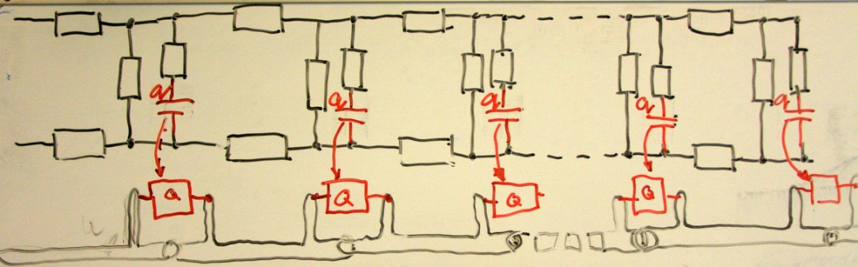
Fig. 12. The coupling between equivalent circuit and mechanical constituent.
Considering the modulus of elasticity $E$ and the second moment of area $I$ as constants allows us to introduce a constant $μ=\frac{α}{EI}$ and rewrite (4) for curvature.

$$\frac{1}{ρ}=μ\left[q\left(t\right)-λe^{-λt}\int_{0}^{t}{q(τ) e^{λτ}dτ}\right].$$
The curvature can be also presented in Cartesian coordinates as:
$$curve\left(s\right)=\left[\int_{0}^{s}{cos⁡(φ\left(s\right))ds}{+x}_{0} \int_{0}^{s}{sin\left(φ\left(s\right)\right)ds}{+y}_{0}\right]$$
where $x_{0}$ and $y_{0}$ are the initial position of the curve and the angle
$$φ\left(s\right)=\int_{0}^{s}{ρ\left(s\right)ds}+φ_{0}$$
where $φ_{0}$is initial angle at s=0.
The parameters of the distributed electromechanical model were determined using differential evolution algorithm. [X12] The cost function was defined by simply minimizing the differences between measured and calculated voltages.
Hoolimata sellest missugune füüsikaline protsess liigutuse tekitab, kas elektrostaatiline tõukumine või mehhaaniline vahelepressimine, igal juhul me seostame liigutuse transferred charge-ga ning oletame et see seos on lineaarne.
Electrode resistance of the sample was measured experimentally … (directly/ four point method kõlaks siin hästi?) All other parameters were obtained by DE algorithm. Since the model is not yet fully optimized its evaluation in the meaning of reasonable precision is still computationally expensive. Therefore, the optimization of each sample was carried out in two stages. First, the parameters C, G, W and$μ$were determined using fixed value of $λ=0$. In other words, we assume that at the beginning of the actuation there is no relaxation present. In second stage, all other parameters were fixed and the optimization was performed respect to $λ$ only. Described two stage optimization gives an advantage to determine $λ$ with coarse set of experimental points while the C, G, W and $μ$ are determined with fine set of points over shorter time period.
 | CPC  with  gold  electrodes | CPC | musclesheet
Dimensions
R | 2 | 1600 | 9
C | 0.468 | 0.00585 | 0.0089
G | 0.035 | 0.0002 | 0.0063
W | 1.889 | 0.0193 | 0.6044
$$μ$$ | 0.10365 | 6.52039 | 8.7504
$$λ$$ | 0 | 0 | 0

6. Verification of the model
Kõik eespooltoodud graafikud on Pt-IPMC jaoks. Siin näitame et kõik tulemused kehtivad ka 2 täiesti erineva IEAP materjali korral. Materjalide kirjeldused, võta Janno artiklist ja viita et autori suulisel loal. Miks me võime oletada et elektriskeem ikka kehtib? Mis on CPC korral RCGW. Mingis Karli artiklis on et Karl ei leidnud elektroodi seest mahtuvuslikku komponenti.
The parameter $λ$ was derived from eq. 5 and was evaluated in region$120s<t<300s$.
Parameter Value  $$R$$ $$1.6\frac{kΩ}{cm }$$  $$C$$ $$0.011\frac{F}{cm }$$  $$W$$ $$5.1\frac{1}{kΩ∙cm}$$  $$G$$ $$0.098\frac{1}{kΩ∙cm}$$  Table 1. Measured parameters for CPC actuator. | Fig. 4 Measured and simulated voltage along the CPC at 2.0 V step input signal.

As seen in figure 1, good correlation between experimental data and simulated data with optimized parameters was obtained.

The simulated points are clearly following the actual shape of the actuator. The shape of the actuator

Fig. 5 Measured and modelled shapes of the actuator at 2.5V. | Fig. 6. Measured and modelled shapes of the actuator at 2.5V

7. Discussion
We have introduced a novel viscoelastic model for representation of bending motion of different types of IEAPs. The two equivalent forms of the model were derived out of which the first one was demonstrated as part of a distributed electromechanical model. However, there is no reason to underestimate the alternative form of the model which allows the substitution of the charge with corresponding current for instance.
Even though the model showed a good performance with the three actuators, there are still several currently ignored issues to examine:
- In this model we assume constant resistance of the electrodes, still it is clear that the extension and compression of the electrodes may noticeably affect the resistance;
- The deformation is modeled in accordance to Hooke’s law and is not covering the creep and the permanent deformation occurring beyond the elastic limit.
- Actually there are 3 elastic modulus and using one effective young modulus is appropriate only in the case of symmetric IEAP.
- Internal friction?

Mida kõike meie mudeliga teha saaks.
Sobib ka muuks. Mõtle näiteid. Näiteks on suur problem supercäppide liikumine. Indreku artiklis on öeldud et aktuaator, sensor ja supercäpp on ehituselt samad. Seega aitaks meie mudel kindlasti supercäppe modelleerida.

Acknowledgments

Refs
X1: doi: 10.1117/12.654740
X2: doi:10.1088/0964-1726/17/3/035011
X3: doi: 10.1117/12.475167
X4: doi: 10.1002/marc.201100535
X5: doi: 10.1002/pen.21955
X6: doi: 10.1063/1.2194127
X7: doi:10.1088/0964-1726/20/8/083001
X8: doi: 10.1117/12.475201
X9: PunnDistrModel
X10: doi: 10.1021/ma800956v
X11: Spie 2002 - 4695-33
X12: DOI: 10.1023/A:1008202821328
X13: doi:10.1088/0964-1726/18/11/115023

Fraasid:
as these parameters can be easily characterized by simple position sensors or force gauges
is of general-purpose and
Of course, the bigger number of vectors describes the shape more trustworthy, but technically it is As the
An already published technique, which satisfies the requirements described above , is to split the curve into segments or vectors (FIGX)[X13]. Although, this representation preserves the exact information about the endpoints of each segment, the curvature in between the points is reduced to a constant. Nevertheless, the desired accuracy can be reached by increasing the count of segments or decreasing the length of a segment.

