Novel viscoelastic model of IEAP actuators.
Veix, Punn, Alvo

Abstract tuleb alles siis kui conclusion on valmis.
The innovatory viscoelastic model of bending ionic electroactive polymer actuators allows modelling
1. Introduction
Already since the very first reports concerning the bending ionic electroactive polymer actuators, the researchers have described the „back-relaxation“ effect – an actuator excited with DC voltage, instead of holding its bent state, relaxes slowly back towards its initial shape. This behavior is commonly treated as a shortcoming of IEAP actuators, decreasing their ability to deliver a constant peak force to target, limiting their frequency range, and hindering their exact control. There have been several attempts to slower the rate of back-relaxation by choosing an opportune combination of separator, electrodes or mobile ions. Nevertheless, there is no report claiming that in the case of some IEAP material this holdback is completely eliminated.
Supposedly the phenomenon of back-relaxation is studied almost only in the case of „old-type“ ionic polymer-metal composites (IPMC). It is a wet ion exchange polymer membrane covered with thin metal electrodes on both sides. [X7] For typical IPMC with platinum electrodes, when a voltage is applied across the thickness direction, the electromechanical transduction occurs due to the motion of the cations along with the water molecules. As a result, one face of IPMC withers and shrinks and the opposite face protracts due to swelling with water and ions. This generates warping of the whole laminate. The resulting fast bending motion toward the cathode is followed by a slow relaxation towards the anode, while IPMC as the whole still remains bent. If now the input of this actuator is shorted, the actuator performs a sharp movement towards its initial state, but will usually outdistance. The steps of this process are depicted in Fig. 1. The speed of back-relaxation is reported being dependent on the type of polymer membrane, solvent, cations, etc. [X6]. It is commonly believed that the slow relaxation happens due to the water diffusion out of the strained polymer matrix. [X7] Most of the proposed electromechanical models describing the behavior of IPMC, just neglect the phenomenon of back-relaxation. [XXX] One of the few exceptions is presented by Bao et al. [X3], proposing the model of IPMC without and with the back-relaxation by adding a separate relaxation time constant. [X8] kirjeldab ka midagi.
Fig. 1. Actuation of IPMC. Forward bending is followed by back-relaxation.
In recent years the range of IEAP materials has been significantly extended by means of materials used for electrodes, separator membrane, as well as the electrolyte. At first glance, all ionic EAPs seem similar in construction – two conducting electrodes separated by a polymer membrane, containing freely moving ions – but their actuation mechanisms can be significantly different. There haven’t appeared any definitive models or at least reports yet, describing the phenomenon of back-relaxation of IEAP actuators with electrodes based on carbon, or conductive polymers.
Experimenting with the IEAP actuators with carbon electrodes, we have noticed that similarly to the water-containing IPMC, virtually all of them exhibit back-relaxation, at least to some extent. It appears that by means of their transient spatial actuation and transient moment of force, the long-term behavior of all IEAP actuators is just similar. The back-relaxation is present regardless of the absence of the fluent liquid, and regardless of the membrane or electrode material.
The bending-relaxing behavior of the IEAP actuators resembles viscoelasticity, but seems working partly conforming, partly contra to the electrical excitation. For this behavior the constitutive models of viscoelasticity, consisting of linear combinations of springs and dampers, are inappropriate. There exist numerous models describing the material’s response in different loading conditions, e.g. Maxwell model, Kelvin-Voigt model, or combinations of both of them. [XX] All the models describe only the response of the material to the external load. Alas, neither of them involves any element causing the actual behavior of the IEAP actuators – lapsing against the load. The the cause of this failure is the concept of the so-called canonic models of viscoelasticity [XX], where the load is external, and is applied to the whole system.
The objective of the current paper is describing the time-dependent correspondence between the transient input voltage and the shape of the IEAP actuators, taking into account also the back-relaxation. We ground to the scalable distributed model of IPMC, presented in [X9], and extend it to different IEAP materials. This approach describes the commonly uneven propagation of voltage along the IEAP material, and associates the voltage and charge carried over with the uneven flexure of the actuator. The experiments described in [X9] assume that the charge-flexure relation is simply linear, and leave off just before the phenomenon of back-relaxation becomes noticeable. The current paper associates our novel model of viscoelasticity with [X9]. The resulting electromechanical model of IEAP allows describing the shape or blocking force of the actuators over a long time. Its transient input signal is not limited in any way, due to the accordance to the Boltzmann superposition principle – each loading step makes independent contribution to the total loading history [ISBN: 1569903484].
This paper is organized as follows: Firstly, in Section 2 we show that the innovatory approach to an assembly of springs and dampers will result with PDE-s describing the truthful bending of the actuators forwards and backwards under a constant exciter. In Section 3 we demonstrate the capabilities of the proposed model of viscoelasticity with the response of a lumped model of a fictional IPMC. The thorough characterization of the mechanics of IEAP actuators given in Section 4 is inevitable for understanding the distributed electromechanical model introduced in Section 5. The verification of the model with the examples of three completely different IEAP materials.is presented in Section 6. The discussion in Section 7 disputes about the further improvements of this representation.

2. The model of viscoelasticity with internal strain.
As mentioned hereinabove, in the canonic models of viscoelasticity the load is external, and is applied to the whole combination of springs and dampers. This configuration does not involve even any possibility to suppress the exciter. The situation changes completely, when the exciting factor is applied between the spring and damper, resembling something expanding-contracting between the elastic threads of the polymer molecules network. The viscoelastic scheme is depicted in Fig. 2. It consists of a damper in series with our new element - internal strain -, both in parallel with a lone spring. The internal strain is a vector of variation of the length of a non-elastic element. Hereinafter we associate it with the transient electrical charge q of the IEAP material, so for clarity we label the strain element with Q and portray with Q between arrows. When internal strain $ε_{q}$of the element Q is applied, the spring reacts momently, while the damper follows with time, tending towards the unstressed state of the spring. In brief, the input of our viscoelastic element is the strain $ε_{q}$, while the output is the strain of the spring $ε_{s}$.
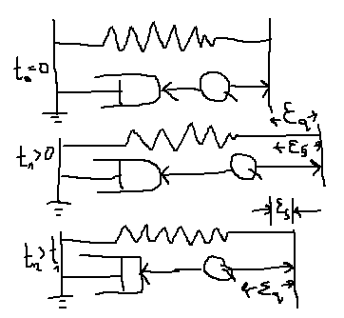
Fig. 2. The model of viscoelasticity with internal strain, at successive points in time.
The behavior of this viscoelastic model in different loading conditions is depicted in Fig. 3. It is assumed that there is no other stresses or strains affecting the system from outside besides $ε_{q}$, which means that $σ_{Total}=0$. Initially the spring and damper are in their unstressed state: $σ_{d}=σ_{s}=0$ (A). The positive strain of Q draws the spring out (B) while the damper releases in time. This process continues regardless of the applied strain Q until the stress of spring is vanished (C). The removal of the strain Q results with the compression of the spring (D), followed by gradual dragging of the damper, until the stress of the spring is again zero (E). The negative strain of Q is depicted as its shortening (F) and compression of the spring. Similarly, the spring draws the damper longer until reaching the unstressed state (G). As seen in this figure, this system strives to gain its unstressed state with any stress Q.
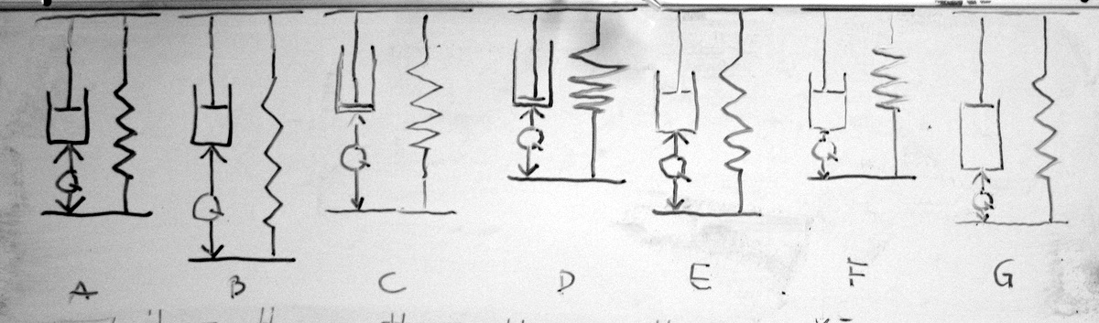
Fig. 3.
The definition of the model is summarized with four relations in (1). Vaata wikipeedia kelvin-voigt termineid ja tuletuskäiku.
$$\left\{\begin{aligned}{σ_{Total}=σ}_{D}\left(t\right)+σ_{S}(t)=0 \\ ε_{Total}=ε_{S}(t)=ε_{D}(t)+ε_{Q}(t) \\ σ_{S}(t)={Eε}_{S}(t) \\ σ_{D}(t)=η\frac{dε_{D}(t)}{dt}\end{aligned}\right.$$
where $E$and$η$ are modulus of elasticity of the spring and viscosity of the damper respectively. We see two equivalent solutions to this model: with respect to the input strain εQ(t) and with respect to the derivative of the input strain εQtdt, here we present both of them. The described relations in (1) can be arranged into differential equation for strain of damper.
$$η\frac{dε_{D}(t)}{dt}+{Eε}_{D}(t)+Eε_{Q}(t)=0.$$
Solving the first order linear differential equation with $ε_{D}\left(0\right)=0$ and bearing in mind $ε_{S}=ε_{D}+ε_{Q}$ the solution for $ε_{S}$ is found.
$$ε_{S}\left(t\right)=ε_{Q}\left(t\right)-\frac{E}{η} e^{-\frac{E}{η}t}\int_{0}^{t}{ε_{Q}\left(τ\right)e^{\frac{E}{η}τ}dτ}.$$
A different form of the equation is derived by combining (1) for strain of the spring directly
EεsS(t)+ηd[εsSt-εqQt]dt=0
Solving (4) with εsS0=0 gives
εSs(t)=e-Eηt0tddξεqQξeEητdτ
This form might be useful if the derivative of εqQ is known.
By introducing the rate of relaxation $λ=\frac{E}{η}$ and expressing the input strain in terms of stress εqQ=σQq(t)E both given forms are simplified to (7) and (8)
εSst=1EσQqt-λe-λt0tσqQ(τ) eλτdτ.
εsSt=1Ee-λt0tddξσQξσiτeλτdτ

3. Lumped model of IEAP with relaxation:
In order to demonstrate the capabilities of the proposed model of viscoelasticity and its correspondence to the superposition principle, we use a simple lumped model of IPMC presented e.g. in [Bao]. This concept couples the input voltage with transferred charge and the tip displacement of an IPMC actuator. It gives reasonable results in case of small displacements only and may be a special case of the complicated approach presented in the next sections of this paper. Here we just demonstrate the transient response of the model to a rectangular input signal without attempting to validate it with any real actuator.
The lumped model of IPMC is presented in Fig. 4A while the electrical signals as well as strains are depicted in Fig. 4B. The correspondence between the input voltage U_{in}(t) and charge q(t) is
ValemZZ
and the correspondence between the strain (or tip displacement) and charge is linear:
ε(t)=k*q(t) .
The transient charge q(t) (green in Fig 4B) corresponds to the rectangular pulse of input voltage U_{in}(t) (red in Fig. 4A). Two, according to (7) numerically modelled transient strain behaviors with different values of λ and convenient values of the coefficient k to fit the graphs into the picture, are presented as blue and yellow graphs.

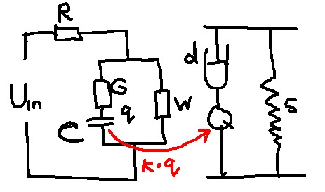
Fig. 4. Lumped model of IPMC.
Supposing that initially the system has been shorted for long time, the initial charge of C is zero: q(0)=0. As seen in Fig. 4., when voltage U_{in} is turned on, the strain ε(t) initially follows the charge q(t), in certain moment turns relatively suddenly back, then relaxes slowly with the speed determined by λ. When the voltage is switched off, the actuation towards the initial state again keeps the curve of charge followed by back-relaxation, but according to the superposition principle starts from the momentary values of strain and charge. Similar back-relaxing behavior of IPMC is described in numerous papers e.g. in [Bao, XX1,XX2,XX3].

4. Distributed bending moment of the actuator
4.1. Characterization of the shape of the bending actuator
In generally the distributed EIBM along the IEAP is not only the function of time, but also a function of coordinate. Therefore a constant curvature along the IEAP can be considered only as a special case and a method for representing a curve in terms of variable curvature is needed. Probably the simplest technique, which satisfies the requirements, is to split the curve into segments or vectors (FIGX). Although, this representation preserves the endpoints of each segment, the curvature in between the points is reduced to a constant. However, the until the desired accuracy can be reached by increasing the count of segments or decreasing the length of a segment.
A possible algorithm for curve segmentation is shown in Figure 3. An arc is drawn in the given direction and the change of an angle corresponding to the extremum of pixel intensities is detected. The search direction for the next iteration coincides with the direction obtained in previous step. Repeating the operations for each frame of the video allows us to analyze the distributed curvature changes of IEAP in time.

Fig. 5 Transformation to vector representation. | 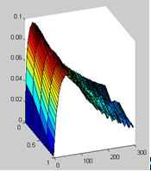  Fig. 6. Transient behavior of the actuator.  Kui saaks siia tagasivajumise ka?

4.2. Characterization of the bending moment of the bending actuator
Th the samples can be observed as cantilever beams with fixed ends attached to contacts (FIGX). There are two bending moments acting on the beam – an electrically induced bending moment (EIBM) and the one produced by the own weight of the actuator $M_{w}$. Although the presented model is able to consider both of them, $M_{w}$ is neglected in this work by placing the sample such that gravity vector and motion vectors of IEAP are always perpendicular. Holding the actuator edgewise allows to neglect the own weight of the actuator.

5. Viscoelastic electromechanical model of IEAP actuators
Our viscoelastic electromechanical model of IEAP actuators is grounded on the one-dimensional model of an IPMC presented in [XX]. It consists of a number of lumped models, similar to those presented in Section 3, coupled with a spatial parameter – a generally uneven distribution of voltage caused by the resistance of the electrodes. The electrical equivalent circuit of the model in the form of a transmission line is given in Fig. XX. It represented by infinite series of equivalent circuits with discrete elements of infinitesimally short lumped circuits. The conductivity of the electrodes of the IEAP material is represented by a series of resistances of the opposite electrodes Ra and Rb, connecting the single units, while C, G, and W are the elements of impedance of the material. In this paper we present only the essential equations, in order to follow the details, please refer to [XX and XXX].
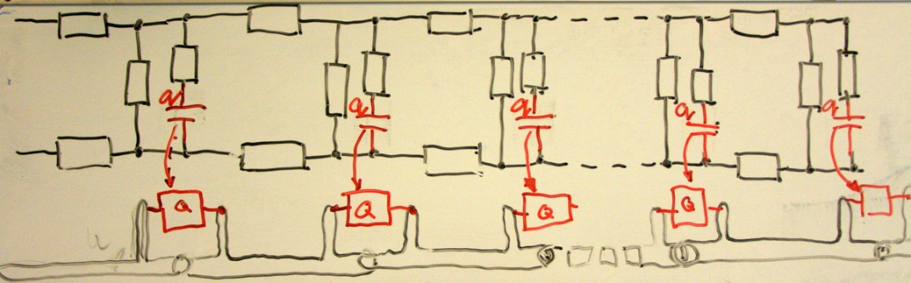
Propagation of voltage along this line is characterized by a pseudo-parabolic PDE, similar to those describing e.g. diffusion in porous environment or heating a rod with radiation and loss present:
The general solution of the PDE for u(x,t) is
Although the transient behavior of charge is described by exactly similar PDE, it is impossible to apply the boundary conditions and obtain the solution.
Fortunately, [XX and XXX] give one analytical solution to the PDE (123) – the response of the circuit to a unit step voltage:
,
where kn and bn are determined by real measurable electrical parameters describing the impedance of the IEAP material, as well as the length of the particular sample.:
and .
Siia tuleb veel mõni valem
In this work, we assume that the EIBM is linearly depending on charge by a coefficient$α$. We also assume the modulus of elasticity $E$ and the second moment of area $I$ to remain constants along the beam. Based on the associations of classic beam theory and denoting $μ=\frac{α}{EI}$ we can rewrite (4) as

$$\frac{1}{ρ}=μ\left[q\left(t\right)-λe^{-λt}\int_{0}^{t}{q(τ) e^{λτ}dτ}\right].$$
The curvature can be also presented in Cartesian coordinates as:
$$curve\left(s\right)=\left[\int_{0}^{s}{cos⁡(φ\left(s\right))ds}{+x}_{0} \int_{0}^{s}{sin\left(φ\left(s\right)\right)ds}{+y}_{0}\right]$$
where $x_{0}$ and $y_{0}$ are the initial position of the curve and the angle
$$φ\left(s\right)=\int_{0}^{s}{ρ\left(s\right)ds}+φ_{0}$$
where $φ_{0}$is initial angle at s=0.
Nüüd tuleb pilt elektriskeem ja liigendatu
Kuidas seostame laengu ja liigutuse.
The parameters of the distributed electromechanical model were determined using differential evolution algorithm. [X12] The cost function was defined by simply minimizing the differences between measured and calculated voltages.
Hoolimata sellest missugune füüsikaline protsess liigutuse tekitab, kas elektrostaatiline tõukumine või mehhaaniline vahelepressimine, igal juhul me seostame liigutuse transferred charge-ga ning oletame et see seos on lineaarne.
Surface resistance of the sample was measured experimentally … (directly/ four point method kõlaks siin hästi?) All other parameters were obtained by DE algorithm. Since the model is not yet fully optimized its evaluation in the meaning of reasonable precision is still computationally expensive. Therefore, the optimization of each sample was carried out in two stages. First, the parameters C, G, W and$μ$were determined using fixed value of $λ=0$. In other words, we assume that at the beginning of the actuation there is no relaxation present. In second stage, all other parameters were fixed and the optimization was performed respect to $λ$ only. Described two stage optimization gives an advantage to determine $λ$ with coarse set of experimental points while the C, G, W and $μ$ are determined with fine set of points over shorter time period.
 | CPC  with  gold  electrodes | CPC | musclesheet
Dimensions
R | 2 | 1600 | 9
C | 0.468 | 0.00585 | 0.0089
G | 0.035 | 0.0002 | 0.0063
W | 1.889 | 0.0193 | 0.6044
$$μ$$ | 0.10365 | 6.52039 | 8.7504
$$λ$$ | 0 | 0 | 0

6. Verification of the model
Kõik eespooltoodud graafikud on Pt-IPMC jaoks. Siin näitame et kõik tulemused kehtivad ka 2 täiesti erineva IEAP materjali korral. Materjalide kirjeldused, võta Janno artiklist ja viita et autori suulisel loal. Miks me võime oletada et elektriskeem ikka kehtib? Mis on CPC korral RCGW. Mingis Karli artiklis on et Karl ei leidnud elektroodi seest mahtuvuslikku komponenti.
The parameter $λ$ was derived from eq. 5 and was evaluated in region$120s<t<300s$.
Parameter Value  $$R$$ $$1.6\frac{kΩ}{cm }$$  $$C$$ $$0.011\frac{F}{cm }$$  $$W$$ $$5.1\frac{1}{kΩ∙cm}$$  $$G$$ $$0.098\frac{1}{kΩ∙cm}$$  Table 1. Measured parameters for CPC actuator. | Fig. 4 Measured and simulated voltage along the actuator at 2.0 V step input signal.

As seen in figure 1, good correlation between experimental data and simulated data with optimized parameters was obtained.

The simulated points are clearly following the actual shape of the actuator. The shape of the actuator

Fig. 5 Measured and modelled shapes of the actuator at 2.5V. | Fig. 6. Measured and modelled shapes of the actuator at 2.5V

7. Discussion
Me tutvustame uut mudelit – viskoelastsust. Sobib hästi iga IEAP-iga. Mida kõike meie mudeliga teha saaks.
Mida ei ole me praegu oma mudelis arvestanud:
- Pinnatakistuse muutumist [viited]
- Sisehõõrdumist.
- Plastne jääv deformatsioon. Võib lisada hõõrdumist kirjeldava liikme.
- Mis veel?
Sobib ka muuks. Mõtle näiteid. Näiteks on suur problem supercäppide liikumine. Indreku artiklis on öeldud et aktuaator, sensor ja supercäpp on ehituselt samad. Seega aitaks meie mudel kindlasti supercäppe modelleerida.

Acknowledgments

Refs
X1: doi: 10.1117/12.654740
X2: doi:10.1088/0964-1726/17/3/035011
X3: doi: 10.1117/12.475167
X4: doi: 10.1002/marc.201100535
X5: doi: 10.1002/pen.21955
X6: doi: 10.1063/1.2194127
X7: doi:10.1088/0964-1726/20/8/083001
X8: doi: 10.1117/12.475201
X9: PunnDistrModel
X10: doi: 10.1021/ma800956v
X11: Spie 2002 - 4695-33
X12: DOI: 10.1023/A:1008202821328

