Novel viscoelastic model of IEAP actuators.
Veix, Punn, Alvo

Abstract tuleb alles siis kui conclusion on valmis.
The innovatory viscoelastic model of bending ionic electroactive polymer actuators allows modelling

Already since the very first reports about the ionic electroactive polymer actuators, the researchers have described the „back-relaxation“ effect – an actuator excited with DC voltage, instead of holding its bent state, relaxes slowly back towards its initial shape, eventually reaching its equilibrium, but seldom attaining its initial state. This behavior is commonly treated as a shortcoming of IEAP actuators, decreasing their ability to deliver a constant peak force to target, limiting their frequency range, and hindering their exact control. There have been several attempts to slower the rate of back-relaxation by choosing an opportune combination of separator, electrodes, and mobile ions. Nevertheless, there is no report claiming that in the case of some IEAP material this holdback is completely eliminated.
Supposedly the phenomenon of back-relaxation is studied almost only in the case of „old-type“ ionic polymer-metal composites (IPMC). It is a wet ion exchange polymer membrane covered with thin metal electrodes on both sides. [X7] For typical IPMC with platinum electrodes, when a voltage is applied across the thickness direction, the electromechanical transduction occurs due to the motion of the cations along with the water molecules. As a result, one face of IPMC withers and shrinks and the opposite face protracts due to swelling with water and ions. This generates warping of the whole laminate. The resulting fast bending motion toward the cathode is followed by a slow relaxation towards the anode, while IPMC as the whole still remains bent. The speed of back-relaxation is reported being dependent on the type of polymer membrane, solvent, cations, etc. [X6]. It is commonly believed that the slow relaxation happens due to the water diffusion out of the strained polymer matrix. [X7]
In recent years the range of IEAP materials has been significantly extended by means of materials used for electrodes, separator membrane, as well as the electrolyte. At first glance, all ionic EAPs seem similar in construction – two conducting electrodes separated by a polymer membrane, containing freely moving ions – but their actuation mechanisms can be significantly different. There haven’t appeared any definitive models or reports yet describing the phenomenon of back-relaxation of IEAP actuators with electrodes based on carbon, or conductive polymers.
There have been proposed several different electromechanical models describing the behavior of IPMC, most of them just neglect the phenomenon of back-relaxation. [XXX] One of the few is presented by Bao et al. [X3] proposing the model of IPMC without and with the back-relaxation by adding a separate relaxation time constant. [X8] kirjeldab ka midagi
Performing our experiments with IEAP actuators of different types, we have noticed that similarly to the water-containing IPMC, to some extent several of them exhibit back-relaxation. It appears that by means of their transient spatial actuation and transient moment of force, the long-term behavior of virtually all IEAP actuators is just similar. This action is present regardless of the absence of the fluent liquid, and is not contingent of the materials of the membrane or electrodes.
The objective the current paper is describing the time-dependent correspondence between the transient input voltage and the shape of the actuator, taking into account also the back-relaxation. We ground to the scalable distributed model of IPMC, presented by Punning et al. [X9], and extend it to different IEAP materials. According to this approach, an IEAP actuator in a cantilever configuration resembles a lossy RC transmission line. The transient behavior of voltage is commonly uneven, and is determined by a set of measurable electrical parameters of the material – conductivity of the electrodes and impedance of the membrane. As the propagation of the electrical signals along this circuit is determined by a simple pseudo-parabolic PDE, it is easy to calculate the instantaneous values of the coordinate-dependent voltages, charges, etc. numerically or even analytically. The electromechanical coupling between the electrical input signal and the flexure of the actuator is determined by the time- and coordinate-dependent charge carried over between the two electrodes. The experiments described in [X9] assume that the charge-flexure relation is simply linear, and leave off just before the phenomenon of back-relaxation becomes noticeable.

Representation of the IEAP
Fig. 1 | Fig. 3 Transformation to vector representation.

Though the manufacturing process of IEAP essentially sets no limits to its shape, this paper is focused on rectangular IEAPs. This way the samples can be observed as cantilever beams with fixed ends attached to contacts (FIGX). There are two bending moments acting on the beam – an electrically induced bending moment (EIBM) and the one produced by the own weight of the actuator $M_{w}$. Although the presented model is able to consider both of them, $M_{w}$ is neglected in this work by placing the sample such that gravity vector and motion vectors of IEAP are always perpendicular.
There are many possibilities to represent the curvature of an IEAP. Probably the simplest one is to split the curve into vectors (FIGX). The vector representation preserves endpoints of each vector, but the actually variable curvature in between is reduced to a constant. The count and length of vectors are depending on the level of accuracy we are targeted at.
In order to describe the bending movement of the actuator, the image of the bending sheet is divided into segments assumed to have a constant curvature. The principle of determining the angles is shown in Figure 3. (angles - ). The angles of the segments are calculated from each frame of the video. The changing flexure of the actuator, electrically characterized in Figure 4, is depicted in Figure 5
Consider an array of vectors $\vec{A_{i}}=\left(x,y\right), i=0..n$ with origin at the clamped end of IEAP, where $n$ is the maximum count of vectors in array. To obtain the vector representation of IEAP, the following algorithm can be used:
- Capture an image of an actuator;
- Consider a point $P_{0}$ located at the clamped end of the actuator;
- Construct an arc with origin $P_{i}$, radius $\left\|P_{i+1}-P_{i}\right\|$ and angle $φ$;
- Determine pixel intensities under the arc;
- Filter the intensities and locate global minimum;
- Rotate $P_{i+1}$ by an angle corresponding to the minimum;
- The search direction for next iteration is determined by $P_{i+2}=2P_{i+1}-P_{i}$;
- Increase $i$ and repeat from step 3 until reached to the end of the actuator;
To improve the result, one could execute steps 3-5 with multiple slightly modified radii and average the found minimums.

The novel model of viscoelasticity
As described hereinabove, the bending behavior of IEAP actuators resembles viscoelasticity, but seems working contra to the exciting force. Decidedly, one would try to apply some constitutive model of viscoelasticity. There exist numerous models describing the material’s response in different loading conditions (e.g. Maxwell model, Kelvin-Voigt model, Standard Linear solid model, etc. [XX]), all describing only the response of the material to the external load. Unfortunately neither of them involves any element corresponding to the real behavior of the IEAP actuators – lapsing against the load. The cause of this inconsistency is the method of application of the deforming external load – it is external, and it is applied to the whole system.
The situation changes completely, when the driving factor is applied “inside” the system, between the spring and damper. The viscoelastic model, pertinent to the real situation, is depicted in Fig. XX. It consists of the new element - internal strain - and dashpot in series with each other, both in parallel with a lone spring. Substantially, the internal strain is a vector of variation of the length of a rigid element. Hereinafter we associate it with the transient electrical charge q of the IEAP material, so we label the strain element with Q. When internal strain $ε_{q}$ is applied, the spring eases off momently, while the dashpot releases with time, tending towards the unstressed state of the spring. Figuratively, the input of our viscoelastic element is strain of Q - $ε_{q}$, while the output is the strain of the spring $ε_{s}$.
The behavior of this viscoelastic model in different loading conditions is depicted in Fig. XXI. Initially the spring and dashpot are in their unstressed state: $σ_{d}=σ_{s}=0$ (A). The positive strain of Q draws the spring out (B) while the dashpot releases in time. This process continues regardless of the applied strain Q until the stress of spring is vanished (C). The removal of the strain Q results with the compression of the spring (D), followed by gradual dragging of the dashpot, until the stress of the spring is again zero (E). The negative strain of Q is depicted as its shortening (F) and compression of the spring. Similarly, the spring draws the dashpot longer until reaching the unstressed state (G). As seen in this figure, this system trends towards its unstressed state with any stress Q.
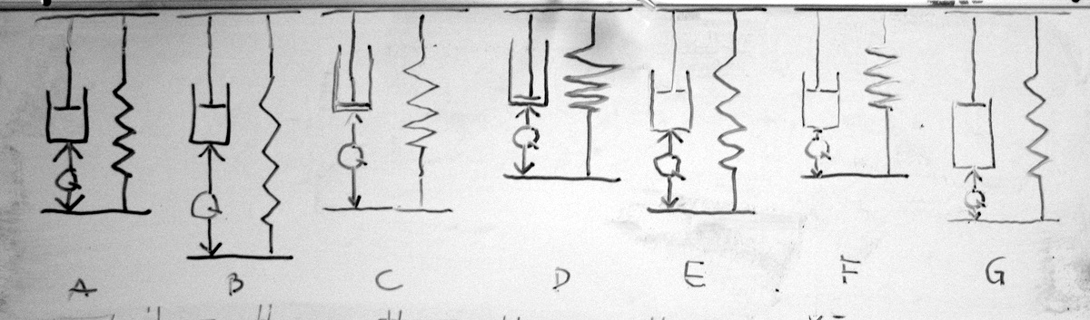
Fig. XXI.
The definition of the model is summarized in (1).
$$\left\{\begin{aligned}σ_{d}\left(t\right)+σ_{s}=0 \\ ε_{s}=ε_{d}+ε_{q} \\ σ_{s}={Eε}_{s} \\ σ_{d}=η\frac{dε_{d}}{dt}\end{aligned}\right.$$
$E$and$η$ are modulus of elasticity of the spring and viscosity of the dashpot respectively. The described relations in (1) can be arranged into differential equation for strain in dashpot.
$$η\frac{dε_{d}}{dt}+{Eε}_{d}+Eε_{q}=0.$$
The obtained equation is first order linear differential equation which in case of homogenous boundary condition $ε_{d}\left(0\right)=0$ has a solution
εsdt=εq-Eη e-Eηt0tεqτeEητdτ.
A different form of the equation is derived by combining (1) for strain of the spring directly
$${Eε}_{s}+η\frac{d(ε_{s}-ε_{q})}{dt}=0$$
Solving (4) gives
εs(t)=e-Eηt0tddξεqξeEητdτe
This form might be useful if $ε_{q}$ is associated with charge but the current is known. The integral of current is charge, therefore
$$ε_{s}(t)=e^{-\frac{E}{η}t}\int_{0}^{t}{ε_{i}\left(τ\right)e^{\frac{E}{η}τ}dτ}$$

By introducing the rate of relaxation $λ=\frac{E}{η}$ and writing the input strain in terms of external stress $ε_{q}=\frac{σ_{q}(t)}{E}$ both forms are simplified to (7) and (8)
$$ε_{s}\left(t\right)=\frac{1}{E}\left[σ_{q}\left(t\right)-λe^{-λt}\int_{0}^{t}{σ_{q}(τ) e^{λτ}dτ}\right].$$
$$ε_{s}\left(t\right)={\frac{1}{E}e}^{-λt}\int_{0}^{t}{σ_{i}\left(τ\right)e^{λτ}dτ}$$
Because of the transient approach of the model it agrees with the Boltzmann superposition principle and does not set any limitations to the input signal.

Lumped model of IEAP with relaxation:
Lumped mudel on niisugune (Bao artiklist) [X3]. Me seostame liigutuse laenguga nagu on teinud ka Bao. Punase ristkülikpinge korral on sinine kondeka laeng ja valemi (4) järgi arvutatud strain on sinine kui konstandid on sobivad. Piltlikult epsilon väljendabki liigutust koos tagasivajumisega.

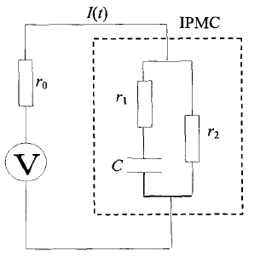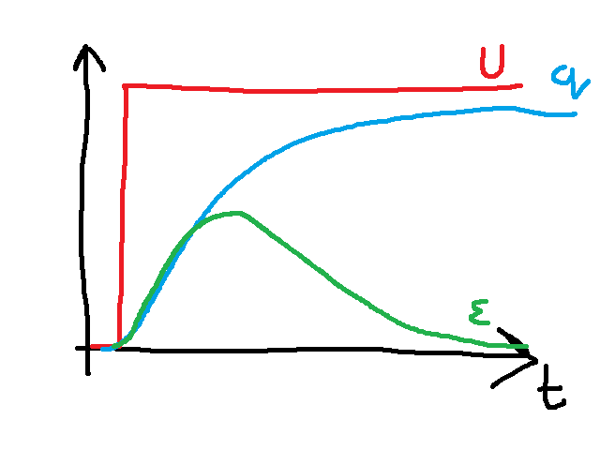
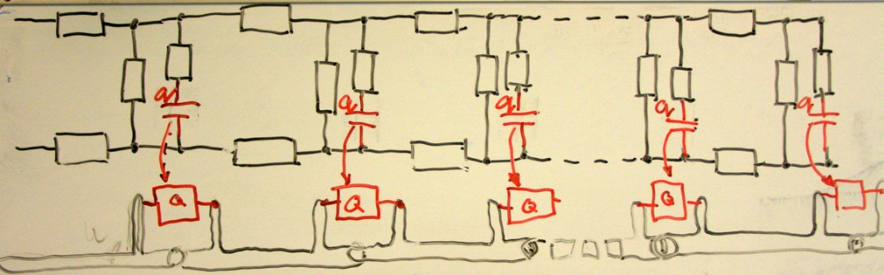
Algul pilt ainult elektriskeemiga. Kirjeldus et mida sisuliselt tähendavad RCGW. Pinge, laengu, voolu diff võrrandid. Tuletamist pole vaja. Üldlahend. Õnneks on meil olemas ühe sisendpinge kuju kohta analüütiline lahend pinge ja laengu jaoks. Pinget saame mõõta, laengut ja voolu saame ainult oletada pinge järgi. Valemid, graafikud.:

In this work, we assume that the EIBM is linearly depending on charge by a coefficient$α$. We also assume the modulus of elasticity $E$ and the second moment of area $I$ to remain constants along the beam. Based on the associations of classic beam theory and denoting $μ=\frac{α}{EI}$ we can rewrite (4) as

$$\frac{1}{ρ}=μ\left[q\left(t\right)-λe^{-λt}\int_{0}^{t}{q(τ) e^{λτ}dτ}\right].$$
The curvature can be also presented in Cartesian coordinates as:
$$curve\left(s\right)=\left[\int_{0}^{s}{cos⁡(φ\left(s\right))ds}{+x}_{0} \int_{0}^{s}{sin\left(φ\left(s\right)\right)ds}{+y}_{0}\right]$$
where $x_{0}$ and $y_{0}$ are the initial position of the curve and the angle
$$φ\left(s\right)=\int_{0}^{s}{ρ\left(s\right)ds}+φ_{0}$$
where $φ_{0}$is initial angle at s=0.
Nüüd tuleb pilt elektriskeem ja liigendatu
Kuidas seostame laengu ja liigutuse.
The parameters of the distributed electromechanical model were determined using differential evolution algorithm. [X12] The cost function was defined by simply minimizing the differences between measured and calculated voltages.
Surface resistance of the sample was measured experimentally … (directly/ four point method kõlaks siin hästi?) All other parameters were obtained by DE algorithm. Since the model is not yet fully optimized its evaluation in the meaning of reasonable precision is still computationally expensive. Therefore, the optimization of each sample was carried out in two stages. First, the parameters C, G, W and$μ$were determined using fixed value of $λ=0$. In other words, we assume that at the beginning of the actuation there is no relaxation present. In second stage, all other parameters were fixed and the optimization was performed respect to $λ$ only. Described two stage optimization gives an advantage to determine $λ$ with coarse set of experimental points while the C, G, W and $μ$ are determined with fine set of points over shorter time period.
 | CPC  with  gold  electrodes | CPC | musclesheet
Dimensions
R | 2 | 1600 | 9
C | 0.468 | 0.00585 | 0.0089
G | 0.035 | 0.0002 | 0.0063
W | 1.889 | 0.0193 | 0.6044
$$μ$$ | 0.10365 | 6.52039 | 8.7504
$$λ$$ | 0 | 0 | 0

Results
Kõik eespooltoodud graafikud on Pt-IPMC jaoks. Siin näitame et kõik tulemused kehtivad ka 2 täiesti erineva IEAP materjali korral. Materjalide kirjeldused, võta Janno artiklist ja viita et autori suulisel loal. Miks me võime oletada et elektriskeem ikka kehtib? Mis on CPC korral RCGW. Mingis Karli artiklis on et Karl ei leidnud elektroodi seest mahtuvuslikku komponenti.
The parameter $λ$ was derived from eq. 5 and was evaluated in region$120s<t<300s$.
Parameter Value  $$R$$ $$1.6\frac{kΩ}{cm }$$  $$C$$ $$0.011\frac{F}{cm }$$  $$W$$ $$5.1\frac{1}{kΩ∙cm}$$  $$G$$ $$0.098\frac{1}{kΩ∙cm}$$  Table 1. Measured parameters for CPC actuator. | Fig. 4 Measured and simulated voltage along the actuator at 2.0 V step input signal.

As seen in figure 1, good correlation between experimental data and simulated data with optimized parameters was obtained.

The simulated points are clearly following the actual shape of the actuator. The shape of the actuator

Fig. 5 Measured and modelled shapes of the actuator at 2.5V. | Fig. 6. Measured and modelled shapes of the actuator at 2.5V

Conclusion and discussion
Me tutvustame uut mudelit – viskoelastsust. Sobib hästi iga IEAP-iga. Mida kõike meie mudeliga teha saaks.
Sobib ka muuks. Mõtle näiteid. Näiteks on suur problem supercäppide liikumine. Indreku artiklis on öeldud et aktuaator, sensor ja supercäpp on ehituselt samad. Seega aitaks meie mudel kindlasti supercäppe modelleerida.

Acknowledgments

Refs
X1: doi: 10.1117/12.654740
X2: doi:10.1088/0964-1726/17/3/035011
X3: doi: 10.1117/12.475167
X4: doi: 10.1002/marc.201100535
X5: doi: 10.1002/pen.21955
X6: doi: 10.1063/1.2194127
X7: doi:10.1088/0964-1726/20/8/083001
X8: doi: 10.1117/12.475201
X9: PunnDistrModel
X10: doi: 10.1021/ma800956v
X11: Spie 2002 - 4695-33
X12: DOI: 10.1023/A:1008202821328

