Novel viscoelastic model of IEAP actuators.
Veix, Punn, Alvo

Abstract tuleb alles siis kui conclusion on valmis.
The innovatory viscoelastic model of bending ionic electroactive polymer actuators allows modelling

Already since the very first reports about the ionic electroactive polymer actuators, the researchers have described the „back-relaxation“ effect – an actuator excited with DC voltage, instead of holding its bent state, relaxes slowly back towards its initial shape, eventually reaching its equilibrium, but seldom attaining its initial state. This behavior is commonly treated as a shortcoming of IEAP actuators, decreasing their ability to deliver a constant peak force to target, limiting their frequency range, and hindering their exact control. There have been several attempts to slower the rate of back-relaxation by choosing an opportune combination of separator, electrodes, and mobile ions. Nevertheless, there is no report claiming that in the case of some IEAP material this holdback is completely eliminated.
Supposedly the phenomenon of back-relaxation is studied almost only in the case of „old-type“ ionic polymer-metal composites (IPMC). It is a wet ion exchange polymer membrane covered with thin metal electrodes on both sides. [X7] For typical IPMC with platinum electrodes, when a voltage is applied across the thickness direction, the electromechanical transduction occurs due to the motion of the cations along with the water molecules. As a result, one face of IPMC withers and shrinks and the opposite face protracts due to swelling with water and ions. This generates warping of the whole laminate. The resulting fast bending motion toward the cathode is followed by a slow relaxation towards the anode, while IPMC as the whole still remains bent. The speed of back-relaxation is reported being dependent on the type of polymer membrane, solvent, cations, etc. [X6]. It is commonly believed that the slow relaxation happens due to the water diffusion out of the strained polymer matrix. [X7]
In order to diminish or slow down the back-relaxation, several different approaches have been described. One may even intuitively guess that thicker IPMC, or IPMC containing viscous liquid are more stiff and exhibit less back-relaxation [X1], however these remedies pull down the working frequency of the resulting device. Kim et al [X2] report that the palladium buffer layer below the platinum electrode improves the performance of IPMC, including the noticeable abatement of the back-relaxation. Some authors suggest using TBA as cations [X11] or different membranes. [X4,X5, X10] …..
In recent years the range of IEAP materials has been significantly extended by means of materials used for electrodes, separator membrane, as well as the electrolyte. At first glance, all ionic EAPs seem similar in construction – two conducting electrodes separated by a polymer membrane, containing freely moving ions – but their actuation mechanisms can be significantly different. There haven’t appeared any definitive models or reports yet describing the phenomenon of back-relaxation of IEAP actuators with electrodes based on carbon, or conductive polymers.
There have been proposed several different electromechanical models describing the behavior of IPMC, most of them just neglect the phenomenon of back-relaxation. [XXX] One of the few is presented by Bao et al. [X3] proposing the model of IPMC without and with the back-relaxation by adding a separate relaxation time constant. [X8] kirjeldab ka midagi
Performing our experiments with IEAP actuators of different types, we have noticed that similarly to the water-containing IPMC, to some extent several of them exhibit back-relaxation. It appears that by means of their transient spatial actuation and transient moment of force, the long-term behavior of virtually all IEAP actuators is just similar. This action is present regardless of the absence of the fluent liquid, and is not contingent of the materials of the membrane or electrodes.
The objective the current paper is describing the time-dependent correspondence between the transient input voltage and the shape of the actuator, taking into account also the back-relaxation. We ground to the scalable distributed model of IPMC, presented by Punning et al. [X9], and extend it to different IEAP materials. According to this approach, an IEAP actuator in a cantilever configuration resembles a lossy RC transmission line. The transient behavior of voltage is commonly uneven, and is determined by a set of measurable electrical parameters of the material – conductivity of the electrodes and impedance of the membrane. As the propagation of the electrical signals along this circuit is determined by a simple pseudo-parabolic PDE, it is easy to calculate the the instantaneous values of the coordinate-dependent voltages, charges, etc. numerically or even analytically. The electromechanical coupling between the electrical input signal and the flexure of the actuator is determined by the time- and coordinate-dependent charge carried over between the two electrodes. The experiments described in [X9] assume that the charge-flexure relation is simply linear, and leave off just before the phenomenon of back-relaxation becomes noticeable.

Representation of the IEAP
Fig. 1 | Fig. 3 Transformation from curvature to vector representation.

Though the manufacturing process of IEAP doesn’t set basically any limitations to its shape, this paper is focused on rectangular IEAPs which can be observed as cantilever beams with fixed ends attached to contacts (FIGX). There are two bending moments acting on the beam – an electrically induced bending moment (EIBM) and the one produced by the own weight of the actuator $M_{w}$. Although the complete model is able to consider the own weight of the IEAP, it is neglected in this work by placing the sample such that gravity vector and shape of the IEAP are always perpendicular.

Since the Assuming that the curvature remains constant in between the end points of each vector, the curvatures for each vector were determined.

Because of the transient approach of the current model, we can take an advantage of the Euler-Bernoulli beam theory (1) to relate bending moments and curvature.
$$ρ\left(s\right)=\frac{dφ}{ds}=\frac{M\left(s\right)}{EI}$$
$EI$ is the bending stiffness, $E$ is the effective modulus of elasticity and $I$ is the second moment of area. In this paper the cross-section of the beam is a rectangle, thus$I=(bh^{3})/12$, where $b$ and $h$ are width and height of the cross-section of the beam respectively.

3d pilt pingest, laengust ja tegelikust liigutusest

Model description
As described hereinabove, the bending behavior of IEAP actuators resembles viscoelasticity, but seems working contra to the exciting force. Decidedly, one would try to apply some constitutive model of viscoelasticity. There exist numerous models describing the material’s response in different loading conditions (e.g. Maxwell model, Kelvin-Voigt model, Standard Linear solid model, etc. [XX]), all describing only the response of the material to the external load. Unfortunately neither of them involves any element corresponding to the real behavior of the IEAP actuators – lapsing against the load. The cause of this inconsistency is the method of application of the deforming external load – it is external, and it is applied to the whole system.
The situation changes completely, when the driving factor is applied from “inside” of the system. The viscoelastic model, pertinent to the real situation, is depicted in Fig. XX. It consists of the new element - internal strain - and dashpot in series with each other, both in parallel with a lone spring. Substantially, the internal strain is a vector of variation of the length of a rigid element. Hereinafter we associate it with the transient electrical charge q of the IEAP material, so we label the strain element with Q. When internal strain $ε_{q}$ is applied, the spring eases off momently, while the dashpot releases with time, tending towards the unstressed state of the spring. Figuratively, the input of our viscoelastic element is strain of Q - $ε_{q}$, while the output is the strain of the spring $ε_{s}$.
The behavior of this viscoelastic model in different loading conditions is depicted in Fig. XXI. Initially the spring and dashpot are in their unstressed state: $σ_{d}=σ_{s}=0$ (A). The positive strain of Q draws the spring out (B) while the dashpot releases in time. This process continues regardless of the applied strain Q until the stress of spring is vanished (C). The removal of the strain Q results with the compression of the spring (D), followed by gradual dragging of the dashpot, until the stress of the spring is again zero (E). The negative strain of Q is depicted as its shortening (F) and compression of the spring. Similarly, the spring draws the dashpot longer until reaching the unstressed state (G). As seen in this figure, this system trends towards its unstressed state with any stress Q.
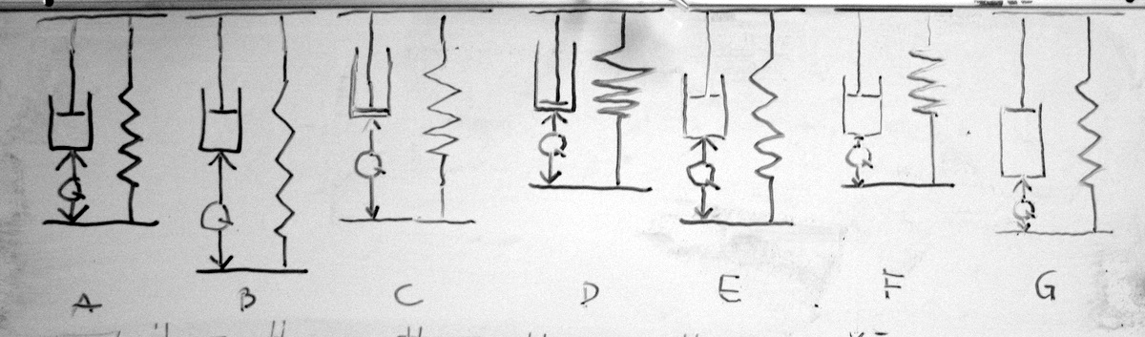
Fig. XXI.
The definition of the model is summarized in (1).
$$\left\{\begin{aligned}σ_{d}\left(t\right)+σ_{s}=0 \\ ε_{s}=ε_{d}+ε_{q} \\ σ_{s}={Eε}_{s} \\ σ_{d}=η\frac{dε_{d}}{dt}\end{aligned}\right.$$
$E$and$η$ are modulus of elasticity of the spring and viscosity of the dashpot respectively. The described relations in (1) can be arranged into differential equation
$$η\frac{dε_{d}}{dt}+{Eε}_{d}+Eε_{q}=0.$$
The obtained equation is first order linear differential equation which in case of homogenous boundary condition $ε_{d}\left(0\right)=0$ has a solution
$$ε_{d}\left(t\right)=-\frac{E}{η} e^{-\frac{E}{η}t}\int_{0}^{t}{ε_{q}\left(τ\right)e^{\frac{E}{η}τ}dτ}.$$
By introducing the rate of relaxation $λ=\frac{E}{η}$ and writing the input strain in terms of external stress $ε_{q}=\frac{σ_{q}(t)}{E}$ gives us a simplified form of the equation for
$$ε_{s}\left(t\right)=\frac{1}{E}\left[σ_{q}\left(t\right)-λe^{-λt}\int_{0}^{t}{σ_{q}(τ) e^{λτ}dτ}\right].$$

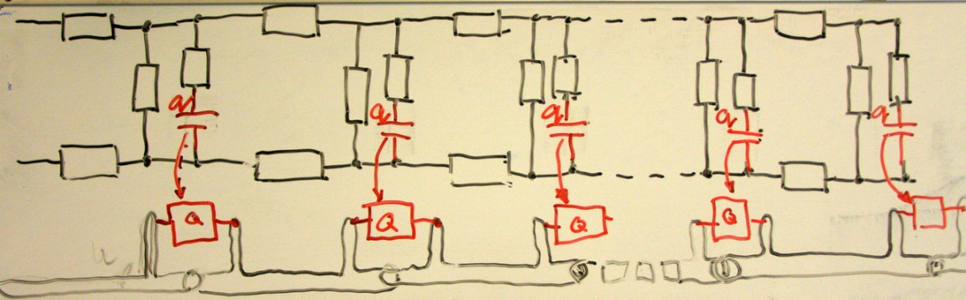
Experimental setup
The actuation process of IEAP was observed visually from side. The shape of the actuator was recorded by CCD camera (Pointgray). The footage was later subjected to several image processing operations to obtain the vector representation of the actuator. All the tasks from signal generation up to the post processing of the curvature changes were carried out with NI LabView software with Matlab engine for numerical model evaluations as indicated in fig 1.
Fig. 2 Experimental setup overview.

In this work, we assume that the EIBM is linearly depending on charge by a coefficient$α$. After some manipulation with Euler-Bernoulli and other classic beam theory relationships we obtain the equation for curvature.
$$\frac{1}{ρ}=μ\left[q\left(t\right)-λe^{-λt}\int_{0}^{t}{q(τ) e^{λτ}dτ}\right]$$
where $I$ is the second moment of area and the constant $\frac{α}{EI}$ is denoted by $μ$.
The curvature can be also presented in Cartesian coordinates as:
$$curve\left(s\right)=\left[\int_{0}^{s}{cos⁡(φ\left(s\right))ds}{+x}_{0} \int_{0}^{s}{sin\left(φ\left(s\right)\right)ds}{+y}_{0}\right]$$
where $x_{0}$ and $y_{0}$ are the initial position of the curve and the angle
$$φ\left(s\right)=\int_{0}^{s}{ρ\left(s\right)ds}+φ_{0}$$
where $φ_{0}$is initial angle at s=0.

The parameters of the distributed electromechanical model were determined using differential evolution (DE) algorithm. DE is one of the fastest evolutionary algorithms having several advantages such as consistent convergence to global minimum, parallelizability, and ability to handle nonlinear multimodal cost functions. The unknowns are represented as parameter vectors, which are mutated with other vectors in current population to attain a new trial vector for next generation. Furthermore, the crossover allows random perturbation of the vectors to increase diversity. The cost function was defined by simply minimizing the differences between measured and calculated voltages.[X12]
Surface resistance of the sample was measured experimentally … (directly/ four point method kõlaks siin hästi?) All other parameters were obtained by DE algorithm. Since the model is not yet fully optimized its evaluation in the meaning of reasonable precision is still computationally expensive. Therefore, we optimized each sample in two stages. First, the parameters C, G, W and$μ$were determined using fixed value of $λ=0$. By this, we assume that at the beginning of the actuation there is no relaxation present. In second stage all other parameters were fixed and the optimization was carried out with respect to $λ$ only. This two stage optimization allows us to use coarser set of experimental points while determining $λ$ over long time period and fine set of points to determine C, G, W and $μ$ over short time period with almost no loss of precision in general.

 | CPC  with  gold  electrodes | CPC | musclesheet
R | 2 | 1600 | 9
C | 0.468 | 0.00585 | 0.0089
G | 0.035 | 0.0002 | 0.0063
W | 1.889 | 0.0193 | 0.6044
$$μ$$ | 0.10365 | 6.52039 | 8.7504
$$λ$$ | 0 | 0 | 0

Results
The parameter $λ$ was derived from eq. 5 and was evaluated in region$120s<t<300s$.
Parameter Value  $$R$$ $$1.6\frac{kΩ}{cm }$$  $$C$$ $$0.011\frac{F}{cm }$$  $$W$$ $$5.1\frac{1}{kΩ∙cm}$$  $$G$$ $$0.098\frac{1}{kΩ∙cm}$$  Table 1. Measured parameters for CPC actuator. | Fig. 4 Measured and simulated voltage along the actuator at 2.0 V step input signal.

As seen in figure 1, good correlation between experimental data and simulated data with optimized parameters was obtained.

The simulated points are clearly following the actual shape of the actuator. The shape of the actuator

Fig. 5 Measured and modelled shapes of the actuator at 2.5V. | Fig. 6. Measured and modelled shapes of the actuator at 2.5V

Conclusion and discussion

Acknowledgments

Refs
X1: doi: 10.1117/12.654740
X2: doi:10.1088/0964-1726/17/3/035011
X3: doi: 10.1117/12.475167
X4: doi: 10.1002/marc.201100535
X5: doi: 10.1002/pen.21955
X6: doi: 10.1063/1.2194127
X7: doi:10.1088/0964-1726/20/8/083001
X8: doi: 10.1117/12.475201
X9: PunnDistrModel
X10: doi: 10.1021/ma800956v
X11: Spie 2002 - 4695-33
X12: DOI: 10.1023/A:1008202821328

References
[1] Chenying Yang, Wei Wang and Zhihong Li, "Optimization of corona-triggered PDMS-PDMS bonding method," in Nano/Micro Engineered and Molecular Systems, 2009. NEMS 2009. 4th IEEE International Conference on, 2009, pp. 319-322.

