Mechanoelectrical impedance of carbide-derived carbon-based laminate at large deflections
Indrek Mustª, Mart Anton^{b}, Erki Viidaleppª, Inga Põldsaluª, Andres Punningª and Alvo Aablooª
ª Intelligent Materials and Systems Laboratory, Institute of Technology, University of Tartu, Estonia
^{b} Centre for Biorobotics, Tallinn University of Technology, Estonia
E-mail: indrekm@ut.ee
Abstract The motion sensing property of a three-layer ionic electroactive polymer laminate is investigated. Carbon derived from titanium carbide is used as an electrode constituent, 1-ethyl-3-methylimidazolium trifluoromethanesulfonate ionic liquid as an electrolyte, Nafion ionic polymer as membrane and electrode binder, and thin gold sheet as current collectors. The mechanoelectrical properties of this laminate are investigated using a special rig, which bent the laminate using an external force following a well-defined bending profile. The bending device is characterized by homogeneous and sinusoidal change in curvature in a wide frequency range (1 mHz…3 Hz), with very high curvature amplitudes (±121 m⁻¹). During the bending, the laminate always has a uniform curvature. Peak-to-peak voltage, electric current and average generated charge is measured during the bending. The results show that the tested material has a nonlinear frequency response in the whole investigated range. Electric current and charge are found to be directly proportional to the bent laminate area and are therefore advantageous for motion sensing. The creep factor observed in case of voltage complicates the extraction of bending amplitude.

1. Introduction
Soft robotic devices are such systems, where the input signal causes the changes in the size and shape of some structural elements of the device [1], and the parts of the structure can also respond to influences from the surroundings [2]. The development of flexible electronics is often inseparable from soft robotics. In the recent few years, the research on highly flexible, stretchable, conductive materials for the use in soft robotics and flexible electronics [3-5] has gained an increasing interest. One of the scopes of soft robotics is development of highly conforming body-compliant or even implantable systems [2, 6, 7].
Ionic electroactive polymer (IEAP) is a soft, flexible, integrable and multifunctional laminate with a perspective to be used in soft robotics. The charging of electric double-layer on high surface area electrode surface [11], or electrochemical oxidation/reduction occurring in conductive polymer [11] or CNT [12] electrodes generates volumetric effects, which in turn allows the use of IEAP as an actuator. IEAPs respond to the bending using external force by formation of voltage and current between the electrodes and can therefore be used to detect motion [13, 14]. In construction, some IEAP laminates are indistinguishable from flexible electric double-layer capacitors [15] and can therefore be used also as an energy storage element.
The mechanoelectrical sensorial properties of ionic polymer-metal composite (IPMC) are studied thoroughly and the state of research is published in a review paper by Pugal et al[16], and also the mechanoelectrical transduction of polypyrrole laminates is also a well-known effect [17-21] and also mechanoelectrical properties of carbon nanotube yarns[22] and solid polymer electrolyte sandwiched between CNT electrodes [14] have been investigated. Still, there exist only a few papers about the same characteristics of CPC [13].
For the research and comparison of voltage and current output of IEAP laminates in response to bending, it is advisable to bend the laminate with an external force so that the laminate has a uniform curvature throughout the whole experiment. The bending device should allow achievement of large (>±100 m⁻¹) curvatures. Also, the bending frequency should be variable in a wide range (0.001…1 Hz). Several technical solutions have been offered previously to achieve homogenous bending, but they do not fulfill all of the mentioned requirements simultaneously.
Electroactive polymer mechanoelectrical sensors are often measured in cantilever configuration, which often corresponds to the typical configuration when used as an actuator. The force can be applied in perpendicular to the laminate at initial position [18, 23-27], which can offer a very wide frequency spectrum, but the bending amplitude is limited. Anchoring one end of the cantilever to the rotating platform allows fast bending to amplitudes up to 90° [28], but the curvature is nonhomogeneous during the bending. Bonomo et al have proposed a non-contact measurement set-up, where the cantilever is actuated using air flow [29].
The characterization of a sensor output dependence on the bending curvature expects the measured material to have a uniform curvature at all time, which constrains the use of cantilever set-up for sensor measurements. To date, several solutions have been proposed. It has been shown that in case of short EAPs attached with rigid elongations, the EAP also preserves constant curvature and the resulting joint could be modeled as a constant curvature hinge with reasonable accuracy [30]. The constant curvature has been applied by fitting the sensor material to the surface of cylindrical objects with different diameters [14, 31, 32] surf resistance] or sliding the sensor on the surface of a sample block between the straight and curved sections [14]. Using these methods, constant curvature is ensured even in the case of a nonhomogeneous sensor material, but the uniform change of curvature in time cannot be achieved. Recently, we have proposed a method of fixing the sample to the steel band, which is turned into a circle [33]. By doing so, the sample exactly follows the curvature of the steel band and is therefore always uniform. The curvature can also be changed fast and seamlessly, but the bending amplitudes are limited (20...60 m⁻¹) and the straight position cannot be achieved by this method. Also, once the laminate is fixed in the bending device, it can only be bent in a single direction.
The soft materials can allow very high deformations and complex geometries, which occur in the potential applications. In the paper at hand, a method for homogenous and continuous bending of the soft laminates is proposed. The method is characterized by bending deflections as large as ±114°, achievable curvatures up to 121 m⁻¹, and by sinusoidal change in curvature in time. The method can be used to perform dynamic measurements in the range <1 mHz…3 Hz and also static measurements. The behavior of an IEAP laminate composed of Nafion membrane, ionic liquid electrolyte and carbide-derived carbon electrodes is investigated at extreme bending amplitudes and in a wide frequency range.

2. Materials
A Nafion 117 ionomer membrane purchased from FuelCellStore.com™ was first boiled in 1 M hydrochloric acid, washed by boiling in deionized water, and then ion-exchanged by boiling in LiClO₄ solution. After subsequent vacuum treatment, the membrane was immersed in 1-ethyl-3-methylimidazolium trifluoromethanesulfonate (EMImTFS) ionic liquid (Fluka, ≥99.0 %). The electrode material was prepared by dispersing carbon powder derived from titanium carbide (TiC; Skeleton Technologies OÜ) with 15 wt% Nafion solution (LIQUION® LQ-1115 1100EW; Ion Power, Inc) using an ultrasonic probe. The dispersion was painted layer-by-layer directly on the both sides of EMImTFS-impregnated membrane using an airbrush. After application of total 8 layers of electrode for both sides of the membrane, solvents were evaporated under infrared lamp. Finally, the membrane was sandwiched between gold foils (Gold-Hammer) with thickness ~100 nm, and fused together by hot-pressing under 3.5 MPa for 5 s. Extra Nafion solution was used to promote gold foil adhesion. The manufacturing method is described in more detail in (Palmre, Brandell et al. 2009).
3. Bending geometry
The concept introduced in the current work assumes that the laminate material under test is uniform and homogeneous in lateral dimensions, i.e. the bending modulus, thickness and mechanoelectrical properties are constant. With these assumptions, it is possible to achieve the uniform curvature of the strip of laminate simply by holding its end points in appropriate position and pointed to appropriate direction.
We have designed mechanical system offering preservation of uniform curvature at bending angles (2α) of up to ±360°. Its geometry, designed following the Equation 1, is depicted in Figure 1. The system involves two identical shapes pushed to contact with each other. The defined fixing points guide the attached EAP in the direction of a tangent of an arc. When these two shapes roll with respect to each other without slipping, the EAP laminate forms an arc. The arched shape is guaranteed with any mutual position of the two shapes. The arc length is always kept constant and the uniform curvature is preserved at bending angles (2α) of up to ±360°. Actually a certain part of the beam is clamped between the electrical terminals for measurement of voltage and electric current, and achievement of a position where the free part of the laminate would make a full turn, is impossible.
$\left\{\begin{aligned}x\left(α\right)={sinc(α)}^{2} \\ y\left(α\right)=\frac{1-sinc(2α)}{α}\end{aligned}\right.$ (1)

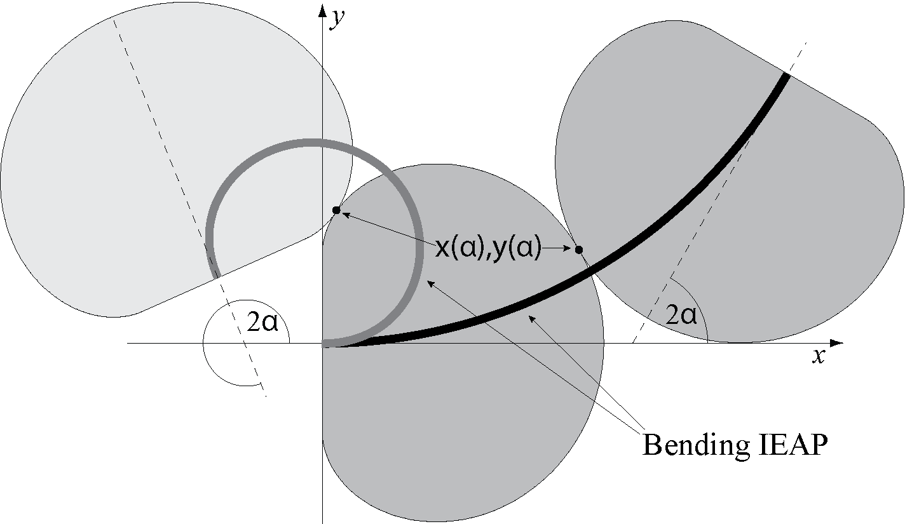
Figure 1. The geometric model for homogenous bending of IEAPs. The bending structure with the attached IEAP laminate is depicted at two different rotary angles (2α).

4. Measurement equipment
In order to research the mechanoelectrical response of the EAP materials, we constructed a computer-driven apparatus, involving the geometry described above. The key components of the instrument are the details, following the geometry defined by Equation 1. These details, depicted in Figure 2A, were designed as noncircular gearwheels, and fabricated of nylon using 3D-printing technology. Both contacting gearwheels can be rotated around their axis, while the angles of both gearwheels in respect to the straight position (Figure 2B) are equal to α (Figure 2C). At large deflections the distance between the rotary axes decreases between the values of D_{α=114°} and D_{α=0°}, as depicted in figures 2B and 2C. The continuous mechanical contact of the gearwheels is assured by preloaded spring acting upon the axis of one of them.
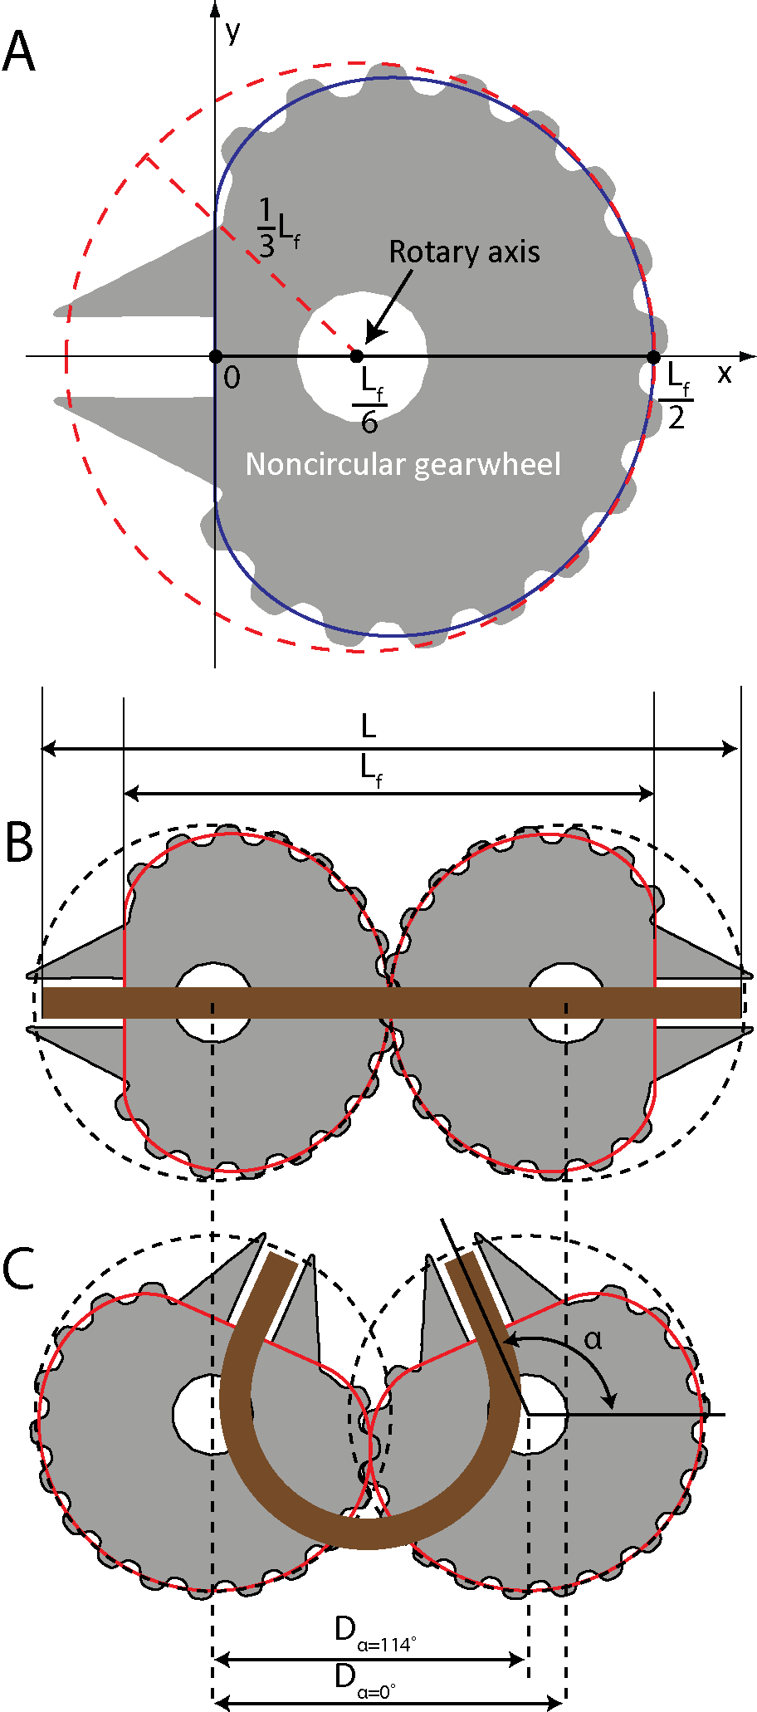
Figure 2. (A) The shape of a noncircular gearwheel. (B) The laminate with a total length L and free length L_{f} is fixed to the gearwheels in a straight (α=0°) position. (C) Both gearwheels are turned to maximum bending amplitude used in the current work (α=114°). The distance between the rotary axis of the gearwheels is decreased (D_{α=0°} vs D_{α=114°}).

The device described in the current work is able to achieve bending angles (2α) up to ±228°. Only the free part of the laminate, L_{f}, is bent, while the rest (L-L_{f}) is rigidly clamped (Figure 2BC). The clamps are fitted in the sockets of the gearwheels. To ensure the right position of the fastening clamps and measurement terminals and the stability of the mechanical transmission, another set of identical synchronously rotating gearwheels was added. A stepper motor is attached with a crank-rod mechanism while the gearwheels are actuated via rack and pinion mechanism. When the stepper motor is rotating at a constant speed, the curvature of the material under test changes sinusoidally with respect to time. The maximum bending amplitude is determined by the offset of the crank attached on the stepper motor rotary axis. The free length of the laminate, L_{f}, is defined by the gearwheels, however different L_{f}-s can be achieved by changing the gearwheels of different scaling. A photograph of the bending device is given in Figure 3B.
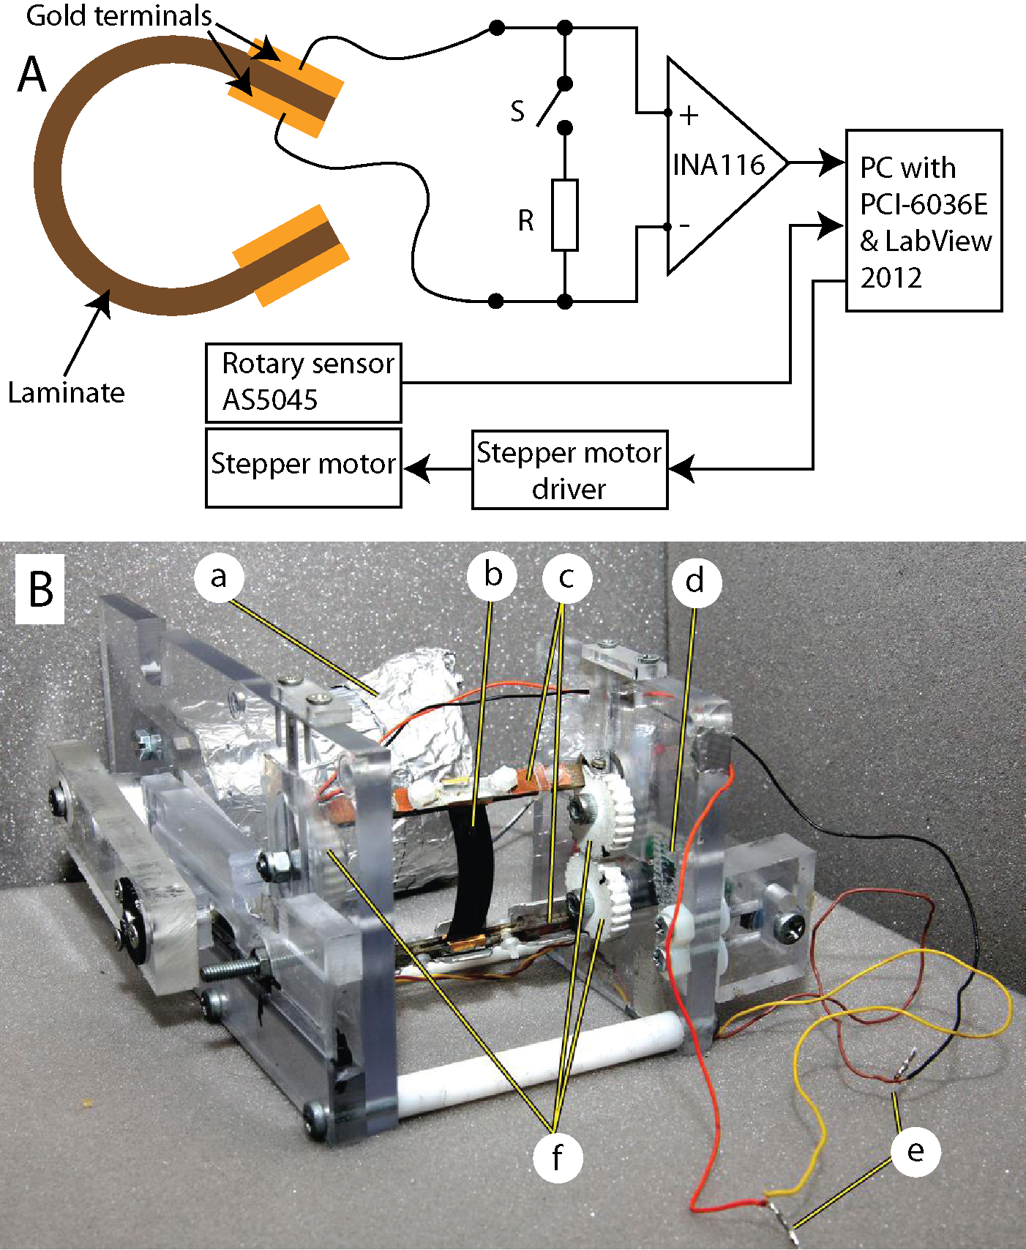
Figure 3. (A) The schematic of experiment set-up. (B) The photograph of the bending device: a – stepper motor; b – bending IEAP; c – measurement terminals; d – rotary sensor; e – wires to amplifier; f – noncircular gearwheels.

A circularly polarized magnet was attached to the rotary axis of one gearwheel and the position of the gearwheel was registered using a Hall Effect rotary encoder AS5045 by Austria Microsystems. The PWM output of the encoder was read in by the counter input of PCI-6036E DAQ card by National Instruments to verify the position of the gearwheels and the test object and to ensure the correct readout of the phase of the sensor signal.
The schematic of the measure set-up is depicted in Figure 3A. The material of length L (see Figure 2B) under test was fixed between the clamps equipped with electric terminals made of gold for measurement of sensor voltage. The output of the laminate material under test was registered using the National Instruments PCI-6036E DAQ board. The bias current of conventional operational amplifiers can eventually charge test objects in a long run. To overcome this problem, the Burr-Brown instrumentation amplifier – INA116 – with extremely low input bias current (<3 fA) was used as a preamplifier. Electric current was measured as a voltage drop over a low-ohm (10 Ω) shunt resistor R connected between the electrodes, as depicted in Figure 3A. The same amplifier set-up functioned as an ammeter or voltmeter, depending on if the shunt resistor was connected via switch S, or not.

5. Results and discussion
The mechanoelectrical characterization of the EAP materials involves measurements of the generated voltage and electric current, estimation of the generated electric charge, and validation of the arched shape as well as homogeneity of the material.
5.1. Validation of the method
The used measurement method assumes the homogeneity of the material. Figure 4 depicts the bending device with EAP laminate fixed between the clamps in various positions. The circle drawn on the pictures exactly coincides with the line corresponding to the cross-section of the laminate, which proves the mechanical properties of the material to be homogenous.
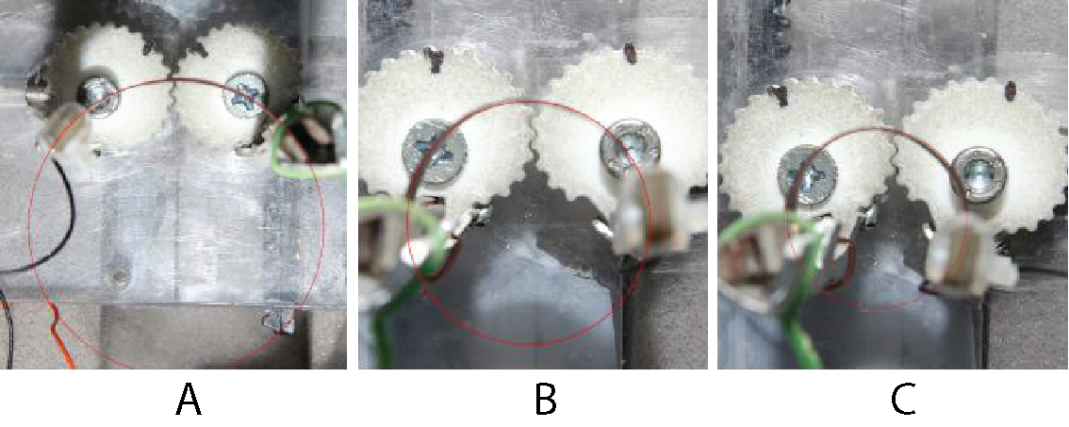
Figure 4. The laminate is bent to (A) 43, (B) 87, and (C) 108 m⁻¹. The circle drawn on the image exactly coincides with the cross-section of the laminate.
The correct fixing of the laminate between the clamps is of great importance. When the free part of the laminate is even slightly longer than the distance between the clamps at straight position, snap-through motion occurs in transition between convex and concave laminate. This effect is illustrated as a course of voltage in case of incorrectly fixed laminate in Figure 5.
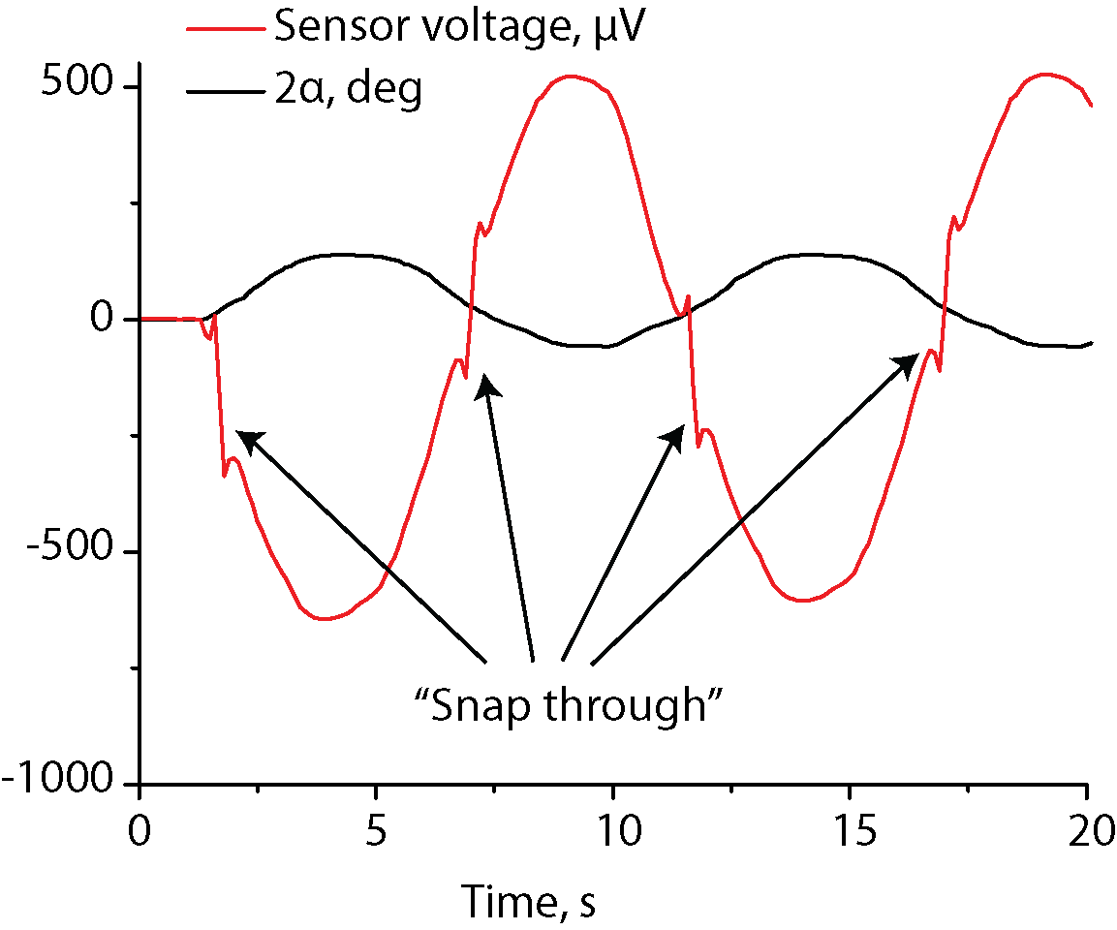
Figure 4. Snap-through effect observed in the output voltage in case of incorrect attachment of the laminate.
The typical transient output voltage and electric current in response to the sinusoidal change in curvature are depicted in Figure 6. The signal corresponding to curvature change is slightly depressed at extreme amplitudes, because the backlash of the gearing system is amplified there. The peak-to-peak values and phase shifts of voltage (U_{pp}) and electric current (I_{pp}) are determined by fitting the output signal with the sine parameters using a differential evolution algorithm.
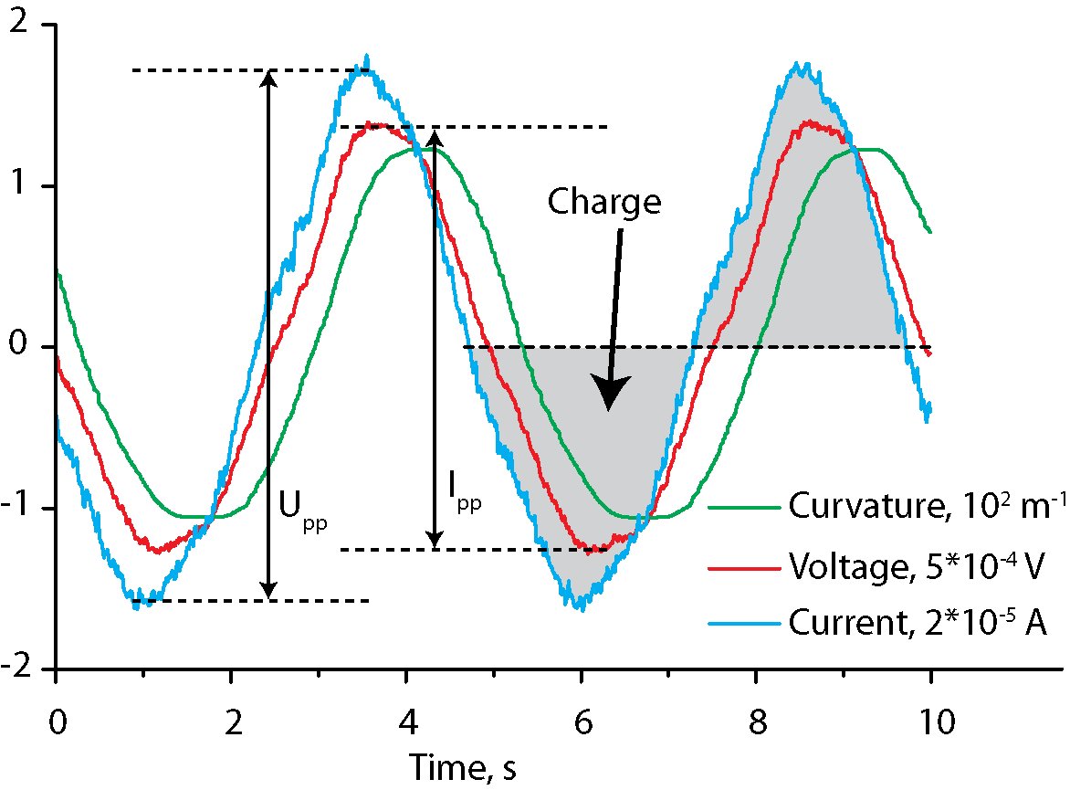
Figure 6. Transient voltage and electric current measured at 0.2 Hz bending frequency. Average generated charge and peak-to-peak values of voltage (U_{pp}) and electric current (I_{pp}) are extracted from the signals.
5.2. Sensorial properties of IEAP laminate
5.2.1 Voltage
Previously, we have proposed a theory [34] explaining the effect of charge generation in IEAP laminates as a result of bending by formation of hydraulic pressure difference between differently strained materials. The difference in pressure causes quick reorganization of electrolyte ions in the proximity of the carbon-electrolyte interface, and subsequent pressure-driven flow of electrolyte towards convex electrode. The both processes result in formation of electric double-layer and induction of electric charge between the electrodes. The peak values of voltage, electric current and charge are in linear relation to the bending amplitude [34].
The IEAP laminate was cut to widths of 3, 6, 9, and 12 mm, fixed between the clamps of the bending device and tested at the maximum bending amplitude. In order to ensure the homogeneity of the parameters of the different samples, the same piece of laminate was cut narrower. Hereinafter the samples are referred to by their widths: S3, S6, S9 and S12. The length of all samples was 42 mm, while the free part (distance between the fixing clamps) was 33 mm. 4.5 mm of material was left from both ends for fixing and for achievement of good electric contact. It must be noted that 21 % of the material was rigidly fixed and was not bent, while it was electrically connected and acted as an EDLC. However, this configuration corresponds well to the potential employment configuration in robotic applications.
The open-circuit voltage of IEAP sensor after steep bending is characterized by an instantaneous increase and subsequent slow diminishing of the voltage with positive polarity on the convex side. The sensor output corresponding to curvature change from -121 to 121 m⁻¹ (which corresponds to bending angles -114°<α<114°) at different bending frequencies is depicted in Figure 7A. After 30 seconds, the voltage has decreased to approximately 60 % of the initial value. The similar, but slightly less attenuated response is also described by Otsuki et al [14]. The attenuation of the response to steep bending can be explained by creep – common characteristic property of polymeric materials. The other possible reason for attenuation is the ion flux due to the pressure gradient, and also slow reorganization in the double layer towards state with minimal energy.
The peak-to-peak voltage with respect to different bending frequencies is depicted in Figure 7B. Due to the attenuated response, the peak-to-peak voltage for slower bending frequencies is considerably lower. It can also be noticed that the narrower laminate strip produces slightly lower voltage peak-to-peak values. This effect, especially expressed in case of the sample S3, can be attributed to the nonhomogeneous surface conductivity, caused by the discontinuities of the gold sheet. The output peak-to-peak voltage plotted with respect to the area of the laminate is depicted in Figure 7C, which similarly reflects the effects of nonhomogeneous change in surface conductivity. The phase shift of voltage output depicted in Figure 7D is relatively small, not exceeding 20° even in the case of the lowest bending frequencies.
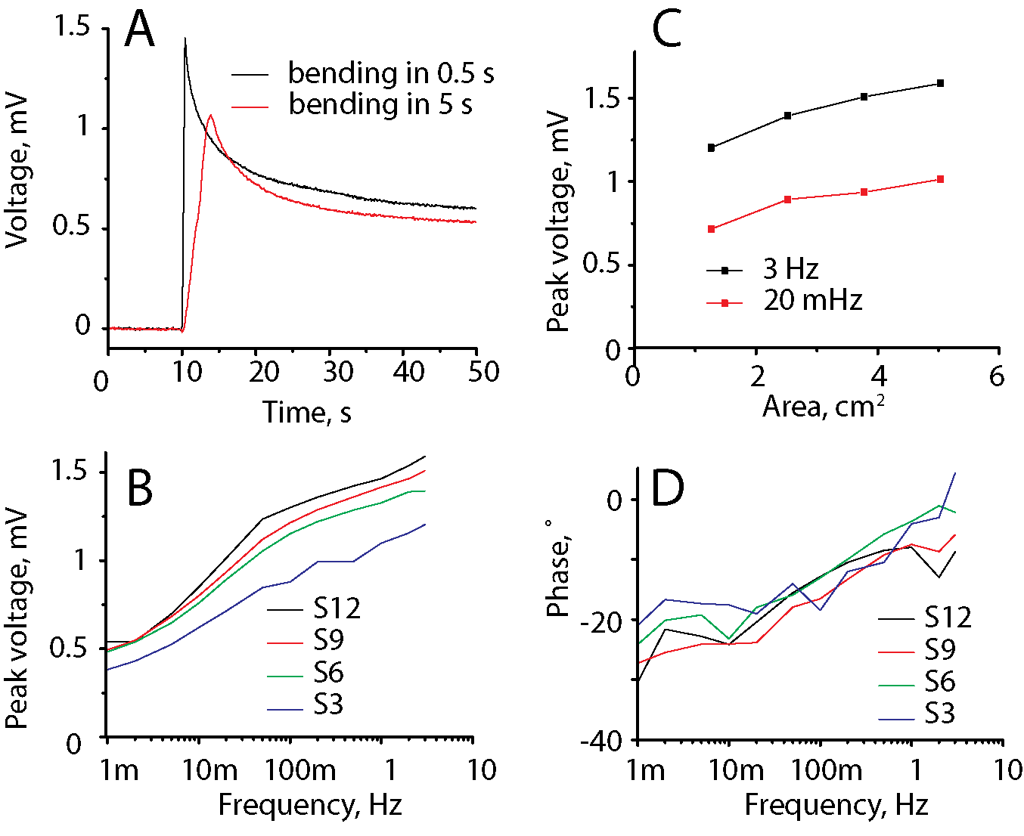
Figure 7. (A) Transient courses of voltage after change of curvature from -121 to 121 m⁻¹ in 0.5 and 5 s. (B) The peak-to-peak voltage frequency response of the different samples. (C) The peak-to-peak voltages as a function of sensor area. (D) The phase shift of voltage.

5.2.2 Electric current
Electric current was measured as a voltage drop over a 10 Ω resistor connected between the opposite electrodes of the IEAP laminate. As depicted in Figure 8A, the transient current shows a sharp peak immediately after steep bending, and diminishes to zero in approximately 10 seconds. The frequency response is depicted in Figure 8B. As expected, the peak-to-peak value is largely dependent on bending frequency. In contrary to the open circuit voltage, the nature of electric current is additive, thus the peak-to-peak value of the electric current is directly proportional to the area of the bent laminate. The peak-to-peak values of electric current are plotted for different bending frequencies in Figure 8C, which affirms the linearity with respect to the area, but also indicates to the noteworthy frequency dependence. The phase shift of electric current, depicted in Figure 7, approaches even -90° in the case of the lowest bending frequencies.
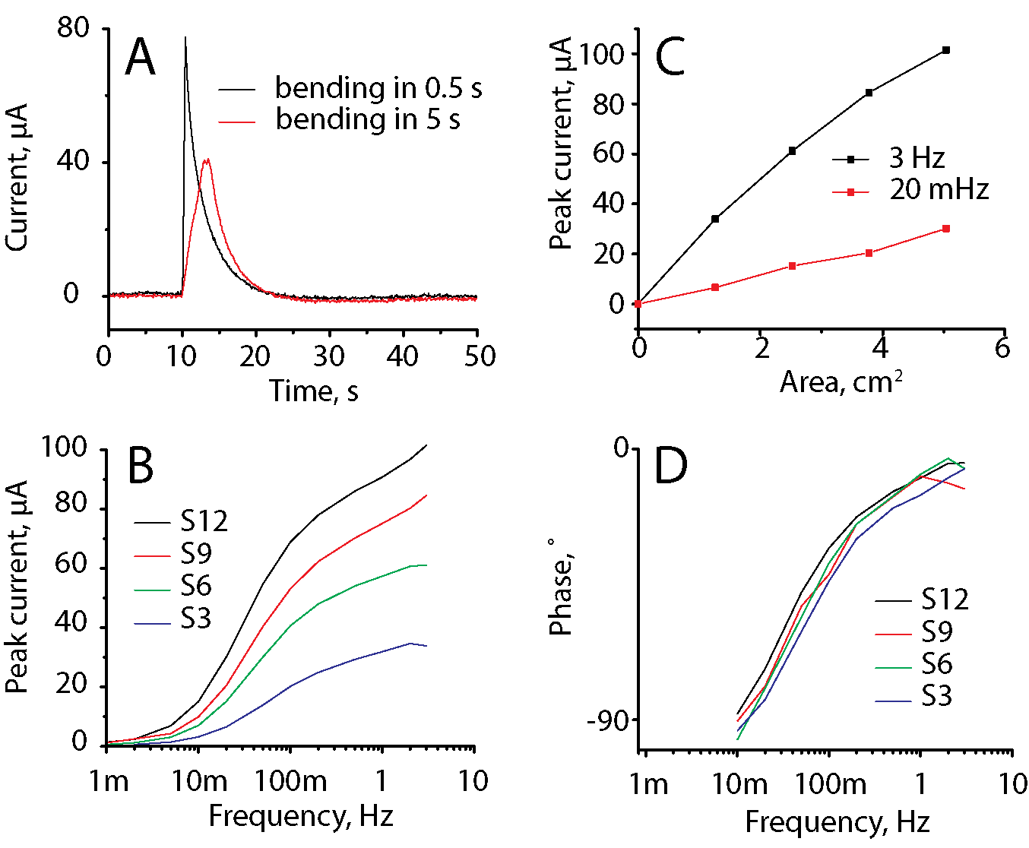
Figure 8. (A) Transient courses of electric current after change of curvature from -121 to 121 m⁻¹ in 0.5 and 5 s. (B) The peak-to-peak voltage frequency response of the different samples. (C) The peak-to-peak voltages as a function of sensor area. (D) The phase shift of voltage.
5.2.3 Electric charge
The produced electric charge given in Figure 9A was calculated by integrating the area under the measured electrical current (see Figure 6). Similarly to the peak-to-peak values of electric current, the maximum averaged charge per time unit is generated at maximum bending frequencies. Figure 9B demonstrates the relation between the bent area and generated charge per second. As expected, the generated charge grows linearly with the increase in area, but slower bending results in lower output power.
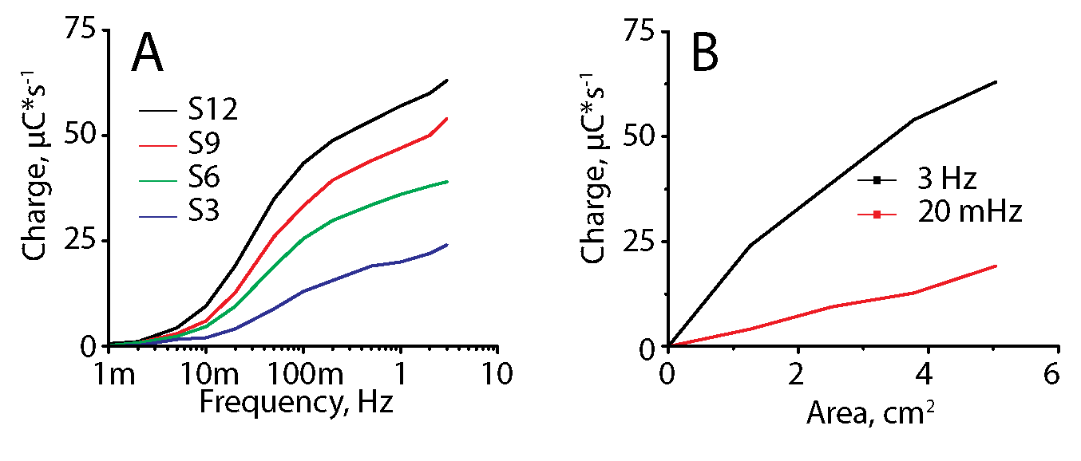
Figure 9. (A) The generated time-averaged charge at different bending frequencies. (B) The charge value as a function of laminate area.

6. Conclusions
An IEAP laminate containing carbide-derived carbon, ionic liquid and ionic polymer can detect motion when bent to extremely large deflections. An original test rig was designed for homogenous and uniform bending of the laminate to up to high curvatures. It guarantees the repeatability of experiments and stands out with its well-defined bending profile, high speed and large achievable deflections in wide frequency range (1 mHz...3 Hz). It is advantageous in characterization of soft bending sensors, as well as in mechanical fatigue tests of the bending sensors or any other soft laminates.
Harmonic analysis revealed that the frequency responses of the voltage and electric current of this type of material is nonlinear in the whole investigated range – 1 mHz to 3 Hz. The experiments show that in comparison to the open-circuit voltage, the electric current is advantageous for two reasons. Firstly, the electric current is directly proportional to the bent area, while the voltage output is more sensitive to the inhomogeneity of the surface conductivity. Secondly, the transient response of voltage as a response to step input is characterized by an instant formation of voltage peak, followed by slow diminishing of the signal. The usage of such material as static position sensor is rather complicated. The transient response of electric current consists of an instantaneous peak and fast decay of zero. This property makes measurement of electric current an accurate motion sensor. The charge output is, similarly to electric current peak values, proportional to the sensor area. As expected, the highest charge is produced at the maximum bending frequency.

Acknowledgments
This work was supported by the Estonian Science Foundation grant no. 7811.

References
References
[1] Ilievski, F., Mazzeo, A.D., Shepherd, R.F., Chen, X. and Whitesides, G.M., "Soft Robotics for Chemists," Angewandte Chemie International Edition, 50(8), 1890-1895 (2011).
[2] Lipomi, D.J., Vosgueritchian, M., Tee, B.C.-., Hellstrom, S.L., Lee, J.A., Fox, C.H. and Bao, Z., "Skin-like pressure and strain sensors based on transparent elastic films of carbon nanotubes," Nat Nano, 6(12), 788-792 (2011).
[3] Jeong, G.S., Baek, D., Jung, H.C., Song, J.H., Moon, J.H., Hong, S.W., Kim, I.Y. and Lee, S., "Solderable and electroplatable flexible electronic circuit on a porous stretchable elastomer," Nat Commun, 3977 (2012).
[4] Su, Y., Liu, Z., Kim, S., Wu, J., Huang, Y. and Rogers, J.A., "Mechanics of stretchable electronics with high fill factors," Int.J.Solids Structures, 49(23–24), 3416-3421 (2012).
[5] Mannsfeld, S.C.B., Tee, B.C.-., Stoltenberg, R.M., Chen, C.V.H.-., Barman, S., Muir, B.V.O., Sokolov, A.N., Reese, C. and Bao, Z., "Highly sensitive flexible pressure sensors with microstructured rubber dielectric layers," Nat Mater, 9(10), 859-864 (2010).
[6] Yamada, T., Hayamizu, Y., Yamamoto, Y., Yomogida, Y., Izadi-Najafabadi, A., Futaba, D.N. and Hata, K., "A stretchable carbon nanotube strain sensor for human-motion detection," Nat Nano, 6(5), 296-301 (2011).
[7] Kim, D., Viventi, J., Amsden, J.J., Xiao, J., Vigeland, L., Kim, Y., Blanco, J.A., Panilaitis, B., Frechette, E.S., Contreras, D., Kaplan, D.L., Omenetto, F.G., Huang, Y., Hwang, K., Zakin, M.R., Litt, B. and Rogers, J.A., "Dissolvable films of silk fibroin for ultrathin conformal bio-integrated electronics," Nat Mater, 9(6), 511-517 (2010).
[8] Y. Bar-Cohen and Society of Photo-optical Instrumentation Engineers., Electroactive polymer (EAP) actuators as artificial muscles [electronic resource] : reality, potential, and challenges, Bellingham, Wash. (1000 20th St. Bellingham WA 98225-6705 USA): SPIE, 2004, .
[9] Martínez, J.G., Sugino, T., Asaka, K. and Otero, T.F., "Electrochemistry of Carbon Nanotubes: Reactive Processes, Dual Sensing?Actuating Properties and Devices," ChemPhysChem, 13(8), 2108-2114 (2012).
[10] Must, I., Kaasik, F., Põldsalu, I., Johanson, U., Punning, A. and Aabloo, A., "A carbide-derived carbon laminate used as a mechanoelectrical sensor," Carbon, 50(2), 535-541 (2012).
[11] Otsuki, M., Okuyama, T. and Tanaka, M., "Time response properties on deformation velocity for a solid polymer electrolyte sensor," Int.J.Appl.Electromagn.Mech., 39(1), 1063-1068 (2012).
[12] Nyholm, L., Nyström, G., Mihranyan, A. and Strømme, M., "Toward Flexible Polymer and Paper-Based Energy Storage Devices," Adv Mater, 23(33), 3751-3769 (2011).
[13] Pugal, D., Jung, K., Aabloo, A. and Kim, K.J., "Ionic polymerâ€“metal composite mechanoelectrical transduction: review and perspectives," Polym.Int., 59(3), 279-289 (2010).
[14] Takashima, W., Uesugi, T., Fukui, M., Kaneko, M. and Kaneto, K., "Mechanochemoelectrical effect of polyaniline film," Synth.Met., 85(1–3), 1395-1396 (1997).
[15] Wu, Y., Alici, G., Madden, J.?.?., Spinks, G.?. and Wallace, G.?., "Soft Mechanical Sensors Through Reverse Actuation in Polypyrrole," Advanced Functional Materials, 17(16), 3216-3222 (2007).
[16] Alici, G., Spinks, G.M., Madden, J.D., Wu, Y. and Wallace, G.G., "Response characterization of electroactive polymers as mechanical sensors," Mechatronics, IEEE/ASME Transactions On, 13(2), 187-196 (2008).
[17] Shoa, T., Madden, J.D.W., Mirfakhrai, T., Alici, G., Spinks, G.M. and Wallace, G.G., "Electromechanical coupling in polypyrrole sensors and actuators," Sensors and Actuators A: Physical, 161(1–2), 127-133 (2010).
[18] Takashima, W., Uesugi, T., Fukui, M., Kaneko, M. and Kaneto, K., "Mechanochemoelectrical effect of polyaniline film," Synth.Met., 85(1–3), 1395-1396 (1997).
[19] Mirfakhrai, T., Jiyoung Oh, Kozlov, M.E., Shaoli Fang, Mei Zhang, Baughman, R.H. and Madden, J.D.W., "Mechanoelectrical Force Sensors Using Twisted Yarns of Carbon Nanotubes," Mechatronics, IEEE/ASME Transactions On, 16(1), 90-97 (2011).
[20] Chen, Z., Tan, X., Will, A. and Ziel, C., "A dynamic model for ionic polymer–metal composite sensors," Smart Mater.Struct., 16(4), 1477 (2007).
[21] Newbury, K.M. and Leo, D.J., "Linear Electromechanical Model of Ionic Polymer Transducers -Part II: Experimental Validation," Journal of Intelligent Material Systems and Structures, 14(6), 343-357 (2003).
[22] Farinholt, K. and Leo, D.J., "Modeling of electromechanical charge sensing in ionic polymer transducers," Mech.Mater., 36(5–6), 421-433 (2004).
[23] Bonomo, C., Fortuna, L., Giannone, P., Graziani, S. and Strazzeri, S., "A model for ionic polymer metal composites as sensors," Smart Mater.Struct., 15(3), 749 (2006).
[24] Paola, B., Fortuna, L., Giannone, P., Graziani, S. and Strazzeri, S., "IPMCs as Vibration Sensors," Instrumentation and Measurement Technology Conference Proceedings, 2008. IMTC 2008. IEEE, 2065-2069 (2008).
[25] Biddiss, E. and Chau, T., "Electroactive polymeric sensors in hand prostheses: Bending response of an ionic polymer metal composite," Med.Eng.Phys., 28(6), 568-578 (2006).
[26] Bonomo, C., Fortuna, L., Giannone, P. and Graziani, S., "A method to characterize the deformation of an IPMC sensing membrane," Sensors and Actuators A: Physical, 123–124(0), 146-154 (2005).
[27] Must, I., Anton, M., Kruusmaa, M. and Aabloo, A., "Linear modeling of elongated bending EAP actuator at large deformations," Electroactive Polymer Actuators and Devices (EAPAD) XI, Proceedings of SPIE, 728723 (2009).
[28] Punning, A., Kruusmaa, M. and Aabloo, A., "Surface resistance experiments with IPMC sensors and actuators," Sensors and Actuators A: Physical, 133(1), 200-209 (2007).
[29] Otsuki, M., Okuyama, T. and Tanaka, M., "Characterization of a curvature sensor using a solid polymer electrolyte," 7500(2009).
[30] Must, I., Kaasik, F., Põldsalu, I., Johanson, U., Punning, A. and Aabloo, A., "Carbon-polymer-ionic liquid composite as a motion sensor," 834031 (2012).
[31] Must, I., Kaasik, F., Põldsalu, I., Johanson, U., Punning, A. and Aabloo, A., "A carbide-derived carbon laminate used as a mechanoelectrical sensor," Carbon, 50(2), 535-541 (2012).

