Variable-focal lens using electroactive polymer actuator

V. Vunder, A. Punning, A. Aabloo

IMS Lab, Institute of Technology, Nooruse 1, Tartu, Estonia

Abstract
The paper describes a simple and cost-effective design and fabrication process of a liquid-filled variable-focal lens. The lens was made of a soft polymer material, its shape and curvature can be controlled with the hydraulic pressure. An electroactive polymer is used as an actuator. A carbon-polymer composite (CPC) was used. The device is composed of an elastic membrane upon a circular lens chamber, a reservoir of liquid, and a channel between them. It was made of three layers of polydimethylsiloxane (PDMS), bonded using the partial curing technique. The channels and reservoir were filled with an incompressible liquid after the curing process. A CPC actuator was mechanically attached to the reservoir to compress or decompress the liquid. Squeezing the liquid between the reservoir and the lens chamber will push the membrane inward or outward resulting in the change of shape of the lens and hence in alteration of its focal length. Depending on the pressure the lens can be plano-convex or plano-concave or even switch between the two configurations. With only a few minor modifications it is possible to fabricate bi-convex and bi-concave lenses. A lens with an 1 mm diameter and focal length from infinity to 17 mm is reported. The 5x15mm CPC actuator with the working voltage of only up to ±2.5 V was capable to alter the focal length within the full range of the focal length in 10 seconds.

Keywords: Liquid lens, variable-focal, electroactive polymer, PDMS, CPC actuator

INTRODUCTION
Variable-focal lenses have been studied for years. There exist a number of fields of interest, e.g. beam steering, portable imaging, etc., where tunable lenses could give an extra value.
Tunable lenses could be classified as follows: electrowetting, gel type, and liquid lenses. An electrowetting lens is based on a drop of liquid whose shape is changed by the applied voltage. The alteration of optical power is obtained by electrowetting behavior of the droplet and the changes of its contact angle. Although these lenses have a fast response time, authors have found it rather difficult to reach larger apertures¹⁻³. A gel type lens is composed of an elastic material that is contracted and expanded thus changing the radius of curvature. For instance, a shape memory alloy actuator has been used to control the contraction/expansion of this type of lenses². Gel type lenses are relatively resistant to vibrations and shocks but have a rather limited focal range. Concept of a liquid lens has three key elements: transparent elastic membrane over a reservoir, liquid, and an actuator. The membrane is deformed as a result of hydraulic pressure. By deforming the membrane, the radius of curvature of the lens is changed; hence the optical power is altered. For pressure control, different actuators have been used: an external pump⁴, directly connected piezostack actuator⁵, etc. Compared to electrowetting lenses, liquid lenses are able to produce a wider focal length range and the design of the lens is rather simple. Considering liquid lenses, there is also an option to choose between different types of actuators or the number of actuators used, allowing the system to be more dynamic.
Probably the most popular type of ionic EAPs is ionic polymer-metal composite – IPMC. Recently, there has been an increasing interest in new types of ionic EAPs based on carbon. One of them is the carbon-polymer composite (CPC) – a three layer actuator with electrodes made of porous carbon material, base polymer, and ionic liquid. CPC is made of fully organic components, which are making it desirable in the areas where usage of metals is prohibited. Even though the shallow response of CPC and IPMC to voltage simulation is rather similar, the working principles of their actuation are totally different. In the case of IPMC the mobile hydrated cations in the fixed anionic polymer network cause gradient of water concentration across the material, hence the material bends. In the case of CPC, both cations and anions of the particular ionic liquid are mobile, the cause of bending is the size-difference of cations and anions. Further details about the actuator are described by Torop et al.⁶
A few attempts of using EAPs to drive a variable-focal lens have been reported in recent years. Shimizu et al.³ have demonstrated a promising variable-focal liquid lens system with four IPMC strips attached to a deformable lens membrane. By moving the edges of the membrane towards the liquid, the center of the membrane deforms to the opposite direction; therefore, a variable-focal length is achieved. Another IPMC-driven lens is described by Lee et al.⁷ The reason for changes in the focal length is the mechanical translational movement of the lens. Niklaus et al.⁸ have introduced a 2x2 array of individually tunable lenses. Using the technique of ion implantation, the dielectric elastomer actuator was covered with highly compliant electrodes, which are over 50% transparent in the visible spectrum. The polymer that covers the liquid channel is able to function as a lens membrane and an as actuator simultaneously. Choi et al.⁹ have reduced the high actuation voltage by reducing the thickness of the actuator. The actuator is composition of several 1~3 µm thick actuators made of P(VDF-TrFE-CFE) [poly(vinylidene fluoride-trifluoroethyleneclorofluoroethylene)]. With these multiple layers of thin actuators, the operational voltage is reduced from kilovolts to 50 volt which allows higher usability in portable devices.
In the current paper we propose a novel approach of liquid-filled variable-focal lens made of PDMS and driven by ionic actuator. Generally, the ionic EAPs bend in response to the applied voltage. It is not easy to mechanically exploit the bending functionality of these materials. However, they can easily exert force to a membrane. Both IPMC and CPC are suitable for driving our liquid lens system; however, the current work presents only the results obtained with the CPC actuator. Using a CPC actuator of dimensions 5x15 mm, a large focal range is obtained by applying the voltage in the range of only ±2.5 volts.

WORKING PRINCIPLE
The whole device is fabricated of PDMS. The excellent optical properties: transparency from near-IR to near-UV spectrum, flexibility, stability over a large temperature range, and precise replicating capabilities makes this material perfectly suitable for this application. PDMS is also widely used in other fields such as replication and microfluidics, where optical properties are often not essential.
The design of the proposed variable-focal lens is shown in Figure 2.1. The lens consists of three PDMS layers. The top layer (1) is a thin film that covers the circular hole created through the middle layer forming the membrane. The middle layer (2) contains a reservoir, a channel, and a thin wall on top of the reservoir. Finally, a rectangular layer of PDMS (3) is used to seal the channel and the reservoir from the bottom. This structure allows transferring hydraulic pressure from the actuator to the membrane. By pushing the thin wall towards the reservoir, a plano-convex lens is formed; by pulling it in the opposite direction, the system behaves as a plano-concave lens. The described construction also enables building an array of lenses by slightly modifying the middle layer (2) and adding multiple vertical channels.
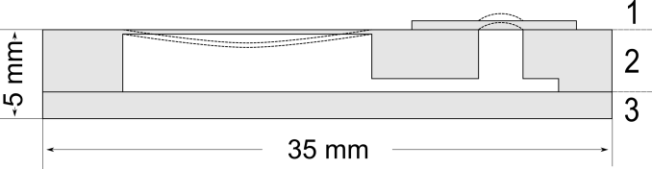
Figure 2.1. Structure of the variable-focal liquid lens.
Since PDMS is known as a material with high gas permeability¹⁰, the evaporation of liquid through the membranes has to be taken into account; hence, the device was filled with ethylene glycol. Although ethylene glycol has several advantages such as low evaporation rate, low freezing temperature, high refractive index, etc., its high toxicity limits the usage in the fields of biomedicine. As relatively safe alternatives, water and cinnamaldehyde have been reported in the literature¹¹

ESTIMATION OF THE PARAMETERS
Center deformation can be observed as a function of thickness, if membrane radius and thickness are treated as constants. This allows us to select suitable thickness for the device and estimate the focal length range. Therefore, calculations were made to obtain the relations between deformation, thickness, and focal length. For comparison to the analytical solution, a FEM (Finite Element Method) model of the circular plate was constructed and simulations were carried out with Comsol Multiphysics software.
In this paper, the edge of the membrane is considered to be clamped, thus the center deformation can be expressed by the following equation¹²:
(1)
where $y_{c}$ is the center deformation, $p$ is the pressure applied to the membrane, $r$ is the radius of the lens, and $D$ is the plate constant that is obtained from¹²:
(2)
where $E$, $t$ and $ν$ are material properties of the membrane respectively: modulus of elasticity, thickness and Poisson’s ratio.
Assuming the profile of the lens membrane to be spherical, the radius of curvature is given by¹³:
(3)
where $R$ is the radius of curvature, $r$ is the radius of the membrane, and $y_{c}$ is the center deformation.
The focal length corresponding to $R$ is related as¹³:
(4)
where $f$ is the focal length, $R$ is the radius of curvature, and $n$ is the refractive index of the membrane.
In order to estimate the operating pressure of the available CPC actuator, and to decide if it qualifies for the desired task, a simple experiment was set up. A small rubber balloon was attached to the pressure sensor (Smartec SPD002GAsil) and squeezed by the actuator. Throughout the measurements, the position of the actuator was varied. According to the results the maximum operating pressure was about 1 kPa (Figure 3.1).
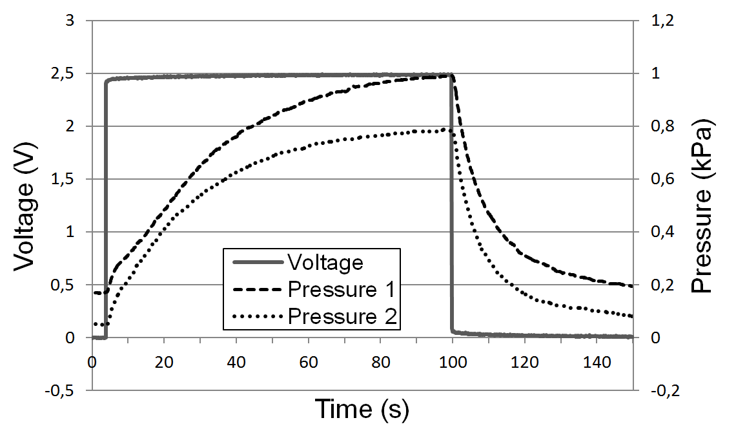
Figure 3.1 Operating pressures of the CPC actuator in different position configurations.
Center deformation (a) and focal length (b) in Figure 3.2 were calculated for different lens thicknesses. The pressure was fixed to 1 kPa, which was the maximum output of the CPC actuator with operating voltage of 2.5 V. The radius of the lens was chosen as 0.5 mm and the parameters of the PDMS were set as follows¹⁴: $E$ – 0.75 MPa, $ν$ – 0.499 and $ρ$ – 920 kg/m³. As indicated in Figure 3.2, decreasing the thickness of the membrane below 30 µm causes rapid deformation which has to be considered to avoid breaking the lens.
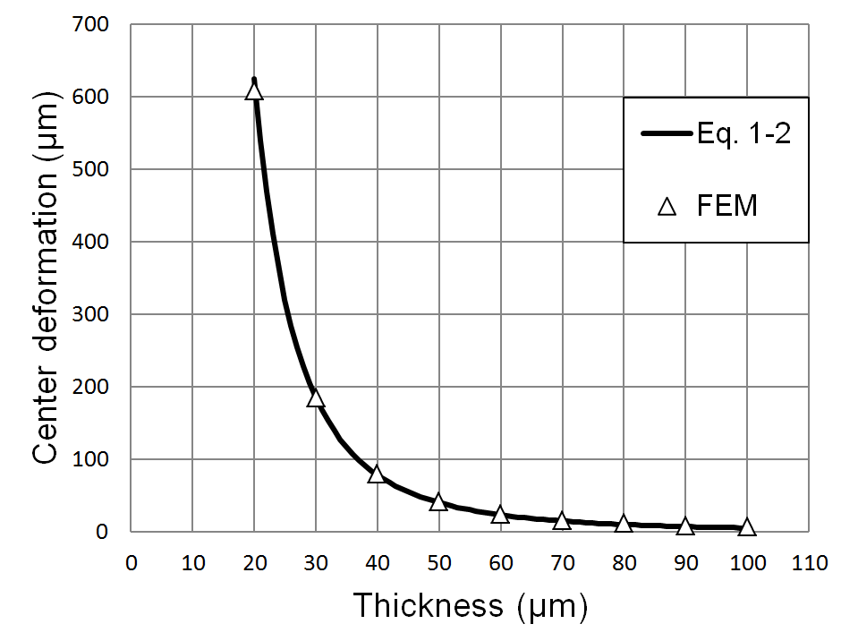 | 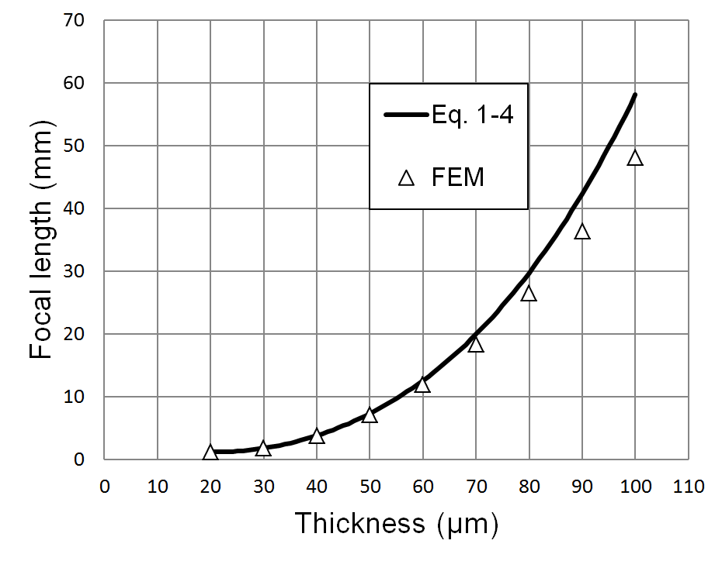
(a) | (b)
Figure 3.2. Relation of center deformation (a) and focal length (b) to thickness in constant pressure of 1 kPa.
The thickness of the membrane was chosen as 40 µm. According to the calculations, the membrane with a radius of 0.5 mm and thickness of 40 µm under 1 kPa pressure will result in the center deformation of 78.13 µm and focal length of 3.76 mm. Despite the fact that the thinner membrane would give a wider focal range, the 40 µm membrane was chosen, because it is complicated to handle a very thin film during fabrication.

EXPERIMENTAL
The components 1 and 2 of the device depicted in Figure 2.1 were molded of PDMS (Sylgard 184). The molds were fabricated of Teflon using a CNC milling machine. The film 1 (Figure 2.1) was casted using a universal applicator (Elcometer 3580).
There are several techniques for PDMS bonding: oxygen plasma, partial curing, uncured PDMS adhesive, corona discharge, etc. Compared to the others, partial curing and uncured PDMS adhesive are reported as the methods with the highest bonding strength¹⁵. Even though partial curing is limited for bonding fully cured layers, this simple and cost-effective method is well suitable for bonding the layers (Figure 2.1) in our device.
All three layers were cured at 65 C° for 20 minutes. By this time PDMS hardens enough for handling and removing from the molds. On the other hand, this time is short enough to leave PDMS uncrosslinked at the interfaces to form an effective bond with other details of the device. The three half-cured parts were assembled as depicted in Figure 2.1, and finally cured at 90 C° for several hours. Finally, liquid was injected into the cured device with a syringe. The device, partially filled with liquid, is shown in Figure 4.1.

Figure 4.1 Variable-focal liquid lens made of PDMS utilizing the partial curing bonding method. The two 1mm diameter lenses are marked with arrows.
Figure 4.1 describes the experimental setup for focal length measurements carried out using Labview 8.2, 650 nm diode laser, and CCD camera (Dragonfly Express of Point Grey Research Inc.). Knowing the distance between the lens and the screen, lens radius, and size of the circle on screen, the focal length was calculated using trivial geometry. The size of the circle on the screen was measured automatically using the camera and image processing capabilities of Labview. The software also analyzed the input of a pressure sensor (Smartec SPD002GAsil) and controlled the output voltage of the actuator. A syringe was used to fine tune the initial pressure of the liquid in the system.
Figure 4.2 Experimental setup overview.
As seen in Figure 4.3, depending on the applied voltage from 2.5 to -2.5 volts, plano-convex and plano-concave lens were achieved accordingly. The pressure was only measured in the range of positive values because of the limited characteristics of the sensor. Although CPC actuator was able to apply about 1 kPa pressure to the rubber balloon in previous measurements (Figure 3.1), the maximum pressure in PDMS lens system was 0.56 kPa. At the time maximum pressure was reached, the diameter of the circle of 8 cm and the focal length of 0.52 cm were obtained. The actuator was able to alter the focal length from ∞ to 10 mm within 4 seconds.
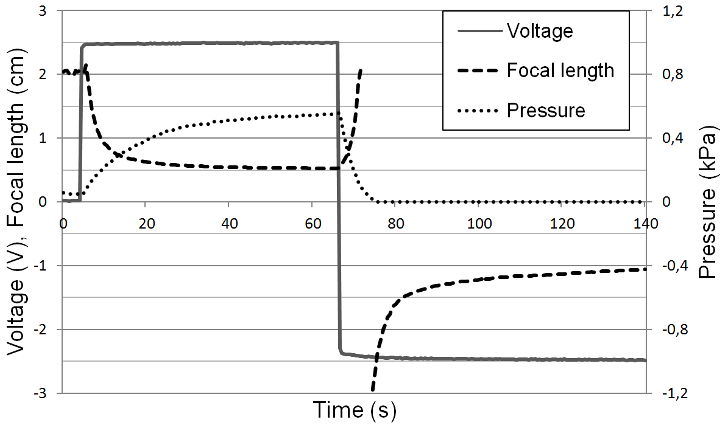
Figure 4.3. Pressure and focal length changes in the variable-focal lens system using the CPC actuator.
The results are limited to 20 mm because of the measurement technique that requires a high resolution CCD and a high quality screen for larger focal length values.

Conclusions
We have demonstrated a simple and cheap construction of a variable-focal lens using a carbon-polymer composite actuator, CNC milling machine, and PDMS bonding with partial curing technology. According to the results the focal length from ∞ to 5 mm was measured, out of which 10 mm was obtained within 4 seconds. Although the first promising results of a CPC driven tunable lens were given, further work has to be done to improve the speed and the force of the actuator. Moreover, a detailed model of the actuator is needed to allow precise control over the lens.

ACKNOWLEDGEMENTS
This research has been partly funded by Estonian Science Foundation (ESF) grants #7811. The authors also appreciate the financial assistance of the Tiger University Program of the Estonian Information Technology Foundation.

References

[1] Hendriks, B. H. W., Kuuiper, S., Van As, M. A. J., Renders, C. A. and Tukker, T. W. , "Electrowetting-based variable-focus lens for miniature systems," Optical Review 12(3), 255 (2005).
[2] Choi, J., Son, H. and Lee, Y., 2533 (2008).
[3] Shimizu, I., Kikuchi, K. and Tsuchitani, S., "Variable-focal length lens using IPMC," ICROS-SICE International Joint Conference, 4752 (2009).
[4] Lin, W., Chen, C. A. and Huang, K., "Design and fabrication of soft zoom lens,", 70610W (2008).
[5] Oku, H. and Ishikawa, M. , "High-speed liquid lens with 2 ms response and 80.3 nm root-mean-square wavefront error," Appl.Phys.Lett. 94(22), 221108 (2009).
[6] Torop, J., Kaasik, F., Sugino, T., Aabloo, A. and Asaka, K., "Electromechanical characteristics of actuators based on carbide-derived carbon," Electroactive Polymer Actuators and Devices (EAPAD), 76422A (2010).
[7] Lee, H., Choi, N., Jung, S., Lee, S., Jung, H., Ryu, J. W. and Park, K., "Application of ionic polymer-metal composites for auto-focusing compact camera modules," Electroactive Polymer Actuators and Devices (EAPAD), 69271N (2008).
[8] Niklaus, M., Rosset, S. and Shea, H., "Array of lenses with individually tunable focal-length based on transparent ion-implanted EAPs," Electroactive Polymer Actuators and Devices (EAPAD), 76422K (2010).
[9] Choi, S. T., Lee, J. Y., Kwon, J. O., Lee, S. and Kim, W., "Liquid-filled varifocal lens on a chip," MOEMS and Miniaturized Systems VIII, 72080P (2009).
[10] Ju, J., Ko, J., Cha, H. and Lee, S. , "Poly(dimethylsiloxane)-Based Micro Chamber with Air Permeable Cover Sheet for the Protoplast of Nicotiana tabacum Culture," IFMBE Proceedings 14, 298 (2007).
[11] Nguyen, N. , "Micro-optofluidic Lenses: A review," Biomicrofluidics 4(3), 031501 (2010).
[12] Young, W. C., Budynas, R. G. and Roark, R. J., [Roark's Formulas for Stress and Strain], McGraw-Hill, New York; London, 455-467 (2002).
[13] Werber, A. and Zappe, H. , "Tunable microfluidic microlenses," Appl.Opt. 44(16), 3238 (2005).
[14] Armani, D., Liu, C. and Aluru, N., "Re-configurable fluid circuits by PDMS elastomer micromachining," Twelfth IEEE International Conference on Micro Electro Mechanical Systems, 222 (1999).
[15] Eddings, M. A., Johnson, M. A. and Gale, B. K. , "Determining the optimal PDMS-PDMS bonding technique for microfluidic devices," J Micromech Microengineering 18(6), 067001 (2008).

* Corresponding author: alvo@ut.ee, www.ims.ut.ee

