Variable-focal lens using electroactive polymer actuator

V. Vunderª, A. Punningª, A. Aabloo^{a,}

ª IMS Lab, Institute of Technology, Nooruse 1, Tartu, Estonia

Abstract
The paper describes a simple and cost-effective design and fabrication process of a liquid-filled variable-focal lens. The lens was made of soft polymer material, its shape and curvature can be controlled by hydraulic pressure. An electroactive polymer is used as an actuator. A carbon-polymer composite (CPC) was used. The device is composed of elastic membrane upon a circular lens chamber, a reservoir of liquid, and a channel between them. It was made of three layers of polydimethylsiloxane (PDMS), bonded using the technics of partial curing. The channels and reservoir were filled with incompressible liquid after curing process. A CPC actuator was mechanically attached to reservoir to compress or decompress the liquid. Squeezing the liquid between the reservoir and the lens chamber will push the membrane inward or outward resulting in the change of the shape of the lens and alteration of its focal length. Depending on the pressure the lens can be plano-convex or plano-concave or even switch between the two configurations. With only a few minor modifications it is possible to fabricate bi-convex and bi-concave lenses. The lens with a 1 mm diameter and the focal length from infinity to 5 mm is reported. The 5x15mm CPC actuator with the working voltage of only up to ±2.5V was capable to alter the focal length within the range of infinity to 10mm in 4 seconds.

Keywords: Liquid lens, variable-focal, electroactive polymer, PDMS, CPC actuator

INTRODUCTION
Variable-focal lenses have been studied for years. There exist a number of fields of interest, e.g. beam steering, portable imaging, etc., where tunable lenses could give an extra value.
Tunable lenses could be classified as follows: electrowetting, gel type, and liquid lenses. An electrowetting lens is based on a drop of liquid which shape is changed by applied voltage. Alteration of optical power is obtained by electrowetting behavior of the droplet and the changes of its contact angle. Although these lenses have fast response time, authors have found it rather difficult to reach larger apertures¹⁻³. A gel type lens is composed of elastic material that is contracted and expanded thus changing the radius of curvature. For instance shape memory alloy actuator has been used to control the contraction/expansion of this type of lenses². Gel type lenses are relatively resistant to vibrations and shocks but have rather limited focal range. Concept of a liquid lens has three key elements: transparent elastic membrane over a reservoir, liquid, and an actuator. The membrane is deformed as a result of hydraulic pressure. By deforming the membrane, the radius of curvature of the lens is changed; hence the optical power is altered. For pressure control, different actuators have been used: an external pump⁴, directly connected piezostack actuator⁵, etc. Compared to electrowetting lens, liquid lenses are able to produce wider range of focal length and the design of the lens is rather simple. Considering liquid lenses, there is also an option to choose between different actuators or the number of actuators, allowing the system to be more dynamic.
Generally, the ionic EAP bend in response to applied voltage. It is not easy to exploit mechanically the bending functionality of these materials. However, it can apply force to a membrane. Recently, there has been an increasing interest in ionic EAPs based on carbon called carbon-polymer composites (CPCs) i.e. a three layer actuator which electrodes are made of porous carbon material, base polymer, and ionic liquid. Even though CPC and IPMC are behaving very similarly, the working principle of actuation is totally different. In IPMC, as a result of the voltage, the movement of mobile hydrated cations is causing higher water concentration near one electrode and lower concentration near the other producing bending motion of the actuator. In CPC both cations and anions are mobile and water is not used. CPC is made of fully organic components which are making it desirable in the areas where usage of metals is prohibited. Unlike IPMC, the relaxation of CPC actuator is notably slower due to the low speed of desorption of ions of the ionic liquid from the porous carbon⁶. Both IPMC and CPC are suitable for driving a liquid lens system; however, current work presents only the results obtained by the CPC actuator. Further details about the actuator are described by Torop et al.⁷
Shimizu et al.³ have demonstrated a promising variable-focal liquid lens system which has four IPMC strips attached to deformable lens membrane. By moving edges of a membrane towards the liquid, the center of the membrane is deforming in the opposite direction; therefore, a variable-focal length is achieved.
In the current paper we propose a novel approach to construct liquid-filled variable-focal lens by using partial curing technique of PDMS and ionic actuator. Using a CPC actuator of dimensions 5x15 mm, a large focal range is obtained by applying the voltage in the range of only 2.5 volts.

Experimental setup
The whole device is fabricated of PDMS. The excellent optical properties: transparency from near-IR to near-UV, flexibility, stability over a large temperature range, and precise replicating capabilities makes this material perfectly suitable for this application. PDMS is also widely used in other fields such as replication and microfluidics where optical properties are often not essential.⁸
The design of the proposed variable-focal lens is shown in Fig 2.1. The lens includes three PDMS layers. Top layer 1 is a thin film that covers the circular hole created through the middle layer forming the membrane. Middle layer 2 contains a reservoir, a channel, and thin wall on top of the reservoir. Finally, a rectangular layer of PDMS 3 is used to seal the channel and the reservoir from bottom. This structure allows transferring hydraulic pressure from an actuator to the membrane. By pushing the thin wall towards the reservoir, a plano-convex lens is formed; by pulling it in opposite direction, the system behaves as a plano-concave lens. The described construction also enables building an array of lenses by slightly modifying the middle layer 2 and adding multiple vertical channels.
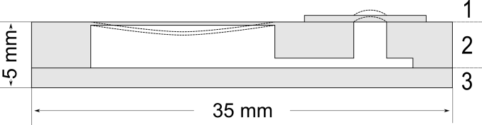
Fig. 2.1. Structure of the variable-focal liquid lens.
Since PDMS is known as material with high gas permeability⁹, liquid evaporation through the thin membranes has to be taken into account; hence, the device was filled with ethylene glycol. Although ethylene glycol has several advantages such as low evaporation rate, low freezing temperature, high refractive index, etc., its toxicity limits the usage in the fields of biomedicine. As relatively safe alternatives, water and cinnamaldehyde have been reported¹⁰.

ESTIMATION OF THE PARAMETERS
Center deformation can be observed as a function of thickness if membrane radius and thickness are treated as constants. This allows us to select suitable thickness for the device and estimate the range of the focal length. Therefore, calculations were made to obtain the relations between deformation, thickness, and focal length. For comparison to analytical solution, FEM (Finite Element Method) model of the circular plate was constructed and simulations were carried out by Comsol Multiphysics software.
In this paper, the edge of the membrane is considered to be clamped, thus the center deformation can be expressed by the following equation¹¹:
(1)
where $y_{c}$ is the center deformation, $p$ is the pressure applied to the membrane, $r$ is the radius of the lens, and $D$ is the plate constant that is obtained from¹¹:
(2)
where $E$, $t$ and $ν$ are material properties of the membrane respectively: modulus of elasticity, thickness and Poisson’s ratio.
Assuming the profile of the lens membrane to be spherical, the radius of curvature is given by¹²:
(3)
where $R$ is the radius of curvature, $r$ is the radius of the membrane, and $y_{c}$ is the center deformation.
The focal length corresponding to $R$ is related as¹²:
(4)
where $f$ is the focal length, $R$ is the radius of curvature, and $n$ is the refractive index of the membrane.

In order to estimate the operating pressure of the available CPC actuator, and to decide if it qualifies to the desired task, a simple experiment was set up. A small rubber balloon was attached to the pressure sensor (Smartec SPD002GAsil) and squeezed by the actuator. Throughout the measurements, the position of an actuator was varied. According to the results the maximum operating pressure was about 1 kPa (Fig 3.1).

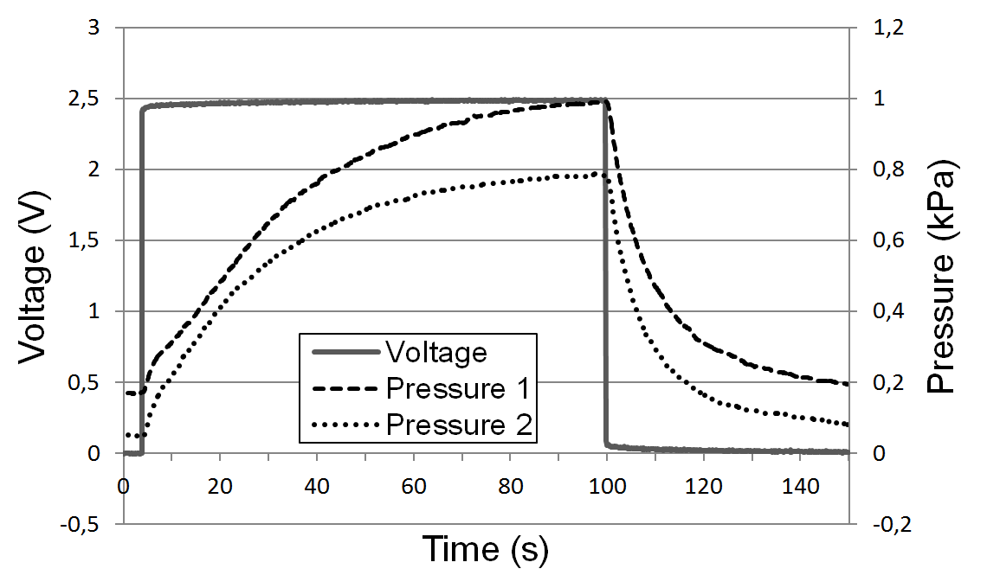
Fig 3.1 Operating pressures of the CPC actuator in different position configurations.

Center deformation (Fig 3.2) and focal length (Fig 3.3) were calculated according to different lens thicknesses. The pressure was fixed to 1 kPa which was the maximum output of a CPC actuator with operating voltage of 2.5V. The radius of the lens was chosen as 0.5 mm and the parameters of the PDMS were set as follows: $E$ – 0.75 MPa,$ν$ – 0.499, and $ρ$ – 920 kg/m3¹³. As seen in Fig 3.2, decreasing the thickness of the membrane below 30 µm causes rapid deformation which has to be considered to avoid breaking it with pressure.
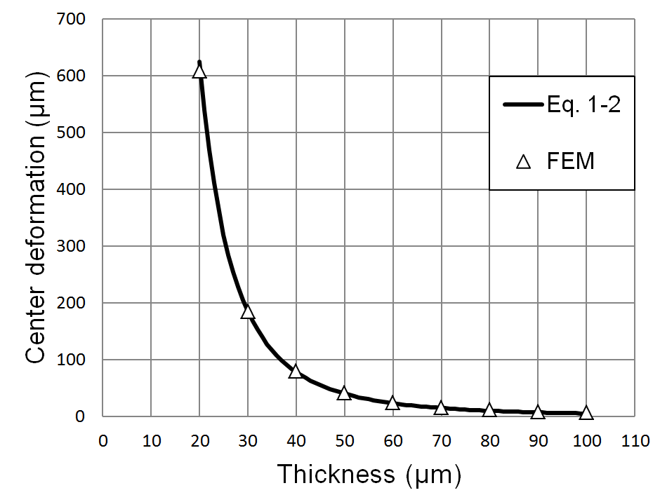 | 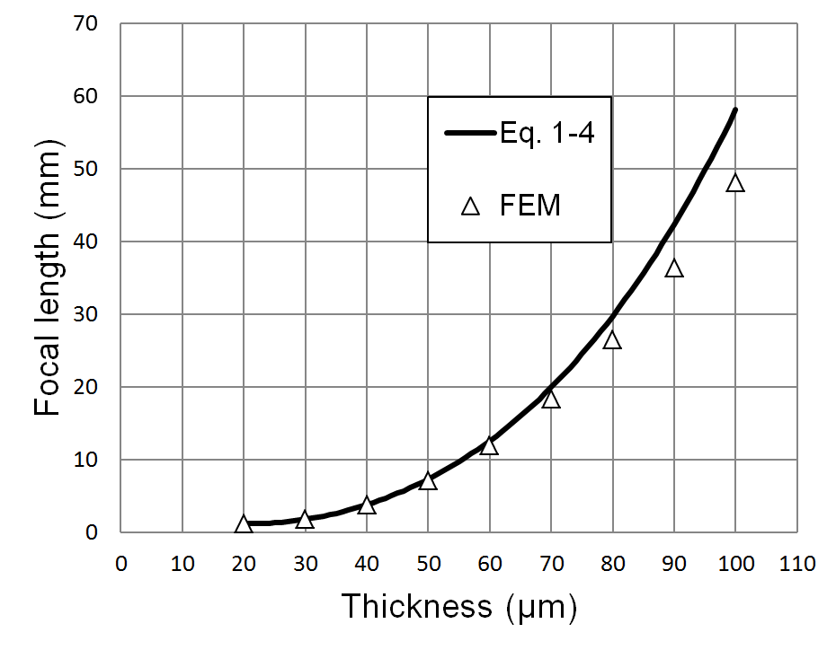
(a) | (b)
Fig 3.2. Relationships of center deformation (a) and focal length (b) to thickness in constant pressure 1 kPa.
The thickness of the membrane was chosen as 40 µm. According to the calculations, the membrane with radius of 0.5 mm and thickness of 40 µm under 1kPa pressure will result the center deformation of 78.13 µm and the focal length of 3.76 mm. Despite the fact that the thinner membrane would give the wider focal range, it is complicated to fabricate the device and remove the membrane from underlying material after curing.

characterization
The components 1 and 2 of the device depicted in Fig. 2.1 were molded of PDMS (Sylgard 184). The molds were fabricated of Teflon using a CNC milling machine. The film 1 (Fig. 2.1) was casted using a universal applicator (Elcometer 3580).
There are several techniques for PDMS bonding: oxygen plasma, partial curing, uncured PDMS adhesive, corona discharge, etc. Compared to the others, partial curing and uncured PDMS adhesive are reported as the methods with highest bonding strength¹⁴. Even though partial curing is limited for bonding fully cured layers, this simple and cost-effective method is well suitable for bonding the layers (Fig 2.1) in our device.
All three layers were heated at 60-65 C° for 20 minutes. Thus, enough crosslinks are formed in PDMS to remove the middle layer 2 in Fig 2.1 from the mold without damage; this short time curing still leaves the ability to bond one PDMS layer to another by further curing. Next, the removed layer was sandwiched between layers 1 and 3 in Fig 2.1 and heated at 90 C° for about an hour to final cure the PDMS. Finally, liquid was injected into the cured device via syringe. As a result, ethylene glycol half-filled variable-focal lens is shown in Fig 3.2.

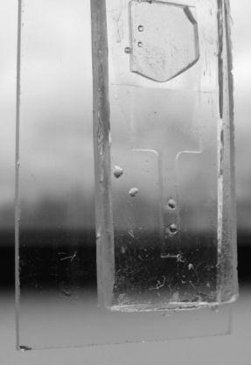
Fig. 4.1 Variable-focal liquid lens made of PDMS utilizing the partial curing bonding method.
Illustrative Fig.4.1 describes experimental setup for focal length measurements that were carried out including the usage of Labview 8.2 software, 650 nm diode laser, screen, and CCD camera (Dragonfly Express by Point Grey Research Inc.). Knowing the distance between the lens and the screen, lens radius, and size of the circle on screen, the focal length was calculated using trivial geometry. The size of the circle on the screen was measured automatically using the camera and image processing capabilities of Labview. The software also analyzed the input of a pressure sensor (Smartec SPD002GAsil) and controlled the output voltage of the actuator. A syringe was used to fine tune the initial pressure of the liquid in the system.
Fig 4.2 Experimental setup overview.
As seen in Fig 4.3, depending on the applied voltage from 2.5 to -2.5 volts, plano-convex and plano-concave lens were achieved accordingly. The pressure was only measured in the range of positive values because of the limited characteristics of the sensor. Although CPC actuator was able to apply about 1 kPa pressure to the rubber balloon in previous measurements (Fig 3.1), the maximum pressure in PDMS lens system was 0.56 kPa. At the time maximum pressure was reached, the diameter of the circle of 8 cm and the focal length of 0.52 cm were obtained. The actuator was able to alter the focal length from ∞ to 10 mm within 4 seconds.
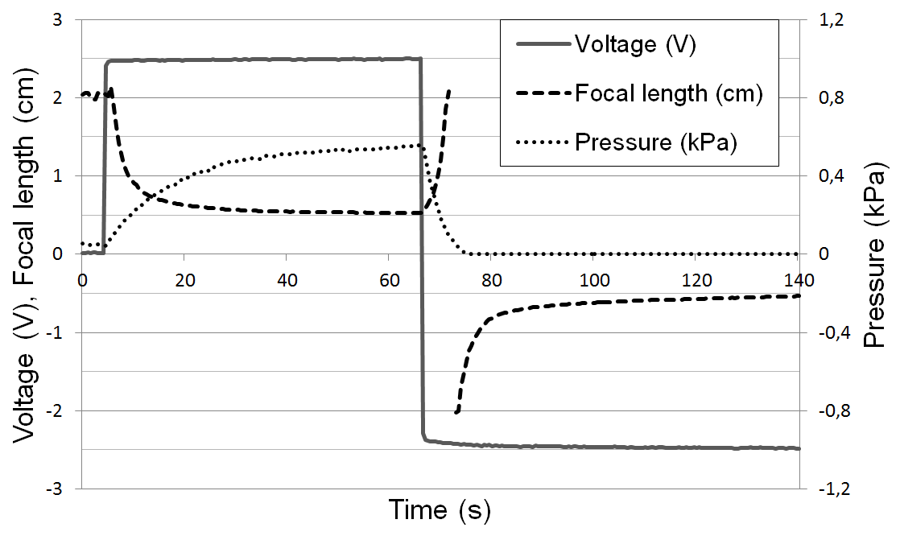
Fig 4.3. Pressure and focal length changes in variable-focal lens system caused by the CPC actuator.

Conclusions
We have demonstrated a simple and cheap construction of a variable-focal lens using carbon-polymer composite actuator, CNC milling machine, and partial PDMS curing technology. According to the results the focal length from ∞ to 5 mm was measured out of which 10 mm was obtained within 4 seconds. The results are limited to 20 mm because of the measurement technique that requires a high resolution CCD and a high quality screen for larger focal length values. Although the first promising results of CPC driven tunable lens were given, further work has to be done to improve the speed and the force of the actuator. Moreover, a detailed model of the actuator is needed to allow precise control over the lens.

ACKNOWLEDGEMENTS
The authors gratefully acknowledge

References
[1] Hendriks, B. H. W., Kuiper, S., VAN As, ,M.A.J., Renders, C. A. and Tukker, T. W. , "Electrowetting-Based Variable-Focus Lens for Miniature Systems," Optical Review 12(3), 255-259 (2005).
[2] Jong-Moon Choi, Hyung-Min Son and Yun-Jung Lee, "Design of biomimetic robot-eye system with single vari-focal lens and winding-type SMA actuator," Control, Automation and Systems, 2008. ICCAS 2008. International Conference on, 2533-2537 (2008).
[3] Shimizu, I., Kikuchi, K. and Tsuchitani, S., "Variable-focal length lens using IPMC," ICCAS-SICE, 2009, 4752-4756 (2009).
[4] Lin, W., Chen, C. A. and Huang, K., "Design and fabrication of soft zoom lens,", 70610W (2008).
[5] Oku, H. and Ishikawa, M. , "High-speed liquid lens with 2 ms response and 80.3 nm root-mean-square wavefront error," Appl.Phys.Lett. 94(22), 221108 (2009).
[6] Torop, J., Arulepp, M., Leis, J., Punning, A., Johanson, U., Palmre, V. and Aabloo, A. , "Nanoporous Carbide-Derived Carbon Material-Based Linear Actuators," Materials 3(1), 9-25 (2009).
[7] Torop, J., Kaasik, F., Sugino, T., Aabloo, A. and Asaka, K., "Electromechanical characteristics of actuators based on carbide-derived carbon,", 76422A (2010).
[8] Niklaus, M., Rosset, S. and Shea, H., "Array of lenses with individually tunable focal-length based on transparent ion-implanted EAPs," Proceedings of {SPIE} (2010).
[9] Ju, J., Ko, J., Cha, H. and Lee, S. , "Poly(dimethylsiloxane)-Based Micro Chamber with Air Permeable Cover Sheet for the Protoplast of Nicotiana tabacum Culture," 14, 298-301 (2007).
[10] Nguyen, N. , "Micro-optofluidic Lenses: A review," Biomicrofluidics 4(3), 031501 (2010).
[11] Young, W. C., Budynas, R. G. and Roark, R. J., [Roark's Formulas for Stress and Strain], McGraw-Hill, New York ;London, 852 (2002).
[12] Werber, A. and Zappe, H. , "Tunable microfluidic microlenses," Appl.Opt. 44(16), 3238-3245 (2005).
[13] Armani, D., Liu, C. and Aluru, N., "Re-configurable fluid circuits by PDMS elastomer micromachining," Micro Electro Mechanical Systems, 1999. MEMS '99. Twelfth IEEE International Conference on, 222-227 (1999).
[14] Eddings, M. A., Johnson, M. A. and Gale, B. K. , "Determining the optimal PDMS-PDMS bonding technique for microfluidic devices," J Micromech Microengineering 18(6), 067001 (2008).

Corresponding author: alvo@ut.ee, www.ims.ut.ee

