Variable-focal lens using electroactive polymer actuator
V. Vunderª, A. Punningª, A. Aabloo^{a,}
ª Institute of Technology, Nooruse 1, Tartu, Estonia

abstract
We present a simple and cost-effective design and fabrication process of a liquid-filled variable-focal lens using electroactive polymer as an actuator. The lens is made of soft polymer material, its shape and curvature can be controlled by hydraulic pressure. As an actuator, we used a carbon-polymer composite (CPC); likewise it is possible to use any other ionic EAP. The device is composed of elastic membrane upon a circular lens chamber, a reservoir of liquid, and a channel between them. It is made of three layers of polydimethylsiloxane (PDMS), bonded using the technics of partial curing. The channels and reservoir are filled with incompressible liquid after curing process. A CPC actuator is mechanically attached to reservoir to compress or decompress the liquid. Squeezing the liquid between the reservoir and the lens chamber will push the membrane inward or outward resulting in the change of the shape of the lens and alteration of its focal length. Depending on the pressure the lens can be plano-convex or plano-concave or even switch between the two configurations. With only a few minor modifications it is possible to fabricate bi-convex and bi-concave lenses. We report on a 1 mm diameter lens that can be converging or diverging with the focal length from infinity to 17 mm. The 5x15mm CPC actuator with the working voltage of only up to ±2.5V was capable to alter within the full range of the focal length in 10 seconds.
Keywords: Liquid lens, variable-focal, electroactive polymer, PDMS, CPC actuator
1. Introduction
Variable-focal lenses have been researched for years. There exist a number of fields of interest, e.g. beam steering, portable imaging, etc., where tunable lenses could give an extra value. Variable-focal length lenses could be constructed without using mechanical translational movement thus noiseless design of the lens system is possible.
Tunable lenses could be classified as follows: electrowetting, gel type, and liquid lenses. An electrowetting lens is based on a drop of liquid which shape is changed by applied voltage. Alteration of optical power is obtained by electrowetting behavior of the droplet and the changes of its contact angle. Although these lenses have fast response time, authors have found it rather difficult to reach larger apertures [1][2][3].
A gel type lens is composed of elastic material that is contracted and expanded thus changing the radius of curvature. For instance shape memory alloy actuator has been used to control the contraction/expansion of this type of lenses [1]. Gel type lenses are relatively resistant to vibrations and shocks but have rather limited focal range.
Concept of a liquid lens has three key elements: transparent elastic membrane over a reservoir, liquid, and an actuator. The membrane is deformed as a result of hydraulic pressure. By deforming the membrane, the radius of curvature of the lens is changed; hence the optical power is altered. For pressure control, different actuators have been used: an external pump [4], directly connected piezostack actuator [5], etc. Compared to electrowetting lens, liquid lenses are able to produce wider range of focal length and the design of the lens is rather simple. Considering liquid lenses, there is also an option to choose between different actuators or the number of actuators, allowing the system to be more dynamic.
Generally, the ionic EAP bend in response to applied voltage. It is not easy to exploit mechanically the bending functionality of these materials. However, it can apply force to a membrane.
Recently, there has been an increasing interest in ionic EAPs based on carbon called carbon-polymer composites (CPCs). CPC is a three layer actuator which electrodes are made of porous carbon material, base polymer, and ionic liquid. It behaves very similarly to IPMC and both are using ionic liquid to operate, but the working principle of actuation is totally different. (siia vist sobiks üks tark lause selle kohta mis siis tegelikult nii väga erinev on, midagi ioonide liikumise teemadel, ipmc-s liiguvad vabad katioonid ja CPC-s mõlemad?) Because CPC is fully organic, it has a major advantage in the applications where usage of metals is prohibited.
Unlike IPMC, the relaxation of CPC actuator is notably slower due to the low speed of desorption of ions of the ionic liquid from the porous carbon. Although IPMC and CPC are both suitable for driving a liquid lens system, current work presents only the results obtained by the CPC actuator. Further details about the actuator are described in [7]. [8, 9]

Shimizu et al [3] have demonstrated a promising variable-focal liquid lens system which has four IPMC strips attached to deformable lens membrane. By moving edges of a membrane towards the liquid, the center of the membrane is deforming in the opposite direction; therefore, a variable-focal length is achieved.

In the current paper we propose a novel approach to construct liquid-filled variable-focal lens by using partial curing technique of PDMS and ionic actuator. Using a CPC actuator of dimensions 5x15 mm, a large focal range is obtained by applying the voltage in the range of only 2.5 volts.

2. WORKING PRINCIPLE OF THE DEVICE
The whole device is fabricated of PDMS. The excellent optical properties: transparency from near-IR to near-UV, flexibility, stability over a large temperature range, and precise replicating capabilities makes this material perfectly suitable for this application. PDMS is also widely used in other fields such as replication and microfluidics where optical properties are often not essential.[6]
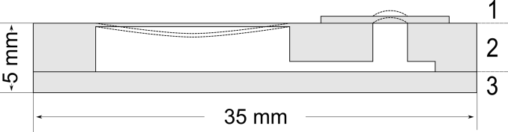
The design of the proposed variable-focal lens is shown in Fig 2.1. The lens includes three PDMS layers. Top layer (1) is a thin film that covers the circular hole created through the middle layer forming the membrane. Middle layer (2) contains a reservoir, a channel, and thin wall on top of the reservoir. This structure allows transferring hydraulic pressure from an actuator to the membrane. Finally, a rectangular layer of PDMS (3) is used to seal the channel and the reservoir from bottom. By pushing the thin wall towards the reservoir, a plano-convex lens is formed; by pulling it in opposite direction, the system is behaving as plano-concave lens. The described construction also enables building a lens array by slightly modifying the middle layer and adding multiple vertical channels. As liquid, ethylene glycol was used, because of its low evaporation rate. Because of the toxicity of ethylene glycol, the usage of the device is limited in the fields of biomedicine. Although water could be used instead, its evaporation through PDMS has to be considered (REF). In the studies, water evaporation has been reduced by PDMS surface treatment with oxygen plasma or acid (REF).

3. ESTIMATION OF THE PARAMETERS
In case of constant pressure, center deformation can be observed as a function of thickness. This allows us to find suitable thickness and whether the edge of the membrane is clamped or not. Therefore, calculations were made to obtain the relations between deformation, thickness, and focal length. For comparison to analytical solution, FEM (Finite Element Method) model of the circular plate was constructed and simulations were carried out by Comsol Multiphysics software.

In this paper, the edge of the membrane is considered to be clamped, thus the center deformation can be expressed by the following equations [10]:
 | $$y_{c}=\frac{-pr^{4}}{64D}$$ | (1)

where $y_{c}$ is the center deformation, $p$ is the pressure applied to the membrane, $r$ is the radius of the lens, and $D$ is the plate constant that is obtained from:
 | $$D=\frac{Et^{3}}{12(1-ν^{2})}$$ | (2)

where $E$, $t$ and $ν$ are material properties of the membrane respectively: modulus of elasticity, thickness and Poisson’s ratio.
Assuming the profile of the lens membrane to be spherical, the radius of curvature is given by [11]:
 | $$R=\frac{r^{2}}{2y_{c}}+\frac{y_{c}}{2}$$ | (3)
where $R$ is the radius of curvature, $r$ is the radius of the membrane, and $y_{c}$ is the center deformation.
The focal length corresponding to $R$ is related as:
 | $$f=\frac{R}{n-1}$$ | (4)

where $f$ is the focal length, $R$ is the radius of curvature, and $n$ is the refractive index of the membrane.

Maximum center deformation (Fig 2.1) and minimal focal length (Fig 2.2) were calculated according to different lens thicknesses. The pressure was fixed to 1kPa which was the maximum output of a CPC actuator with operating voltage of 2.5V. The PDMS parameters were set as follows: $E$ – 0.75 MPa,$ν$ – 0.499, and $ρ$ – 920 kg/m³ [12]. As seen in Fig 2.1, decreasing the thickness of the membrane causes rapid deformation which has to be considered to avoid breaking the membrane.

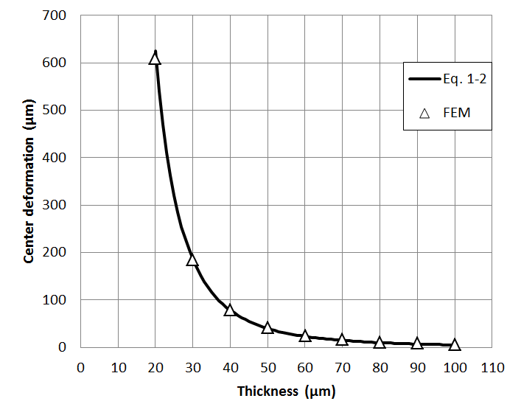
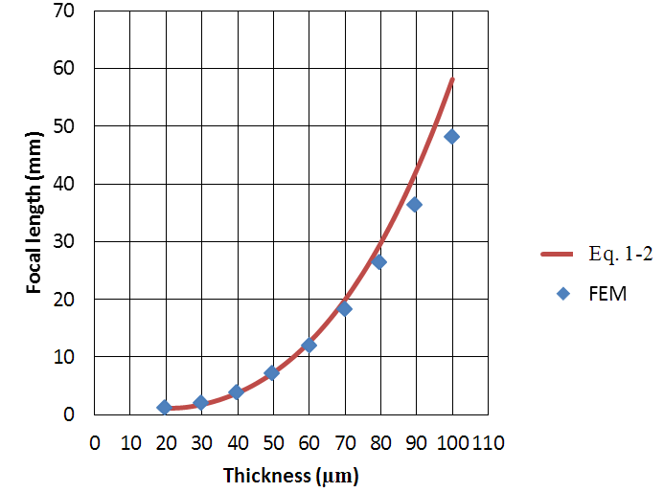
Fig. 2.1 Center deformation depending on the thickness of membrane if pressure 1 kPa is applied.
Fig. 2.1 Center deformation depending on the thickness of membrane if pressure 1 kPa is applied.
In order to estimate the operating pressure of the available CPC actuator, and to decide if it qualifies to the desired task, a simple experiment was set up. A small rubber balloon was attached to the pressure sensor (Smartec SPD002GAsil) and squeezed by the actuator. Throughout the measurements, the position of an actuator was varied. The results with different positions of the actuator are presented in Fig. 2.1 According to the results the maximum achieved pressure was about 1 kPa (Fig 2.1).

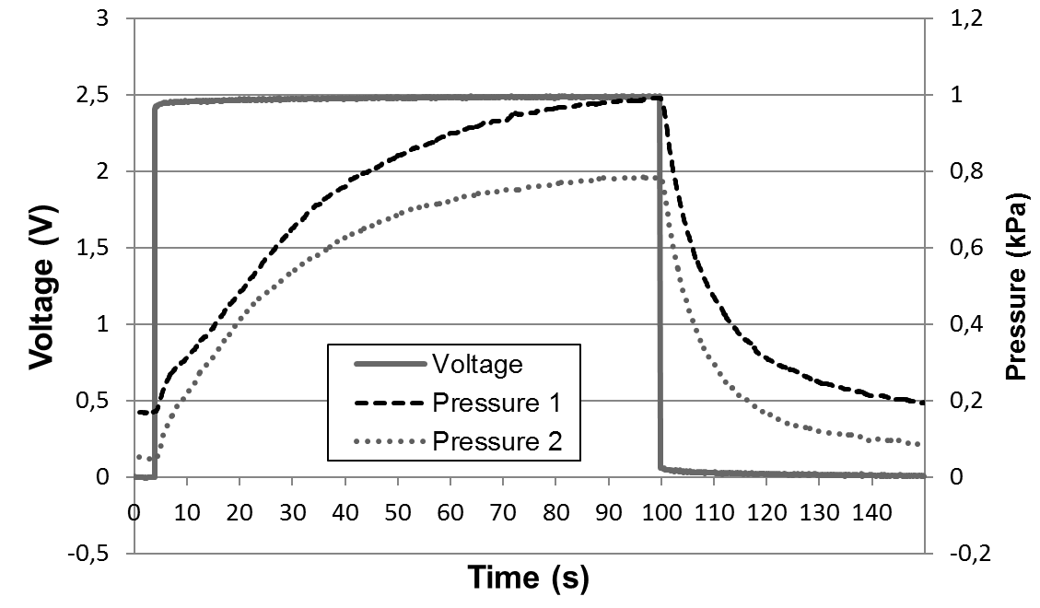
Fig 2.1 Operating pressure of the CPC actuator .
The thickness of the membrane was chosen as 40 µm. According to the calculations, 1kPa pressure to the system with 40 µm membrane will result the center deformation of the lens 78.13 µm and focal length of 3.76 mm. The thinner membrane would give the wider focal range, it is complicated to fabricate the device remove it from underlying material after curing.

4. EXPERIMENTAL

Paari lausega et bondimine on keeruline, erinevates bondimisviisidest, aga et niisuguse asja jaoks sobib partial curing väga hästi.
The components 1 and 2 of the device depicted in Fig. 2.1 were molded of PDMS (Sylgard 184). The molds were fabricated of Teflon using a CNC milling machine. The film 1 (Fig. 2.1) was casted using a universal applicator (Elcometer 3580).

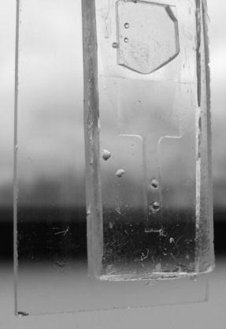
PDMS (Sylgard 184) was obtained from Dow Corning. Curing agent and base polymer was mixed using the ratio 1:10. Next, mixture was carefully stirred for about 5 minutes after which it was degased in vacuum oven at room temperature for another 10 minutes. Then, PDMS was casted into the molds and the film was fabricated using a universal casting applicator (MODEL HERE). All three layers were heated at 60-65 C° for 20 minutes. This ensures that there are enough crosslinks formed inside PDMS to remove the middle layer from the mold without damage while still leaving the ability to bond to another PDMS layer by further curing. Next, the removed layer was attached between other layers and heated at 90 C° for about an hour to final cure the PDMS. Finally, the liquid was injected into the lens system via syringe. The result of ethylene glycol half-filled variable-focal lens is shown in Fig 3.2.
Fig. 3.2

Illustrative Fig.4.1 describes experimental setup for focal length measurements that were carried out including the usage of Labview 8.2 software, diode laser, screen, and CCD camera (Dragonfly Express by Point Grey Research Inc.). Knowing the distance between the lens and the screen, lens radius, and size of the circle on screen, the focal length was calculated using trivial geometry. The size of the circle was obtained using the CCD camera and image processing capabilities of Labview. The software also analyzed the input of a pressure sensor (Smartec SPD002GAsil) and controlled output voltage of the actuator. A syringe was used to fine tune the initial pressure of the liquid in the system.

Pilt 6.8
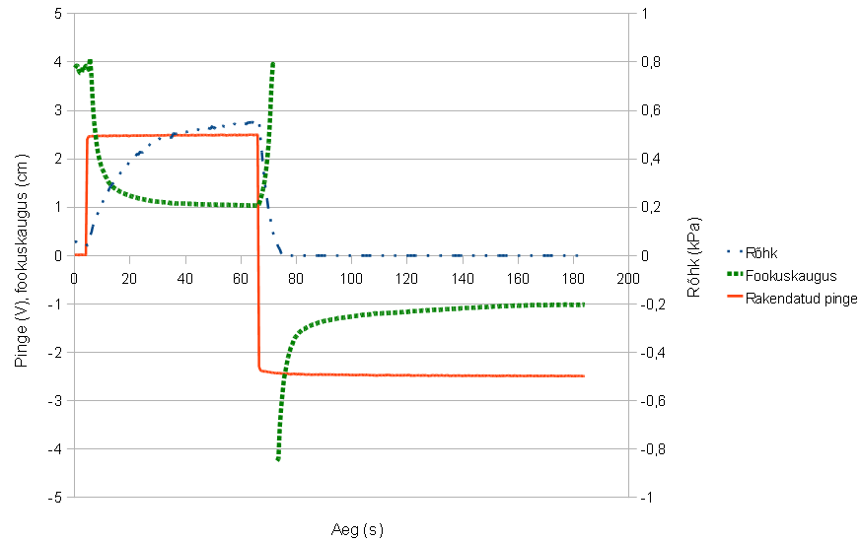
Results of the experiment are shown in Fig 4.2.

Pilt 8.1 ja seletus
7. Conclusions
We have demonstrated a simple and cheap solution to construct a variable focal lens using carbon-polymer composite actuator, CNC milling machine and partial PDMS curing technology. According to measurements the focal length from ∞ to 10 mm was achieved while the range from ∞ to 17 mm was obtained within 10 seconds. The result is limited to 40 mm because of the measurement technique that requires a high resolution CCD and a high quality screen for larger focal length values.

References
[1] Jong-Moon Choi, Hyung-Min Son and Yun-Jung Lee, "Design of biomimetic robot-eye system with single vari-focal lens and winding-type SMA actuator," in Control, Automation and Systems, 2008. ICCAS 2008. International Conference on, 2008, pp. 2533-2537.
[2] B. H. W. Hendriks, S. Kuiper, VAN As M.A.J., C. A. Renders and T. W. Tukker, "Electrowetting-Based Variable-Focus Lens for Miniature Systems," Optical Review, vol. 12, pp. 255-259, 05/01, 2005.
[3] I. Shimizu, K. Kikuchi and S. Tsuchitani, "Variable-focal length lens using IPMC," in ICCAS-SICE, 2009, 2009, pp. 4752-4756.
[4] W. Lin, C. A. Chen and K. Huang, "Design and fabrication of soft zoom lens," in 2008, pp. 70610W.
[5] H. Oku and M. Ishikawa, "High-speed liquid lens with 2 ms response and 80.3 nm root-mean-square wavefront error," Appl. Phys. Lett., vol. 94, pp. 221108, 1 June 2009, 2009.
[6] M. Niklaus, S. Rosset and H. Shea, "Array of lenses with individually tunable focal-length based on transparent ion-implanted EAPs," in Proceedings of {SPIE}, SAN DIEGO, CA, USA, 2010, .
[7] J. Torop, M. Arulepp, J. Leis, A. Punning, U. Johanson, V. Palmre and A. Aabloo, "Nanoporous Carbide-Derived Carbon Material-Based Linear Actuators," Materials, vol. 3, pp. 9-25, 2009.
[8] J. Torop, M. Arulepp, J. Leis, A. Punning, U. Johanson, V. Palmre and A. Aabloo, "Nanoporous Carbide-Derived Carbon Material-Based Linear Actuators," Materials, vol. 3, pp. 9-25, 2009.
[9] J. Torop, F. Kaasik, T. Sugino, A. Aabloo and K. Asaka, "Electromechanical characteristics of actuators based on carbide-derived carbon," in 2010, pp. 76422A.
[10] W. C. Young, R. G. Budynas and R. J. Roark, Roark's Formulas for Stress and Strain. New York ;London: McGraw-Hill, 2002.
[11] A. Werber and H. Zappe, "Tunable microfluidic microlenses," Appl. Opt., vol. 44, pp. 3238-3245, 06/01, 2005.
[12] D. Armani, C. Liu and N. Aluru, "Re-configurable fluid circuits by PDMS elastomer micromachining," in Micro Electro Mechanical Systems, 1999. MEMS '99. Twelfth IEEE International Conference on, 1999, pp. 222-227.

Corresponding author: alvo@ut.ee, www.ims.ut.ee

