Variable-focal lens using electroactive polymer actuator
V. Vunderª, A. Punningª, A. Aabloo^{a,}
ª Institute of Technology, Nooruse 1, Tartu, Estonia

abstract
We present a simple and cost-effective design and fabrication process of a liquid-filled variable-focal lens using electroactive polymer as an actuator. The lens is made of soft polymer material, its shape and curvature can be controlled by pneumatic pressure. As an actuator, we used a carbon-polymer composite (CPC); likewise it is possible to use any other ionic EAP. The device is composed of elastic membrane upon a circular lens chamber, a reservoir of liquid, and a channel between them. It is made of three layers of polydimethylsiloxane (PDMS), bonded using the technics of partial curing. The channels and reservoir are filled with incompressible liquid after curing process. A CPC actuator is mechanically attached to reservoir to compress or decompress the liquid. Squeezing the liquid between the reservoir and the lens chamber will push the membrane inward or outward resulting in the change of the shape of the lens and alteration of its focal length. Depending on the pressure the lens can be plano-convex or plano-concave or even switch between the two configurations. With only a few minor modifications it is possible to fabricate bi-convex and bi-concave lenses. We report on a 1 mm diameter lens that can be converging or diverging with the focal length from infinity to 17 mm. The 5x15mm CPC actuator with the working voltage of only up to ±2.5V was capable to alter within the full range of the focal length in 10 seconds.
Keywords: Liquid lens, variable-focal, electroactive polymer, PDMS, CPC actuator
1. Introduction
Variable-focal lenses have been researched for years. There are several fields including beam steering and portable imaging where usage of tunable lenses could give an extra value. Variable-focal length lenses could be constructed without using mechanical translational movement thus noiseless design of the lens system is possible.
Tunable lenses could be classified as follows: electrowetting, gel type, and liquid lenses. An electrowetting lens is based on a drop of liquid which shape is changed by applied voltage. Alteration of optical power is obtained by electrowetting behavior of the droplet and the changes of its contact angle. Although these lenses have fast response time, authors have found it hard to reach larger apertures {{1040 Jong-Moon Choi 2008}}. Moreover, relatively high voltage (~50V) is required to operate {{1056 Hendriks,B.H.W. 2005}}{{1007 Shimizu,I. 2009}}.
A gel type lens is composed of elastic material that is contracted and expanded thus changing the radius of curvature. For instance SMA actuator has been used to control contraction/expansion {{1040 Jong-Moon Choi 2008}}. Gel type lenses are relatively resistant to vibrations and shocks but have limited focal range.
Finally, the concept of a liquid lens has three key elements: transparent elastic membrane (often made of polydimethylsiloxane – PDMS), liquid, and an actuator. The membrane is deformed as a result of pneumatic pressure in the liquid. By deforming the membrane, the radius of curvature of the lens is changed and optical power is altered. For pressure control, different actuators as an external pump {{1024 Lin,Wei-Cheng 2008}} or directly connected piezostack actuator {{1021 Oku,H. 2009}} have been used. Compared to electrowetting lens, liquid lenses are able to produce wider range of focal length and the design of the lens is rather simple. Considering liquid lenses, there is also an option to choose between different actuators allowing the system to be more dynamic.
PDMS has received a lot of attention from researchers lately. Excellent optical properties: transparency from near-IR to near-UV, flexibility, stability over a large temperature range, and precise replicating capabilities makes this material perfectly suitable for variable-focal lens. PDMS is also widely used in other fields such as replication and microfluidics where optical properties are often not essential.{{1028 Niklaus,M. 2010}}
Electroactive polymers (EAPs) are materials that change their shape and size in response to applied voltage. These materials have large potential in the fields of microfluidics, robotics, and biomedicine. Although ionic EAPs, as ionic polymer metal composites (IPMCs), have been developed for years, they have been rather rarely used to control tunable lenses. However, Shimizu et al {{1007 Shimizu,I. 2009}} have demonstrated a promising variable-focal liquid lens system which has four IPMC strips attached to deformable lens membrane. By moving edges of a membrane towards the liquid, the center of the membrane is deforming in the opposite direction; therefore, a variable-focal length is achieved.
IT WOULD BE NICE TO FIND SOME SERIOUS CAP IN THIS DEVICE. Synchronization of all the 4 IPMC strips?
Recently, there has been an increasing interest in ionic EAPs based on carbon called carbon-polymer composites (CPCs). CPC is a three layer actuator which electrodes are made of porous carbon material, base polymer, and ionic liquid. Unlike IPMC, the relaxation of CPC actuator is notably slower due to the low speed of desorption of ions of the ionic liquid from the porous carbon. Another advantage of CPC is. Further details about the CPC actuator, used in this paper, are described in {{1016 Torop,Janno 2009}}. {{1058 Torop,Janno 2009; 1057 Torop,Janno 2010}}
In the current paper we propose a novel approach to construct liquid-filled variable-focal lens by using partial curing technique of PDMS and CPC actuator. In this configuration large focal range is obtained by applying the voltage in the range of only 2.5 volts.

2. STRUCTURE OF THE LENS
Components of the proposed variable-focal lens are shown in Fig 2.1. The lens includes three PDMS layers. Top layer (1) is a thin film that covers the circular hole created through the middle layer forming the membrane. Middle layer contains a reservoir, a channel, and thin wall on top of the reservoir. This structure allows to transfer pneumatic pressure from an actuator to the membrane. Finally, rectangular layer of PDMS is used to seal the channel and the reservoir from bottom. By pushing the thin wall towards the reservoir, plano-convex lens is formed; furthermore, the system is behaving as plano-concave lens if the membrane is pulled in opposite direction. Described construction also enables building a lens array by slightly modifying the middle layer and adding multiple vertical channels. As liquid, ethylene glycol was used, because of its low evaporation rate. Because of the toxicity of ethylene glycol, the usage of the device is limited in the fields of biomedicine. Although water could be used instead, its evaporation through PDMS has to be considered (REF). In the studies, water evaporation has been reduced by PDMS surface treatment with oxygen plasma or acid (REF).

Aktuaatori poolt avaldatav rõhk
An experiment was carried out to test the pressure range where CPC actuator is operating at. This measurement A small rubber balloon was attached to the pressure sensor (Smartec SPD002GAsil) and squeezed by a CPC actuator with an actuating voltage of 2.5V. At the time t=100, the voltage was set back to zero. Throughout the measurements, the position of an actuator was varied. According to the results, the maximum pressure ~1 kPa was obtained (Fig 2.1).
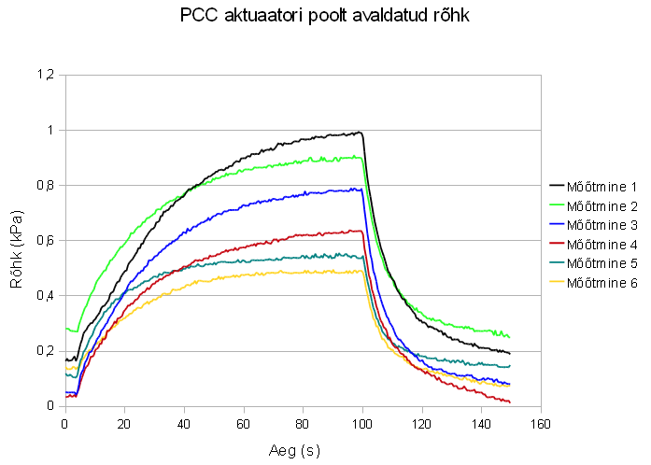

Math & Simulations
In case of constant pressure, center deformation can be observed as a function of thickness. This allows us to find suitable thickness and whether the edge of the membrane is clamped or not. Therefore, calculations were made to obtain the relations between deformation, thickness, and focal length. For comparison to analytical solution, FEM (Finite Element Method) model of the circular plate was constructed and simulations were carried out by Comsol Multiphysics software.

In this paper, the edge of the membrane is considered to be clamped, thus the center deformation can be expressed by the following equations {{1019 Young,Warren C. 2002}}:
 | $$y_{c}=\frac{-pr^{4}}{64D}$$ | (1)

where $y_{c}$ is the center deformation, $p$ is the pressure applied to the membrane, $r$ is the radius of the lens, and $D$ is the plate constant that is obtained from:
 | $$D=\frac{Et^{3}}{12(1-ν^{2})}$$ | (2)

where $E$, $t$ and $ν$ are material properties of the membrane respectively: modulus of elasticity, thickness and Poisson’s ratio.
Assuming the profile of the lens membrane to be spherical, the radius of curvature is given by {{1018 Werber,Armin 2005}}:
 | $$R=\frac{r^{2}}{2y_{c}}+\frac{y_{c}}{2}$$ | (3)
where $R$ is the radius of curvature, $r$ is the radius of the membrane, and $y_{c}$ is the center deformation.
The focal length corresponding to $R$ is related as:
 | $$f=\frac{R}{n-1}$$ | (4)

Where $f$ is the focal length, $R$ is the radius of curvature, and $n$ is the refractive index of the membrane.

Maximum center deformation (Fig 2.1) and minimal focal length (Fig 2.2) were calculated according to different lens thicknesses. The pressure was fixed to 1kPa which was the maximum output of a CPC actuator with operating voltage of 2.5V. The PDMS parameters were set as follows: $E$ – 0.75 MPa,$ν$ – 0.499, and $ρ$ – 920 kg/m³ {{1020 Armani,D. 1999}}. As seen in Fig 2.1, decreasing the thickness of the membrane causes rapid deformation which has to be considered to avoid breaking the membrane.
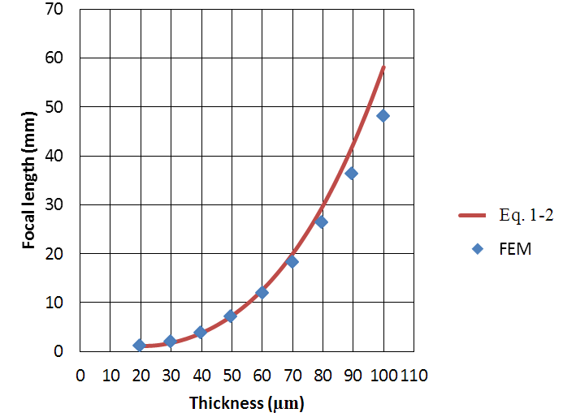
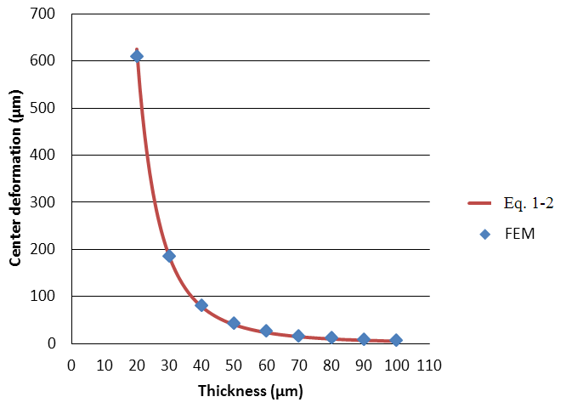
Fig. 2.1 Center deformation depending on the thickness of membrane if pressure 1 kPa is applied.
Fig. 2.1 Center deformation depending on the thickness of membrane if pressure 1 kPa is applied.
3. Fabrication
Ainult prototüüp 3. Natuke bondimisest ja vormist ja lõplikust kujust.

To achieve the lens system described in Sec. 2, special mold for fabrication of the middle layer is needed (Fig 3.1 mold mode1?). CNC milling machine (Wabeco, F1410LF) and Teflon was used to construct the mold. Also simple rectangular mold was created for the bottom layer. Thickness of the film (top layer) was set to 40 µm. In this configuration, according to the calculations indicated in Sec. 2, the focal length of 3.76 mm is reachable while applying a 1 kPa pressure to the system. Although we get a better focal range while using thinner film, it is more complicated to remove it from underlying material after curing.

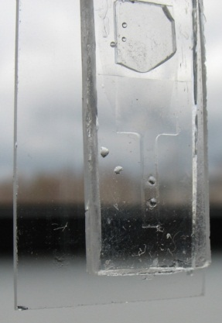
PDMS (Sylgard 184) was obtained from Dow Corning. Curing agent and base polymer was mixed using the ratio 1:10. Next, mixture was carefully stirred for about 5 minutes after which it was degased in vacuum oven at room temperature for another 10 minutes. Then, PDMS was casted into the molds and the film was fabricated using a universal casting applicator (MODEL HERE). All three layers were heated at 60-65 C° for 20 minutes. This ensures that there are enough crosslinks formed inside PDMS to remove the middle layer from the mold without damage while still leaving the ability to bond to another PDMS layer by further curing. Next, the removed layer was attached between other layers and heated at 90 C° for about an hour to final cure the PDMS. Finally, the liquid was injected into the lens system via syringe. The result of ethylene glycol half-filled variable-focal lens is shown in Fig 3.2.
Fig. 3.2

4. Experimental
Illustrative Fig.4.1 describes experimental setup for focal length measurements that were carried out including the usage of Labview 8.2 software, diode laser, screen, and CCD camera (Dragonfly Express by Point Grey Research Inc.). Knowing the distance between the lens and the screen, lens radius, and size of the circle on screen, the focal length was calculated using trivial geometry. Size of the circle was obtained using the CCD camera and image processing capabilities of Labview. The software also analysed the input of a pressure sensor (Smartec SPD002GAsil) and controlled output voltage of the actuator. A syringe was used to fine tune the initial pressure.
Pilt 6.8 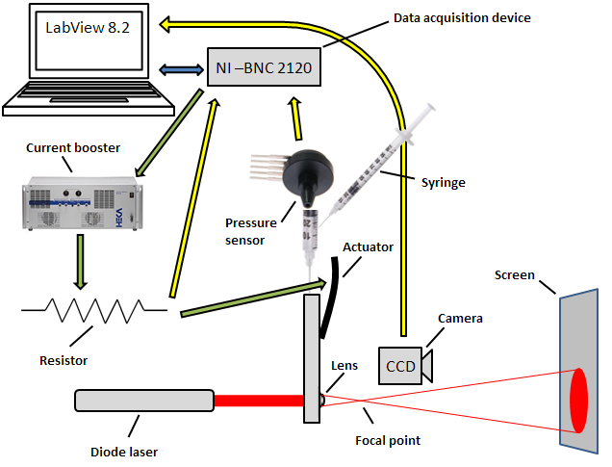
Vedeliku valik

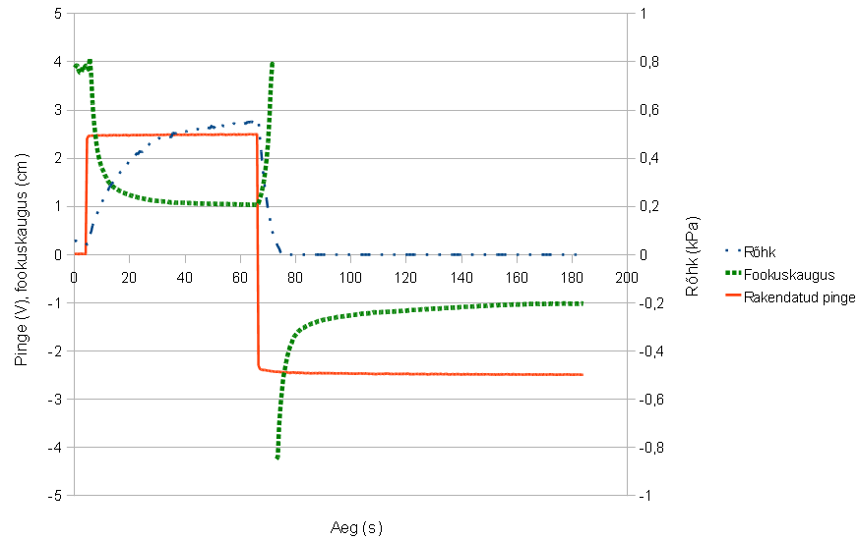
Results of the experiment are shown in Fig 4.2.

Pilt 8.1 ja seletus
5. Conclusions
We have demonstrated a simple and cheap solution to construct a variable focal lens using carbon-polymer composite actuator, CNC milling machine and partial PDMS curing technology. According to measurements the focal length from ∞ to 10 mm was achieved while the range from ∞ to 17 mm was obtained within 10 seconds. The result is limited to 40 mm because of the measurement technique that requires a high resolution CCD and a high quality screen for larger focal length values.

Corresponding author: alvo@ut.ee, www.ims.ut.ee

