Variable-focal lens using electroactive polymer actuator
V. Vunderª, A. Punningª, A. Aabloo^{a,}
ª Institute of Technology, Nooruse 1, Tartu, Estonia

abstract
We present a simple and cost-effective design and fabrication process of a liquid-filled variable-focal lens using electroactive polymer as an actuator. The lens is made of soft polymer material, its shape and curvature can be controlled by pneumatic pressure. As an actuator, we used a carbon-polymer composite (CPC); likewise it is possible to use any other ionic EAP. The device is composed of elastic membrane upon a circular lens chamber, a reservoir of liquid, and a channel between them. It is made of three layers of polydimethylsiloxane (PDMS), bonded using the technics of partial curing. The channels and reservoir are filled with incompressible liquid after curing process. A CPC actuator is mechanically attached to reservoir to compress or decompress the liquid. Squeezing the liquid between the reservoir and the lens chamber will push the membrane inward or outward resulting in the change of the shape of the lens and alteration of its focal length. Depending on the pressure the lens can be plano-convex or plano-concave or even switch between the two configurations. With only a few minor modifications it is possible to fabricate bi-convex and bi-concave lenses. We report on a 1 mm diameter lens that can be converging or diverging with the focal length from infinity to 17 mm. The 5x15mm CPC actuator with the working voltage of only up to ±2.5V was capable to alter within the full range of the focal length in 10 seconds.
Keywords: Liquid lens, variable-focal, electroactive polymer, PDMS, CPC actuator
1. Introduction
Variable-focal lenses have been researched for years. There are several fields including beam steering and portable imaging where usage of tunable lenses could give an extra value. Variable-focal length lenses could be constructed without using mechanical translational movement thus noiseless design of the lens system is possible.
Tunable lenses could be classified as follows: electrowetting, gel type, and liquid lenses. Electrowetting lens is based on a drop of liquid which shape is changed by applied voltage. Alteration of optical power is obtained by electrowetting behavior of the droplet and the changes of its contact angle. Although these lenses have fast response time, authors have found it hard to reach larger apertures {{1040 Jong-Moon Choi 2008}}. Moreover, relatively high voltage (~50V) is required to operate {{1056 Hendriks,B.H.W. 2005}}{{1007 Shimizu,I. 2009}}.
Gel type lens is composed of elastic material that is contracted and expanded thus changing the radius of curvature. For instance SMA actuator has been used to control contraction/expansion {{1040 Jong-Moon Choi 2008}}. Gel type lenses are relatively resistant to vibrations and shocks but have limited focal range.
Finally, the concept of liquid lens uses three key elements: transparent elastic membrane (often made of polydimethylsiloxane – PDMS), liquid, and an actuator. The membrane is deformed as a result of pneumatic pressure in the liquid. As a result of deforming the membrane, the radius of curvature of the lens is changed and optical power is altered. For pressure control, different actuators like an external pump {{1024 Lin,Wei-Cheng 2008}} or directly connected piezostack actuator {{1021 Oku,H. 2009}} have been used. Compared to electrowetting lens, liquid lenses are able to produce wider range of focal length and the design of the lens is rather simple. Considering liquid lenses, there is also an option to choose between different actuators allowing the system to be more dynamic.
Electroactive polymers (EAPs) are materials that change their shape and size in response to applied voltage. These materials have large potential in the fields of microfluidics, robotics, and biomedicine. Although ionic EAPs, like ionic polymer metal composites (IPMCs), have been developed for years, they have been rather rarely used to drive tunable lenses. However, Shimizu et al {{1007 Shimizu,I. 2009}} have demonstrated a promising variable-focal liquid lens system which has four IPMC strips attached to deformable lens membrane. By moving the edges of a membrane towards the liquid, the deformation occurs in the opposite direction. Therefore, a variable-focal length is achieved. IT WOULD BE NICE TO FIND SOME SERIOUS CAP IN THIS DEVICE. Synchronization of all the 4 IPMC strips?
Recently there has been an increasing interest in ionic EAPs based on carbon. These EAPs are called carbon-polymer composites (CPCs). CPC is a three layer actuator which electrodes are made of porous carbon material, base polymer, and ionic liquid. Unlike IPMC, the relaxation of CPC actuator is notably slower due to the low speed of desorption of ions of the ionic liquid from the porous carbon. Another advantage of CPC is. Further details about the CPC actuator used in this paper are described in {{1016 Torop,Janno 2009}}. {{1058 Torop,Janno 2009; 1057 Torop,Janno 2010}}
In current paper we propose a novel approach to construct liquid-filled variable-focal lens by using partial curing technique of PDMS and CPC actuator. In this configuration large focal range is obtained by using the voltage in the range of only 2.5 volts.

2. STRUCTURE OF THE LENS
Components of the proposed variable-focal lens are shown in Fig 2.1. The lens includes three PDMS layers. Top layer (1) is a thin film that covers the circular hole created through the middle layer to form the lens membrane. Middle layer contains a reservoir and a channel connecting it to the membrane. Thin wall confines reservoir from top allowing an actuator to transfer pneumatic pressure to the lens membrane. Finally, rectangular layer of PDMS is used to cover the channel and reservoir from the bottom. By applying positive pneumatic pressure to the top of the reservoir, plano-convex lens is formed; furthermore the system is acting as plano-concave lens by the result of negative pressure.

Aktuaatori poolt avaldatav rõhk
To test the pressure range where CPC actuator is operating, simple experiment was carried out. Small rubber balloon was attached to the pressure sensor (Smartec SPD002GAsil) and squeezed by CPC actuator with an actuating voltage of 2.5V. Voltage was set back to zero at the time t=100. Fig. 2.1 shows results where actuator position is varied throughout the measurements. According to the results, the maximum pressure ~1 kPa was obtained.
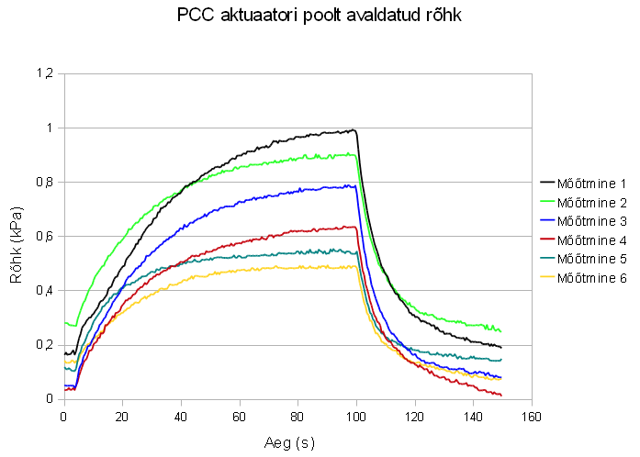

Matemaatika
The center deformation of the lens membrane can be expressed by following equations {{1019 Young,Warren C. 2002}}:
 | $$y_{c}=\frac{-pr^{4}}{64D}$$ | (1)

where $y_{c}$ is the center deformation, $p$ is the pressure applied to the membrane, $r$ is the radius of the lens, and $D$ is the plate constant that is obtained from:
 | $$D=\frac{Et^{3}}{12(1-ν^{2})}$$ | (2)

where $E$ is the modulus of elasticity of the PDMS, $t$ is the thickness of the lens membrane, and $ν$ is the Poisson’s ratio of the PDMS.
Moreover, if center deformation is known we can find the radius of curvature by assuming the lens membrane profile to be spherical {{1018 Werber,Armin 2005}}:
 | $$R=\frac{r^{2}}{2y_{c}}+\frac{y_{c}}{2}$$ | (3)
where $R$ is the radius of curvature, $r$ is the radius of the membrane, and $y_{c}$ is the center deformation of the membrane. For known $R$, the corresponding focal length is related by the following equation:
 | $$f=\frac{R}{n-1}$$ | (4)

Where $f$ is the focal length, $R$ is the radius of curvature of the lens, and $n$ is the refractive index of the PDMS.

Comsoli arvutused
Using equations 1-2, relation between the center deformation and lens thickness was calculated. For comparison, FEM (Finite Element Method) model of the lens was created and solved using Comsol Multiphysics software. Maximum pressure obtained from CPC actuator (1 kPa) was used in calculations. Also the following parameters of PDMS were used: $E$ – 0.75 MPa,$ν$ – 0.499, and $ρ$ – 920 kg/m³ {{1020 Armani,D. 1999}}. Center deformation of PDMS is affected by choosing different thicknesses. Based on eq. 3-4, the focal length and thickness are related as shown in Fig. 2.2.
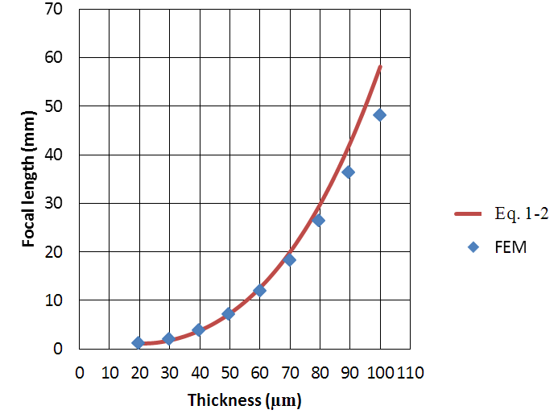
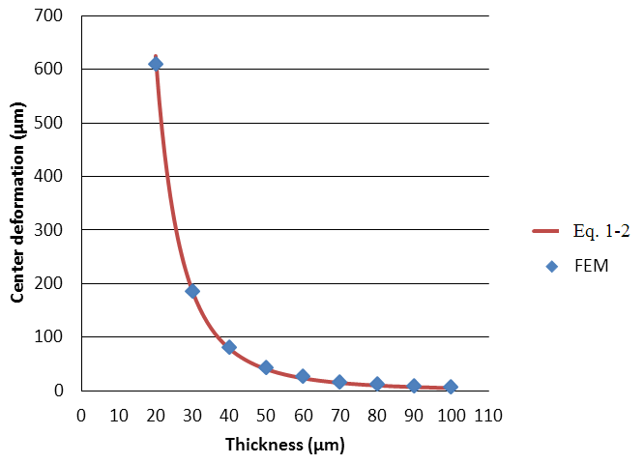
Fig. 2.1 Center deformation depending on the thickness of membrane if pressure 1 kPa is applied.
Fig. 2.1 Center deformation depending on the thickness of membrane if pressure 1 kPa is applied.
3. Fabrication
Ainult prototüüp 3. Natuke bondimisest ja vormist ja lõplikust kujust.

To achieve the lens system described in Sec. 2, special mold for fabrication of the middle layer is needed (Fig 3.1 mold mode1?). CNC milling machine (Wabeco, F1410LF) and Teflon was used to construct the mold. Also simple rectangular mold was created for the bottom layer. Thickness of the film (top layer) was set to 40 µm. In this configuration, according to the calculations indicated in Sec. 2, the focal length of 3.76 mm is reachable while applying a 1 kPa pressure to the system. Although we get a better focal range while using thinner film, it is more complicated to remove it from underlying material after curing.

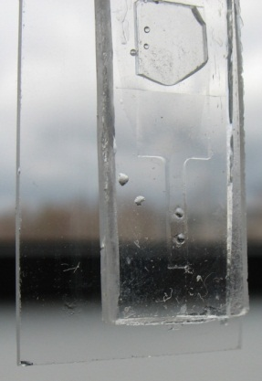
PDMS (Sylgard 184) was obtained from Dow Corning. Curing agent and base polymer was mixed using the ratio 1:10. Next, mixture was carefully stirred for about 5 minutes after which it was degased in vacuum oven at room temperature for another 10 minutes. Then, PDMS was casted into the molds and the film was fabricated using a universal casting applicator (MODEL HERE). All three layers were heated at 60-65 C° for 20 minutes. This ensures that there are enough crosslinks formed inside PDMS to remove the middle layer from the mold without damage while still leaving the ability to bond to another PDMS layer by further curing. Next, the removed layer was attached between other layers and heated at 90 C° for about an hour to final cure the PDMS. Finally, the liquid was injected into the lens system via syringe. Ethylene glycol was used as liquid, because of its very similar refraction index to PDMS (~1.43) (REF) and low evaporation rate. This enables us not to consider the light fraction between liquid and PDMS. Because of the toxicity of ethylene glycol, the usage of this device is limited in the fields of biomedicine. The problem could be resolved by using water instead (REF), but in that case evaporation of the water through PDMS has to be considered. For example water vaporization has been avoided using PDMS surface treatment with oxygen plasma or acid(REF). The result of ethylene glycol filled tunable lens is shown in Fig 3.2.
Fig. 3.2

4. Experimental
Illustrative Fig.4.1 describes experimental setup for focal length measurements that were carried out including the usage of Labview 8.2 software, diode laser, screen, and CCD camera (Dragonfly Express by Point Grey Research Inc.). Knowing the distance between the lens and the screen, lens radius, and size of the circle on screen, the focal length was calculated using trivial geometry. Size of the circle was obtained by CCD camera and image processing software. The software also analyzed input of the pressure sensor (Smartec SPD002GAsil) and controlled output voltage of the actuator. A syringe was used for initial pressurization.
Pilt 6.8 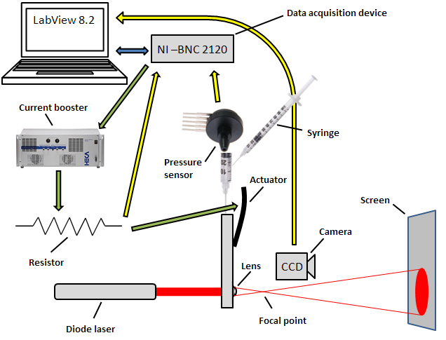
Vedeliku valik

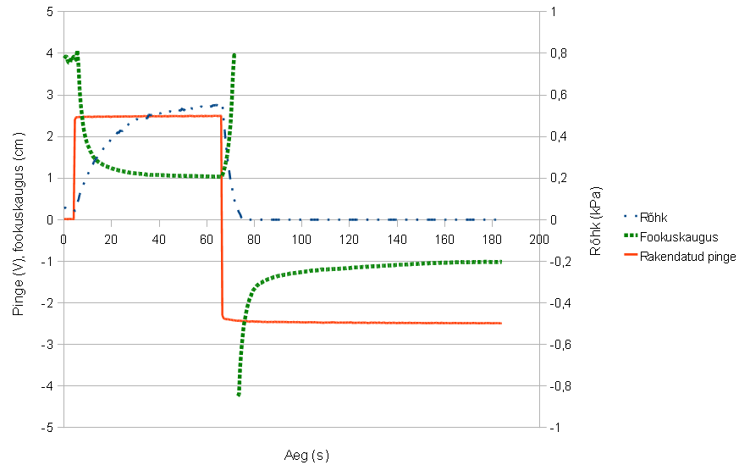
Results of the experiment are shown in Fig 4.2.

Pilt 8.1 ja seletus
5. Conclusions
We have demonstrated a simple and cheap solution to construct a variable focal lens using carbon-polymer composite actuator, CNC milling machine and partial PDMS curing technology. According to measurements the focal length from ∞ to 10 mm was achieved while the range from ∞ to 17 mm is obtained within 10 seconds. The result is limited to 40 mm because of the measurement technique that requires a high resolution CCD and a high quality screen for larger focal length values.

Corresponding author: alvo@ut.ee, www.ims.ut.ee

