Electromechanial characteristics of actuators based on carbide-derived carbon

Abstract.
An electromechanical transducer was prepared using non-ionic polymer, ionic liquid and carbide-derived carbon (CDC). Recently simple layer-by-layer casting method was discovered for actuator production using „bucky gel" mixture as a precursor of actuator electrode layers. In this paper we investigate carbide-derived carbon as new alternative candidate to carbon nanotubes to replace nanotubes in electrode layer of transducer. The results revealed that the optimal component ratio for electrodes is: 35 wt% PVdF(HFP), 35 wt% EMIBF₄ and 30 wt% CDC. The assembled three layer transducers were characterized by measuring blocking force, maximum strain, speed and their power consumption and capacitance. The synthesized actuator showed very good force and capacitive characteristics and it is preferable for slow response applications compared to transducers based on carbon nanotubes.

Intoduction
Electro-active polymers are materials which change their propertis due to electrical energy. For example electromechanically activepolymermaterials that can change electrical energy directly to mechanical energy. These kind of materials can be used in robotics, microfluidics or bio-medical. Those applications are possible because of a big strength an mass ratio and possibility and also make actuators in different size and shape. Mukai et al have reported from a fully plastic actuator based on ionic-liquid-based bucky gel []. c

Experimental details
  - Chemicals and materials used
Carbide-derived carbon (CDC)
TiC-derived carbon powder, precursor of the actuator electrodes, was produced by Carbon Nanotech Ltd. TiC-derived carbon is synthesized from titanium carbide by chlorination at high temperature (400 - 900 °C). The reaction product is amorphous carbon powder with particle size 2-5 μm, and a large quantity of nanopores with pore size 6-10 Å in carbon powder particles.
poly (-vinylidene fluoride-co-hexafluoropropylene) (PVdF(HFP)) Sigma Aldrich (81433), 1-ethyl-3-methylimidazolimu tetrafluoroborate (EMIBF₄) Sigma Aldrich, dimethylacetamide (DMAc) Fluka (38839). Ultrasonic bath Sonarex Digital, DK 102 P),

2.2 Preparation
Electrode films were prepared from poly (-vinylidene fluoride-co-hexafluoropropylene) (PVdF(HFP)), 1-ethyl-3-methylimidazolimu tetrafluoroborate (EMIBF₄), CDC TiC 800 and dimethylacetamide (DMAc). PVdF(HFP) was dissolved in DMAc. Next day EMIBF₄, CDC powder were mixed in 0,5 ml DMAc and treated in ultrasonic bath using maximum power for 25 minutes. After that the polymer mixture was added to the CDC and IL suspension and stirred on a magnetic stirrer for 5 minutes and sonicated for 20 minutes in ultrasonic bath. Finally it was poured out into TeflonTM mold. Separator was prepared from EMIBF₄ and PVdF(HFP) solution wt 1/1, into a polymer solution was added IL and treated on ultrasonic bath for 25 minutes in maximum power and then poured out into a TeflonTM mold.
Final step preparing an actuator is hot-pressing, were electrode films and separator film are hot-pressed. Before pressing it is important that electrode films are not homogeneous. During dring process CDC carbon deposit and therefore the side, which was the upper one must go near the separator. Therefore the conductivity of the electrode film was better on the side which was down during the drying process. Parima elektroodimaterjali eletrijuhtivus määrati nelja kontakti meetodi abil. Mõõtmine näitas et kuivamise ajal üleval pool olnud külje takistus oli 840 Ω, seejuures oli elektroodi kile tüki laius 1,7 mm ja mõõtekontaktide vaheline kaugus 5 mm. Sama elektroodikile teisel (alumisel) küljel mõõdetud takistuse väärtus oli 576 Ω.

2.3 Electromechanical characterization

The experimental setups used for electromechanical characterization are described in [].
Electrode films surfaces resistance was measured using a four-probe system and using a National Instruments PCI-6034 DAQ with an SCC-RTD01 module. Electrode film was 1,7 mm wide and distance between contacts was kept 5 mm.

Strain and speed of the actuators were characterized using the experimental set-up, which is shown in figure 1. The actuators were clamped in a vertical cantiliver position and measurments were done in dry air. Actuator driving pulses (retangular) were applied throug contacts made out of gold. The measurements were conducted with National Instruments LabView 8.2 control software. The driving voltage was generated by an NI PCI- 6703 DAQ board and amplified by electric current from an NS LM675 power op-amp. The voltages with respect to the ground were measured with an NI PCI-6034 DAQ board. One input contact of the PCC sample was also connected to the ground. The electric input current of the sample was measured as a voltage drop over the resistor R. The value of the resistor was 5 Ω. Electrc current was calculated according to Ohm’s law.
The actuator bending motions were recorded with FireWire camera, Dragonfly Express from Point Grey Research Inc., recording 3,75 frames per second. The camera was set transverse to the actuator and was illuminated from the background using frosted glass. In this camera position, the recorded image of the actuator consists of a single curved contrast line.

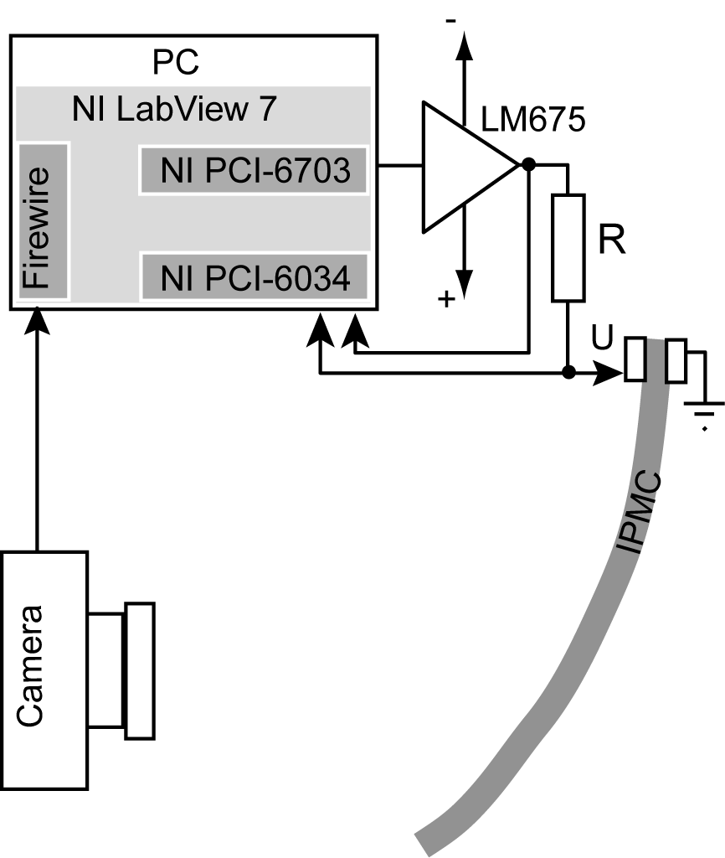
Figure 1.

Result and discussion

Sample  Substance | 1 | 2 | 3 | 4 | 5 | 6 | 7 | 8 | 9
CDC carbon wt% | 10 | 20 | 30 | 40 | 50 | 60 | 60 | 70 | 30
IL EMIBF₄ wt % | 70 | 60 | 50 | 30 | 30 | 25 | 30 | 20 | 35
(PVdF(HFP)) wt% | 20 | 20 | 20 | 30 | 20 | 15 | 10 | 10 | 35
Best result

Maximum stain is defined as
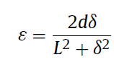
where L is the free length, δ is displacement and d is the thickness of the actuator strip [] . Maximum strain of our actuator was to one side 1.2% and to the other side 1%. Summarne järelikult 2,2.

Blockingforse was 79 mN. Blockingforse was measured 13 mm away from contacts and the actuator was 16 x 6 x 0,3 mm and weighed 48 mg.

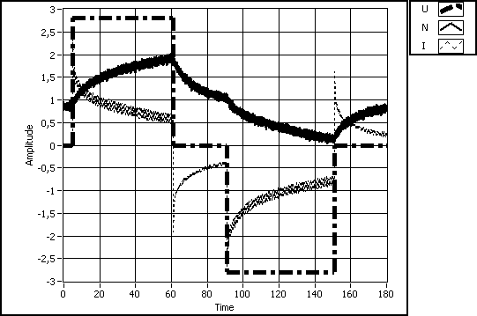

Palmre, V., Brandell, D., Maeorg, U., Torop, J. Volobujeva, O., Andres Punning, A., Johanson, U., Kruusmaa, M. and Aabloo, A. “Nanoporous carbon-based electrodes for high strain ionomeric bending actuators” Smart Mater. Struct. 18 (2009) 095028
I. Takeuchi, K. Asaka, K. Kiyohara, T. Sugino, N. Terasawa,K. Mukai, T. Fukushima, T. Aida, Electromechanical behavior of fully plastic actuators based on bucky gel containing various internal ionic liquids. Electrochim. Acta 54 (2009) 1762.

