Charging of supercapacitors with moisture gradient
Supercapacitor-fuel cell hybrid fueled by ambient moisture
- Abstract
- Introduction
The interest on novel energy-related carbon materials is gaining even growing interest.
The three-layer laminate made out of two high surface area carbon - ionic liquid composite electrodes and an ion-permeable ionic polymer membrane in between is an electromechanically active material. When electric potential is applied between the electrodes, the charge separation occurs, and this device can be used as an electric double-layer capacitor. As a result of charging from the external power source, also volumetric effects arise in the electrodes and as a result, the laminate bends and can therefore be used as an actuator []. In the devices optimized for actuation, however, the ion mobility and charge transfer dynamics is much lower than that of sealed supercapacitors, but electric efficiencies over 90 % can still be obtained [Viljar].
The bending of the laminate with external force results in formation of strain difference between the electrodes. The formation of electric charge between the electrodes on bending of an ionic polymer- based laminate with noble metal electrodes is a well-known effect [Deivid] and can be explained by the flow of solvent molecules along with mobile ions as a result of hydraulic pressure gradient. The stream of mobile ions results in formation of double layer in the electrodes, and voltage and current can be registered between the electrodes. The mechanoelectrical transduction has previously been registered in case of CNT gel [Kamamichi], [mina], and polypyrrole electrodes [Wu, Alici].
The formation of electric double layer in the three-layer laminate due to mechanical deformation offers new possibilities for feedback sensors in sift robotics. However, it is possible to evolve the idea of charge generation from the pressure gradient even further. In the current research, the pressure gradient has been applied in the form of humidified gas. Merely the water diffusion due to concentration gradient, without applying any extra pressure, can generate substantial amount of electric power.
The carbon-based electrodes are composed out of carbon particles engaged in an ionic polymer matrix and the whole structure is swelled in an ionic liquid. All components of an electrode composite – carbon, polymer and ionic liquid – are hygroscopic.
High surface area and relatively high electronic conductivity makes carbon a popular electrode material for both EDLCs and actuators. The same qualities make carbon also a beneficial material for various chemical sensors. In other words, when this laminate is exposed to the environment, different sorption processes start to emerge. In this paper we investigate the humidity sensor properties of a composite of high surface area carbon, ionic liquid and ionomer.
The change in ambient water content above the surface of the laminate causes water sorption. If the opposite electrodes of a laminate are exposed to different ambient water content, diffusion gradient arises. This causes the formation of volumetric effects in the electrode; the more soaked electrode stretches out and obtains convex shape. The water diffusion and sorption also induces the dislocation of ionic liquid ions in the carbon micropores and consequently gives rise to double layer formation. The double layers begin to form, and voltage and current can be registered between the electrodes exposed to different ambient water content. ((In standard ambient temperature and pressure conditions, merely the air humidity difference between the electrodes can generate a charge and , which is as high as 10 % of the value typically applied to this device to induce actuation, and voltages up to 5 % of the electrochemical window of the used ionic liquid.)) Consequently, this device can potentially be used as an energy harvesting device.
A simple demonstration of the charge generation effect can be done by approaching a (moist) finger towards the composite, and registering the voltage across the electrodes. The electrode facing the finger develops negative charge. The fast adsorption also induces volumetric effects – the moistened electrode elongates and the laminate bends towards dry (positively charged) electrode.
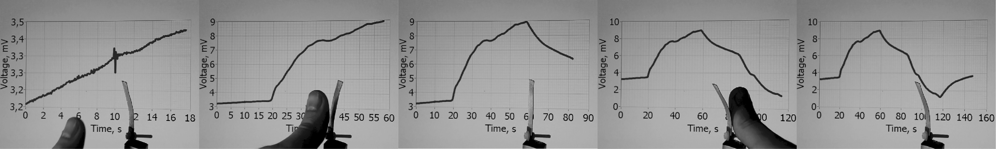
Figure 1
The advantage of ionic liquid – electrolyte operable in totally dry environment, but the parameters change in a large extent. Important to characterize (or seal) flexible supercaps. Important to characterize air humidity in actuator measurement.
A new approach to energy harvesting. Diffusion current has been proposed as an energy source for microfluidic devices [], but the device which generates and subsequently also stores a considerable electric charge from merely an air humidity gradient is a novel approach.

- Experimental

Material fabrication:
A Nafion 117 ionomer membrane was first ion-exchanged by boiling in LiClO₄ solution and then immersed in EMITFS ionic liquid. The electrode material was prepared by mixing carbide-derived carbon with Nafion 1110 dispersion in ethanol/water solution. The dispersion was applied on the ionic-liquid impregnated membrane using an airbrush. Solvents were evaporated under IR lamp. Then, gold foil was attached to the electrode. Nafion solution was used to promote gold foil adhesion and finally the laminate was hot-pressed. The manufacturing method is described in more detail in [].
Electrical characterization:
The sensor output was measured using Burr-Brown INA116 low bias current instrumentation amplifier as a preamplifier and National Instruments PCI-6036E DAQ device as analog-digital converter. The higher bias current of conventional operational amplifiers causes the capacitor-like test object to charge and this can result in inaccurate sensor measurements. Current was measured as a voltage drop over a low ohm resistor using the same amplifier set-up. The resistor value was chosen so that maximum electric power is generated and dissipated by the resistive load.
Humidity generation:
The humidity sensing properties were measured by exposing the opposite sides of the laminate to air chambers with different humidity contents. Different saturated salt solutions were used to generate humidity points. All measurements were performed at 25 degrees Celsius. Dry (0 % RH) environment was created using dehydrated calcium chloride (CaCl₃) as absorbent. Saturated solutions of potassium acetate, magnesium nitrate and sodium chloride were used to generate fixed relative humidity points 22.5 %, 52.9 % and 75.3 %, respectively; and distilled water was used to generate 100 % RH. An air agitator was used to accelerate achievement of equilibrium humidity. The laminate under test with dimensions of xx x xx mm was clamped between two boards with gold terminals. The board with laminate under test was placed between two chambers with known humidity. The unclamped area (exposed to the humidity chambers) was xx mm². First, the laminate was exposed to equal humidity and shorted electrically until equilibrium was reached in about 1000 seconds. Then, one of the chambers was changed with the one with different humidity value and current or voltage was measured between the terminals.
Impedance measurement:
Voltage and current measurement:
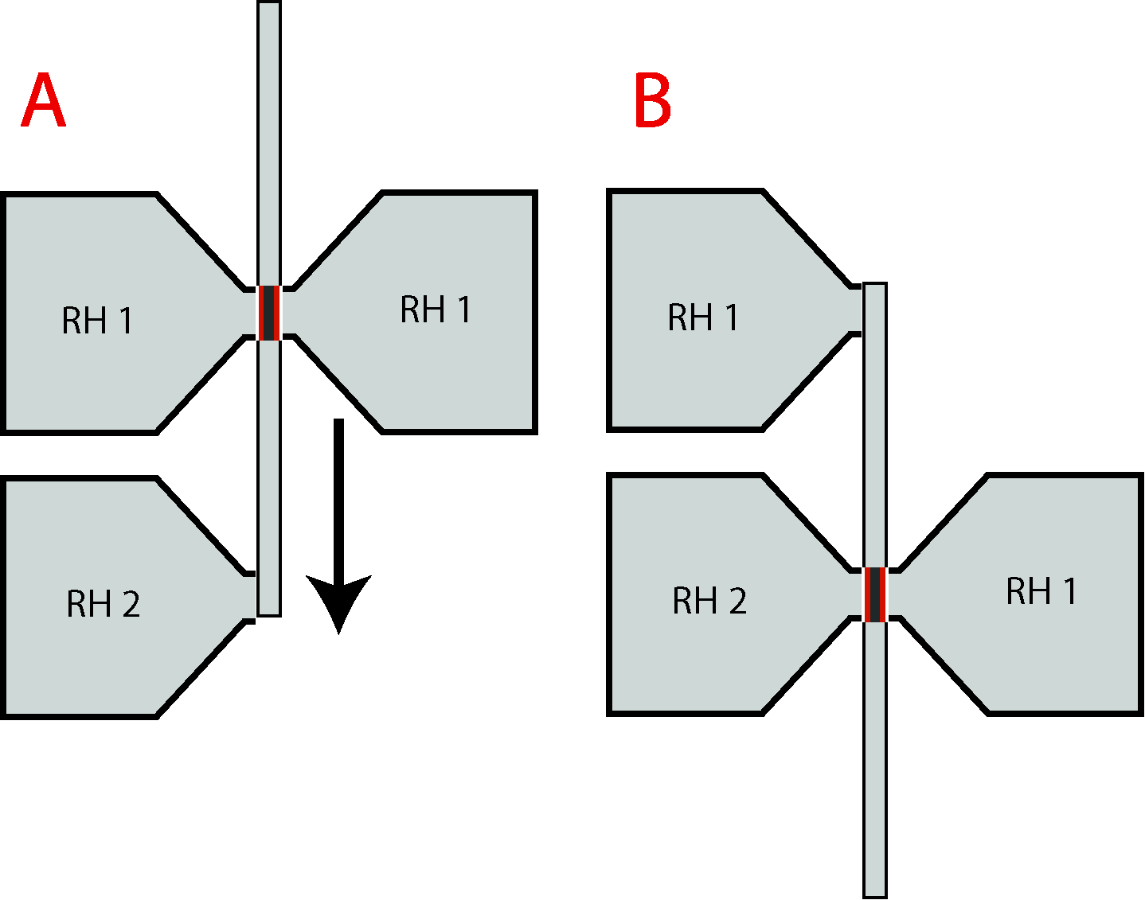
- Results and discussion

  - Open-circuit voltage
Two distinguishable processes can be observed from the results of open-circuit voltage measurements. After changing the ambient humidity level at one side of the laminate (Fig. 2B), after approximately 100 seconds a voltage peak can be registered (Fig 2C). When the laminate is exposed to humidity gradient for a longer time, some combinations of the initial humidity and humidity changes can result in the rise of voltage up to 160 mV in 2 hours’ time (Fig. XX). The observed combinations are depicted on Fig 3.
The peak voltage corresponds to reorientation of ions in the electrode on this side of a laminate, which was exposed to different humidity. The reorientations induce also polarization in the carbon electrode, which can be registered as voltage. The open circuit voltage peak values are depicted on Fig. 2A. Some combinations of the initial humidity and humidity changes do not, however, form a peak, because the peak is overlapped by the signal from the other (consecutive) process. For example, in Fig. 2C there is no peak formed when the humidity changes from 0 to 23 %. In these cases, the voltage measured after 500 seconds is plotted. The transient voltage in Fig. 2C indicates that the higher change in humidity results in a higher peak value (up to 50 mV, when one side of an initially dry laminate is exposed to an environment with 100 % humidity), but it also decreases more rapidly. After 600 s, the signal with the highest peak value (change from 0 to 100 % RH) is now the lowest in magnitude. As illustrated on Fig 3, this humidity change also does not result in eventual achievement of a high voltage magnitude, but the change from dry to 25 % yields an increase of voltage in several hours’ time. The relation between the long-term peak values to the voltage magnitudes needs an additional study.
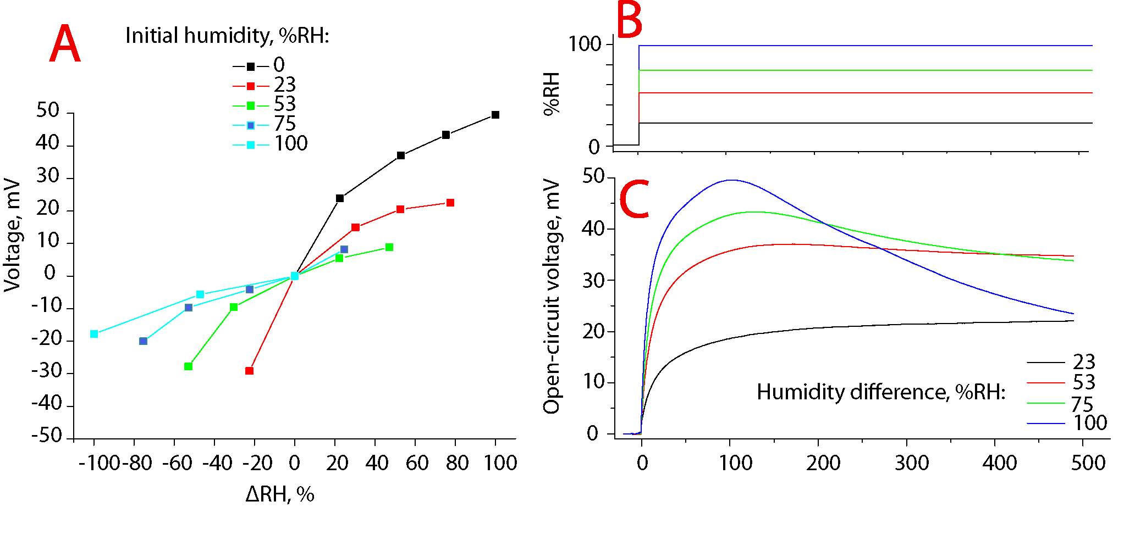
Figure 2
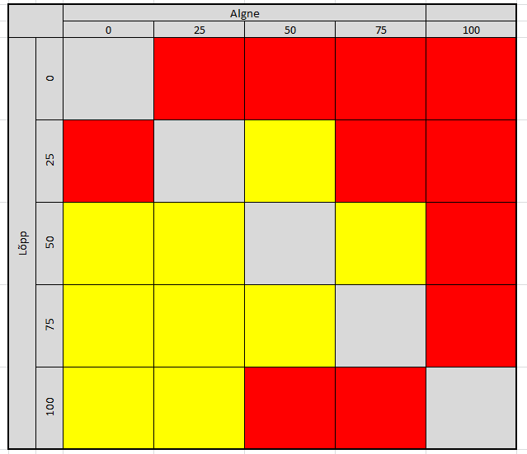
Figure 3. See tuleks välja jätta, sest ka kollastel ruutudel ei vähene ju nullini.. täpset käitumist veel ei tea.
The peak voltages of Fig 2C correspond to the curve on Fig 2A with 0 % initial humidity. The peak voltage decreases exponentially, when the humidity difference is increased. Other initial humidity also results in a diminishing increase in peak voltage when the humidity is increased, but the decrease of humidity results in an exponential increase in peak voltage. However, the peak voltages formed as a result of decrease in humidity are considerably lower, because the drying process is slower and the resulting water diffusion gradient is smaller.
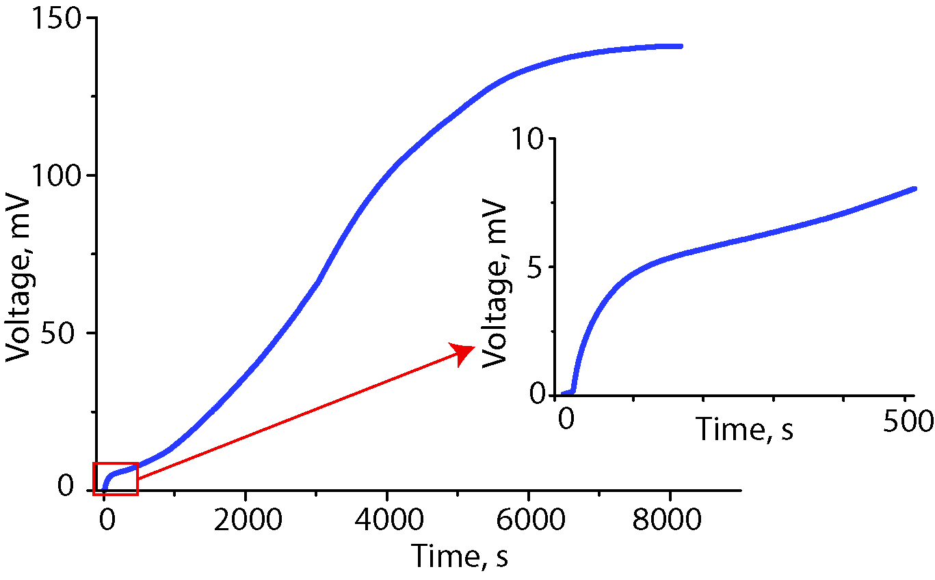
Figure 4
The slower process is a result of dislocation of ionic liquid ions as a result of water diffusion. The flux of ionic liquid induces changes in double layer, which results in the rise of voltage between the electrodes. The voltage caused by the ion flux is in the order of magnitude greater than the quick reorientation after change of humidity and the resulting diffusive water flux. The slower process caused by ion flux is semi-irreversible. The reversal of water diffusion gradient does not result in the immediate reversal of the voltage, but many cycles are needed to achieve the same voltage with opposite polarity. This observation bears a strong analogy to EDLCs. The supercapacitors are in principle non-polar devices, i.e. they can be charged with either polarity, but the real EDLC devices are operated only by charging them with the same polarity, which is defined by the first charging cycle. This is explained by the trapping of certain ions in the smallest range of micropores. If the ions are introduced in the micropores with the sizes close to the ion size, the ion gets fixed in the pore and a large (kui suur???) potential barrier has to be overcome to release the ion [???], but this results in the decrease in energy storage efficiency.
  - Current and charge generation
The current was measured as a voltage drop over low-ohm (10 Ω) resistor. The transient course of current after change of humidity (Fig. 5C) results in a sharp peak with magnitudes up to 280 µA. Initially, the laminate was held at constant humidity conditions (in Fig. 5C-D it was 0 %), then humidity was changed at one side to different values and after 300 seconds the laminate was returned to initial equal humidity value at both sides. The peak voltage, which resulted from the increase of humidity, is depicted on Fig. 5A, and the peak resulted from the decrease of humidity, is depicted on Fig. 5B. The peak resulted from the increase of humidity decreases exponentially with increased humidity change, just as it was in the case of open-circuit voltage. The current peak that corresponds to increase of humidity is not proportional to the one that corresponds to decrease in humidity. The highest increase in humidity (wetting out) results in the highest peak value, but also corresponds to the lowest current peak value after return to initial humidity. As expected, if the laminate is initially held at 100 % humidity and then one side is dried out (cyan line at Fig. 5A-B), the current peak value that corresponds to drying out is much lower than that resulting from wetting out.
The transient course of generated charge depicted on Fig. 5E was calculated by integrating the current values depicted on Fig. 4D. It can be noticed that the initial increase in charge is in correlation with the change in humidity. On the other hand, the highest humidity change does not yield the highest charge values, but instead starts to decrease after 100 seconds. The decrease in charge corresponds to the negative current.
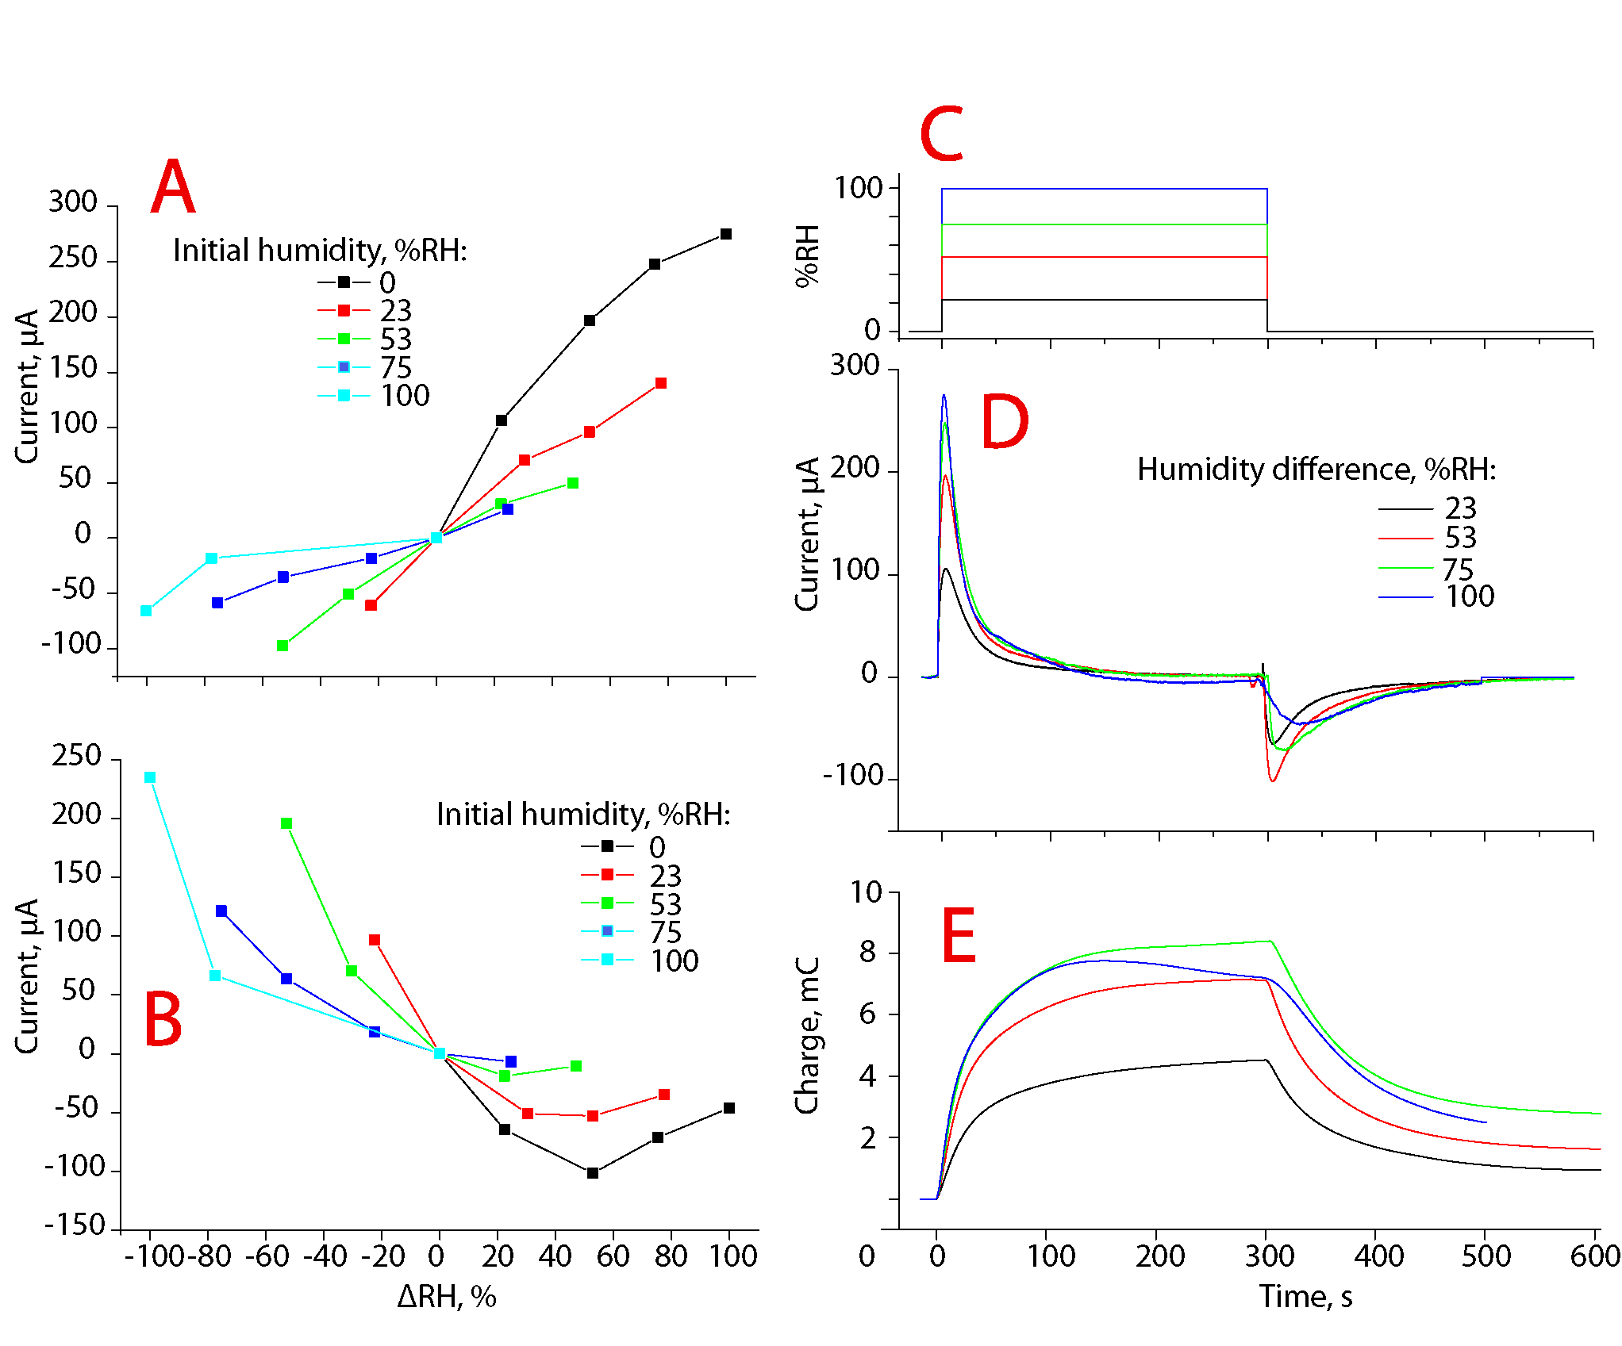
Figure 5

  - Strain
The IEAP laminate respond to the change not only with voltage and current, but also with the formation of strain difference between the electrodes, which can be observed as bending of the laminate. Fig. 6 illustrates the (?kahetine?) transient response to introduced humidity. The displacement was measured at 20 mm distance from the point, where the laminate was fixed as a cantilever between the voltage measurement terminals. It can be observed that both deflection and current are evoked instantly after humidity change, but the voltage shows a much steeper change at the beginning of the humidity change, while the deflection changes with almost constant rate. However, the accurate characterization of the stain and humidity relation is to be done in the future work.

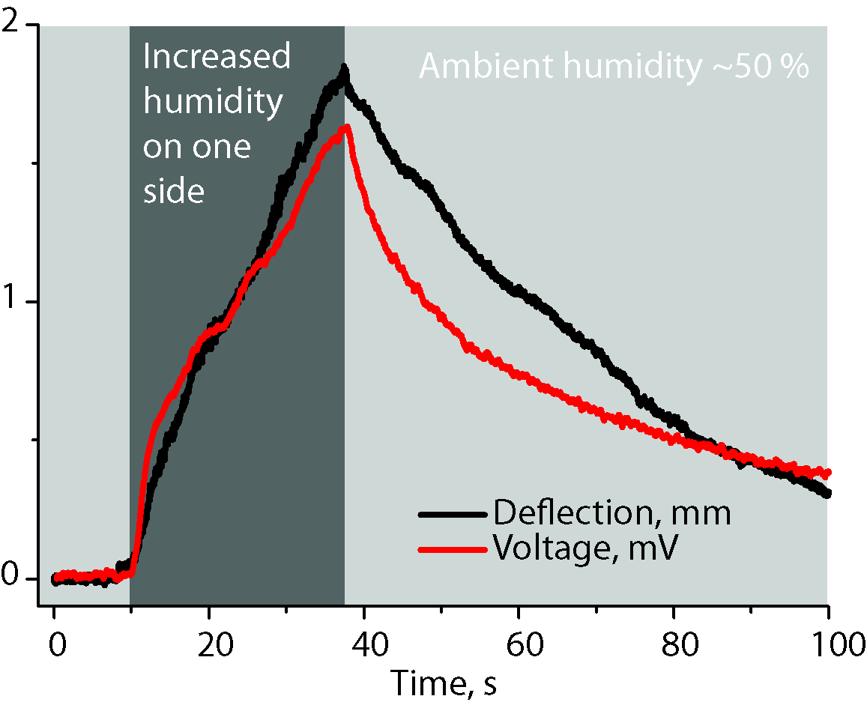
Figure 6

  - Energy harvesting
The IEAP laminate generates a considerable amount of charge when moisture gradient is applied. The output is relatively high in current and charge, but the collection of charge with a purpose of powering electronic devices is limited with the low magnitude of generated voltage. The maximum power output is achieved when the internal resistance of the power source matches with the resistance of the consumer device. The internal resistance of the laminate under investigation was 30 Ω*cm² at 50 % RH and at room temperature. Around 0 % RH, the internal resistance increased up to 160 Ω*cm². In the current research, a 3 cm² piece with an internal resistance of 10 Ω was used and the power output was investigated on a 10 Ω resistor. In this case, the current measured in a continuous regime did not exceed 250 µA, which corresponds to 2.5 mV in potential. Voltage as low could not be directly used to power electronic devices. Moreover, the currently available step-up converters, which raise the voltage to usable level for the electronics, require higher voltages.
To overcome this problem, a periodic discharge cycle depicted on Fig. 7 is proposed. As it was described in the introduction, the IEAP laminate is in its nature a supercapacitor. The streaming current generated as the result of water diffusion is stored in the high surface area carbon electrodes. In this way, the capacitor can be used not only as an energy storage element, but also as a voltage amplifier.
The initially entirely dried laminate was introduced to 50 % humidity at one side; the other side was continuously dried. After 2.2 hours, the voltage stabilized at 180 mV. Subsequently, a load was connected between the electrodes and the generated and stored charge of 20 mC was consumed just like from an ordinary supercapacitor. After disconnecting the load, the voltage rose back to around 160 mV and the charge was again available for consuming.
It is interesting to note that there is a sharper increase at the very beginning of the introduction of humidity. This is caused by the hydration of a single electrode, but afterwards, only constant concentration gradient is present.
Commercially available step-up converters, for example, LTC3108 from Ambient Sensors, can boost the voltage from the voltage sources as low as 20 mV. Before the decrease of the voltage below that level, up to 14 mC of charge could be collected from the unstacked device.

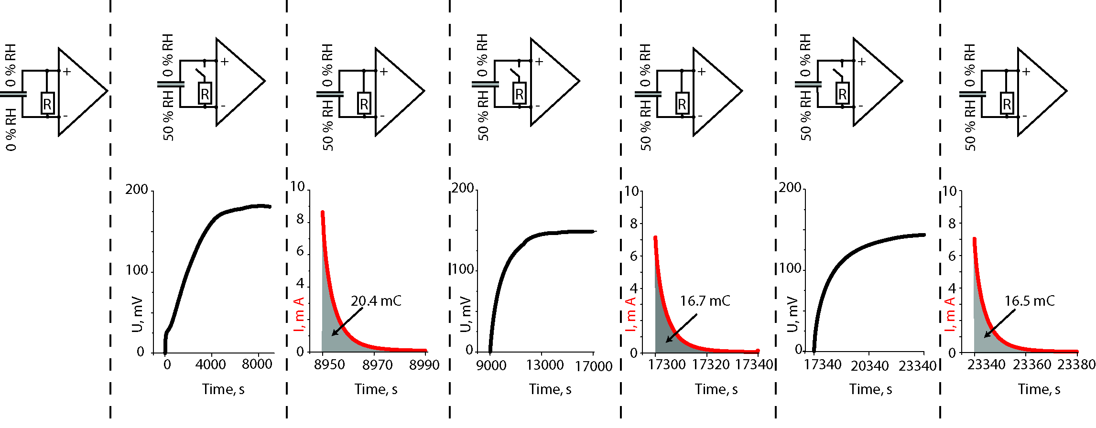
Figure 7

  - Impedance study
The impedance was measured between the electrodes by placing the laminate completely in a vessel, which contained saturated salt solution for humidity generation.
The impedance data presented on Fig. 8A-C shows huge dependence of laminate properties on humidity change.
At humidity over 50 %, the Nyqvist plot shows a small semicircle at high frequencies. This can be explained by the formation of double-layer between the measurement terminals and the electrolyte. At low humidity, the measurement terminals are not in a direct contact with the electrolyte, but rather directly with carbon particles, and therefore the semicircle is less pronounced.
It can be seen that at low frequencies, the laminate with highest absorbed water content resembles to an almost perfect supercapacitor, with a phase angle reaching -80.8° at 10 mHz. In case of maximally dried laminate, the corresponding value is only 64.2°. The impedance magnitude between the electrodes shows a significant decrease in case of rising humidity content. Without calculations, it can be seen that the laminates operated in the ambient humidity below 50 % have clearly lower performance as supercapacitors.

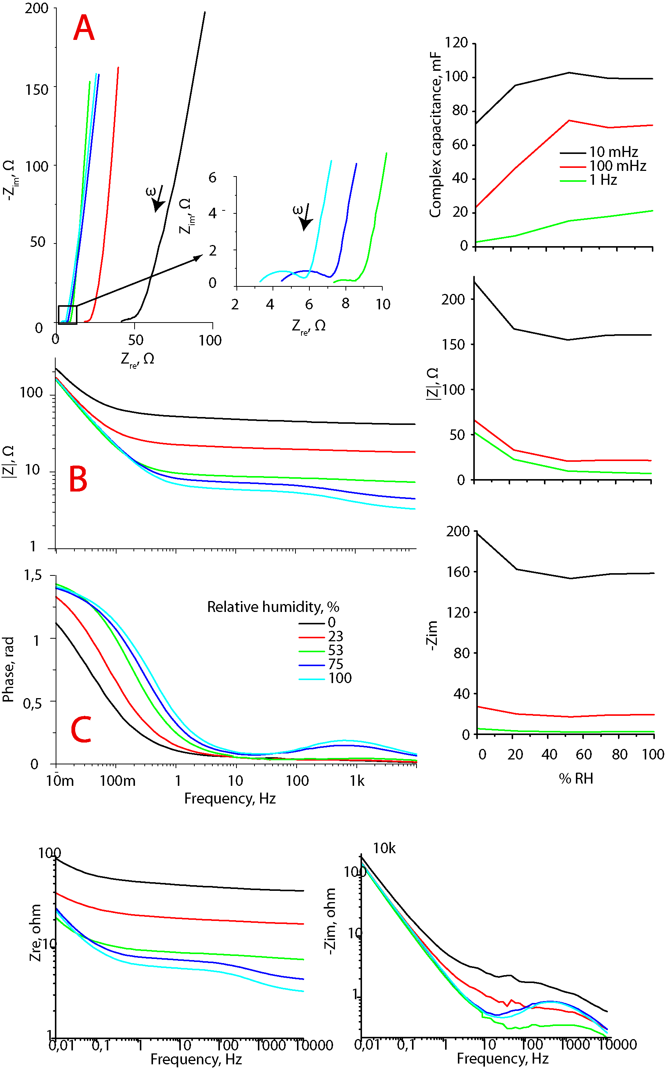
Figure 8. (Need, millel tähist pole, jätaksin välja.)

The impedance data was fitted with the equivalent schematics depicted on Fig. 9A. The system consists of a resistor R, capacitor C, and constant phase element CPE connected in series. The impedance data was fitted using z-fit software only in the range of 0.01-100 Hz, because additional circuit elements are needed to describe the system at higher frequencies, but the (kinetic?) processes occurring at higher frequencies are not the target of this study.
The resistance R corresponds to charge transfer resistance, which is closely related to the viscosity of the ionic liquid. The capacitance C refers to the double-layer capacitance at the carbon-ionic liquid boundary. CPE expresses diffusion component in the system.
As a rule, the pure ionic liquid is more viscous than the ionic liquid-water mixture. It has been shown that the water content can decrease the ionic liquid viscosity up to ten times. (As a remark, in large dilutions, the ionic liquid solution does not differ from an ordinary salt solution.) The Fig. 9C shows that the resistance decreases exponentially with an increase in humidity, as expected. In maximum humidity conditions, the viscosity decreased as much as 8 times in the current system.
The capacitance did not change considerably with the increase in humidity, as can be seen on Fig. 9D. ((Still, the higher humidity content increases capacity 32%)).
The n-parameter (Fig. 9E) of the CPE varied between 0.37 and 0.66, which correspond to diffusion. The n-parameter of 0.5 corresponds to ideal diffusion, as it was measured at 50% RH, and the small differences show deviations from the Fick’s Law.
The proportionality parameter CPE-Q depicted on Fig. 9H indicates the amount of diffusion. As expected, in the case of low water content, the amount of matter undergoing diffusion is significantly lower.

Figure 9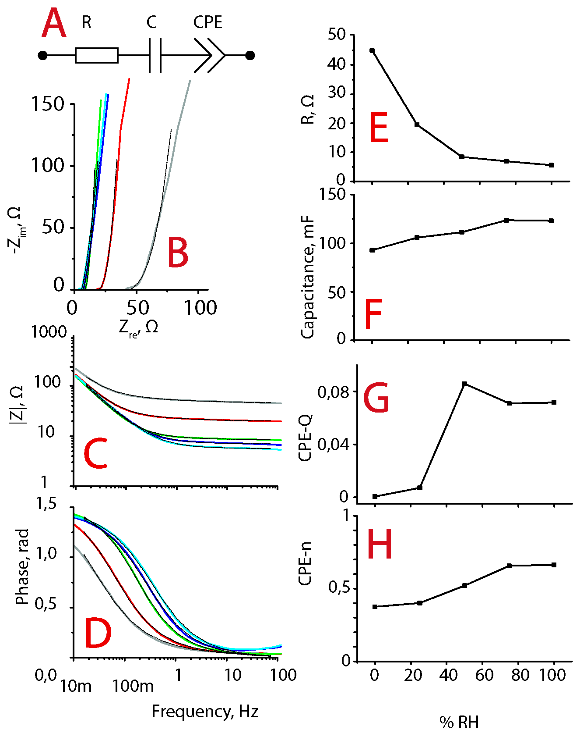

  - Working principle

Electro-osmosis is one of the mechanisms responsible for generation of volumetric effects between oppositely charged electrodes in actuators. The charging of carbonaceous electrodes with external current results in separation of electrolyte ions with opposite charges. In the humidity sensor, however, there is no external voltage source. The diffusion of water in the cluster channels of Nafion induces streaming current. However, standard streaming current theory is not easily applicable in such system. The streaming current generated in response to the humidity gradient results from the reorientation and dislocation of ionic liquid, which induces charge at the carbon electrodes.

The (hypothetical) explanation of the generation of charge is based on a result of the following concurring processes – the absorption of water by IL, the hydration of Nafion, and double layer formation on carbon.
Nafion consists of a hydrophobic tetrafluoroethylene backbone with perfluorovinyl ether side chains, which are terminated by hydrophilic ionic sulfonate groups. In the process of the preparation of the laminate, Nafion (which has initially Li⁺ cations as counter-ions at ionic sulfonate groups) is swelled in an ionic liquid. During the immersion in an IL, ion exchange occurs, where Li⁺ cations change place with EMI⁺ cations (LiTFS is left in the solution – concentration gradient).
In low humidity conditions, the Nafion membrane consists of EMI⁺ cations bound to the sulphonic acid groups attached to the hydrophobic perfluorocarbon backbone. The ionomer cluster channels formed during the swelling stage of manufacturing process are filled with mobile EMI⁺ cations and TFS⁻ anions of ionic liquid. The sulphonic acid groups make the cluster channels of Nafion strongly hydrophilic. The water molecules are attracted by sulphonic acid groups; dry (without being soaked in an IL) Nafion can absorb water 22 % of its weight and each sulphonic acid group can coordinate up to 15 water molecules [james].
EMITFS contained in hydrophilic channel network is classified as a hydrophilic IL. The increase in ambient humidity level results first in a fast sorption of water by the sulphonic acid groups of Nafion. The sulphonic acid group makes Nafion extremely hydrophilic. The sulphonate group of TFS⁻ anion makes it the next potent attractor of water molecules.
The 1-ethyl-3-methylimidasolium has hydrophobic character due to its hydrocarbon chain and the imidazolium group, which suggests that at high water concentrations they even act as simple surfactants [Varela 2009]. The hydrophobicity increases with the increase of hydrocarbon chain length. Still, EMI⁺ is reported to be the most hydrophilic ionic liquid cation [Ranke 2009], which suggests that the EMI⁺ cation can also collect water molecules to its coordination sphere (?). Moreover, the anisotropic distribution of charge over the cation causes the IL cation to have preferential adsorbation orientation [Zhang 2012]. Also, a strong orientation of the cation is presumed over the surface with large dipole. This suggests that the orientation of cation could be significantly altered with the introduction of water molecules, or just by mechanical strain on the material, which creates locally in the pores of carbon hydrostatic pressure on IL. The alteration of orientation induces dipole in the adsorbate (CDC carbon), which could be instantly registered as voltage between differently strained electrodes.
From the all species of IL-water mixtures – cations, anions, and neutral water molecules, as a rule, the organic cations are the most hydrophobic species and tend to adsorb positively, while the main function for the anion is the preservation of both global and local electroneutrality, and the effect of anions on adsorption is minimal [Varela 2009]. This is in good accordance with our observations in case of application of both pressure and water gradient that cations are the more mobile than anions, and the formation of double layer due to the pressure change is dominated by the relatively hydrophobic cation.
When the ambient humidity conditions change, the pressure gradient is induced by water sorption and diffusion. The ambient humidity change causes water diffusion along the Nafion cluster network. The lateral dimension of EMI⁺ is 0.53–0.95 nm and of TFS⁻ is 0.XX nm. The diameter of a water molecule is 0.2 nm, this indicates that it can easily diffuse in the ionic liquid. In dry state, the EMI⁺ cations are strongly bonded to sulphonic acid groups. As a result of hydration, the sulphonic acid group gets coordinated by more water and the bond length between sulphonic acid group and EMI⁺ cation significantly increases. Consquently, the EMI⁺ cation can now relocate more easily and even get carried along with water flux caused by diffusion.
The charged surface of the cluster network of Nafion also represents of itself an obstruction to the ionic groups trying to diffuse through the pores.
The CDC particles are covered with and connected to each other by the Nafion network. Although CDC itself is also strongly hydrophilic and the small dimension (0.2 nm) of water molecule allows it to easily reach the carbon surface, the water has to first pass through the Nafion network. The change in ambient humidity causes water molecules to compete towards adsorption with ionic liquid. The water diffusion induces polarization of an IL from reorientation and entrainment of cations from ionic polymer. As previously suggested [mina], the smaller anions are fixed in the smaller micropore range, while the larger cations are more mobile. Therefore, the ionic liquid at the carbon boundary orientates itself as a result of diffusing particles. It has been shown [wu 2012] that the mechanism of charge storage at low voltages is swapping the co-ions in the pore with the counterions from the free IL. The processes at carbon – ionic liquid interface have been divided also to slow and fast processes. The slow process is suggested to be related to charge redistribution in the innermost layer [Rolling 2011], the slow kinetics of this process has even suggested an analogy to faradaic reaction between the carbonaceous electrode and IL [Gimenez 2011].

The specific orientation causes the polarization of the carbon. The electrode exposed to higher humidity acquires a negative electric potential. This indicates the predominance of anions at the double layer of more hydrated electrode. This suggests the hypothesis of cations being more mobile ions.

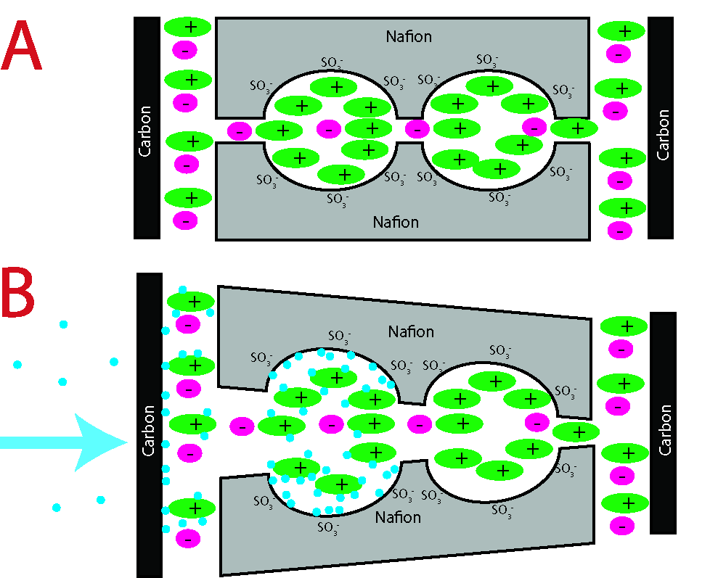
Figure 10
The components that are chosen for manufacture of this laminate are currently from theoretical viewpoint the best available. The carbide-derived carbon has an exceptional surface area and tunable porosity distribution, which is well matched with the used ionic liquid. The ionic liquid is amongst the most hydrophilic ionic liquids currently available. The imidasolium-based cations with short ligands are the most hydrophilic cations published to date []. The superhigh hydrophilicity is one of the assets of Nafion which has favored it to be used, for example, in fuel cell applications [].
The humidity sensing capability of a supercapacitor-like technology has previously been investigated in case of potassium hydroxide electrolyte []. The hydration of the salt increases ionic conductivity approximately 10 times, which also proportionally increases the device capacitance.
The effect of dimensional changes has been researched in case of polypyrrole actuators [Okuzaki] and carbon [Łukaszewicz], where the contraction is achieved by water desorption by Joule heating.
The bending actuation caused by water sorption has been investigated in case of self-assembled rodlike nanostructures [ciszek].
In case of an electrochemical cell with conductive polymer (polypyrrole) electrodes, the ability of transportation of (ambient) water has been demonstrated [Xu 2006]. This suggests that at least the diffusion constant should be different in the case of short- or open-circuited electrodes.

Conclusions
Purely water diffusion gradient can charge the capacitor to 160 mV and produce 3 mC*cm⁻¹*h⁻¹ of charge.

