Electroactive polymer actuators with carbon aerogel electrodes

  - Viljar Palmreª, Enn Lust^{b}, Alar Jänes^{b}, Mihkel Koel^{c}, Janno Toropª, Urmas Johansonª and Alvo Aabloo^{a,}*

ªIMS Lab, Institute of Technology, University of Tartu, Nooruse 1, 50411 Tartu, Estonia
^{b}Institute of Chemistry, University of Tartu, Ravila 14a, 50411 Tartu, Estonia
^{c}Institute of Chemistry, Tallinn University of Technology, Akadeemia tee 15, 12618 Tallinn, Estonia

Abstract

Electromechanically active polymers (EAPs) change their shape in response to the voltage stimulus. They can be used as actuators or sensors. Several researchers have introduced different materials and assembling methods for EAPs. It is generally accepted that the porous structure of electrodes with possibly high specific surface area can greatly improve the actuation performance. In this paper, a carbon aerogel is introduced as a new material for fabrication of nanoporous electrodes for EAP actuators. Using the direct assembly process (DAP), carbon ionic liquid EAPs with either activated or non-activated carbon aerogel electrodes are prepared and analyzed. Their electrochemical and electromechanical characteristics are presented and compared to our recently reported actuators based on the carbide-derived carbon and activated carbon electrodes. The results show that our newly developed actuators with activated carbon aerogel electrodes and non-activated carbon aerogel electrodes have maximum strains of 1.2% and 1.3%, respectively, which are comparable to the parameters reported previously for carbide-derived carbon and activated carbon based actuators and also to any other low-voltage driven EAP actuators.

Keywords: Actuator; Electroactive polymer; EAP; Ionic Polymer Metal Composite; Nafion; Carbon Aerogel; Carbon Electrode; Carbide Derived Carbon.

1. Introduction

Electromechanically active polymers (EAP) are soft, flexible materials that can convert electrical energy into mechanical energy or vice versa []. The ability to respond quickly with large bending deformations makes them attractive for a wide range of applications including biomimetics, robotics, micro-electromechanical systems, and medical devices. EAPs can be manufactured applying variety of different materials. Based on the actuation mechanism, they are generally divided into two principal classes: electronic EAPs based on the dielectric elastomers, in which the actuation is initiated by applied electric field induced forces, and ionic EAPs, in which the actuation is produced by displacement of ions inside the polymer material layer [1].

One of the most widely studied ionic EAPs are ionic polymer-metal composites (IPMC), which typically consist of thin ionic polymer membrane (e.g. NafionTM) plated on both surfaces with the noble metal layers (Pt or Au) to serve as conductive electrodes. When the voltage is applied to the electrodes, the IPMC undergoes a large bending deflection []. However, IPMCs in their conventional configuration suffer from several issues like time-consuming and expensive manufacturing process (i. e. electroless plating of noble metals) [], platinum layer cracks under continuous actuation []. It should be noted that processing of gold electrodes is relatively complex and gives results with low reproducibility. Water as a solvent inside the polymer decomposes when IPMCs operated at higher voltage, which in turn degrades the actuation properties and thermodynamic efficiency []. Due to these limitations, a lot of attention has been focused on developing manufacturing techniques using less expensive electrode materials and more stable solvents and electrolytes, including ionic liquids []. Akle et. al. have proposed a new manufacturing technique – Direct Assembly Process (DAP) – in which the electrode is spray painted onto the ionic liquid-swollen NafionTM membrane and hot-pressed []. In comparison with conventional IPMC fabrication techniques that are based on chemical reactions, the DAP is fast and flexible process allowing to use variety of different solvents, salts and electrode materials.

It is generally understood that the large interfacial surface area of electrodes gives rise to better actuation performance; therefore designing EAPs with high specific surface area electrodes is of interest. Using the DAP, Akle and their co-workers synthesized ionic liquid (EMI-TF) based IPMCs with porous RuO₂ electrodes, which showed great actuation performance and reliability for long-time operation in air []. Fukushima and Asaka et. al. came up with unique fabrication technique for assembling bucky gel actuators []. In this process the dry actuator can be fabricated simply through layer-by-layer casting of “bucky gel” – gelatinous room-temperature ionic liquid that contains single walled carbon nanotubes (SWNTs).

In our previous work [], we reported high-strain IPMC actuators using for the first time highly porous carbide-derived carbon (CDC) and coconut shell-based activated carbon powder as an electrode material. Actuators with CDC electrodes produced more than twice as much strain as previously reported RuO₂-based actuators. In this paper, we introduce carbon aerogels [] as new less expensive alternative materials for assembling EAP actuators with nanoporous electrodes. We synthesized carbon-ionic liquid electroactive polymers (CIL-EAPs) with activated carbon aerogel and for comparison the non-activated carbon aerogel electrodes were studied as well. The carbon electrodes were applied onto ionic liquid-swollen Nafion membranes using the direct assembly process. The assembled CIL-EAPs were characterized in terms of actuation performance and the results obtained were compared to our recently reported actuators based on carbide-derived carbon and activated carbon electrodes.

Carbon aerogel is highly porous carbon material (Table 1) obtained by the pyrolysis of organic aerogel. It has large specific surface area and extremely low density. Due to these properties carbon aerogels can be used as adsorbents, materials for chromatographic separation, membranes and carriers for metal catalysts. Furthermore, having a controllable porous structure and electrically conductive network, they can be used as electrodes for supercapacitors [] or fuel cells []. Carbon aerogels used in this study were derived from 5-methylresorcinol-formaldehyde gel [11]. After drying in the supercritical carbon dioxide the gel forms an aerogel, which was then pyrolysed in an inert (N₂) atmosphere to prepare a carbon aerogel. Activation of these aerogels was carried out at 1,173 K in continuous flow of CO₂ for 1 – 4 hours. Carbon aerogels were ball-milled to achieve fine-powdered material.

2. Experimental

2.1 Chemicals and materials

Carbon aerogels (activated and non-activated) were prepared as described by Koel et al [13]. Nafion™ 117 membrane (product of DuPont) was purchased from FuelCellStore.com™. Gold foil from Gold-Hammer (24-carat, 80x80 mm²) was used as contact material on electrode surface.

All reagents were of analytical grade and used without further purification: 1-ethyl-3-methylimidazolium trifluoromethanesulfonate (EMI-TF, Fluka); lithium perchlorate (LiClO₄, Fluka); 2-Propanol ((CH₃)₂CHOH, 99.9%, Sigma Aldrich); ethanol (CH₃CH₂OH, 96%, Sigma Aldrich); hydrochloric acid (HCl, 36%, Stanchem). All solutions were prepared using deionized water (Millipore Milli-Q).

The list of physical properties for electrode materials is given in Table 1.

Table 1. Physical properties of the electrode materials tested.
Electorde material | Density (g/cm³) | BET surface area (m²/g) | Total volume of pores (g/cm³) | Average pore width (nm) | Degree of graphitization (%)
Non-activated carbon aerogel | 0.42 | 560 | 2.07 | 14.75 | 0
Activated carbon aerogel | ??? | 790 | 2.18 | 11.05 | 0

2.2 Preparation of the CIL-EAP-s

Bare Nafion™ 117 membrane was pretreated by roughening both sides with emery paper (2500 Grit) in order to remove the outer polymer surface layer, which due to its relatively high hydrophobicity interacts weakly with the solutions used. Roughening also enhances the polymer-electrode interface area, thereby providing better adhesion. Both sides of the membranes were roughed until the surface appeared to be non-transparent, after which the membranes were cleaned by boiling in 1 M hydrochloric acid for 30 minutes, followed by boiling in deionized water for 1 h to remove acid residuals. After exchanging the water, the membranes were boiled additionally during 30 min in deionized water.

In order to prevent degradation of the ionomer during the relatively long drying procedure at elevated temperature [], the membranes were ion-exchanged by boiling for 2 h in a 1 M LiClO₄ aqueous solution. The membranes were then dried in vacuum at 150º C for 12 h. Thereafter, the membranes were instantly immersed in neat ionic liquid (Emi-Tf) and heated for 5 h at 150º C. Afterwards, the uptake of Emi-Tf is expected to be near 60% of the dry weight of the membrane [8].

The electrodes were applied to the membrane using DAP method [7]; i.e., a conductive carbon powder with high specific area was mixed with an ionomer solution and painted directly onto the ionic liquid-swollen membrane and sandwiched between two gold foils followed by hot-pressing step. A 5 wt% Nafion 1110 dispersion was prepared by heating the ionomer in an autoclave for 3 h at 210º C under continuous stirring in the presence of a 50% ethanol/water solution. Thereafter, the ionomer dispersion was mixed with conductive carbon powder. The mixture for carbon electrodes was adjusted to contain 1.7 wt% of carbon powder, 48.3 wt% of Nafion solution and 50 wt% of isopropanol. All mixtures were then sonicated for 1 – 3 h to disperse the conductive powder particles.

The conductor/ionomer mixtures were applied to the membrane using an SB-1107 Sumake airbrush operated by compressed-air. Volatile solvents were evaporated under an infrared lamp (150 W, Philips) after deposition of each layer. Typically 8 to 15 layers of the conductor/ionomer mixture were sprayed on both sides of the membrane to achieve layers with uniform thicknesses. After painting of the electrodes, a layer of 5 wt% Nafion solution was applied onto the sprayed electrode to provide better surface adhesiveness to the gold foil. Thereafter, the membranes were placed under IR light for an additional 15 min for heat treatment. Finally, the membranes were sandwiched between two gold foils (270 nm thick) and fused together by hot-pressing at 150º C under 3.5 MPa pressure for 5-10 s. This step decreases the surface resistance of painted layers to less than 1 Ω/cm, according to the results from the four-point probe measurements.

Using the aforementioned process, two sets of samples with three membranes in each set were prepared. All samples were 40 mm in length and 8 mm in width.

2.3 Electromechanical characterization

For electromechanical characterization, the experimental setup described in our previous paper was used []. A scheme of the experimental setup for the characterization of the actuator strain and speed of bending is shown in Figure 1. The actuators were clamped in vertical cantilever position and measurements were done in the dry state in air. Rectangular or sinusoidal driving pulses were applied via a fixed contact U and a ground contact (contacts were made of gold). The measurements were conducted applying National Instruments LabView software. The driving voltage was generated by a NI PCI-6703 DAQ board and amplified by electric current using the high current booster HEKA HCB-20 (Me oleme juba mitu aastat tagasi LM675 välja vahetanud) The voltages with respect to the ground were measured with a NI PCI-6034 DAQ board. The electric input current of the sample was measured as a voltage drop over the resistor R. The value of the resistor should be chosen as low as possible, but still sufficiently high with respect to the value of the current and the sensitivity of the measuring equipment. In the course of the experiments described here, the value of the resistor R was 0.5 … 1.0 Ω. Electric current passed through the sample was calculated according to Ohm’s law.

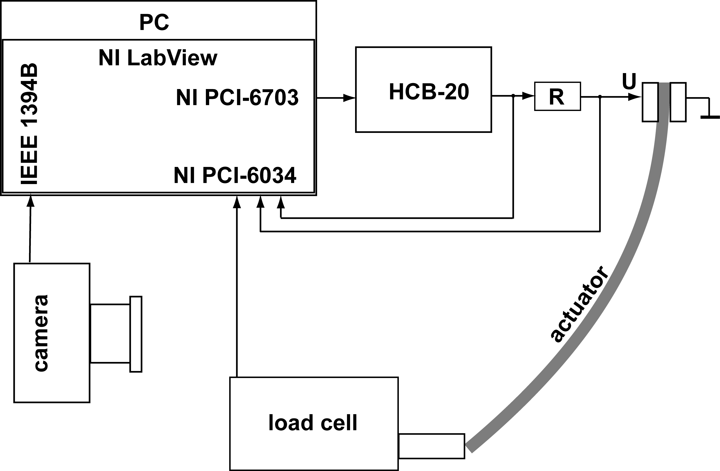
Figure 1. Experimental setup for electromechanical characterization.

- The bending motions of the actuator were recorded with a firewire camera, Dragonfly Express from Point Grey Research Inc., recording images at 30 frames per second. The direction of the camera was set transverse to the actuator and the experiment was illuminated from the background through a frosted glass and a graph paper. In this camera position, the recorded image of the actuator consists of a single curved contrast line. Blocking force was measured at zero displacement using the Panlab MLT0202 load cell. Sample stiffness was determined by a 3-point bending test [].
The surface resistances (conductivities) of both electrodes were measured using a four-point probe method. A National Instruments PCI-6034 DAQ with an SCC-RTD01 module was used to measure the resistances of the electrode surface using a four-point probe method. (Liigne) The range of the module allows reliable measurement of resistances from 0 to 200 Ω. In order to connect the four probes simultaneously to the IPMC strip, a special flexible contact strip was made by fixing four contacts made of gold foil onto the surface of a thin ribbon of PTFE. The distance between the test-contacts was kept at 21 mm. The capacitance of the material was determined using the technique of aperiodic charging-discharging curves as described in []. Sa ju ei räägigi edaspidi kuskil shunt conductivityst, annad ainult mahtuvuse.

2.4 Scanning electron microscopy

Scanning electron micrographs (SEM) were obtained for all samples using a Helios Nanolab 600 microscope in secondary electron image mode with a 5 keV accelerating voltage and magnification of 350x, and are given and discussed in next chapter.

2.5 Evaluation of carbon materials

BET surface area, pore size distribution, total volume of pores and average pore width of the carbon aerogels were obtained by using the Micromeritics ASAP 2020 Surface Area and Porosity Analyzer for liquid nitrogen adsorption measurements at -196 °C. The degree of graphitization was determined from XRD spectra measured by Bruker D8 Advance X-Ray Diffractometer.

3. Results and discussion

The cross-sections of the prepared CIL-EAPs were probed using SEM, in order to investigate the electrode layer thicknesses and adherence to the ionic polymer membrane. It should be noted that samples must have very similar electrode thicknesses as the dimensions of the electrodes can strongly affect the comparison exactness of actuation performance. Figure 2 shows the SEM cross-sectional views of the samples with activated and non-activated carbon aerogel electrodes. It is clearly seen that electrode thicknesses on both sides of the membranes are exceptionally similar, as well as the thicknesses in case of different samples tested. The electrode layer thickness is in the range of 25 – 40 µm and has an average value of 30 µm. The boundary line between the ionic polymer membrane and carbon electrode is hardly distinguishable, which indicates that the electrodes are well bonded with the Nafion membrane. The curved traces seen on the polymer area and rough surfaces near the polymer-electrode interface (esp. image A in Fig 2) are due to the fracturing of the sample in liquid nitrogen.

Figure 2. SEM cross-sectional micrographs of CIL-EAPs with: A) activated carbon aerogel electrodes, B) non-activated carbon aerogel electrodes.

Prepared CIL-EAP actuators were characterized in terms of maximum strain, strain rate, capacitance, electrode surface resistance, blocking force and stiffness (Young modulus). Table 2 represents a summary of the measurements performed. The results were obtained by measuring three samples for each electrode material (non-activated and activated carbon aerogel). In case of all experiments, the measurement standard deviation percentages were below 15%.

First, the electrode surface resistance was measured in order to make sure that there are no significant cracks or disjunctions in the electrode layer, which may occur during the hot-pressing procedure. As observed in Table 2, the electrode resistances range only from 0.3 to 0.4 Ω/cm. These measurements confirm that the gold foil on the surface was in a good condition, providing a good conductivity along the sample length. Exceptionally similar values in electrode resistances obtained also assure that the samples can be adequately compared in terms of other characteristics. It should also be mentioned that these results are in good agreement with our previously reported data for actuators based on carbide-derived carbon (CDC) and activated carbon electrodes (see Table 3), which demonstrates that the used manufacturing process (direct assembly process) provides a good reproducibility for actuators prepared.

Table 2. Summary of the results for actuators based on carbon aerogels (measured at ± 2 V rectangular actuation signal).
Electrode material | Maximum peak-to-peak strain (%) | Maximum strain rate (%/s) | Capacitance (mF/cm²) | Electrode surface resistance (Ω/cm) | Blocking force (mN) | Stiffness (MPa)
Non-activated carbon aerogel | 1.3 | 0.15 | 8 | 0.4 | 1.7 | 99
Activated carbon aerogel | 1.2 | 0.13 | 14 | 0.3 | 1 | 100

Table 3. Properties for the actuators based on the CDC and activated carbon powders (measured at ± 2 V rectangular signal).
Electrode material | Maximum peak-to-peak stain (%) | Maximum strain rate (%/s) | Capacitance (mF/cm²) | Electrode surface resistance (Ω/cm) | Blocking force (mN) | Stiffness (MPa)
Carbide derived carbon (CDC) | 2.0 | 0.23 | 16 | 0.7 | 3.6 | 97
Activated carbon | 1.0 | 0.16 | 51 | 0.6 | 3.1 | 103

Another property that can greatly affect the electromechanical properties (blocking force and strain) is the sample’s stiffness i.e. Young modulus. The stiffness was determined by the 3-point bending test, described in [16]. As can be seen from the data in Table 2, respective values of Young modulus for both samples are around 100 MPa. Since there is almost no variation in Young modulus, it seems to us that the sample’s stiffness will not affect the other electromechanical parameters for actuators under the study. The data also compares well to our previous work (see Table 3), in which the Young modulus for actuators based on CDC and activated carbon electrodes were 97 MPa and 103 MPa, respectively. These results indicate that the sample’s stiffness is mainly determined by the fabrication process, not by the specific porous electrode material characteristics or binding polymer framework properties, which is similar in the samples under the study. All samples were prepared as similar as possible, which explains very minor variations in stiffness obtained.

The maximum strain was calculated according to the equation (1), described in []:
, (1)
where d is the thickness, L is the free length and δ is the displacement of the actuator. The measurements show that the actuators with non-activated and activated carbon aerogel electrodes are capable to generate strains up to 1.3% and 1.2%, at ± 2 V actuation signal applied, respectively. These peak-to-peak strains are comparable to our previously reported data for carbide-derived carbon and activated carbon actuators (Table 3) and the best to our knowledge to any other low-voltage driven EAP actuators.

It is interesting to note that although activated carbon aerogel has significantly higher specific surface area than non-activated carbon aerogel, they perform relatively similar in terms of strain. As can be seen on the plots of pore size distributions in Figure 3, the activated carbon aerogel, while having almost the same pore distribution in micropore range (> 1 nm), exhibits considerably higher amount of micropores in range of 0.5 – 0.6 nm. Micropores of this size range, however, are probably too small to be easily accessible for electrolyte (EMI-TF) ions (the size of EMI⁺ is 0.71 x 0.50 x 0.475 nm). Therefore, we can conclude that the actuation is mainly generated in bigger micro- and mesopores (2 – 50 nm), which are freely accessible for electrolyte ions (under the applied electric field, the repulsive interactions between the ions in formed double layer induce the actuation). As observed in Figure 3, both carbons have almost identical pore size distribution in micropore range (> 1 nm), which explains their similar performance in strain output.

When compared to our previous results in Table 3, the newly developed CIL-EAPs outperform the maximum strain of activated carbon based actuators, while showing lower strain compared to the CDC based actuators. This is related to the structural differences between the carbon materials. Besides the pore characteristics, the actuation is also affected by the deformability of the carbon particles, which is determined by the degree of graphitization and can be obtained from XRD or Raman spectra. In case of carbide derived carbon the degree of graphitization is 5% [] and it is considered to be intrinsic for carbons with relatively rigid structure. In terms of actuation performance, if the carbon structure is sufficiently rigid not to be pressed together by the electrostatic interaction during the actuation, the total volume change in electrodes will be greater, which in turn provides higher strain output. In contrast to the CDC, the degree of graphitization in case of both carbon aerogels – activated and non-activated – is nearly 0% (Table 1); and for carbon aerogels at all the (002) reflex that indicates the graphitization of carbon material was not revealed in the XRD spectra. This means that the structures of activated and non-activated carbon aerogels are completely amorphous and hence, significantly more elastic compared to the CDC material. Thus, during the actuation, the structure of carbon aerogels can be deformed in more extent and the volume of carbon matrix is decreased, thereby diminishing also the total volume change in electrodes, which explains lower performance in strain output compared to the CDC. As noted in Table 2 and 3, carbon aerogels produce more strain (up to 30%) compared to the activated carbon electrodes. Unlike the activated carbon, which also has amorphous structure, carbon aerogels exhibit high pore volume (Table 1). High pore volume refers to the higher content of ionic liquid involved in electrodes, thereby giving rise to better strain output.

As well as the actuation, the blocking force is also dependent on the rigidity (degree of graphitization) of carbon matrix. It is clear that the carbon matrix has to be rigid in order to generate higher force. The measurements data show that in case of carbon aerogels the blocking forces are considerably lower compared to our previously reported data for CDC based actuators (Table 3). As already mentioned, carbon aerogels have completely amorphous structure, which can be deformed upon the repulsive interactions of ions in formed double layer, and hence the lower performance in blocking force.
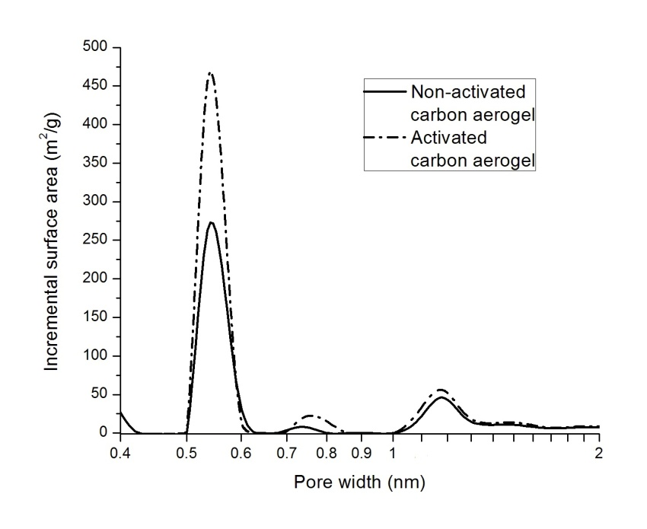
Figure 3. Incremental pore size distributions of activated and non-activated carbon aerogels.

The maximum strain rate was calculated from recorded video clip, indicating the highest speed that the sample experiences while actuating from one maximally deflected position to another. As the measurements show, the maximum strain rates for non-activated and activated carbon aerogel electrodes are 0.15 %/s and 0.13 %/s. Thus, it appears that the differences in results are relatively minor. It should be noted that the actuator’s speed is closely related to the porous structure of electrode, since it directly affects the migration rate of electrolyte ions in the porous electrode matrix. As discussed earlier, both carbons have almost the same structure in micropore range, which also explains rather small variation in strain rates observed.

As mentioned before, the interfacial area between the electrodes and electrolyte greatly affects the actuation performance (strain output). In this regard, the capacitance measurements were performed, in order to analyze how the specific surface area of electrodes correlates with the strain output. Typically, higher capacitance indicates larger interfacial surface area and more electrolyte ions involved in electrical double layer formation process, which in turn refers to a greater strain due to the stronger repulsive interactions in double layer. However, in the context of the data presented here, the capacitances are not in a good correlation with respective strain values for the samples analyzed. Non-activated carbon aerogel, showing slightly higher strain, has considerably lower capacitance (8 mF/cm²) compared to the activated carbon aerogel (14 mF/cm²). This result can be expected, since different electrode materials with different structures are compared. As discussed earlier, activated carbon aerogel has significantly higher amount of smaller micropores (< 1 nm) compared to the non-activated carbon aerogel. Although these micropores are too small to be freely penetrable for electrolyte ions, they may still contain adsorbed electrolyte ions that are immobile and are constrained in the pores. These adsorbed immobile ions are not contributing to the actuation process, but still give rise to the capacitance, which explains the higher capacitance for activated carbon aerogel electrodes, while having slightly lower bending performance compared to the non-activated carbon aerogel electrodes.

4. Conclusions

In this study, carbon aerogels were proposed as new materials for the fabrication of nanoporous microporous electrodes for EAPs. Carbon ionic liquid electroactive polymer acutators (CIL-EAPs) with either activated or non-activated carbon aerogel electrodes were successfully fabricated. The electromechanical and electrical characteristics of prepared actuators were examined and compared to our previously reported actuators based on the carbide-derived carbon and activated carbon electrodes. The differences in actuation performance were analyzed in the context of pore characteristics and degree of graphitization of carbons. The results demonstrate that our newly developed CIL-EAPs with activated and non-activated carbon aerogel electrodes are capable for generation of strains up to 1.2% and 1.3%, at ± 2 V step voltage, which are comparable to any other low-voltage driven EAP actuators. The respective maximum strain rates are 0.13 %/s and 0.15 %/s. The gas sorption measurements showed that activated and non-activated carbon aerogels have almost identical pore size distributions in micropore range, which explains minor differences in their actuation performance. Although activated carbon aerogel has significantly higher specific area in the smaller micropore range (0.5 – 0.6 nm), the pores in this size range are too small for quick penetration by electrolyte ions. It was found that blocking force and strain output are strongly related to the rigidity i.e degree of graphitization of carbon materials. Carbon aerogels having completely amorphous structure showed lower strain and blocking force compared to the carbide-derived carbon, which have relatively high degree of graphitization (nearly 5% for the CDC material tested by us).

5. Acknowledgements

The financial support of Estonian Science Foundation grants #8172 and #7811 and targeted financing #SF0180008s08 from Estonian Ministry of Education is acknowledged.
6. References

* Corresponding author: Alvo Aabloo, alvo@ut.ee, http://www.ims.ut.ee
() Bar-Cohen, Y., Electroactive polymer (EAP) actuators as artificial muscles : reality, potential, and challenges. 2nd ed.; SPIE Press: Bellingham, Wash., 2004; p xvii, 765 p.
() Oguro, K.; Kawami, Y.; Takenaka, H., Bending of an ion-conducting polymer film-electrode composite by an electric stimulus at low voltage. Journal of Micromachine Society 1992, 5, 27–30.
() Kim, K. J.; Shahinpoor, M., Ionic polymer-metal composites: II. Manufacturing techniques. Smart Materials & Structures 2003, 12 (1), 65-79.
() Punning, A.; Kruusmaa, A.; Aabloo, A., Surface resistance experiments with IPMC sensors and actuators. Sensors and Actuators a-Physical 2007, 133 (1), 200-209.
() Shahinpoor, M.; Kim, K. J., Ionic polymer-metal composites: I. Fundamentals. Smart Materials & Structures 2001, 10 (4), 819-833.
() Bennett, M. D.; Leo, D. J., Ionic liquids as stable solvents for ionic polymer transducers. Sensors and Actuators a-Physical 2004, 115 (1), 79-90.
() Akle, B. J.; Bennett, M. D.; Leo, D. J.; Wiles, K. B.; McGrath, J. E., Direct assembly process: a novel fabrication technique for large strain ionic polymer transducers. Journal of Materials Science 2007, 42 (16), 7031-7041.
() Akle, B.; Nawshin, S.; Leo, D., Reliability of high strain ionomeric polymer transducers fabricated using the direct assembly process. Smart Materials & Structures 2007, 16 (2), S256-S261.
() Fukushima, T.; Asaka, K.; Kosaka, A.; Aida, T., Fully plastic actuator through layer-by-layer casting with ionic-liquid-based bucky gel. Angewandte Chemie-International Edition 2005, 44 (16), 2410-2413.
() Palmre, V.; Brandell, D.; Maeorg, U.; Torop, J.; Volobujeva, O.; Punning, A.; Johanson, U.; Kruusmaa, M.; Aabloo, A., Nanoporous carbon-based electrodes for high strain ionomeric bending actuators. Smart Materials & Structures 2009, 18 (9).
() Perez-Caballero, F.; Peikolainen, A. L.; Uibu, M.; Kuusik, R.; Volobujeva, O.; Koel, M., Preparation of carbon aerogels from 5-methylresorcinol-formaldehyde gels. Microporous and Mesoporous Materials 2008, 108 (1-3), 230-236.
() Lee, Y. J.; Jung, J. C.; Park, S.; Seo, J. G.; Baeck, S. H.; Yoon, J. R.; Yi, J.; Song, I. K., Preparation and characterization of metal-doped carbon aerogel for supercapacitor. Current Applied Physics 2010, 10 (3), 947-951.
() Marie, J.; Chenitz, R.; Chatenet, M.; Berthon-Fabry, S.; Cornet, N.; Achard, P., Highly porous PEM fuel cell cathodes based on low density carbon aerogels as Pt-support: Experimental study of the mass-transport losses. Journal of Power Sources 2009, 190 (2), 423-434.
() Akle, B. J.; Bennett, M. D.; Leo, D. J., High-strain ionomeric-ionic liquid electroactive actuators. Sensors and Actuators a-Physical 2006, 126 (1), 173-181.
() Punning, A.; Kruusmaa, M.; Aabloo, A., A self-sensing ion conducting polymer metal composite (IPMC) actuator. Sensors and Actuators a-Physical 2007, 136 (2), 656-664.
() Mitchell, B. S., An introduction to materials engineering and science for chemical and materials engineers. John Wiley: Hoboken, NJ, 2004; p xv, 954 p.
() Punning, A.; Johanson, U.; Anton, M.; Aabloo, A.; Kruusmaa, M., A Distributed Model of Ionomeric Polymer Metal Composite. Journal of Intelligent Material Systems and Structures 2009, 20 (14), 1711-1724.
() Takeuchi, I.; Asaka, K.; Kiyohara, K.; Sugino, T.; Terasawa, N.; Mukai, K.; Fukushima, T.; Aida, T., Electromechanical behavior of fully plastic actuators based on bucky gel containing various internal ionic liquids. Electrochimica Acta 2009, 54 (6), 1762-1768.
() Leis, J.; Perkson, A.; Arulepp, M.; Nigu, P.; Svensson, G., Catalytic effects of metals of the iron subgroup on the chlorination of titanium carbide to form nanostructural carbon. Carbon 2002, 40 (9), 1559-1564.

