Electroactive polymer actuators with carbon aerogel electrodes

  - Viljar Palmreª, Enn Lust^{b}, Alar Jänes^{b}, Mihkel Koel^{c}, Janno Toropª, Urmas Johansonª and Alvo Aabloo^{a,}*

ªIMS Lab, Institute of Technology, University of Tartu, Nooruse 1, 50411 Tartu, Estonia
^{b}Institute of Chemistry, University of Tartu, Ravila 14a, 50411 Tartu, Estonia
^{c}Institute of Chemistry, Tallinn University of Technology, Akadeemia tee 15, 12618 Tallinn, Estonia

Abstract

Electromechanically active polymers (EAPs) change their shape in response to the voltage stimulus. They can be used as actuators or sensors. Several researchers have introduced different materials and assembling methods for EAPs. It is generally accepted that the porous structure of electrodes with possibly high specific surface area can greatly improve the actuation performance. In this paper, a carbon aerogel is introduced as a new material for fabrication of nanoporous electrodes for EAP actuators. Using the direct assembly assembling process (DAP), carbon ionic-liquid EAPs with either activated or non-activated carbon aerogel electrodes are synthesized prepared and analysed. Their electrochemical and electromechanical characteristics are presented and compared to our recently reported actuators based on the carbide-derived carbon and activated carbon electrodes. The results show that our newly developed actuators with non-activated carbon aerogel electrodes and activated carbon aerogel electrodes have maximum strains of 1.3% and 1.1%, respectively, which are comparable to our previously reported actuators parameters reported previously and also any other low-voltage driven EAP actuators.

Keywords: Actuator; Electroactive polymer; EAP; Ionic Polymer Metal Composite; Nafion; Carbon Aerogel; Carbon Electrode; Carbide Derived Carbon.

1. Introduction

Electromechanically active polymers (EAP) are soft, flexible materials that can convert electrical energy into mechanical energy or vice versa [1]. The ability to respond quickly with large bending deformations makes them attractive for a wide range of applications including biomimetics, robotics, micro-electromechanical systems, and medical devices. EAPs can be manufactured using applying variety of different materials. Based on the actuation mechanism, they are generally divided into two principal classes: electronic EAPs, e.g. based on the dielectric elastomers, in which the actuation is initiated by electric field or Coloumb’ forces, and ionic EAPs, in which the actuation is produced by displacement of ions inside the polymer material layer [].

One of the most widely studied ionic EAPs are ionic polymer-metal composites (IPMCs), which typically consist of thin ionic polymer membrane (e.g. NafionTM) plated on both surfaces with the noble metal layers (Pt or Au) to serve as conductive electrodes. When the voltage is applied to the electrodes, the IPMC undergoes a large bending deflection []. However, IPMCs in their conventional configuration suffer from several issues like time-consuming and expensive manufacturing process (i. e. electroless plating of noble metals) [], platinum layer cracks under continuous actuation []. It should be noted that processing of gold is relatively complex and gives results with low reproducibility. Water as a solvent inside the polymer decomposes when operated at higher applied voltage, which in turn degrades the actuation properties and thermodynamic efficiency [].

Due to these limitations, a lot of attention has been focused on developing manufacturing techniques using inexpensive electrode materials and more stable solvents, e.g. and electrolytes, including ionic liquids []. Akle et. al. have proposed a new manufacturing technique – Direct Assembly Process (DAP) – in which the electrode is spray painted on the ionic-liquid swollen NafionTM membrane and hot-pressed []. Other than In comparison with other conventional IPMC fabrication techniques that base are based on chemical reactions, the DAP is fast and flexible process allowing to use variety of different solvents, salts and electrode materials.

It is generally understood that the large interfacial surface area of electrodes gives rise to better actuation performance, therefore designing EAPs with high specific surface area electrodes is of interest. Using the DAP, Akle and their co-workers synthesized ionic liquid (EMI-TF) based IPMCs with porous RuO₂ electrodes, which showed great actuation performance and reliability for long-time operation in air []. Fukushima and Asaka et. al. came up with unique fabrication technique for assembling bucky gel actuators []. In this process the dry actuator can be fabricated simply through layer-by-layer casting of “bucky gel” – gelatinous room-temperature ionic liquid that contains single walled carbon nanotubes (SWNTs).

In our previous paper [], we reported high-strain IPMC actuators using for the first time highly porous carbide-derived carbon (CDC) and coconut shell-based activated carbon powder as an electrode material. Actuators with CDC electrodes produced more than twice as much strain as previously reported RuO₂-based actuators. In this paper, we introduce carbon aerogels as new less expensive alternative material for assembling of EAP actuators with based on nanoporous carbon electrodes. We synthesize carbon-ionic-liquid electroactive polymers (CIL-EAPs) with either activated carbon aerogel or and for comparison with the non-activated carbon aerogel electrodes. The carbon electrodes are applied onto ionic liquid-swollen Nafion membranes using the direct assembly process. The assembled CIL-EAPs are characterized in terms of actuation performance and results obtained are compared to our recently reported actuators based on carbide-derived carbon and activated carbon electrodes.

Carbon aerogel is highly porous carbon material (Table 1) obtained by the pyrolysis of organic aerogel. It has large specific surface area and extremely low density. Due to these properties they can be used as adsorbents, materials for chromatographic separation, membranes and carriers for metal catalysts. Furthermore, having a controllable porous structure and electrically conductive network, they may be used as electrodes for supercapacitors [] or fuel cells []. Carbon aerogels used in this study are derived from 5-methylresorcinol-formaldehyde gel []. After drying in the supercritical carbon dioxide the gel forms an aerogel, which is then pyrolysed in an inert (N₂) atmosphere to obtain prepare a carbon aerogel. Activation of these aerogels is carried out at 1,173 K in continuous flow of CO₂ for 1 – 4 hours.

2. Experimental

2.1 Chemicals and materials

Carbon aerogels (activated and non-activated) were prepared as described by Koel et al [13]. Nafion™ 117 membrane (product of DuPont) was purchased from FuelCellStore.com™. Gold foil from Gold-Hammer (24-carat, 80x80 mm²) was used as contact material on electrode surface.

All reagents were of analytical grade and used without further purification: 1-ethyl-3-methylimidazolium trifluoromethanesulfonate (EMI-TF, Fluka); lithium perchlorate (LiClO₄, Fluka); 2-Propanol ((CH₃)₂CHOH, 99.9%, Sigma Aldrich); ethanol (CH₃CH₂OH, 96%, Sigma Aldrich); hydrochloric acid (HCl, 36%, Stanchem). All solutions were prepared using deionized water (Millipore Milli-Q).

The list of physical properties for electrode materials is given in Table 1.

Table 1. Relevant physical Physical properties of electrode materials tested.
Electorde material | Density (g/cm³) | BET surface area (m²/g) | Total volume of pores (g/cm³) | Average pore width (nm)
Non-activated carbon aerogel | 0.42 | 560 | 2.07 | 14.75
Activated carbon aerogel | ? | 790 | 2.18 | 11.05

2.2 Preparation of the CIL-EAP-s

Bare Nafion™ 117 membrane was pretreated by roughening both sides with emery paper (2500 Grit) in order to remove the outer polymer surface layer, which due to its relatively high hydrophobicity interacts weakly with the solutions used further on. Roughening also enlarges enhances the polymer-electrode interface area, thereby providing better adhesion. Both sides of the membranes were roughed until the surface appeared to be non-transparent, after which the membranes were washed cleaned by boiling in 1 M hydrochloric acid for 30 minutes, followed by boiling in de-ionized water for 1 h to remove acid residuals.

In order to prevent degradation of the ionomer during the relatively long drying procedure at elevated temperature [], the membranes were ion-exchanged by boiling for 2 h in a 1 M LiClO₄ aqueous solution. The membranes were then dried in vacuum at 150º C for 12 h. Thereafter, the membranes were instantly immersed in neat ionic liquid (Emi-Tf) and heated for 5 h at 150º C. Afterwards, the uptake of Emi-Tf is expected be near 60% of the dry weight of the membrane used [8].

The electrodes were applied to the membrane using DAP method [7]; i.e., a conductive carbon powder with high specific area was mixed with an ionomer solution and painted directly on the diluent-swollen membrane and sandwiched between two gold foils followed by hot-pressing. A 5 wt% Nafion 1110 dispersion was prepared by heating the ionomer in an autoclave for 3 h at 210º C under continuous stirring in the presence of a 50% ethanol/water solution. Thereafter, the ionomer dispersion was mixed with conductive powder. The mixture for carbon electrodes was adjusted to contain 1.7 wt% of carbon powder, 48.3 wt% of Nafion solution and 50 wt% of isopropanol. All mixtures were then sonicated for from 1 to 3 h to disperse the conductive powder particles.

The conductor/ionomer mixtures were applied to the membrane using an SB-1107 Sumake airbrush operated by compressed-air. Volatile solvents were removed under an infrared lamp (150 W, Philips) after application deposition of each layer. Typically 8 to 15 layers of the conductor/ionomer mixture were sprayed on both sides of the membranes membrane to achieve layers with uniform thicknesses. After painting on the electrodes, a layer of 5% Nafion solution was applied onto the sprayed electrode to provide better surface adhesiveness to the gold foil. Thereafter, the membranes were placed under IR light for an additional 15 minutes for heat treatment. Finally, the membranes were sandwiched between two gold foils (270 nm thick) and fused together by hot-pressing at 150º C under 3.5 MPa for 5-10 s. This step decreases the surface resistance of painted layers to less than 1 Ω/cm, according to four probe impedance measurements at high ac frequency.

By this process Therefore, two sets of samples with three membranes in each set were prepared. All samples were 40 mm in length × and 8 mm in width.

2.3 Electromechanical Characterization

For electromechanical characterization, the experimental setup described in [] was used. A National Instruments PCI-6034 DAQ with an SCC-RTD01 module was used to measure the resistances of the surfaces using a four-probe system. This method eliminates inexactnesses caused by the inconsistent current density and the resistances of the contacts. The SCC-RTD01 is a dual-channel resistance-temperature detector (RTD) module that accepts 2, 3, or 4-wire RTDs. Each channel of the SCC-RTD01 has an amplifier with a gain of 25 and a 30 Hz lowpass filter. In addition, the module has a 1 mA excitation source for powering the RTDs. The range of the module allows reliable measurement of resistances from 0 to 200 Ω. In order to connect the four probes simultaneously to the IPMC strip, a special flexible contact strip was made by fixing four contacts made of gold foil onto the surface of a thin ribbon of PTFE. The distance between the test-contacts was kept at 21 mm.

A schematic scheme of the experimental setup for the characterization of the actuator strain and speed of bending is shown in Figure 1. The actuators were clamped in vertical cantilever position and measurements were done in the dry state in air. Rectangular or sinusoidal driving pulses were applied via a fixed contact U and a ground contact made of gold. The measurements were conducted with National Instruments LabView7 control software. The driving voltage was generated by a NI PCI-6703 DAQ board and amplified by electric current from a NS LM675 power op-amp. The voltages with respect to the ground were measured with a NI PCI-6034 DAQ board. One input contact of the IPMC sample was also connected to the ground. The electric input current of the sample was measured as a voltage drop over the resistor R. The value of the resistor should be chosen as low as possible, but still sufficiently high with respect to the value of the current and the sensitivity of the measuring equipment. In the course of the experiments described here, the value of the resistor R was 0.5-1 Ω. Electric current passed through samples was calculated according to Ohm’s law.

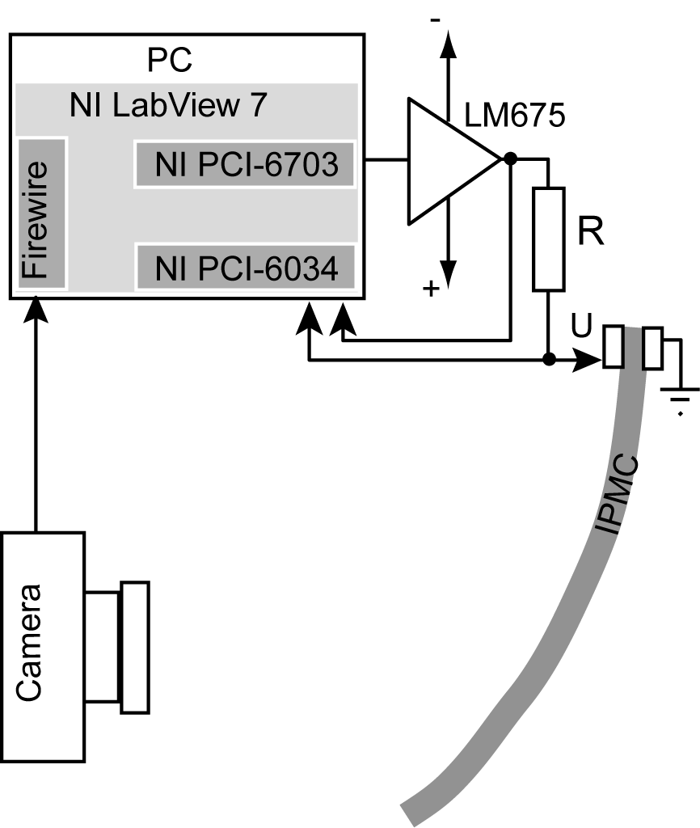
Figure 1. Experimental setup for electromechanical characterization.

The bending motions of the actuator were recorded with a firewire camera, Dragonfly Express from Point Grey Research Inc., recording images at 30 frames per second. The direction of the camera was set transverse to the actuator and the experiment was illuminated from the background through a frosted glass and a graph paper. In this camera position, the recorded image of the actuator consists of a single curved contrast line.

The resistances (conductivities) of both electrodes were measured using a four-probe system. The values of the shunt conductivity parameters were determined using impedance spectroscopy with variable-voltage step pulses as described in []. Blocking force was measured at zero displacement using the Panlab MLT0202 load cell. Sample stiffness was determined by a 3-point bending test [17].

2.4 Scanning electron microscopy
Scanning electron micrographs were obtained for all samples using a Helios Nanolab 600 microscope in secondary electron image mode with a 5 keV accelerating voltage and magnification of 350x and are given and discussed in next chapter.

3. Results and discussion

The cross-sections of prepared CIL-EAPs were probed using SEM, in order to investigate electrode layer thicknesses and adherence to the ionic polymer membrane. It should be noted that samples must have possibly very similar electrode thicknesses as the dimensions of electrodes can strongly affect the comparison of actuation performance. Figure 2 shows the SEM cross-sectional views of the samples with activated and non-activated carbon aerogel electrodes. It is clearly seen that electrode thicknesses on both sides of the membranes are exceptionally similar, as well as the thicknesses in case of different samples tested. The electrode layer thickness is in the range of 25 – 40 µm and has an average value of 30 µm. The boundary line between the ionic polymer membrane and carbon electrode is hardly distinguishable, which indicates that the electrodes are well bonded with the Nafion membrane.

Figure 2. SEM cross-sectional micrographs of CIL-EAPs with different electrodes: A) activated B) non-activated carbon aerogel electrodes.

Prepared CIL-EAP actuators were characterized in terms of maximum strain, strain rate, capacitance, electrode surface resistance, blocking force and stiffness (Young modulus). Table 2 represents a summary of performed the measurements performed. The results were obtained by measuring three samples for each electrode material (non-activated and activated carbon aerogel). In case of all experiments, the standard deviation percentages (error %) were below 15%.

First, the electrode surface resistance was measured in order to make sure that there are no significant cracks or disjunctions in the electrode layer, which may occur during the hot-pressing procedure. As observed in Table 2, the electrode resistances range from 0.3 to 0.4 ohms Ω/cm. These measurements confirm that the gold foil on the surface is in great a good condition, providing good conductivity along the sample length. Exceptionally similar values in electrode resistances also assure that the samples can be adequately compared in terms of other characteristics. It should also be mentioned that these results are in good agreement with our previously reported data for actuators based on carbide-derived carbon (CDC) and activated carbon electrodes (see Table 3), which show that the used manufacturing process (direct assembly process) provides a good reproducibility.

Table 2. Summary of the results based on carbon aerogels (measured at ±2 V rectangular actuation signal).
Electrode material | Maximum peak-to-peak strain (%) | Maximum strain rate (%/s) | Capacitance (mF/cm²) | Electrode surface resistance (Ω/cm) | Blocking force (mN) | Stiffness (MPa)
Non-activated carbon aerogel | 1.28 | 0.15 | 8 | 0.4 | 1.7 | 99
Activated carbon aerogel | 1.15 | 0.13 | 14 | 0.3 | 1 | 100

Table 3. Properties of our previously reported actuators prepared from carbide derived carbon materials (measured at ± 2 V rectangular signal).
Electrode material | Maximum peak-to-peak stain (%) | Maximum strain rate (%/s) | Capacitance (mF/cm²) | Electrode surface resistance (Ω/cm) | Blocking force (mN) | Stiffness (MPa)
Carbide derived carbon (CDC) | 2.04 | 0.23 | 16 | 0.7 | 3.6 | 97
Activated carbon | 1.03 | 0.16 | 51 | 0.6 | 3.1 | 103

Another property that can greatly affect the electromechanical properties (blocking force and strain) is the sample’s stiffness i.e. Young modulus. The stiffness was determined by the 3-point bending test, described in []. As can be seen from the data in Table 2, respective values of Young modulus for both samples are around 100 MPa. Since there is almost no variation in Young modulus, the sample’s stiffness will not affect the comparison of other electromechanical parameters. The data also compares well to our previous work (see Table 3), in which the Young modulus for actuators based on CDC and activated carbon electrodes were 97 MPa and 103 MPa, respectively. The results indicate that the sample’s stiffness is mainly determined by the fabrication process, not by specific porous electrode material or binding polymer framework, which is similar in the samples. All samples were prepared as similar as possible, which explains very minor variations in stiffness obtained.

The maximum strain was calculated according to the equation described in []: ,
where d is the thickness, L is the free length and δ is the displacement of the actuator. The measurements show that the actuators with non-activated and activated carbon aerogel electrodes are capable for generating strains up to 1.28% and 1.15%, respectively, at ± 2 V actuation signal applied, respectively. These peak-to-peak strains are comparable to our previously reported data for carbide derived carbon actuators (Table 3) and best to our knowledge to any other low-voltage driven EAP actuators. It is interesting to note that although activated carbon aerogel has significantly higher specific surface area than non-activated carbon aerogel, they perform relatively similar in terms of strain. As can be seen on the plots of pore size distributions in figure Figure 2, the activated carbon aerogel, while having almost the same pore distribution in micropore range (> 1 nm), exhibits considerably higher amount of nanopores in range of 0.5 – 0.6 nm. Nanopores of this size range, however, are probably too small to be easily accessible for electrolyte (EMI-TF) ions (the size of EMI⁺ is 0.71 x 0.50 x 0.475 nm). Therefore, the actuation is mainly generated in bigger micro- and mesopores, which are freely accessible for electrolyte ions (under the applied electric field, the repulsive interactions between the ions in formed double layer induce the actuation). As can be observed in figure 2 Figure 3, both carbons have almost identical pore size distribution in micropore range (> < 1 nm), which explains similar performance in strain output.
When compared to the previous results, the newly developed actuators outperform the activated carbon [] while lagging behind the CDC electrodes []. This is probably related to the structural differences between these materials. As discussed in [10], CDC has very uniform and well-structured framework, being easily stretched out upon the ionic interactions, which gives rise to better actuation performance. Activated carbon with relatively non-uniform structure is too rigid to be deformed by electrostatic interactions. Carbon aerogel, also having relatively rigid structure, shows enormously high pore volume (see Table 1), which facilitates the ion migration (displacement) in electrodes, thereby showing better performance compared to the activated carbon.

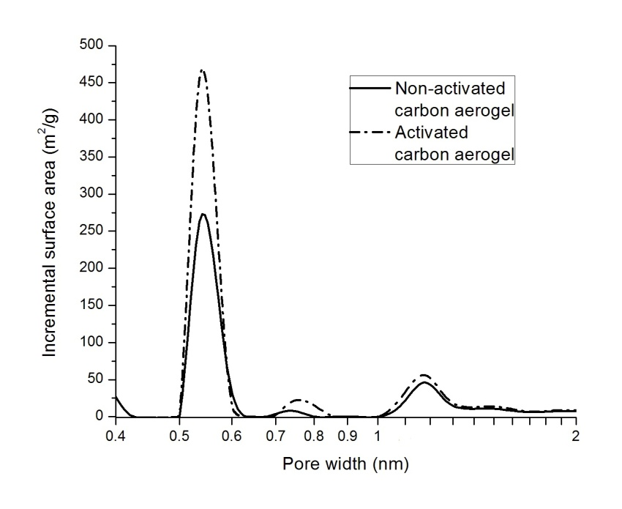
Figure 2 3. Incremental pore size distributions of activated and non-activated carbon aerogel.

The maximum strain rate was calculated from recorded video clip, indicating the highest speed that the sample experiences while actuating from one maximally deflected position to another. As the measurements show, the maximum strain rates for non-activated and activated carbon aerogel electrodes are 0.15 %/s and 0.13 %/s. Appears Thus it appears that the differences in results are relatively minor. The actuator’s speed is closely related to the porous structure of electrode, since it directly affects the electrolyte migration rate of electrolyte ions. As discussed earlier, both carbons have almost the same microporous structure, which also explains rather small variation in strain rates observed.

As mentioned before, the interfacial area between the electrodes and electrolyte greatly affects the actuation performance (strain output). In this regard, the capacitance measurements were performed, in order see to analyse how the specific surface area of electrodes correlates with actuation. Typically, higher capacitance indicates larger interfacial surface area and more electrolyte is involved in double layer formation process, which in turn refers to a greater strain due to the stronger repulsive interactions in double layer. However, in the context of the data presented here, the capacitances are not in correlation with respective strain values of the samples analysed. Non-activated carbon aerogel, showing slightly higher strain, has considerably lower capacitance (8 mF/cm²) compared to the activated carbon aerogel (14 mF/cm²). This is actually not unexpected, This result can be expected, since different electrode materials with different structures are compared. As discussed earlier, activated carbon aerogel has significantly higher amount of nanopores (< 1 nm) compared to the non-activated carbon aerogel. The However the nanopores are too small to be freely passable penetrable for electrolyte ions, but they may still contain adsorbed electrolyte ions that are immobile and are constrained in the pores. These immobile ions are not contributing to the actuation step, but still give rise to the capacitance, which explains high the higher capacitance for activated carbon aerogel electrodes, while having slightly lower bending performance for actuators under study.

4. Conclusions
5. References

* Corresponding author: Alvo Aabloo, alvo@ut.ee, http://www.ims.ut.ee
Electroactive Polymer (EAP) Actuators as Artificial Muscles, Reality, Potential, and Challenges (Ed.: Y. Bar-Cohen), 2nd ed., SPIE Press, Washington, DC, 2004.
Oguro, K., Kawami, Y. and Takenaka, H., “Bending of an ion-conducting polymer film-electrode composite by an electric stimulus at low voltage,” J. Micromachine Soc., 5, 27–30 (1992).
Kim K J and Shahinpoor M 2003 Ionic polymer-metal composites: II. Manufacturing techniques Smart Mater. Struct. 12 65-79.
Punning, A., Kruusmaa, M. and Aabloo, A., “Surface resistance experiments with IPMC sensors and actuators,” Sens. Actuators A, 133, 200-209 (2007).
Shahinpoor M and Kim K J 2001 Ionic polymer-metal composites - I. Fundamentals Smart Mater. Struct. 10 819-33.
Bennett, M. D. and Leo, D. J., “Ionic liquids as stable solvents for ionic polymer transducers,” Sens. Actuators A, 115, 79-90 (2004).
Akle, B. J., Bennett, M. D., Leo, D. J., Wiles, K.B. and McGrath, J.E.,“Direct assembly process: A novel fabrication technique for large strain ionic polymer transducers,” J. Mater. Sci., 42, 7031-7041 (2007).
Akle, B., Nawshin, S. and Leo, D., “Reliability of high strain ionomeric polymer transducers fabricated using the direct assembly process,” Smart Mater. Struct., 16, S256-S261 (2007).
Fully Plastic Actuator through Layer-by-Layer Casting with Ionic-Liquid-Based Bucky Gel Takanori Fukushima, Kinji Asaka, Atsuko Kosaka, Takuzo Aida p. Angewandte Chemie International Edition Volume 44, Issue 16 2410 2005.
V. Palmre, D. Brandell, U. Mäeorg, J. Torop, O. Volobujeva, A. Punning, U. Johanson, M. Kruusmaa and A. Aabloo, “Nanoporous carbon-based electrodes for high strain ionomeric bending actuators”, 2009 Smart Mater. Struct. 18 095028
Yoon Jae Lee, Ji Chul Jung, Sunyoung Park, Jeong Gil Seo, Sung-Hyeon Baeck, Jung Rag Yoon, Jongheop Yi and In Kyu Song, “Preparation and characterization of metal-doped carbon aerogel for supercapacitor,” Current Applied Physics, Volume 10, Issue 3, 947-951 (2010).
Julien Marie, Regis Chenitz, Marian Chatenet, Sandrine Berthon-Fabry, Nathalie Cornet and Patrick Achard , “Highly porous PEM fuel cell cathodes based on low density carbon aerogels as Pt-support: Experimental study of the mass-transport losses,” Journal of Power Sources, Vol 190, Issue 2, , 423-434 (2009).
F. Pérez-Caballero, A.-L. Peikolainen, M. Uibu, R. Kuusik, O. Volobujeva and M. Koel, “Preparation of carbon aerogels from 5-methylresorcinol-formaldehyde gels”, Microporous and Mesoporous Materials, 108, 230-236, (2008).
Akle, B., Bennet, M. D. and Leo, D. J., “High-strain ionomeric–ionic liquid electroactive actuators,” Sens. Actuators A, 126, 173-181 (2006).
Punning, A., Kruusmaa, M. and Aabloo, A., “A self-sensing ion conducting polymer metal composite (IPMC) actuator,” Sens. Actuators A, 136, 656–664 (2007).
Punning, A., Johanson, U., Anton, M., Aabloo, A. and Kruusmaa, M., “A Distributed Model of Ionomeric Polymer Metal Composite”, J. Intell. Mater. Syst. and Struct., 20, 1711-1724 (2009).
B. S. Mitchell, An introduction to materials engineering and science for chemical and materials engineers, Michigan, (J. Wiley 2004) 416.
Ichiroh Takeuchi, Kinji Asaka, Kenji Kiyohara, Takushi Sugino, Naohiro Terasawa, Ken Mukai, Takanori Fukushima and Takuzo Aida, “Electromechanical behavior of fully plastic actuators based on bucky gel containing various internal ionic liquids,” Electrochimica Acta, Volume 54, Issue 6, 1762-1768 (2009).

