Materials 2009, 2, 1-x manuscripts; doi:10.3390/ma20x000x
OPEN ACCESS
materials
ISSN 1996-1944
www.mdpi.com/journal/materials
Article
Nanoporous carbide-derived carbon material based linear actuators
Janno Torop ¹, Mati Arulepp ², Jaan Leis ^{2,3}, Andres Punning ¹, Urmas Johanson ¹, Viljar Palmre⁽¹⁾ and Alvo Aabloo ^{1,} *
¹ IMS Lab, Institute of Technology, University of Tartu, Nooruse1, 50411 Tartu, Estonia
² Carbon Nanotech Ltd., Riia 185, 51014 Tartu, Estonia
³ Institute of Chemistry, University of Tartu, Ravila 14a, 50411, Tartu, Estonia
E-Mails: janno.torop@ut.ee (J. T.); alvo.aabloo@ut.ee (A. A)
* Author to whom correspondence should be addressed; E-Mail: alvo.aabloo@ut.ee;
Tel.:+372-7-375-534; Fax:+ 372-7-374-825
Received: / Accepted: / Published:

Abstract: Devices using electroactive polymer-supported carbon material can be exploited as alternatives to conventional electromechanical actuators in applications where electromechanical actuators have some serious deficiencies. One of the numerous examples is precise microactuators. In this paper, we show for first time the dilatometric effect in nanocomposite material actuators containing carbide-derived carbon (CDC) and polytetrafluoroetylene polymer (PTFE). Transducers based on a high surface area carbide-derived carbon electrode materials are suitable for short range displacement applications, because of the proportional actuation response to the charge inserted, and high Coulumbic efficiency due to the EDL capacitance. The material is capable to develop stresses in the range of tens N cm⁻². The area of an actuator can be dozens of cm², which means that forces above 100 N are achievable. The actuation mechanism is based on the interactions between the high-surface carbon and the ions of the electrolyte. Electrochemical evaluations of the four different actuators with linear (longitudinal) action response are described. The actuator electrodes were made from two types of nanoporous TiC-derived carbons with surface area (S_{A}) of 1150 m²·g⁻¹ and 1470 m²·g⁻¹, respectively. Two kinds of electrolytes were used in actuators: 1.0 M tetraethylammonium tetrafluoroborate (TEABF₄) solution in propylene carbonate and pure ionic liquid 1-ethyl-3-methylimidazolium trifluoromethanesulfonate (EMITf). It was found that CDC based actuators exhibit a linear movement of about 1% in the voltage range of 0.8 V to 3.0 V at DC. The actuators with EMITf electrolyte had about 70% larger movement compared to the specimen with TEABF₄ electrolyte.
Keywords: Linear actuator; Porous carbon; Ionic liquid; Carbide-derived carbon; Electroactive polymer (EAP) actuator

1. Introduction
Electroactive materials can respond to electrical stimulus with a significant shape or size change. Polymer-composite electroactive materials are the object of interest due to their small dimensions and the possibility to make displacement in any direction. These materials can be cut (almost) in any shape and form, and some of them, for example, the respective materials like ionic polymer metal composites (IPMC) may work at relatively low voltages (1 - 5 V) [1- 4]. These properties make them valuable as mechanical actuators in applications where conventional actuators have their natural limitations. One of the promising areas of application is biomedical devices. EAP actuators are soft, easy to miniaturize and some of them can operate at low voltages.
There are, however, some issues with the actuator materials not completely solved. The main problems are the short lifetime, the complexity of manufacturing process, not sufficient reproducibility of properties of formed actuators, the insufficient control and guidance of the actuator movement. It has been reported that the movement depends mainly on the used charge and not on the applied voltage. High-speed actuators with relatively high power are still a challenge [2, 5].
Several types of carbon based electroactive materials are widely known [5]. Carbon nanotubes (CNT), fullerenes and graphene like structures are one of the attractive candidates for actuators. These materials have uniquely high mechanical actuation force properties, but low strain [6]. Carbon based actuators predicate on two main actuation mechanisms. The first principle is based on the electronic conductivity of carbon material. Actuators of such type need high electrical potential (field) for actuation [7]. Actuation occurs due to carbon-carbon interaction change due to high electrical field. Another principle is ion and ion pairs’ diffusion induced by applied low potential. These transducers usually combine carbon materials with polymer matrix and some ionic conducting media. They seem to have much more possible applications in near future [8, 9].
Che Guangli et al. made the first example of an actuator based on a nanostructured carbon material. The actuator consisted of branched carbon nanotubules embedded within the pores of a microporous alumina template membrane and graphitic carbon used as the electroactive material. Electrochemical Li⁺ intercalation caused this nanotubule-containing membrane to flex, and electrochemical de-intercalation causes the membrane to relax to its original position [10].
CNT has been one of the most intensively studied carbon material [1]. The first actuator made of CNTs was a macro scale sheet of nanotubes termed bucky gel-paper [12-15]. This actuator produced strain due to the change in dimension of the nanotubes in the covalently bonded direction caused by an applied electric potential. Created excess charge is compensated at the nanotubes - electrolyte interface by the electrolyte ions forming a double layer. The charge induces ion movement, which leads to a change in the dimension of the nanotube paper causing the assembly to bend. Soon after the bucky paper actuator demonstrated actuation of single-walled carbon nanotubes (SWNT), in which the SWNT were suspended over a trench, and the edges fixed at the surface with a metal layer. The charging leads to a rearrangement of the electronic structure of the nanotubes, and to Coulombic forces, both of which result in dimensional changes [14].
Besides CNT-s, several microporous- and graphitic carbons were studied by means of dilatometry by Campana and Hahn et al [18]. The graphitic carbon exhibited highest volume change (10-15%), whereas the expansion was observed at voltages between -2.0 and +2.5 V ($∆$U=4.5 V). The microporous carbons had the expansion about ~5% at voltages below -1.0 V and above +1.0 V ($∆$U=2.0 V) [18]. The in situ Raman spectroscopy technique was applied to study ion intercalation behavior into the carbon body [19].
Behind several traditional nanostructured carbons like CNT-s, fullerenes and graphene-, the high surface area amorphous carbon is also an interesting candidate for actuators. The actuation phenomenon of porous carbon was discovered while searching appropriate material for the new alternative energy storage devices [21].
Figure 1. A structure (a) and High Resolution Transmission Electron Microscope (HRTEM) picture (b) of amorphous microporous carbon.
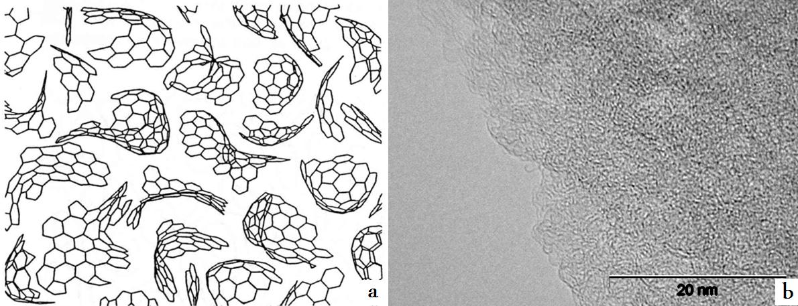

Microporous amorphous carbons have non-uniform distribution of the curved graphene flakes as shown in Figure 1. Carbon atoms have hybridization of sp², but graphene particles form 3D network. Due to non-uniform structure, it is quite difficult to describe porous carbon, because HRTEM images only show a very small area of samples. [22].
So called template carbons which based on metal carbides are of interest in energy storage devices beside of widespread activated carbons commonly produced from thermal decomposition of organic precursor material and successive water vapor activation, because the pore size is tunable due to synthesize parameters and by modifying the template. One of the representatives of template carbons is carbide-derived carbon (CDC), which is obtained by extracting the non-carbon atoms from the carbide lattice. The CDC-s are investigated as promising candidates for electric double layer capacitor (EDLC) electrode materials, for adsorbents of low molecular weight gas (CH₄, H₂ etc.) and for electron emission sources [23, 24]. These materials usually possess high surface area (1000-2000 m²·g⁻¹), controlled micro-pore volume and pore size distribution. The advanced CDC materials have high electric double layer (EDL) capacitance (130 F·g⁻¹ and 90 F·cm⁻³ in nonaq.), high electric energy conversion efficiency, very good material stability and the chemical inertness. Supercapacitors based on CDC have shown electrode lifetimes up to 10⁶ cycles [25].
The expansion of the carbonaceous electrodes is generally undesired, and a crucial factor for the lifetime of energy storage devices. Hahn et al. have performed dilatometric studies on the porous and graphitic carbon electrodes and observed significant reversible volumetric change of the electrodes during the charging-discharging. This confirms the electroactive properties of porous carbon [18- 20].
The volume changes of the supercapacitor materials during the charging process were previously observed by Hahn et al. [17, 18]. In principle, the design of ionic polymer actuator described in this paper is comparable to supercapacitors. Thereby, relying on association by similarity, the electroactive mechanism of nanoporous carbon electrodes is related to electric double-layer formation during charging of material, and the dimensional change of the actuator is the consequence of charge injection in carbon nanopores during the electric double-layer charging. It is also reported that particular gas evolution (Faradic process) on the micro-pores could be a reason of the carbon actuation process, but using TEABF₄ salt in propylene carbonate solution and ionic liquid EMITf the electrochemical reactions are marginal in the voltage range of 0 to 3.0 V [27-29].
In this paper, we show for first time the dilatometric effect in actuators containing the CDC materials. Transducers based on a high surface area carbide-derived carbon electrode material are suitable for short range displacement applications, because of proportional actuation response to the charge inserted and high Coulumbic efficiency due to the EDL capacitance. The films/sheets made from the material change their thickness, so it is possible to fabricate a device with linear actuation properties.
2. Preparation of actuators
2.1. Synthesis of carbide-derived carbon
Titanium carbide loaded into the horizontal quartz reactor was reacted with a flow of chlorine gas (99.999% assay) at reaction temperatures 600 °C or 800 °C until all carbide was converted into carbon. A flow rate of chlorine gas was set so that the optimum mass transfer of gaseous reactants and products occurred, which depended on reaction volume, and the reaction temperature. The mass balance of titanium carbide chlorination reaction is expressed by the Equation 1 describing the corresponding chemical reaction.
$TiC+{2Cl}_{2}→C+{TiCl}_{4}↑$ (1)
The by-product, TiCl₄, was evacuated from reactor by the stream of the excess chlorine. During the heat-up and cooling phase, the reactor was flushed with a slow stream of argon. Resulting carbon powders were finally purified in the flow of hydrogen at 800 °C. The sample chlorinated at 800 °C was additionally oxidized according to the method of the high-temperature treatment of the carbon previously saturated with the trapped water in nanopores [30].
2.2. Preparation of the electrodes
CDC powder (1 g) was mixed with a small amount of ethanol and 10% (by wt.) of PTFE (as a 60% suspension in water) to form slurry, which thereafter was gently pressed until a wet material was formed. After evaporation of ethanol, the material was impregnated with heptane, shaped to a cylinder and rolled in the axial direction of the cylinder. The latter procedure was repeated until elastic properties appeared to the carbon sheet. Finally, the heptane was removed at ~110 ºC, the carbon sheet was rolled stepwise down to the desired thickness, dried in vacuum at 170 ºC and coated from one side with a thin (~2 μm) aluminum layer, using Plasma Activated Physical Vapor Deposition. The electrode discs of desired size were cut from these sheets.
2.3. Assembling of the actuators
Linear actuators 1 – 4 (see Table 1) were assembled from the pairs of carbon electrode discs (∅ 1.7 cm), separated with an ion-permeable separator paper from Kodoshi Nippon (cf. Fig. 2). Each actuator consisted of five electrode pairs with a total geometric surface area of 11.35 cm². The electrode assembly was placed in a sealed aluminum container. Additional mechanical pressure (p=48 N cm⁻²) was applied by a spring through a special connecting rod. This rod was further used for measuring the linear movement of actuator by a laser beam.
Fig. 2. The principal scheme of linear actuators.
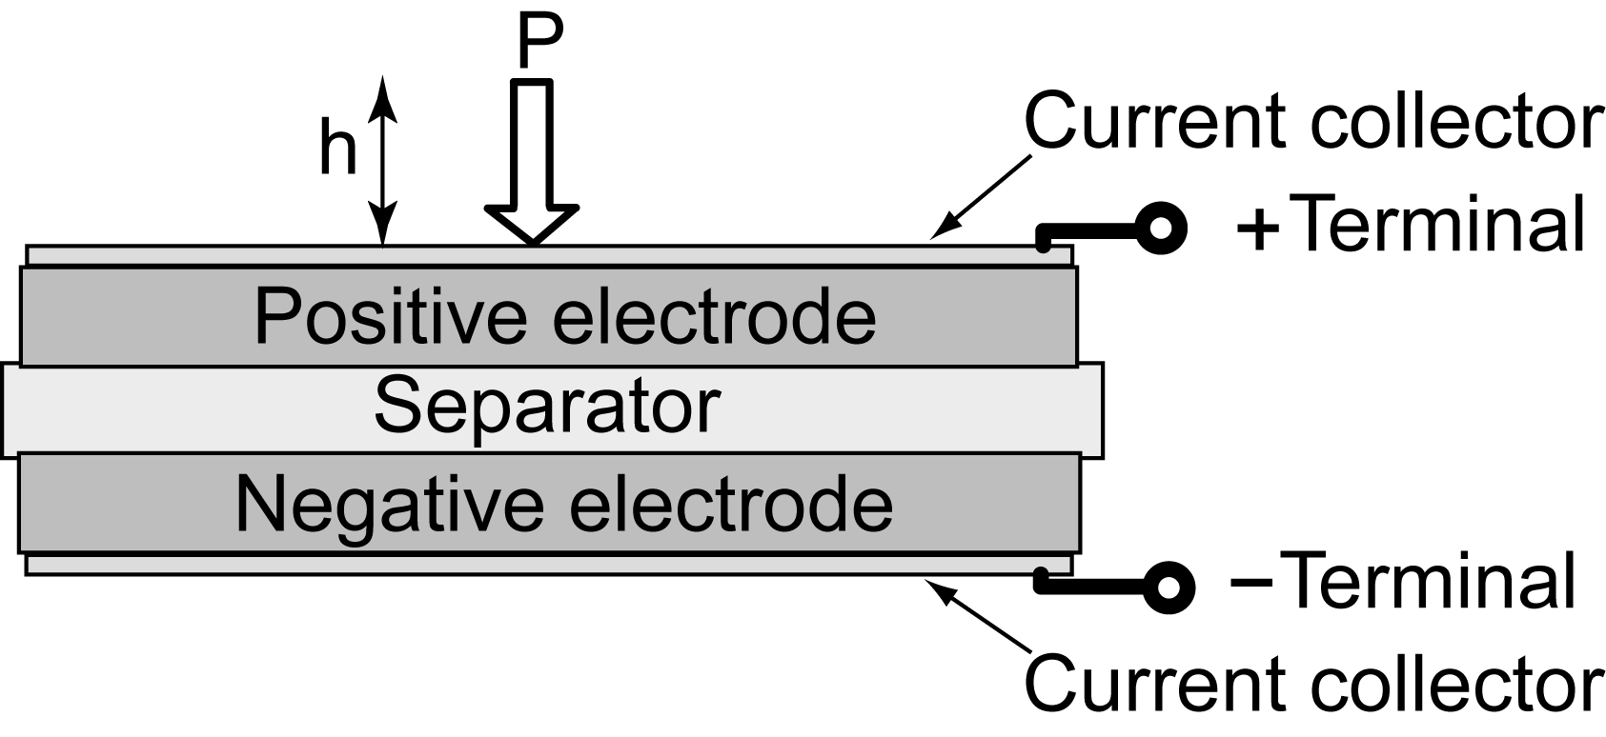
The actuator cells were vacuumed at 120° C for 24 h before being impregnated with the electrolyte. The electrolytes used in this study were 1.0 M tetraethylammonium tetrafluoroborate in propylene carbonate (“Honeywell Digirena ®” TEABF₄/PC, H₂O < 0.003 %) and the ionic liquid 1-ethyl-3-methylimidazolium trifluoromethane-sulfonate (EMITf, Fluka).
Table 1. The actuators in this study
Actuator  # | Notation of actuator | Notation of CDC material | Electrolyte
1 | TEA600 | TiC-600 | 1.0 M TEABF₄/PC
2 | TEA800 | TiC-800 | 1.0 M TEABF₄/PC
3 | EMI600 | TiC-600 | EMITf
4 | EMI800 | TiC-800 | EMITf

Before evaluation, the actuator cells were kept at 60 °C for 48 h, to saturate the compact nanoporous electrode body with the electrolyte. Thereafter, continuous galvanostatic cycling between 2.7 V and 0.05 V with the current I = 100 mA was carried out, prior to performing the further studies. The purpose of preliminary galvanostatic cycling is to distribute the electrolyte ions and decompose the traces of H₂O as well as to inactivate other possible impurities. Usually 5 cycles were needed to establish a stable actuation of the electrochemical system.
2.4. Evaluation of carbon materials
The low-temperature nitrogen sorption experiments were performed at boiling temperature of nitrogen (77 °K). The specific surface area (S_{A}) was calculated according to the BET theory [31] up to the nitrogen relative pressure (P/P₀) of 0.2. The total volume of pores (V_{p}) was calculated at relative pressure (P/P₀) of 0.95 and the volume of the micropore (V_{μ}) from t-plot, using Harkins-Jura thickness values between 5Å and 90Å calculated according to the Equation 2.
$t=\sqrt{\frac{13.99}{0.034-log\frac{P}{P_{0}}}}$ (2)

Average pore size (APS) is calculated according to the Eq. 3.
$APS=\frac{{2V}_{p}}{S_{A}}$ (3)

Table 2. Some physical parameters of TiC derived carbons
Notation of CDC material | T_{Chlorin} [°C] | S_{A}  [m² g⁻¹] | Vp  [cm³ g⁻¹] |  | V_{μ}  [cm³ g⁻¹] |  | APS  [Å]
TiC-600 | 600 | 1150 | 0.53 | 0.49 |  | 9.3
TiC-800 | 800 | 1470 | 0.71 | 0.59 |  | 10.2

3. Electrochemical properties
3.1. Experimental setup
Electrochemical characterization of the actuators was performed in sealed electrochemical cell at room temperature, by using the Solatron potentiostat 1287 with FRA analyzer. Experiments of cyclic voltammetry (CV), constant current (CC), constant potential (CP) and electrochemical impedance spectroscopy (EIS) techniques were carried out. The CV was performed at different voltage sweep rates: 2, 5, 10 ja 50 mV s⁻¹. The region of working voltage was varied in the interval of: 0 − 2.5 V, 0 − 2.7 V and 0 − 3 V. The galvanostatic measurements were performed in the current range of 10 − 1000 mA at voltages from 0.05 V to 3 V. The impedance spectra were recorded at fixed DC potentials: 1.5 V; 2.5 V and 2.7 V, using an AC signal of 5 mV.
3.2. Results of electrochemical measurements
The charge-discharge capacitance calculated from the cyclic voltammetry plots of actuators is shown in Figures 3a and 3b. Note that the specific capacitance is expressed per dry weight of carbon (F·g⁻¹).
Figure 3. Capacitance vs. voltage of the actuators EMI600 (a) and EMI800 (b) at different voltage sweep rates.
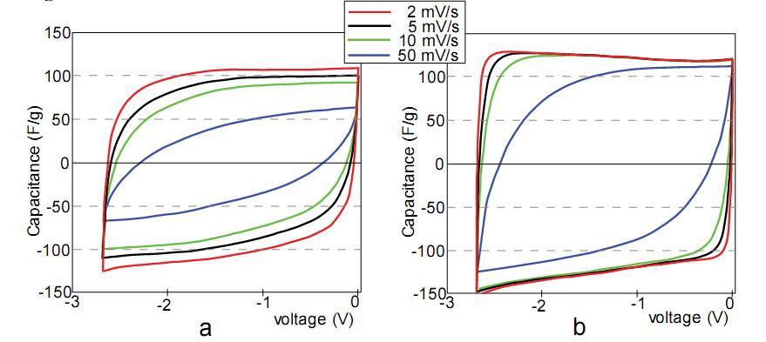

The cyclic voltammetry analyses of the actuators show a non-faradic charging behavior, and the electrical double layer capacitance is predominant in the voltage range of 0 to 2.7 V. Generally, it is known that the specific capacitance may depend on the voltage sweep rate. In our study, the main difference between the linear actuators EMI600 and EMI800 is the carbonaceous material used in assembly. The actuator EMI600 was made from nanoporous TiC-600 carbon with the average pore size of APS = 9.3 Å, whereas carbon in the actuator EMI800 has slightly increased APS of 10.2 Å. In Figures 4a and 4b, it is seen that in case of EMI600 the potential sweep rate has a large influence on the capacitance. However, the specific capacitance of EMI800 is almost independent of voltage sweep rate. The observed differences in specific capacitance can be explained by different nanostructure and pore distribution of investigated carbon materials. TiC-800 has a sparse media with slightly higher pore volume compared to TiC-600. Hence, a sparse microstructure of TiC-800 provides higher mobility of electrolyte ions and dependencies to voltage sweep rate will become obvious at higher values. Similar behaviors were observed for TEA600 and TEA800, which differ from the EMI600 and EMI800 by the electrolyte used (1.0 M TEABF₄/PC vs. EMITf).
The EIS measurements were carried out at AC signal 5 mV and fixed DC potentials 2.5 V and 1.5 V in frequency range of 1 MHz to 5 mHz. The capacitance (C_{S}) was calculated at the frequency of 10 mHz and resistance of the actuators (R_{S}) at 100 Hz using the model of a series RC- circuit. The phase angle (Θ) for the ideal capacitors is –90°. In current study, the measured phase angle values of the actuators were in the range of –55° to –72°. The EMI600 sample has higher resistance than EMI800, and it has also lower capacitance than EMI800. This phenomenon can be explained by the fact that both devices EMI600 and EMI800 used the same EMITf electrolyte which has the unsymmetrical cation with the ionic radii of 7.6×4.3 Å, but almost symmetric anion ~4 Å. Apparently, part of the nanopores in EMI600 are not suitable for adsorbing the cations due to the steric restrictions, which results in the decreased capacitance and the increased internal resistance. This fact is partly proven by the data of EMI800, which uses the same electrolyte, but has slightly larger nanopores in the carbon. The EMI800 has highest capacitance and also low internal resistance, which indicates on the best fit between the porous structure and the size of electrolyte ions. The calculated data from the EIS measurements is presented in Table 3.
Table 3. The series capacitance (C_{s}), series resistance (R_{s}) and phase angle (Θ) obtained from EIS spectra.
Notation of actuator | C_{s}  [F·g⁻¹] | R_{s}  [Ω∙cm²] | Θ  [ °]
TEA600 | 64 | 3.9 | -71
TEA800 | 112 | 9.3 | -72
EMI600 | 75 | 7.3 | -55
EMI800 | 121 | 4.6 | -71

4. Electromechanical characterization
4.1. Modes of electromechanical measurements
The extent of actuation of the actuators in time-domain was detected using a custom-made optical system. The measurements were performed in two modes:
- the constant current charge-discharge process (CC mode);
- the current of the actuator is limited and the relatively short period of constant current is followed by a prolonged period of constant potential (CCCP mode).
4.2. Experimental setup
The test cell of the linear actuator is depicted in Fig. 4. It consists of two fundamental parts: the electrochemical actuator and the optical detecting mechanism. The actuator is assembled in a sealed cell. The cell incorporates a spiral spring, compressing the actuator by the force of 100 N. The optical system is mounted on the top of the cell. The mechanical coupling between the actuator and the optical system is implemented by a shifting vertical rod. The movement of the rod is transferred to the moving mirror using a steel eccentric and a lever. This mechanics magnifies the scale of movement of the actuator by 25 times. Further magnification of the scale is performed by a laser beam, reflecting from the mirror and targeted to a distant screen, as depicted in Fig. 5.
Figure 4. The linear actuator test cell.
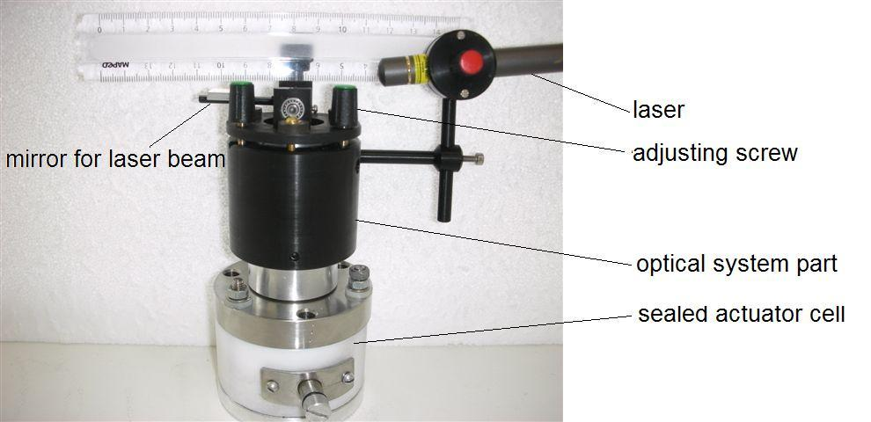

The described optical system is able to magnify the scale of movement of the linear actuator by thousands of times, depending solely on the distance of the screen. In the course of the experiments, the distance to the screen was 6.25 m and the expansion of the actuator by 1 μm was detectable as a displacement of the spot of the laser beam on the screen by 1 cm. The displacement of the spot on the screen was recorded by a firewire camera and the motion was thereafter digitalized using LabView software. Simultaneously, the electrical parameters - voltage and electric current - were recorded using National Instruments PCI-6034 DAQ card and LabView software. The electric current was measured as a voltage drop over the low ohmic resistance R.
Figure 5. Experimental setup

4.3. CC mode experiments
In this mode, the actuation amplitude was estimated using the constant current charge-discharge process. The amperage of the constant current I_{C} was varied in the range of 10 to 400 mA. The actuation amplitude was recorded simultaneously with charging or discharging current characteristics of the actuator. The potential of the electrodes gained some certain predefined values, e.g. 1.5, 2.0, 2.5 and at 3.0 V. The results of the measurements are given in Figure. 6.
Figure 6. The actuation of the actuators at different voltages obtained at charging current I_{C} = 10 mA.
The graph reveals that the four actuators function almost similarly - the difference between the amplitudes of actuation is less than 20% - at the voltages up to 2.5 V. At higher voltages the dissimilarity increases. At 3.0 V the difference between the actuation of TEA600 and EMI600 is almost twofold.
In CC mode, the electrical energy E is derived from the voltage diagram according to Equation 4.
$E=\int_{t_{1}}^{t_{2}}{U\left(t\right)dt}$ (4)
It is possible to evaluate the energy loss E_{loss} = E_{out} - E_{in} of the actuators during a single working cycle by defining the electrical input energy (E_{in}) of the actuator as the energy of its charging current and defining the output energy (E_{out}) as the energy of discharging current. The calculated energies at different values of charge-discharge currents are given in Table 4. The loss of energy is contingent on charging, relocating the ions, and probably on the microscopic dimensional changes. Another possible reason of energy loss can be the ongoing faradic process. However, the impedance spectroscopy of the actuators did not reveal any of it.
Table 4. Electrical energies (J) and maximum actuation of the linear actuators (μm) at different amperages of the charge-discharge current (ΔU=3.0 V).
I_{C} | 70 mA |  |  |  | 300 mA
 | E_{in}  (J) | E_{out}  (J) | E_{loss}  (J) | actuation  (μm) | E_{in}  (J) | E_{out}  (J) | E_{loss}  (J) | actuation  (μm)
TEA600 | 15 | 11.9 | 3.1 | 4.0 | 12.2 | 6.6 | 5.6 | 2.4
TEA800 | 25 | 16 | 9 | 8.0 | 18.9 | 11.3 | 7.6 | 5.0
EMI600 | 18.9 | 11.5 | 7.4 | 7.2 | 8.3 | 2.8 | 5.5 | 1.5
EMI800 | 25 | 19.8 | 5.2 | 6.0 | 20 | 10.8 | 9.2 | 3.0

Table 4 shows that there exists a correlation between the energy loss and the amplitude of actuation of the actuators at charging current of 70 mA. Actuator TEA800 possessed the highest energy loss during charging cycle and TEA800 overcame the other studied actuators in actuation rate at 70 mA and 300 mA. This indicates that the electrical energy is transferred into mechanical energy and loss of energy during charging cycle is proportional to the displacement generated by the actuators. The charge injection mechanism for the actuation of carbon is non-faradaic, whereupon the charging of the actuator of capacitive nature causes the relatively large changes in the covalent bond lengths due to the structure of the band and the Coulombic effects. The actuation is caused by the microscopic dimensional changes of the carbon-polymer electrodes.
At the charging current of 300 mA, the highest actuations were exhibited by TEA800 and EMI800. In CC mode, the actuation produced by actuators with the nanoporous carbon TiC-600 is weaker than of those containing TiC-800. The correlation clearly appears at high charging current values. Polymer-supported carbon electrode materials have internal resistance, retarding the propagation of electric field in electrode sheets. At relatively high charging current values, the actuation of porous carbon material is limited by diffusion, which excludes the quick actuation response. Amount of confined ions in nanopores can be enlarged by increasing the diffusion rate. Therefore TiC-800 carbon material is preferred to give quick actuation response, due to its slightly macroporous 3D network compared to TiC-600. Viscosity of the electrolyte cannot be neglected when aiming at quick response of an actuator. TEABF₄/PC electrolyte has an observable advantage when used in TiC800 actuator to generate rapid electromechanical response. In TiC-600, the effect of the low value of viscosity of TEABF₄/PC is reduced by the fact that TiC 600 has narrower pores and TEABF₄ will render up the PC solvent shell when entering into the nanopores [30].
4.4. Estimation of actuator efficiency
The efficiencies of the actuators were calculated in two different ways (see Equations 5 and 6). Respective values are presented in Table. 5.
$Efficiency\left(E_{in}\right)=\frac{F×s}{E_{in}}×100\%$ (5)

$Differential Efficiency\left(E_{loss}\right)=\frac{F×s}{E_{in}-E_{out}}×100\%$ (6)

In Equations 5 and 6, F is a force inflicted by the spring and s is the displacement of actuators during charging. E_{in} and E_{out} are input and output energies calculated from CC mode according to Equation 4. As discussed in the previous section, E_{in}-E_{out} can be defined as an energy loss of the actuators. One component of energy loss is the energy generated by the actuator to compress the spring during the actuation. Other components of energy loss are related to carbon material inner resistance and thermal effects occur during charging cycle. E_{in} is the total electric energy inserted in the actuator during charging and efficiency calculated by E_{in} characterizes the situation when output energy E_{out} cannot be collected. In reality, collecting of output energy of actuators is convenient and therefore implementation of output energy increases an efficiency of actuators. Efficiencies in Table 5 are calculated from data collected by charging actuators with 70 mA and 300 mA. At current value 70 mA, the average efficiency of the actuators is two times higher than the value calculated at 300 mA. At 300 mA charging current value, the differences in efficiencies tend to decrease because the total energy inserted is significantly decreased compared to values measured at 70 mA. The highest efficiency value of 0.014 % was observed for actuator EMI600. At current value 70 mA EMI600 has actuation 4.0 mm, which is lowest value compared to other actuators and respective energy loss was 3.1 J (see Tab. 4). Thereby, the high efficiency of EMI600 is mainly provided by low energy loss value.
Table 5. Calculated efficiencies of the actuators at different charging current values.
I_{C} | 70 mA |  | 300 mA
 | Efficiency by E_{in} (%) | Differential  efficiency by E_{loss} (%) | Efficiency by E_{in} (%) | Differential  efficiency by E_{loss} (%)
TEA600 | 0.0029 | 0.014 | 0.0022 | 0.0047
TEA800 | 0.0035 | 0.01 | 0.0029 | 0.0072
EMI600 | 0.0042 | 0.011 | 0.002 | 0.0047
EMI800 | 0.0026 | 0.013 | 0.0017 | 0.0036

4.5. CCCP mode experiments
In order to examine the dynamics and peak of the actuation of the actuators, the CCCP mode was used - after charging the actuator to certain voltage using constant current I_{C}, a constant potential V_{C} was applied for up to 5 minutes. During the period of the constant potential, the current decreases substantially and the peak of actuation appears in few minutes. In the course of different experiments, the amperage of the constant current was varied in the range of 50 to 1000 mA.
Figure 7. CCCP measurement of EMI800 (I_{C} = 400 mA, V_{C} = 2.5 V); (a) voltage, current and actuation vs. time; (b) actuation vs. charge.

Fig. 7a depicts the diagrams of charging the actuator EMI800 in the CCCP mode. The actuation culminates and remains stable in about 120 seconds, while the voltage reaches its stable level already in 60 seconds. This diagram is very typical, similar behavior was observed for all tested actuators. The actuation-charge diagram depicted in Fig. 7b indicates that there exists a nonlinear correlation between the actuation and the electric charge of the actuator.
Figure 8. CCCP measurement of EMI800 (I_{C} = 1000 mA, V_{C} = 3 V); (a) voltage and current; (b) actuation and charge.

Figure 8 depicts the series of periodic charging-discharging cycles of the actuator. As the charging current is high, the period of constant current ceases already in a few seconds. During this time interval, almost no actuation is detected, since the voltage is low and the adsorption of ions is a diffusion-limited process in the porous electrodes. The current dies away slowly due to the internal resistance of the actuator. While discharging by short-circuiting, the adsorbed energy is wasted through the low ohmic discharge resistor.
The actuation throughout the simultaneous cycles is of similar characteristics. The peak of actuation (12 μm) is gained in the both cycles of Figure 8. The average speed of actuation can be calculated from the data of actuation, and is 0.2 μm s⁻¹. Due to the low speed of desorption of ions of the ionic liquid from the porous carbon, the process of discharging is slow and the cell does not relax to its initial thickness between the simultaneous cycles. The actuators are able to gain their initial position after about 5 minutes shorting only.

Figure 9. Actuation of EMI600 and EMI800 vs. time (a) and vs. charge (b) (I_{C} = 50mA; V_{C} = 3V).

Figure 9 depicts the comparison of the actuators EMI600 and EMI800. Both actuators expand slowly as the relatively low current (I_{C} = 50 mA) gives to the systems enough time to charge the double layer of carbon electrodes. The graph given in Fig. 9a indicates that EMI600 is faster than EMI800. After 200 seconds of charging, the actuations of the two systems differ about 4 times and EMI600 requires less charge for the same degree of actuation. When the charge of the actuators reaches 10 C, the difference between the amplitudes of actuation of the two systems is about 4 times.
Figure 10. Peak actuation in the case of different constant potentials (I_{C} = 400mA).

Figure 10 represents the extreme expansion of the actuators in the case of different constant potentials of the CCCP mode. The highest actuation was generated by EMI600. It reaches its ultimate amplitude of actuation at 2.5 V already, while the actuation of TEA600 and EMI800 are about half lower. In CCCP mode, the actuators consisting of the highly nanoporous carbon TiC-600 exhibit higher motion when compared to the carbon TiC-800 in both electrolytes. The reason of their performance can be revealed by comparing the sizes of the pores of carbon and the sizes of the ions of the ionic liquid. The average nanopore size of TiC-600 is 9.3 Å - approximately close to the size of the cations of EMITf. The density of the TiC-600 carbon material is higher than that of TiC-800. 70 % of the pores of the material TiC-600 are smaller than 11 Å, for the material TiC-800 the corresponding value is 50 %. Electrolyte ions evoke higher dimensional changes when they enter into the nanoporous carbon media with narrower pores.
EMI⁺ and Tf⁻ appear in ionic liquid as ion pairs with much larger ionic dimensions, compared to TEA⁺ and BF₄¯ in PC electrolyte. The volume changes of the actuator depend on the volume difference between cation and anion of the electrolyte used [32].
5. Conclusions
Novel linear electromechanical actuators based on TiC-derived carbon material were prepared and studied. The actuator consists of carbon material thin films and an electrolyte. Two different nanoporous carbons were used to prepare actuators combined with TEABF₄ in PC and EMITf electrolytes. The method for TiC-derived carbon synthesis offers a unique control over carbon microstructure and allows specific tuned porosity of the material. Therefore, it is possible to design a structure of CDC material to best suit the electrolyte used, and to enhance the performance of the actuators. During continuous cycling, good reproducibility of actuation was observed. Displacement of the actuators was measured simultaneously to the electrochemical measurements, and from where the electric energy and mechanical energy dependencies were calculated. The mechanical energy generated by an actuator was found to be five orders of amplitude smaller than the electrical energy provided to the actuator during charging, however during discharging at least 80 % of the stored electrical energy can be collected, which improves the efficiency of the actuators by almost two orders of magnitude. The advantage of described linear actuator is not only the considerably high force generated during actuation, but also the long life cycle and high capacitance due to the device being evolved from a material commonly used in supercapacitors.
Acknowledgements
The authors wish to thank colleagues from Carbon Nanotech Ltd for the kind assistance in preparing CDC carbon. Dr. Gunnar Svensson, Stockholm University, is thanked for the HRTEM study of carbon materials. Financial support from Estonian Ministry of Education and Science, Estonian Information Technology Foundation and CRDF-ESF common grant is very much appreciated.
References and Notes
1. Shahinpoor, M.; Kim, K. J.; Novel ionic polymer-metal composites equipped with physically loaded particulate electrodes as biomimetic sensors, actuators and artificial muscles. Sens. Actuators, A: Phys. 2002, 96, 125-132.
2. Robinson, J. W. Charge control of ionic polymers. Blacksburg, Virginia, USA 2005
3. Punning, A.; Kruusmaa, M.; Aabloo, A. Surface resistance experiments with IPMC sensors and actuators. Sens. Actuators: A. Phys. 2007, 133, 200-209.
4. Wilsona, S. A.; Jourdaina, R.-P. J.; Zhanga, Q.; Doreya, R. A.; Bowenb C. R. et al. New materials for micro-scale sensors and actuators: An engineering review. Materials Science and Engineering: Reports. 2007 56 1-129.
5. Bar-Cohen Y. Electroactive Polymer (EAP) Actuators as Artificial Muscles-Reality, Potential and Challenge, 2nd Ed.; SPIE Press, San Diego, USA, 2004.
6. Baughman, R.H.; Cui, C.; Zakhidov, A.A.; Iqbal, Z.; Barisci, J.N.; Spinks, G.M.; Wallace, G.G.; Mazzoldi, A.; DeRossi, D.; Rinzler, A.; Jaschinski, G.O.; Roth, S.; Kertesz, M.; Carbon Nanotube Actuators, Science 1999, 284, 1340-1344.
7. Schwarz, J.A.; Contescu, C.I.; Putyera, K. Dekker Encyclopedia of Nanoscience and Nanotechnology, Taylor & Francis Group, USA, 2004; Volume 4, pp. 475-519.
8. Mukai, K.; Asaka, K.; Sugino, T.; Kiyohara, K.; Takeuchi, I.; Terasawa, N.; Futaba, D.N.; Hata, K.; Fukushima, T.; Aida, T. Highly conductive sheets from millimeter-long single-walled carbon nanotubes and ionic liquids: application to fast-moving, low-voltage electromechanical actuators operable in air. Adv. Mater. 2009, 21, 1582–1585.
9. Takaeuchi, I.; Asaka, K.; Kiyohara, K.; Sugino, T.; Terasawa, N.; Mukai, K.; Fukushima, T.; Aida, T.; Electromechanical behavior of fully plastic actuators based on bucky gel containing various internal liquids. Elecrochimica Acta 2009, 54, 1762-1768.
10. Guangli, C.; Miller, S.A.; Fisher, E.R.; Martin, C.R. An electrochemically driven actuator based on a nanostructured carbon. Material. Anal. Chem. 1999, 71, 3187 -3191.
11. Akle, B.J.; Leo, D.J. Single-walled carbon nanotubes - Ionic polymer electroactive hybrid transducers. Journal of Intelligent Material Systems and Structures 2008, 19, 905-915.
12. Baughman, R.H. Conducting polymer artificial muscles, synthetic metals 1996, 78, 339-353.
13. Mazzoldi, D.D.; Baughman, R.H.; Electro-mechanical behavior of carbon Nnanotube sheets in electrochemical actuators. Electroactive Polymer Actuators and Devices, In: 7th SPIE International Symposium, Smart Structures and Materials, 2000, 25-32.
14. Roth, S.; Baughman, R.H. Actuators of individual carbon nanotubes, Current Applied Physics 2002, 2, 311-314.
15. Mukai, K.; Asaka, K.; Kiyohara, K.; Sugino, T.; Takeuchi, I.; Fukushima, T.; Aida, T. High performance fully plastic actuator based on ionic-liquid-based bucky gel. Electrochim. Acta 2008, 53, 5555-5562.
16. Campana, F.P.; Hahn, M.; Foelske, A.; Ruch, P.; Kötz, R.; Siegenthaler, H. Intercalation into and film formation on pyrolytic graphite in a supercapacitor-type electrolyte (C₂H₅)₄NBF₄ /propylene carbonate. Electrochem. Comm. 2006, 8, 1363-1368.
17. Hahn, M.; Barbieri, O.; Gallay, R.; Kötz, R. A dilatometric study of the voltage limitation of carbonaceous electrodes in aprotic EDLC type electrolytes by charge-induced strain. Carbon 2006, 44, 2523-2533.
18. Hahn, M.; Barbieri, O.; Campana, F.P.; Kötz, R.; Gallay, R. Carbon based double layer capacitors with aprotic electrolyte solutions: the possible role of intercalation/insertion processes. Applied Physics A 2006, 82, 633-638.
19. Ruch, P.; Hahn, M.; Rosciano, F.; Holzapfel, M.; Kaiser, H.; Scheifele, W.; Schmitt, B.; Novák, P.; Kötz, R.; Wokaun, A; In situ X-ray diffraction of the intercalation of (C₂H₅)₄N⁺ and BF₄⁻ into graphite from acetonitrile and propylene carbonate based supercapacitor electrolytes. Electrochim. Acta 2007, 53, 1074-1082.
20. Smart, L.E.; Moore A.E. Solid State Chemistry: An introduction. CRC Press, Boca Raton, USA, 2005.
21. Hahn, M.; Barbieri, O.; Campana, M.; Gallay, R.; Kötz, R. Charge-induced dimensional changes in electrochemical double layer capacitors. In: Proc. 14th International Seminar on Double Layer Capacitors and Hybrid Energy Storage Devices, Deerfield Beach, FL. USA, 2004.
22. Harris, P.H. Carbon nanotubes and related structures. Cambridge University Press, UK, 1999
23. Dash, R.; Chmiola, J.; Yushin, G.; Gogotsi, Y.; Laudisio J.; Singer, J.; Fischer, J.; Kucheyev, S. Titanium carbide derived nanoporous carbon for energy-related applications. Carbon 2006, 44, 2489-2497.
24. Lätt, M.; Leis, J.; Arulepp, M.; Kuura, H.; Lust, E. Latest developments in Carbide Derived Carbon for Energy Storage Applications. The 16th International Seminar on Double Layer Capacitors & Hybrid Energy Storage Devices, Deerfield Beach, Fl, USA, 2006.
25. Arulepp, M.; Leis, J.; Lätt, M.; Miller, F.; Rumma, K.; Lust, E.; Burke, A.F. The advanced carbide-derived carbon based supercapacitor. J. Power Sources 2006, 162 1460-1466.
26. Becker, H.I. Low voltage electrolytic capacitor. US 2,800,616, 1954
27. Hahn, M; Kötz, R.; Gallay, R; Siggel, A. Pressure evolution in propylene carbonate based electrochemical double layer capacitors. Electrochim. Acta 2006, 52, 1709-1712.
28. Kötz, R.; Hahn, M.; Ruch, P.; Gallay, R. Comparision of presseure evolution in supercapacitor devices using different aprotic solvents. Electrochem. Comm. 2008, 10, 359-362.
29. Kötz, R.; Hahn, M; Barbieri, O.; Campana, F.; Foelske, A.; Würsig, A.; Novak, P.; Gallay, R. Pseudo capacitive processes and lifetime aspects of electrochemical double-layer capacitors. The 15th International Seminar on Double Layer Capacitors and Hybrid Energy Storage Devices, Deerfield Beach, FL, USA, 2005.
30. Chimola, J.; Largeot, C.; Taberna, P.L.; Simon, P.; Gogotsi, Y.; Desolvation of ions in subnanometer pores and its effect on capacitance and double-layer theory. Angew. Chem. Int. Ed. 2008, 47, 3392-3395.
31. Brunauer, S.; Emmett, P.H.; Teller, E. Adsorption of Gases in Multimolecular Layers. J. Am. Chem. Soc. 1938, 60, 309-319.
32. Kiyohara, K.; Sugino, T.; Takeuchi, I.; Mukai, K.; Asaka, K. Expansion and contraction of polymer electrodes under applied voltage. J. Appl. Phys. 2009, 105. 063506.

© 2009 by the authors; licensee Molecular Diversity Preservation International, Basel, Switzerland. This article is an open-access article distributed under the terms and conditions of the Creative Commons Attribution license (http://creativecommons.org/licenses/by/3.0/).

