Reliability measurements of ionic eap materials

Andres Punning, Indrek Must, Inga Põldsalu, Veiko Vunder, Rauno Temmer, Karl Kruusamäe, Friedrich Kaasik, Janno Torop, Pille Rinne, Urmas Johanson, Tarmo Tamm, Alvo Aabloo

Intelligent Materials and Systems Laboratory,
Institute of Technology, University of Tartu
Nooruse 1, 50411 Tartu, Estonia

E-mail: punn@ut.ee

Abstract The research is focused on measurements of durability and lifetime of ionic electroactive polymers (IEAP). The aim of the research is developing an universal methodology suitable for comparing the different IEAP types. The principles of the proposed lifetime test methodic and measures of the performance of the actuators are given in conjunction with the evolutionary trends, common to several IEAP materials. The tests are carried out using a large scale test equipment, capable to perform the testing process upon many actuators automatically.

1. Motivation
A major goal in soft polymeric electromechanical actuator research is to develop a device of low energy consumption that operates rapidly with high displacement or high force at low applied voltage . The current technologies based on electromechanical and pneumatic actuators make the application products often too noisy, heavy and too complicated. For that reason a notable demand exists for soft, simple and miniature actuation devices in many technological solutions. The ionic electroactive polymer (IEAP) actuators are good candidates for this purpose. IEAPs are lightweight and soft multi-functional materials presenting several advantages including the capability of large bending deformation even at low (~1%) intrinsic strains of the electroactive layer and low driving voltages (0.1-5V). In addition to electromechanical bending, an IEAP can sense motion or humidity, harvest energy, and even store electric energy acting as a supercapacitor [1-5]. The possible application areas for IEAPs arethe space crafts, medicine, lab-on-chip devices, etc., as this technology can significantly reduce the volume and mass of the equipment. There exists an ample of IEAP-based devices proposed in the scientific journals during the recent decade [6,7]. As a rule, the proposed applications have demonstrated their capabilities for a limited time, working close to the performance limit of the IEAP actuators. However, besides the actual performance of the IEAP devices, there exists another issue, limiting their acceptance in critical applications – reliability.
Reliability has been recognized as the most critical attribute of both critical application areas: space systems and medical systems. Any malfunction of a space mission device commonly means years of work hours wasted and loss of money in the amount of a significant portion of a national budget. Malfunction of prosthesis or a medical device causes serious trouble to the patient. In both cases the worst case scenario may lead to human casualties. Therefore any piece of technology, prior to sending to orbit, or surgically embedding to human body, is carefully tested for the potential causes of failures. Here arises another issue, cutting down the confidence of the reliability tests – sample size.
It is widely recognized that testing anything, for better confidence the total number of the samples should be large. However, the state of the art in the iEAP actuators at present time has not reached the mass production or commercial applications yet. Based on our own experience we recognize that the results published in the scientific papers and reports are obtained upon a few individual samples only. The samples are manufactured in laboratory conditions in small batches, whereas the fabrication resembles cooking, requiring know-how, experience, and skillful hands. The production is obviously irregular and it can be argued that no two samples are exactly alike. As a result, the situation of the iEAP industry is very different from that, say, of the confectionery industry, where millions of identical biscuits are always available for testing. Nevertheless, in our lab, in the course of the process of fine tuning the IEAP fabrication recipes, the pile of IEAP samples of various kinds grew up to the quantities difficult to handle. In order to compare the individual samples and perform the lifetime tests we developed a large scale test equipment to perform the testing process upon many actuators automatically. This setup excludes the human errors and guarantees the all samples are tested in exactly similar conditions. Moreover, this setup is able comparing different IEAP types, carrying out the measurements using identical methodology.
The purpose of the paper at hand is sharing the good and bad experiences emerged in the course of designing and putting into practice the automatic equipment of IEAP testing. As its design and capabilities are based on the trade-off between the automation level, ease of use, and the acquired data, the focus of the current paper is justifying the design principles. In terms of the long-term degradation of the IEAP actuators, the evolutionary trends, common to all IEAP materials, rather than the comparative data analysis or formal statistics of all particular samples, are given.

2. Method

Pre-requisites
In general, the performance of the IEAP actuators decreases in time. The rate of performance drop depends on a variety of processes such as temperature, humidity, number of performed work cycles, applied load, etc. It is likely that some of the factors remain yet unknown.
The long-term experiments with the IEAP actuators show that there exist two types of degradation of the CIL-EAP materials:
- degradation during operation – the fatique of the membrane and electrodes as well as leakage of the electrolyte out of the membrane caused by its mechanical deformation;
- spontaneous self-degradation – long-term alteration of the parameters of the material caused by the ambient parameters. We noticed the spontaneous self-degradation even when the materials were held in the ideal conditions suggested by the manufacturer, e.g. immersed in the electrolyte.

General test procedure.
In order to detect the presence of the two types of degradation, the long-term test was carried out in the following order:

- Testing the initial condition of each particular sample;
- In 10 weeks the condition of each particular sample was recorded again;
- In 10 weeks from the Step 2 the lifetime of the samples under continuous loading was determined. This process was terminated when the performance of most of the samples was below some pre-determined value, commonly 5% of the mean value of the initial values.
- In about 2 weeks after completing the Step 3 the final condition of the samples was recorded again.

Between the steps the samples were kept in ideal environmental conditions – each one in a separate vial, in the appropriate solvent, if required.

The lifetime measurements were carried out using identical methodology upon the different IEAP types. The shape of the exciting signal, timing, and even the dimensions of all samples were identical – 5 x 20 mm – for all types of the IEAP materials. The only parameter that was dependent on the type of actuators was the amplitude of the excitation voltage as it was determined by the electrochemical window of the particular IEAP material.
As the lifetime of the actuators is expected in 10⁴ ... 10⁷ working cycles, it is not necessary to measure just each cycle. It is enough to test each sample after a while of working. Therefore each sample is switched between measuring station and training station. During training the actuator is loaded with sine input signal of appropriate frequency but its electrical and mechanical responses are not recorded. During measurement the actuator is engaged with sweep signal, while the mechanical and electrical parameters of interest are recorded.
The relatively high cost of the components (camera, displacement sensor, force gauge, current booster, data acquisition system, etc.) of a measurement station justifies dividing the equipment to expensive test station and inexpensive training station. On the other hand, this switching makes the whole procedure quite labor-intensive. Testing a single actuator manually consists of the following steps:
- The actuator is attached to the electric contacts. The samples are somewhat fragile, therefore should be handled carefully. If the sample is reattached to the contacts several times, the operator must ensure that every sample is always oriented similarly and that the length of the sample between the contacts must be always similar.
- The camera or laser displacement sensor, recording the bending response of the actuator, is focused to the sample. The actuator is excited with the pre-defined test signal. Simultaneously, the mechanical output, input voltage and input current of the actuator are recorded.
- The camera is replaced by a force sensor. The blocking force is measured only in the straight position. Analogously to the previous, the actuator is again excited with the similar test signal, and output signals are recorded.
- The actuator is detached from the measurements station, and attached to the separate training station, where all actuators are excited with similar sine voltage of constant frequency
This process is continuously repeated until decided to terminate.

2.2. Large Scale Test Equipment

The described testing procedure is a tough and precise work for an operator. One operator is able testing concurrently 10-20 samples only, performing a few tens of cycles per day. Therefore we designed an authentic equipment to perform this process upon many actuators automatically. This setup excludes the human errors and guarantees the all samples are tested in exactly similar conditions. Its design and capabilities are based on the trade-off between the automatization level, ease of use, and the amount and type of the acquired data.
The photo of the test bench is given in Figure 2. It is a circular conveyor of 4 storeys, sharing the same rotary axis and acting synchronously. Each storey can hold up to 60 actuators of similar type, so the whole bench can hold up to 240 samples of up to four different types. The actuators are attached to the clamps, hanging around the turntable during the whole measurement process. This method avoids their damage and ensures that the samples are not turned over between the cycles.
Figure 2. 4-storey conveyor. | Figure 3. For measurement a sample is lifted out of the water bath. Proper illumination is essential.

Concurrently 4 samples are measured by the cameras (one for each storey); and 4 samples are measured with the force sensors (one for each storey). After performing the measurement cycle, the circular conveyor turns for 6 degrees, sets the 8 just tested samples for training, and positions the next 8 samples for testing.
Measurements are carried out in cantilever configuration - one end of an actuator is fixed while the rest is free to move or to apply force to the force gauge. During the measurement cycle the sample is held horizontally and edgewise, in this configuration the mass of the actuator itself distorts less its free bending. During the training cycle the sample is held hanging vertically. This is done for two purposes. Some IEAP actuators exhibit creep - permanent deformation under the influence of the inner stresses. When the actuator is hanging freely, its own weight diminishes this effect. Furthermore, some types of IEAP materials must be continuously in the wet environment, others have to be moistened in a water or some solvent after every certain time. Therefore the vertical placement of the samples allows soaking the wet types of IEAP actuators in their solvent. To avoid drying of the “wet” actuators, the measurement cycle that is carried out in ambient environment should not exceed a few minutes, covering all required frequencies. An example of an actuator, lifted out of the wet environment, is depicted in Figure 3.

Only the samples under testing are positioned horizontally while all remaining samples under training are hanging vertically. The process of turning the samples between the two positions is explained in Figure 2. Initially the sample is hanging vertically, possibly in a container of solvent, while the turntable squeezes the electrical terminals of the clamp against the properly positioned electric contacts (Figure 2A). In order to align the sample horizontally, the turntable with all clamps lifts up and turns, positioning the particular clamp over a tubular support, named “lower support”. The lowering turntable forces turns the clamp up (Figure 2B), until the electrical terminals are squeezed against the appropriate spring contacts (Figure 2C). After that, the sample is ready for testing - in the cameras field of view or pushed against a force sensor. The state of the remaining 58 samples is as in Figure 2A. Aligning the sample back vertically is performed by lifting the turntable up, and pushing the clamp against the upper tubular support. Next, the turntable is rotated by 6 degrees, while lifting it down arranges the just measured sample in the alignment depicted in Figure 2A, and sets the next one under measurement (Figure 2C). This mechanism allows switching between two alignments synchronously 8 samples – two on each of the four storeys. This way, rotation of the turntable enables measurement of all samples, one after another. The videos showing the repositiong of the samples are given in the online supplementary materials.

- Training cycle. Actuator is positioned vertically | - Lifting sample up.
- Measurement cycle. Actuator is positioned edgewise and horizontally. | - Lifting sample down.
Figure 2. Repositioning the samples between vertical and horizontal alignments.

Recorded mechanical output
The recorded mechanical outputs were the output of the force gauge and the information of bending. The most reliable way of describing the behavior of IEAP actuators is the visual information of bending. The bending behavior of the actuators was recorded by cameras, particularly the monochrome USB cameras DMK 22BUC03 equipped with a lens of long focal length. The proper illumination of the samples from back and from two sides as depicted in Figure 2 simplifies the latter image processing.
For force gauges, the Millinewton force sensors of EPFL, and MLT0202 of ADInstruments were used. Measuring the force may seem a simple and cheap task, as the output of the force sensor is easily registrable voltage. However, automated positioning of an actuator to a force gauge is a complicated procedure as a clumsy manipulation may easily damage the samples, especially the samples suffering from the creep. The illustrative examples of such warped actuators, given in Figure X, are quite vigorous, despite their initial twisted shape. For such types of actuators the force gauge was removed in order to prevent their damage.

Figure X. Actuators suffering from creep, in their initial state.

Schematics of the measurement
The schematics of the experiment set-up is given in Figure 2. Similar configurations are described in our previous works [X,X]. In order to reduce the load of the computer, the voltages are generated by specialized generator using an Atmel microprocessor. The generator produces the AC signal for driving the actuators, and the trigger for synchronizing camera and he DAQ device. Using this special generator allows synchronizing the measurements and camera with the input signal in the minimal sampling rate for each particular frequency. Thus the number of frames captured by the camera and the number of acquired samples in 2.5 minutes of measurement were reduced to 170 and 700 respectively. The input signals are amplified by custom made current amplifiers, based on the Burr-Brown OPA548 op amp. Altogether, the 4-storey conveyor incorporates:
- 5 special generators: one for each storey, and one for generating the common training cycles;
- 8 current amplifiers, two at each storey: one for measurements and one for training;
- 4 USB cameras: one for each storey;
- 4 force gauges: one for each storey.
- 1 motorized linear actuator Thorlabs TravelMax Stage LNR50VK1/M to lift the circular turntable up and down within 5 cm;
- 1 motorized rotational stage Thorlabs CR1/M-Z7E to rotate the turntables continously around the vertical axis.

All electrical signals – voltages, electric currents, and outputs of the force gauges are registered by the National Instruments NI PCI-6254, M Series DAQ with 32 analog inputs. The electric current is measured as a voltage drop over a low-ohm resistor. The whole system is operated by a single PC-type computer, and the National Instruments LabView software.

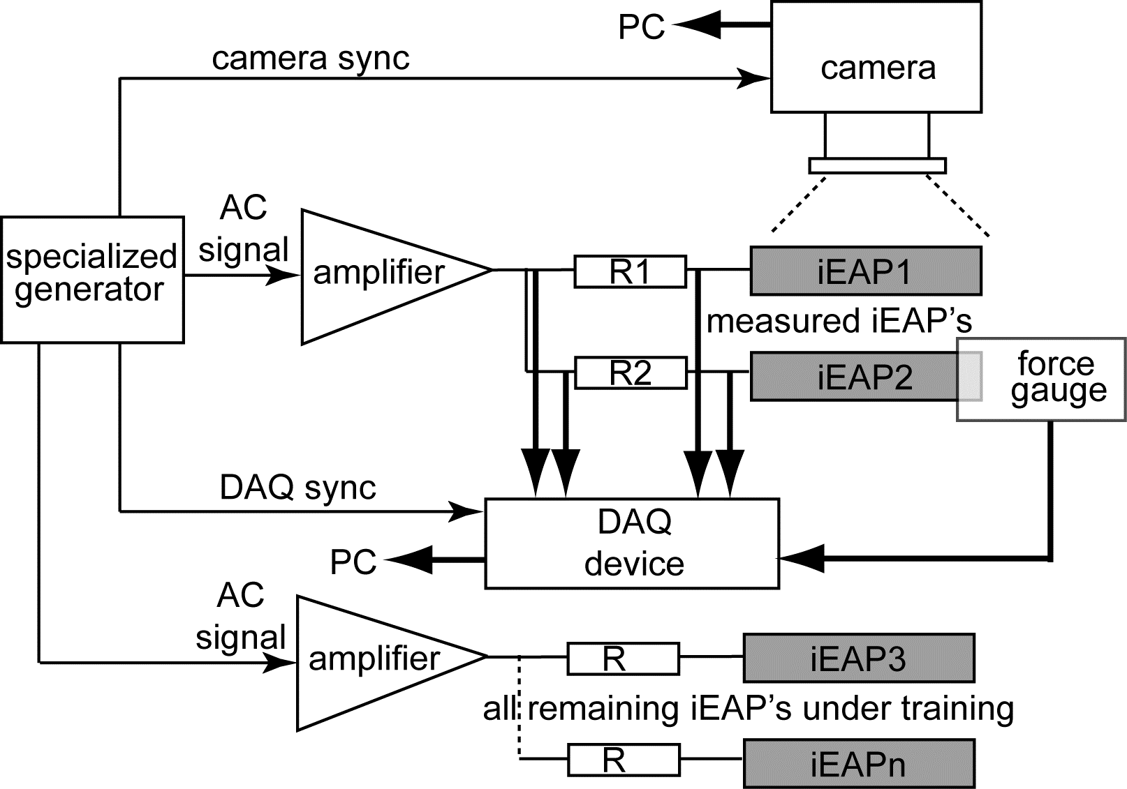
Figure 3. | Figure 4.

Driving signal
Measuring the „wet“ EAPs in dry environment should be performed as fast as possible, while in the case of „dry“ EAPs there is no such restriction. For example, the conventional aqueous ionic polymer-metal composite (IPMC) can be in air up to a few minutes before its parameters change drastically due to drying. For our synchronous 4-storey conveyor, the „wet“ EAPs require that the cycle of measurement should not exceed 2-3 minutes. To cover wide frequency range, the driving voltage signal is a gradual sweep lasting 2.5 minutes. It consists of series sequence of sine signals of different frequencies. Each frequency lasts 3 half periods. The delay between the sequences is at least 0.5 half periods of the previous frequency while the initial phases are opposite. The frequencies are (in this order) 10, 5, 2.5, 1.25, 0.64, 0.32, 0.16, 0.08 and 0.04 Hz. An example of the driving voltage signal is presented in Figure 4.
The amplitudes of the driving signal for measurement and training were chosen individually for each IEAP type. As the goal of this project was testing the endurance of the samples to harsh environments, rather than trying to demonstrate their ability to perform millions of working cycles, the amplitude of the applied voltage was chosen close to the uppermost allowed for each particular type. The actual voltages were 2.8V for the IEAP materials A, B, and D; 1.0V for the polypyrrole actuators F and G; and 2V for the IEAP materials C and E.

Acquired data
The set of the data acquired during the measurement of a single sample involves the analog signals such as voltage applied to the actuator, consumed electric current, and the output of the force gauge. As an example, typical set of acquired signals of a force measurement is given in Figure 4A. We see that the signal of the force gauge is asymmetrical. This is caused by improper automatic positioning of a twisted sample.
In order to describe behavior of the actuators in time, we needed a parameter, describing their performance. A comprehensive overview about the commonly used quantitative representations is given in [Karl]. As the total number of IEAP actuator samples is quite large, an important requirement fo this parameter is the possibility to perform the measurements automatically, regardless of the behavior of each sample or each particular IEAP type. For estimating the performance of the bending IEAP actuators, the commonly used parameters are the strain difference [X, X] and tip displacement [X, X]. Both of them can be used in the case of small deflections only. In order to describe large bending of the actuators, we characterize the shape of the actuators by a set of vectors. Similar methodic is described in our previous works [X, X].
The vectorial interpretation of the shape of the actuator expresses its bending with respect to the distance from the input contacts along the sample. The curved line representing the shape of the actuator is divided into vectors of equal lengths as depicted in Figure 3, assuming that within every vector the curvature is constant. The shape of the actuator is characterized by a number of angles θ1, θ2, … θn. Each consecutive angle along the length of the actuator is relative to the previous one. The length and total number of the vectors is a trade-off between the accuracy of the result and the resolution of the camera. It is self-evident that more vectors represent a complicated shape better. However, the relative error of detecting the angle depends on the resolution of the recorded image In our experiment the resolution of captured images was 640×480 pixels, while the actuators were divided into 9 vectors.
The image of the actuator is recorded by a USB camera (particularly the DMK 22BUC03 was used), and processed by the appropriate National Instruments LabView tools. A proper lighting and exposure as shown in Figure 3, greatly simplifies the procedure of determining the vectors. When the direction of the camera is set transverse to the actuator and the stage is illuminated from the background, the image of the actuator becomes a single contrast curved line. The side illumination, as depicted in Figure 3, further eliminates the shadows emerging due to the actuator twisting.
An experiment setup like described above, generates enormous amount of data, if data acquisition rate for the whole procedure is chosen based on the highest frequency. The required disk space, especially for storing the video information, easily grows into terabytes. Another critical issue besides the storage challenges, is the bandwidth of data bus given that 4 USB cameras were used. In order to reduce the load on the main PC, stand-alone signal generators were designed and implemented.
These signal generators also produce the trigger signal to synchronize the camera and the driving voltage. This setup allows capturing video with a dynamic frame rate that adapts to the particular frequency of input signal. The number of frames captured by the camera during the approximately 2.5 minutes of measurement was, thus, reduced to 175. However, as the file size of such a video was around 50 MB, the images were converted to the vector representation immediately after the measurement cycles. Discarding the images helped to reduce the amount of required storage space significantly as the data describing a single measurement was condensed to a few dozens of kilobytes.
While the obtained set of vectors allows exact reconstruction of the shape of the actuator during the measurements, it is still too large to effectively describe the degradation level of the actuator. Analysis of the obtained data showed that a convenient quantitative parameter to evaluate the performance the condition of an actuator is the angle between the tip tangents in the case of maximal bending displacements to the opposite directions. It describes well the behavior of an actuator of given length and as all the tested IEAP samples were of same length, adequate comparison of performance for all the actuators is possible. As depicted in Figure 3, this parameter, named as β , will not fail even in the case of considerable creep of the sample. As an example, a typical set of acquired signals of a video measurement is given in Figure 4B.

A | B
Figure 4. A – Force measurement; B – video measurement. For clarity, all signals except voltage are scaled

3. Measurements
Siia mingi joga et saab mõõta nii-ja naa-suguseid, meie piirdusime jne…

In the scope of current paper we present and analyze long-term degradation of two different types of IEAP fabricated onsite, with carbonaceous electrodes and with conducting polymer electrodes:

- A PVdF(HFP) membrane with electrodes consisting of nanoporous carbide–derived carbon. The electrolyte is EMIBF4 ionic liquid [X, X, X].
The electrolyte of this IEAP material is a nonvolatile ionic liquid, while the main component of the electrodes is extremely absorbent porous carbon. Therefore it is intended to work only in dry environment without adding the electrolyte. The amplitude of the driving voltage was the recommended ultimate working voltage - 2.8 V.
Preparation: the electrode layer, composed of CDC powder, EMIBF4, PVdF(HFP) was made by casting the suspension into a Teflon mold and then drying at 80° C in a vacuum oven. The electrolyte film was obtained by pouring the mixture of PVdF(HFP) and EMIBF4 into the Teflon mold and evaporating the solvent completely. Finally, the electrolyte film was sandwiched between two electrode films and hot-pressed to connect the layers.
For the details, see e.g. [X, X, X].
- A PVdF membrane with polypyrrole electrodes and with PC+LiTFSI (1.0M) electrolyte, fabricated by the combined chemical and electrochemical synthesis method [X, X, X].
This iEAP material is capable working in air, but in order to avoid drying, it is recommended to soak it periodically in the electrolyte solution. In the course of the long experiment, the delay between moistening procedures was 110 minutes. The amplitude of the driving voltage was 2.0V.
Preparation: commercial Millipore PVdF membrane (according to specification: hydrophobic, thickness 125 µm, pore size 0.45 µm, porosity 70%) was used as electrode storage layer. Electrodes for electrochemical synthesis were synthesized chemically as follows: membrane was permeated with pyrrole monomer and immersed in 0.006 M NaDBS, 0.075 M Na2S2O8 aqueous solution at 60 °C for 45 s; the polymerizing Py from outer-most pores turned the membrane black. The chemical synthesis was terminated by washing membrane with cold methanol. PPy was deposited galvanostatically on both sides of the membrane. Electrochemical synthesis was carried out galvanostatically in an one-compartment two-electrode electrochemical cell. The synthesis solution contained 0.2 M Py and 0.2 M NaDBS dissolved in a mix of water and MEG. 1 M LiTFSI in PC was used as actuation electrolyte.

3.1. Electromechanical impedance
In the course of the long-term experiment, measurements resulting with graphs as depicted in Figure 4, are taken after every 174 of training cycles. The obtained data allows describing the performance of the actuator until its degradation at each particular frequency. The 3 impedances of an arbitrary sample of the IEAP actuator of the material B are given in Figure 5.

FR C5 UI | Rau N23 UI

In Figure 5 we see that the in 8000 bending cycles the electrical impedance voltage/current, or the internal resistance of the actuator, increases about one magnitude. Similar one-magnitude decrease shows the relation tip angle/voltage. However, the relation between the tip angle and electric current remains constant in the whole frequency range. Analyzing the data we have found that observing the electric current gives adequate information about the degradation level of all samples investigated. Moreover, this electrically measurable parameter can indicate the sudden failure in the case of conductivity break-off as well as short-circuit of an actuator.

3.2. Long-term degradation of the IEAP actuators.

The electromechanical impedances presented in Figure 5 show that the tip angles β evolve in a similar manner in the whole frequency range. For that reason it is justified to only look at the long-term performance of a single - in our case the lowest – frequency (Figure 4B).
The obtained performance data can be plotted in respect to time as well as to performed work-cycles for each particular sample. The former describes the spontaneous self-degradation while the latter shows degradation during operation.
Figure 6 presents the plots of two samples of the IEAP material B with respect of the two coordinate axes. One of them suffers from an occasional damage between the days 100-120. The time-dependent behavior shows that the performance of the actuators decreases even in the idle state. The Step 5 shows that degradation continues with the similar rate after the long experiment is terminated. Comparing the degradation rates of the two samples shows that UV radiation damages this IEAP material. The graph of the performance versus number of performed working cycles shows that at maximum load the performance decreases nearly exponentially. In spite of many efforts we could not find any functional fit of degradation, matching all samples or all IEAP materials with sufficient accuracy.

A | B
Figure 6. Pair of degradation charts of two arbitrary samples of the IEAP material B. Each point in the graphs marks one measurement cycle. To each point in the left graph corresponds one point in the right graph.

3.3. Occasional damage
Although the objective of the current project was determining the durability of the IEAP actuators to the harsh environmental conditions, this experiment of large scale gave several unexpected results. Here we present some of them.
- Besides the progressive weakening of the performance, some occasional samples exhibited sudden destruction, independent on the environmental conditions. This behavior was observed in the case of all IEAP materials except the aqueous IPMC. The corresponding illustrative pair of the degradation graphs is given in the diagram Figure 7 (black graph). Tracking the corresponding behavior of electric current and the electromechanical impedance shows that there exist two ways of sudden destruction:
  - Conductivity break-off. The sharp decrease of the performance is accompanied by sharp decrease of the electric current. This is caused mainly due to the delamination of the electrodes. An optical micrograph of a delaminated part of the IEAP material A is depicted in Figure 8.
  - Short-circuit of the sample. The sharp decrease of the performance is accompanied by sharp increase of the electric current. The close inspection showed that the short-circuit happens exclusively due to the permeation of the membrane and the electrolyte between the electric contacts. This may happen due to overheating and poor thermal conductivity of the contact clamps. A SEM image of a melt part of the IEAP material A is depicted in Figure 9.

A | B
Figure 7. Pair of degradation charts. Black: a sample suffering from a sudden destruction after 2000 excitations, Red: performance is regained after 5000 ineffectual excitations.
 | 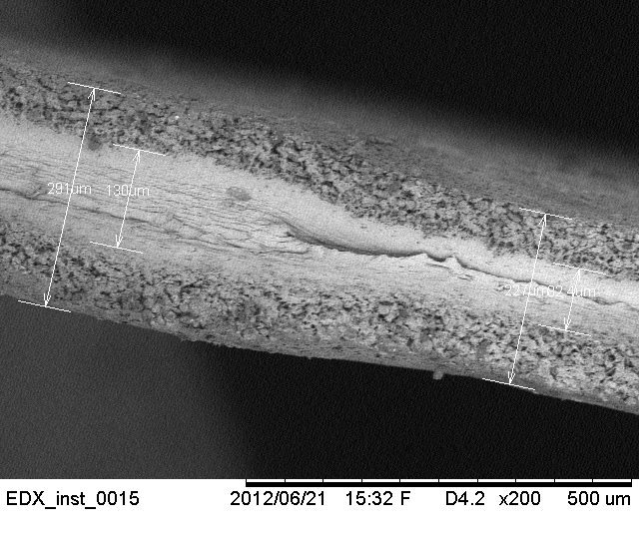
Figure 8. Delaminated electrodes of the IEAP material A. Kuupäevad kinni katta! | Figure 9. Partially melt membrane of the IEAP material A.

- Analyzing the data we found that some samples of the IEAP materials B and E regained their performance at long time after sudden destruction. The corresponding pair of degradation charts is given in Figure 7, (red graphs). Commonly, when experimenting with IEAP actuators, the destructed samples are considered being unsuitable for further experiments. In our long-term degradation experiment none of the samples were removed from the conveyor before total termination. Analyzing the data we have observed that some samples have regained their performance after several thousand ineffectual excitations. We are not able to give any correct explanation to this phenomenon yet, however we have reason to believe that finally the melt electrolyte, stained near the electric contacts, dries out, and eliminates the short-circuit.

3.4. Rate of use
We found that the lifetime of the IEAP materials depends on many processes, terms and conditions: the amplitude, frequency, and signal shape of the applied signal, temperature and humidity of the ambient environment, etc. Moreover, it depends leven on the rate of use. To demonstrate this phenomenon we performed an experiment with two identical samples of the IEAP material G. Actually, a 5x20 mm sample was cut into halves lengthwise. One of them was subjected to a continous repetitive test cycle, while for the other the delay between the test cycles was one hour. The resulting degradation charts given in Figure 11 show that the lifetimes of the samples are different by means of the performend working cyckes as well as by means of time. The performance of the continously working actuator falls to 0.05 in 8 hours after performing 3300 bends. The less frequently actuated sample weakens to the same level after performing only 400 bends in 36 hours.

A | B
Figure 11. Degradation of a sample of the IEAP material G at different utilization rates.

It is therefore we propose that any report about the lifetime of the IEAP actuator (e.g. successful performance exceeding, say, 10⁵ working cycles) should be accompanied by exact descriptions of all the input parameters such as the applied signal shape, amplitude, frequency, load, as well as the ambient conditions: temperature, humidity, etc.

Conclusions

- the performance loss and sudden destruction of the 3 materials is rather random;
applying maximal allowed driving voltage, the materials work only a few hundreds of working cycles with absolute certainty;

According to the long-term degradation experiments we suppose that the most important phenomenon, hindering usage of the iEAP materials in space, is the spontaneous long-term self-degradation. The freezing temperature and duration shows no difference. Naturally, these materials are not capable working when the electrolyte is frozen, but they definitely continue working after melting up.

Acknowledgments

