Reliability measurements of ionic eap materials

Andres Punning, Indrek Must, Inga Põldsalu, Veiko Vunder, Rauno Temmer, Karl Kruusamäe, Friedrich Kaasik, Janno Torop, Pille Rinne, Urmas Johanson, Tarmo Tamm, Alvo Aabloo

Intelligent Materials and Systems Laboratory,
Institute of Technology, University of Tartu
Nooruse 1, 50411 Tartu, Estonia

E-mail: punn@ut.ee

Abstract The research is focused on durability, degradation, and lifetime of ionic electroactive polymers, subjected to different hazardous environments like gamma, X-ray and UV radiation, temperature cycling. The levels of radiation were chosen according to the Low Earth Orbit (LEO) conditions. Large scale effort was taken to test the majority of available iEAP actuators materials developed in several labs.

1. Introduction
A major goal in soft polymeric electromechanical actuator research is to develop a device of low energy consumption that operates rapidly with high displacement or high force at low voltage applied. The current technologies based on electromechanical and pneumatic actuators make application product often too noisy, heavy and too complicated. For that reason a notable demand exists for soft, simple and miniature actuation devices in many technological solutions. The ionic electroactive polymer (iEAP) actuators are good candidates for this purpose. iEAPs are lightweight and soft multi-functional materials presenting several advantages including the capability of large bending deformation even at low (~1%) intrinsic strains of the electroactive layer and low driving voltages (0.1-5V). An iEAP can respond to the applied voltage with bending displacement, sense motion or humidity, harvest energy, and even store electric energy acting as a supercapacitor [1-5]. One of the possible challenging application areas of iEAPs is space crafts, as this technology can significantly reduce the volume and mass of the equipment. There exists an ample of iEAP-based space-worthy devices proposed in the scientific journals during the recent decade [6,7]. However, besides the actual performance of the iEAP devices, there exists another issue, limiting their acceptance in critical applications - lack of confidence.
Already since the very first launches, reliability has been recognized as a critical attribute of the space systems, as any failure during the mission can lead to complete failure. A failure of a mission commonly means years of wasted time, lost money in the amount of a significant portion of a national budget, but in the worst case even up to human casualties. Therefore any design and technology to be sent to orbit is carefully sought for the potential causes of failures prior to launch. In order to determine whether iEAPs are likely candidates for space applications, we performed the ground-laboratory tests. In this paper we report on the durability tests performed with actuators of 7 significantly different iEAP materials, subjected to different harsh environments. This project was conducted as a part of a contract with the European Space Agency (ESA), therefore the harsh environments and their levels were chosen conformably to those of the low Earth orbit (LEO).
The experiment covered measuring the performance of the activated iEAP actuators until their final degradation. The total number of samples was large – totally over 500 actuators. The amount of the obtained data is huge, therefore in the scope of the current paper we focus on the methodic, equipment, and conclusive results, rather than on the comparative data analysis or formal statistics of all particular samples.

Survival Test
In general, the performance of the iEAP actuators decreases during working. The decrease rate depends on a variety of processes, some of them are probably unknown yet. A few examples are temperature, humidity, number of performed working cycles, applied load, just the time passed, etc. Testing the lifetime of IEAP actuators was carried out by measuring their electrical and electromechanical impedances under continuous load, until their performance decreased under a defined level. The samples were divided into separate portions for the different environmental afflictions, 7-10 pieces of each. In order to retain the possibility to compare different iEAP materials, the measurements were carried out using identical methodology upon the different iEAP types
The lifetime measurements were carried out using identical methodology upon the different iEAP types. The shape of the exciting signal, timing, and even the dimensions of all samples were identical – 5 x 20 mm – for all 7 types of the iEAP materials. The only different parameter was the amplitude of the applied voltage, determined by the electrochemical window of the particular material of each particular iEAP material.
The process of measurement consists of two types of cycles: training cycles and measurement cycles. During the training cycle the actuator is actuating due to the sine input signal of appropriate frequency while its electrical and mechanical responses are not recorded. During the measurement cycle the actuator is engaged with sweep signal while the mechanical and electrical parameters are recorded. The number of training cycles between measurements was 290 for the iEAP materials D and E, and 174 for the others.
Measurements are carried out in cantilever configuration - one end of an actuator is fixed while the rest is free to move or to apply force to the force gauge. The samples are attached to their contact clamps during the whole measurement process. This way we avoid their damage and ensure that they are not turned over between the cycles. During the measurement cycle the sample is held horizontally and edgewise, in this configuration the mass of the actuator itself distorts less its free bending. During the training cycle the sample is held hanging vertically. This is done for two purposes. Some samples exhibit creep - permanent deformation under the influence of the inner stresses. When it is hanging freely, the weight of the sample itself diminishes this effect. Another reason for the vertical placement of the samples is the need for soaking the wet types of IEAP actuators in their solvent. Some types of IEAP materials must be continuously in the wet environment, others have to be moistened in a water or some solvent after every certain time. To avoid drying the “wet” actuators, the measurement cycle should not exceed a few minutes, covering all required frequencies.

Large Scale Test Equipment
Performing the testing procedure manually is a tough and precise work for the operator. Therefore we designed an authentic equipment to perform this process upon many actuators automatically. This setup excludes the human errors and guarantees that all samples are tested in exactly similar conditions. The large scale test equipment was designed based on the trade-off between the automatization, ease of use, and the amount of the acquired data.

Mechanical design
The photo of the testbench is given in Fig. 1. It is a circular conveyor standing of 4 floors, sharing the same axis, one motorized linear actuator and one motorized rotational stage. The Thorlabs TravelMax Stage LNR50VK1/M and Thorlabs CR1/M-Z7E were used respectively. These two motorized control devices can lift the circular turntable up and down within 5 cm, as well as rotate infinitely around the vertical axis. The iEAP samples are attached to the convertible clamps, hanging around the turntable.
Each floor can hold up to 60 actuators of similar type, so the whole bench can hold up to 240 samples of up to four different types. As all 4 floors act synchronously. Concurrently 4 samples are measured by the cameras (one for each floor); and 4 samples are measured with the force sensors (one for each floor). After performing the measurement cycle, the circular conveyor turns 6 degrees, sets the 8 just tested samples for training, and positions the new 8 samples for testing.
Only the samples under testing are positioned horizontally while all remaining samples under training are hanging vertically. The process of turning the samples between the two positions is realized by pushing the clamps against two properly positioned supports. Rotation of the turntable enables measurement of all samples, one after another.
The recorded mechanical outputs were the output of the force gauge and the information of bending. However, motorized positioning an actuator to a force gauge is a complicated operation. A clumsy manipulation may easily damage the sample, especially in the case of actuators suffering from creep. Therefore the most reliable parameter describing the behavior of iEAP actuators is the visual information of bending. The bending behavior of the actuators was recorded by cameras, particularly the monochrome USB cameras DMK 22BUC03 equipped with a lens of long focal length. For force gauges, the Millinewton force sensors of EPFL, and MLT0202 of ADInstruments were used. The proper illumination of the samples from back and from two sides as depicted in Figure 2 simplifies the latter image processing.
Figure 1. 4-floor conveyor. | Figure 2. For measurement a sample is lifted out of the water bath. Proper illumination is essential.

Driving signal
Measuring the „wet“ EAP-s in dry environment should be performed as fast as possible, while in case of „dry“ EAP-s it is not the case. For example the traditional ionic polymer-metal composite (IPMC) with water as electrolyte can be in air up to a few minutes only before its parameters change drastically due to drying out. For our synchronous 4-floor conveyor, the „wet“ EAP-s determine that the round of measurement should not exceed a few minutes. To cover wide frequency range, the driving voltage signal is a gradual sweep. It consists of series sequence of sine signals of different frequencies. Each frequency lasts 3 half periods. The delay between the sequences is at least 0.5 half periods of the previous frequency while the initial phases are opposite. The frequencies are (in this order) 10, 5, 2.5, 1.25, 0.64, 0.32, 0.16, 0.08 and 0.04 Hz. The whole signal lasted about 2.5 minutes, while the actual delays between the separate frequencies were different for the „floors“ of the conveyor.
The amplitudes of the driving signal for measurement and training were chosen individually for each iEAP type. As the goal of this project was testing the endurance of the samples to harsh environments, rather than trying to demonstrate their ability to perform millions of working cycles, the amplitude of the applied voltage was chosen close to the uppermost allowed for each particular type. The actual voltages were 2.8V for the iEAP materials A, B, and D; 1.0V for the polypyrrole actuators F and G; and 2V for the iEAP materials C and E.

Schematics of the measurement
The schematics of the experiment set-up is given in Figure 2. Similar configurations are described in our previous works [X,X]. In order to reduce the load of the computer, the voltages are generated by specialized generator, realized using an Atmel microprocessor. The generator generates the AC signal for driving the actuators, and the synchronizing signals for the hardware triggered camera and for the DAQ device. Using the specialized generator allows synchronizing the measurements and camera with the input signal in the minimal sampling rate for each particular frequency. This way the number of frames taken by the camera and the number of DAQ samples in 2.5 minutes of measurement were reduced to 170 and 700 respectively. The voltages are amplified by custom made current amplifiers, based on the Burr-Brown OPA548 op amp. Altogether, the 4-floor conveyor incorporates:
- 5 specialized generators: one for each floor, and one for generating the common training cycles;
- 8 current amplifiers, two at each floor: one for measurements and one for training;
- 4 USB cameras: one for each floor;
- 4 force gauges: one for each floor.
All electrical signals – voltages, electric currents, and outputs of the force gauges are registered by the National Instruments NI PCI-6254, M Series DAQ with 32 analog inputs. The electric current is measured as a voltage drop over a low-ohm resistor. The whole system is operated by a single PC-type computer, and the National Instruments LabView software.

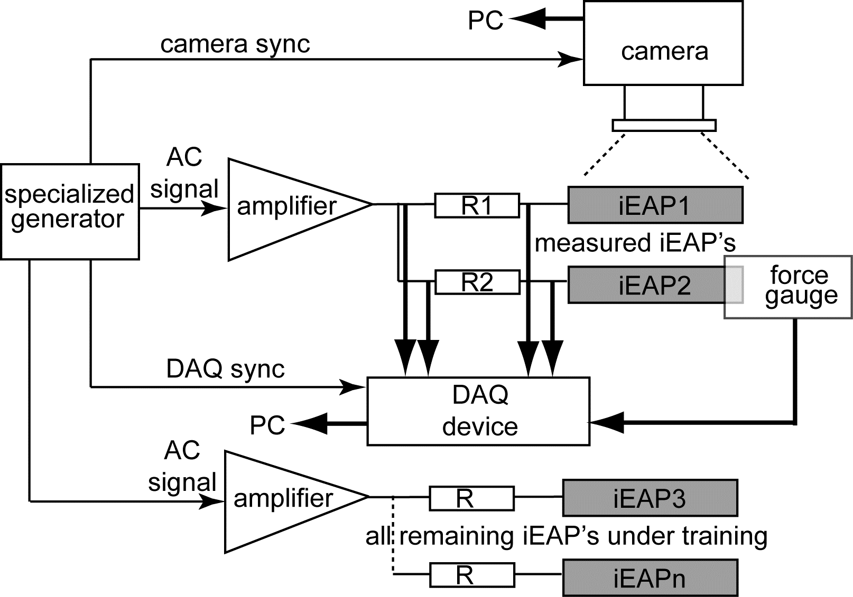
Figure 3. | Figure 4.

Acquired data
The set of the data acquired during measurement of a sample involves the electrical signals – voltage applied to the actuator, consumed electric current, and the output of the force gauge. As an example, typical set of acquired signals of a force measurement is given in Figure 4A. We see that the signal of the force gauge is asymmetrical. This is caused by improper automatic mechanical positioning of a twisted sample.
In order to describe evolution of the actuators in time, we had to choose a parameter, describing their performance. As the total number of samples is huge, an important requirement to this parameter is the possibility to perform the measurements automatically, regardless of the behavior of each sample or each particular iEAP type. For estimating the performance of the bending iEAP actuators, the commonly used parameters are strain [X,X] and tip displacement [X,X]. Both of them can be used in the case of small deflections only. In order to describe large bending of the actuators, we characterize the shape of the actuators by a set of vectors. Similar methodic is described in our previous works [X,X].
The vectorial interpretation of the shape of the actuator expresses its bending with respect to the distance from the input contacts along the sample. The curved line representing the shape of the actuator is divided into vectors of equal lengths as depicted in Figure 3, assuming that within every vector the curvature is constant. The shape of the actuator is characterized by a number of angles θ1, θ2, … θn. Each next angle along the length of the actuator is relative to the previous one, while the angles of the first column may be arbitrary. The length and total number of the vectors is a trade-off between the accuracy of the result and the resolution of the camera. It is self-evident that more vectors represent a complicated shape better. However, the relative error of detecting the angle depends on the discretization of the recorded image. Hence, it is important to provide sufficient resolution of the pixelated actuator to minimize image processing errors. In our experiment the 18 mm long images of the actuators were divided to 9 vectors.
The image of the actuator is recorded by a camera and may be processed by some convenient image processing software, we used the National Instruments LabView package. A proper lighting and exposure greatly simplifies the procedure of determining the vectors. When the direction of the camera is set transverse to the actuator and the stage is illuminated from the background, the image of the actuator consists of a single contrast curved line. Applying the procedure for sequential images gives a 3-dimensional evolution of curvature along the actuator in time.
An experiment, set up like described hereinabove, generates a huge amount of data, when acquiring data with the sampling rate, appropriate for the highest frequency. The required disk space, especially for saving the video information, can easily grow to terabytes. In order to reduce the amount of data and to fit to the bandwidth of an ordinary PC, especially by means of the USB cameras, a specialized hardware signal generators were exploited.
The specialized signal generator generates the hardware triggering signal for the camera synchronously with the driving voltage signal. This setup allows capturing video with the minimal sampling rate for each particular frequency. The number of frames taken by the camera in about two minutes of measurement was reduced to 175 only. Nevertheless the file size of the video was approximately 50 MB. For further reducing the amount of saved data, the videos were converted to the vector representation “on the fly”, while saving the video itself was obsolete. This way the amount of data describing a single measurement was reduced to a few tens of kilobytes only.
The obtained set of vectors allows exact reconstruction of the shape of the actuator during the whole measurement. Nevertheless, this set is too large to estimate the degradation level of the actuator. Analyzing the obtained data we found that a convenient quantitative parameter to evaluate the performance the condition of an actuator is the angle between the tip tangents in the case of maximal bending displacements to the opposite directions. It describes well the behavior of an actuator of given length. As depicted in Figure 3, this parameter, named as β , will not fail even in the case of considerable creep of the sample. As an example, a typical set of acquired signals of a video measurement is given in Figure 4B.

A | B
Figure 4. A – Force measurement; B – video measurement. For clarity, all signals except voltage are scaled

iEAP materials
The collection of the test objects involved in the project was chosen among the well-studied iEAP materials with the consideration of including wide selection of the combinations of the commonly used electrode and membrane materials as well as electrolytes. For details about their fabrication and properties please find the appropriate references.
- IPMC with carbonaceous electrodes: nafion membrane with electrodes consisting of nanoporous carbide–derived carbon. The electrolyte is EMITF ionic liquid, while the conductivity is improved by thin gold foil. For the details see [9, X, X].
- A PVdF(HFP) membrane with electrodes consisting of nanoporous carbide–derived carbon. The electrolyte is EMIBF₄ ionic liquid. For the details see [10].
- A PVdF(HFP) membrane with electrodes made of a gelatinous mixture of SWNT and IL - bucky-gel. For IL, the EMIBF₄ was used. For the details see [11].
- A traditional aqueous IPMC with Nafion membrane and electrodes made of chemically plated platinum with palladium buffer layer. For the details see [12].
- A Semi-interpenetrating polymer network based on gradual dispersion of PEDOT through the thickness of the PB/PEO IPN matrix with EMImTFSI as electrolyte. For the details see [13].
- Polypyrrole doped with TFSI− ion films grown galvanostatically on gold-coated PVdF membrane with PC+LiTFSI (0.1M) electrolyte. For the details see [14].
- A PVdF membrane with polypyrrole electrodes and with PC+LiTFSI (1.0M) electrolyte, fabricated by the combined chemical and electrochemical synthesis method.For the details see [15].

Kuidagi tuleb kemikaalide lühendid ära kirjeldada et korrektne oleks.

Electromechanical impedance
In the course of the long-term experiment, measurements resulting with graphs, similar to that depicted in Figure 4, are taken after every pre-defined number of training cycles (290 or 174, see hereinabove). The obtained set of data allows describing the gradual evolvement of the actuator until its degradation at each particular frequency. The 3 impedances of an arbitrary sample of the iEAP actuator of the material B are given in Figure 5.

A
B
C
Figure 5. Impedances. A: voltage-electric current; B: tip angle-voltage; C: Tip angle – electric current

In Figure 5 we see that the in 8000 bending cycles the electrical impedance voltage/current, or the internal resistance of the actuator, increases about one magnitude. Similar one-magnitude decrease shows the relation tip angle/voltage. However, the relation between the tip angle and electric current remains constant in the whole frequency range. Analyzing the data we have found that observing the electric current gives adequate information about the degradation level of all samples investigated. Moreover, this electrically measurable parameter can indicate the sudden failure in the case of conductivity break-off as well as short-circuit of an actuator.

Long-term degradation of the iEAP actuators.
The samples were divided into small batches, 6-9 pieces each, and subjected to their pre-assigned environmental conditions described hereinabove. Naturally, one batch was kept in ideal conditions for reference. The long-term degradation test was carried out in the following order:

- Testing the initial performance of each particular sample;
- In about 60 days the performance of each particular sample was recorded again a few times. This step allows determining the rate of the spontaneous self-degradation of the materials.
- In the days 80-110 all batches of samples were subjected to their pre-assigned harsh environments.
- In 60 days from the Step 2 the lifetime of the samples under continuous loading was determined. This process was terminated when the performance of most of the samples was below some pre-determined value, commonly 5% of the mean value of the initial values.
- In about 10 days after the Step 4 the final performance of the samples was recorded again.

Between the steps the samples were kept in ideal conditions – each one in a separate vial, in the appropriate solvent, if required.

The electromechanical impedances presented in Figure 5 show that the tip angles β evolve in a similar manner in the whole frequency range. This behavior justifies further reducing the amount of data by narrowing the frequency range to only one frequency. Hereinafter we observe the performance of an actuator as the tip angle β at the lowest frequency, see Figure 4B.
The obtained data allows plotting the performance of each particular sample with respect to the time as well as with respect to the total number of cycles passed. The former indicates the spontaneous self-degradation, while the latter shows degradation during operation.
Figure 6 presents the plots of two samples of the iEAP material B with respect of the two coordinate axes. One of them is the sample subjected to UV radiation, while the other is the reference - not subjected to any harsh environment. The time-dependent behavior shows that the performance of the actuators decreases even being idle. The Step 5 shows that degradation continues with the similar rate after the long experiment is terminated. Comparing the degradation rate of the two samples shows that UV radiation damages this iEAP material. The graph of the performance versus number of performed working cycles shows that at maximum load the performance decreases nearly exponentially. In spite of many efforts we could not find any functional fit of degradation, matching all samples or all iEAP materials with sufficient accuracy.

A | B
Figure 6. Pair of degradation charts of two arbitrary samples of the iEAP material B. Red: undamaged; Black: damaged by UV-radiation.

Endurance of the iEAP materials
Unlike the materials for the conventional actuators, the CIL-EAP materials do not embody any crystal lattice, characteristics of which could be sensitive to ionizing radiation. Instead, the CIL-EAP laminates consist of materials of high radiation resistance – PVdF, Nafion, carbon powder and ionic liquid. The most likely damageable part of the materials is mechanical delamination of the electrodes due to strain, fast variation of temperature, or too high voltage applied. As pointed out hereinabove, the levels of radiation were chosen close those of the low Earth orbit (LEO) conditions. The synergism effects - simultaneous action of several destructive factors that can enhance or reduce each other’s effect - were not studied.

Though there exist numerous methods to modify the structure of these materials with ionizing radiation, the damaging doses are several magnitudes higher than any object can absorb in the space near Earth during many years. (16,17).
X-ray radiation was carried out in the Faxitron RX-650 cabinet X-ray system. This equipment is commonly used for sterilization of the equipment in the Institute of Molecular and Cell Biology, hence we could easily achieve a total doze, definitely harmful for any living organism. With the energy of 110 kV the intensity of radiation was 139,5 R/min. The exposure lasted 120 min, yielding the total radiation dose of 167.4 Gy. In order to avoid contamination of the radiation chamber, each sample under test was individually encapsulated in a 2 cm³ glass vial.
Gamma radiation test was performed at the ESTEC Co-60 Facility, Noordwijk, Netherlands. The samples ordained to Gamma radiation were divided into 3 groups, exposed to different doses of radiation: 400, 1200, and 2040 Gy. The repeat test was carried out at Steri - an Estonian company, providing irradiation services with the Co-60 source. The dose rate was 1180 Gy/h and the total ionizing dose was 2180 Gy. Each sample was individually encapsulated to a poly(methyl methacrylate) box unit.
Based on the results of the degradation experiments we can acknowledge that Gamma radiation and X-ray radiation of the levels and doses described here do not make any harm to any of the iEAP materials involved in the current project. Moreover, we did not notice any difference between the different radiation doses in the case of all 7 iEAP materials.
UV radiation was carried out onsite. The source of the UV radiation was a xenon gas-discharge lamp at the distance of 25 cm. The samples were exposed directly to the UV source at the distance of 25 cm. At this distance the air temperature measured close to the surface of the samples was 37 °C. Periodically, but not more often than in 24 hours, the samples were turned over in order to expose the other side. In this regime both sides of all samples were exposed to the source 180 hours.
From the environmental parameters tested, the direct UV radiation is the most dangerous one to the iEAP actuators. UV-degradation of the conducting polymers PEDOT and Ppy is described in numerous papers (18,19). Our experiments show that direct UV radiation of this level destroys only the materials with polypyrrole electrodes E and F, but is not enough to make harm to the G (PEDOT IPN). As mentioned hereinabove, UV radiation also makes slight damage to the iEAP material B with carbonaceous electrodes, however later it is able working with lower performance.
Freezing. 2 different tests regarding the temperature effects were carried out onsite. The tests were of two types: freezing to the temperature of boiling helium (4,22K) for about 10 minutes, and keeping the samples in the temperature of boiling nitrogen (77K) for 60 days. The samples were individually encapsulated in closed 2 ml high-grade polypropylene Greiner bio-one Cryo-s vials. The melt-up was carried out in the room temperature during at least 24 hours, while the samples were still in their vials. The latter analysis did not show any difference between these experiments - freezing does not have any effect to the tested iEAP actuators of the 7 types. Naturally, these materials are not capable working in the temperatures below the freezing point of the electrolyte, but they definitely continue working after melting up.
Vacuum. The samples were held in vacuum chamber under pressure of <1mb for two weeks. The experiments were conducted onsite. The iEAP actuators of types D, E, F, and G involve volatile electrolytes, and occurred being dried out in vacuum and UV. These samples were soaked in the appropriate solvent for at least 2 days before performing the following lifetime test. Degassing in vacuum does not make any harm to the iEAP actuators with non-volatile electrolyte – ionic liquid. The conducting polymer actuators (materials F and G) after drying in vacuum and the following soaking the iEAP materials in the appropriate electrolyte recover completely. However, the aqueous IPMC (iEAP material D) does not gain the former condition even after careful impregnation in deionized water.

Unexpected results
Although the objective of the current project was determining the durability of the iEAP actuators to the harsh environmental conditions, this experiment of large scale gave several unexpected results. Here we present some of them.
- Besides the progressive weakening of the performance, some occasional samples exhibited sudden destruction, independent on the environmental conditions. This behavior was observed in the case of all iEAP materials except the aqueous IPMC. The corresponding illustrative pair of the degradation graphs is given in the diagram Figure 7 (black graph). Tracking the corresponding behavior of electric current and the electromechanical impedance shows that there exist two ways of sudden destruction:
  - Conductivity break-off. The sharp decrease of the performance is accompanied by sharp decrease of the electric current. This is caused mainly due to the delamination of the electrodes. An optical micrograph of a delaminated part of the iEAP material C is depicted in Figure 8.
  - Short-circuit of the sample. The sharp decrease of the performance is accompanied by sharp increase of the electric current. The close inspection showed that the short-circuit happens exclusively due to the permeation of the membrane and the electrolyte between the electric contacts. This may happen due to overheating and poor thermal conductivity of the contact clamps. A SEM image of a melt part of the iEAP material B is depicted in Figure 9.

A | B
Figure 7. Pair of degradation charts. Black: a sample suffering from a sudden destruction after 2000 excitations, Red: performance is regained after 5000 ineffectual excitations.
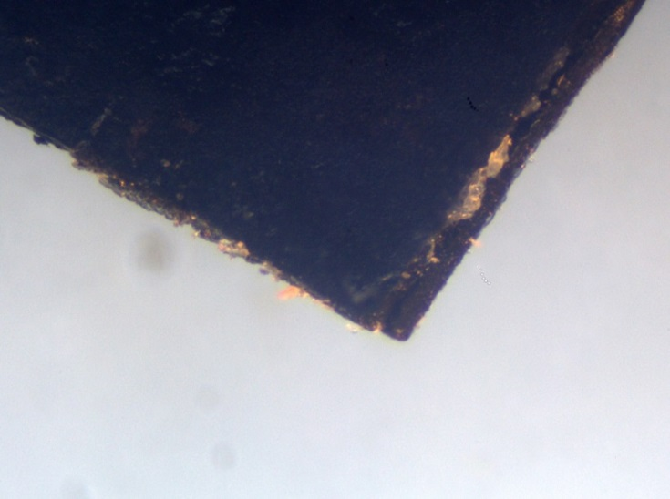 | 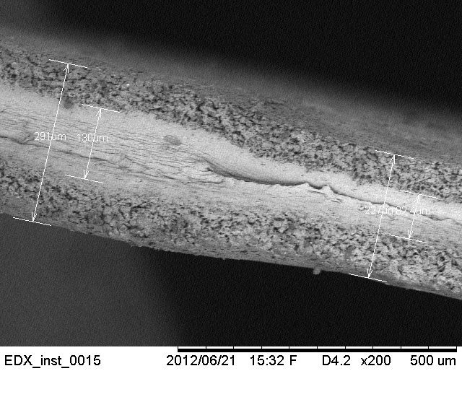
Figure 8. Delaminated electrodes of the iEAP material C | Figure 9. Partially melt membrane of the iEAP material B.

- Analyzing the data we found that some samples of the iEAP materials B and E regained their performance at long time after sudden destruction. The corresponding pair of degradation charts is given in Figure 7, (red graphs). Commonly, when experimenting with iEAP actuators, the destructed samples are considered being unsuitable for further experiments. In our long-term degradation experiment none of the samples were removed from the conveyor before total termination. Analyzing the data we have observed that some samples have regained their performance after several thousand ineffectual excitations. We are not able to give any correct explanation to this phenomenon yet, however we have reason to believe that finally the melt electrolyte, stained near the electric contacts, dries out, and eliminates the short-circuit.
- The samples of both iEAP materials with Ppy electrodes – F and G – exhibited significant increase in performance after exposing to X-ray radiation, however, this effect did not last long. On the other hand, the Gamma radiation had no effect to neither of the iEAP materials with conducting polymer electrodes. This contrast gives reason to believe that the cause of the interim performance peak is the radiation-induced doping of conducting polymer electrodes. The described phenomenon has not yet been studied in detail, the few available papers about the ionizing radiation induced doping of conductive polymers [20-22], most of which are over two decades old, cover only separate conducting polymer film instead of conductive polymer actuators. An intelligible explanation to the phenomenon of ionizing radiation induced doping is given in [20]. At lower doses the ionizing radiation acts as a catalyst, allowing excess dopant to attach to the polymer chain. This, in turn enhances the material conductivity. As the dose increases, damage to the polymer chains will be the dominant result of ionizing radiation, leading to further decrease of conductivity. In the case of the conducting polymer actuators, the alternate polarization during the very next excitations nullifies the effect of the excess dopant, resulting with the tentative performance at the very next measurement cycles.
- We found that the lifetime of the iEAP materials depends on many processes, terms and conditions: the amplitude, frequency, and signal shape of the applied signal, temperature and humidity of the ambient environment, etc. Moreover, it depends leven on the rate of use. To demonstrate this phenomenon we performed an experiment with two identical samples of the iEAP material G. Actually, a 5x20 mm sample was cut into halves lengthwise. One of them was subjected to a continous repetitive test cycle, while for the other the delay between the test cycles was one hour. The resulting degradation charts given in Figure 11 show that the lifetimes of the samples are different by means of the performend working cyckes as well as by means of time. The performance of the continously working actuator falls to 0.05 in 8 hours after performing 3300 bends. The less frequently actuated sample weakens to the same level after performing only 400 bends in 36 hours.

A | B
Figure 11. Degradation of a sample of the iEAP material G at different utilization rates.

As a result we propose that any report about the lifetime of the iEAP actuator (e.g. able to perform 10⁵ working cycles) should be accompanied by exact descriptions of all conditions: the applied signal shape, amplitude, frequency, load, etc., as well as the environmental conditions: temperature, humidity, etc.

Acknowledgments
Täname neid kes meile muskleid valmistasid: Kim, Vidal, Alici, Asaka. Selle artikli autoriteks neid ei võeta.

