Charging of supercapacitors with moisture gradient
- Abstract
- Introduction
The interest on novel energy-related carbon materials is gaining even growing interest.
The three-layer laminate made out of two high surface area carbon - ionic liquid composite electrodes and an ion-permeable ionic polymer membrane in between is a multifunctional electromechanically active material. When electric potential is applied between the electrodes, the charge separation occurs, and this device can be used as an electric double-layer capacitor (EDLC). The origin of energy storage in EDLCs has been exclusively attributed to an electrochemical double-layer formed at the electrode/electrolyte interface {{1 Kötz,R. 2000}}. Recently, the research on flexible and integrative EDLCs for use as power sources in flexible{{115 - Niu,Zhiqiang}}, wearable {{111 Fu,Yongping 2012}} and transparent electronics {{114 Yu,Aiping 2010}}{{113 Wei,Di 2009}} and automotive applications {{112 Hu,Shan 2012}} has drawn much attention. The commercial EDLCs are sealed devices, where the volumetric effects of the electrodes caused by ion sieving, insertion or trapping are depressed by rigid enclosure {{105 Hantel,M.M. 2011}}{{49 Hahn,M. 2006}}. The application field of flexible and wearable supercapacitors expects the ability to work under ambient air condition. At the same time, for example in case of using ionic liquid as electrolyte, the ambient water is responsible for degradation of the device due to hydrolysis of water and IL. The choice is between manufacture of water and oxygen-tolerable devices or incorporation of the device between barrier films. However, the effects from ambient air to the EDLC properties and endurance are at the time not thoroughly researched.
The charge injection from the external power source arises volumetric effects in the electrodes and as a result, the laminate bends and can therefore be used as an actuator []. From the standpoint of selection of the materials and construction of the device, EDLC and actuators are rather similar, their electrochemical properties are comparable {{58 Torop,Janno 2012}} and electric efficiencies over 80 % can be obtained {{79 Torop,Janno 2009}}. The difference in material preparation determines whether the resulting device works better as an EDLC or as an actuator. As a rule, the device with more limited ion mobility and charge transfer dynamics works better as an actuator than EDLC.
The requirements on the actuator total thickness, bending modulus and the ability to work under ambient air conditions result in higher internal resistance, more limited ion mobility and charge transfer dynamics, whereas the large power densities of commercial-grade EDLCs are achieved by thin electrodes with suitable porosity, rigid current collectors, and low viscosity electrolyte.
The origin of the actuation mechanism of actuators with carbonaceous electrodes is currently on debate. The volumetric effects are attributed to the expansion of carbon structure due to insertion of either electrons or holes to the carbon structure (as described by {{44 Baughman,Ray H. 1999}}{{107 Roth,Siegmar 2002}} in case of CNT electrodes), or the ion transfer. The origin of volumetric effects in case of conductive polymer acutators is due to the exchange of charge-balancing ions between the polymer and electrolyte. Recently, the actuation mechanism in case of CNT electrodes has been attributed to the combination of capacitive and faradaic processes {{96 Giménez,Pablo 2012}}, or even exclusively to faradaic processes {{103 Martínez,José G. 2012; 102 Martínez,José G. 2012}}. Although the electrochemically active nature allows CNT to be used in electrochemical sensors [], it is also widely used as EDLC electrodes []. The sensors and actuators generally benefit mainly from the high electrical conductivity of CNT {{108 Li,Chunyu 2008}}.
The properties of CDC fulfill all the requirements for use as EDLC electrodes [], and the charge store in CDC electrodes is of capacitive nature []. The carbide-derived carbon is produced by chlorination of metal carbides in an oxygen-free atmosphere {{35 Presser,Volker 2011}}. After synthesis, the CDC contains sites, which bond chemically oxygen after exposure to ambient air. This can lead to significant surface functionalization, which is often unwanted, especially in energy-related applications {{82 Osswald,Sebastian 2012; 81 Dash,Ranjan 2006}}. One of the outcomes of the surface functionalization is its hydrophilicity []. Moreover, the adsorbed water is responsible for large decrease in the friction coefficient of CDC in the humid atmosphere {{83 Carroll,B. 2003}}.
The bending of the laminate with external force results in formation of strain difference between the electrodes. The formation of electric charge between the electrodes on bending of an ionic polymer- based laminate with noble metal electrodes is a well-known effect {{14 Pugal,Deivid 2010}} and can be explained by the flow of solvent molecules along with mobile ions as a result of hydraulic pressure gradient. The stream of mobile ions results in formation of double layer in the electrodes, and voltage and current can be registered between the electrodes. The mechanoelectrical transduction has previously been registered in case of CNT gel {{22 Kamamichi,Norihiro 2007}}, CNT yarn {{85 Mirfakhrai,T. 2011}}, CDC {{64 Must,Indrek 2012}}, and polypyrrole {{45 Wu,Y. 2007}} electrodes.
(seletada pulkade peal, kumba pidi on pinge sensori puhul)
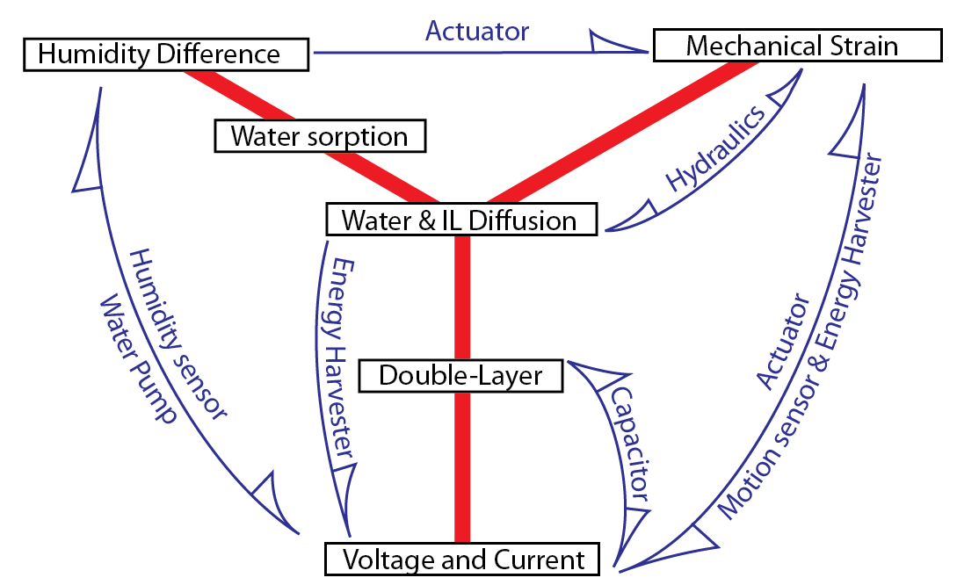
Figure 1
In response to unit step change in pressure (by fast bending or change in ambient conditions), numerous processes with different time constants occur. The processes can be divided into polarization and diffusion. The polarization process is a fast process. The time required for electronic polarization is in the range of 10⁻¹⁶…10⁻¹⁵ s and for ionic polarization 10⁻¹³…10⁻¹² s, and for orientation polarization 10⁻⁷…10⁻⁵ s, and for charge hopping polarization 10⁻⁵…10⁻⁴ s [raamat Rolando 2009]. After 0.1 ms, the formation of double-layer is limited only by diffusion.
The carbon-based electrodes are composed out of carbon particles engaged in an ionic polymer matrix and the whole structure is swelled in an ionic liquid. All components of an electrode composite – carbon, polymer and ionic liquid – are hygroscopic.
High surface area and relatively high electronic conductivity makes carbon a popular electrode material for both EDLCs and actuators. The same qualities make carbon also a beneficial material for various chemical sensors. In other words, when this laminate is exposed to the environment, different sorption processes start to emerge. In this paper we investigate the humidity sensor properties of a composite of high surface area carbon, ionic liquid and ionomer.
The change in ambient water content above the surface of the laminate causes water sorption. If the opposite electrodes of a laminate are exposed to different ambient water content, diffusion gradient arises. This causes the formation of volumetric effects in the electrode; the more soaked electrode stretches out and obtains convex shape. The water diffusion and sorption also induces the dislocation of ionic liquid ions in the carbon micropores and consequently gives rise to double layer formation. The double layers begin to form, and voltage and current can be registered between the electrodes exposed to different ambient water content. In room temperature and atmospheric pressure conditions, merely the air humidity difference between the electrodes can generate an electric charge, which would result in considerable actuation if it would be introduced to the electrode from external power source. The generated voltage, 160 mV, is only one order of magnitude less than voltage, which can cause faradaic processes in the actuator working at this voltage 13% of the electrochemical window of water, and 6 % of the highest magnitude of voltage generally applied to the actuator in ambient air conditions without instant damage.
Consequently, this device can potentially be used as an energy harvesting device. Diffusion current has been proposed as an energy source for microfluidic devices {{88 Yang,Yang 2011}}, but the device which generates and subsequently also stores a considerable electric charge from merely an air humidity gradient is a novel approach.
The hydration also causes itself volumetric effects, which are considerably larger in magnitude than the strain caused by charging the device with external power. A simple demonstration of the charge generation effect can be done by approaching a (moist) finger towards the composite, and registering the voltage across the electrodes. The electrode facing the finger develops negative charge. The fast adsorption also induces volumetric effects – the moistened electrode elongates and the laminate bends towards dry (positively charged) electrode.
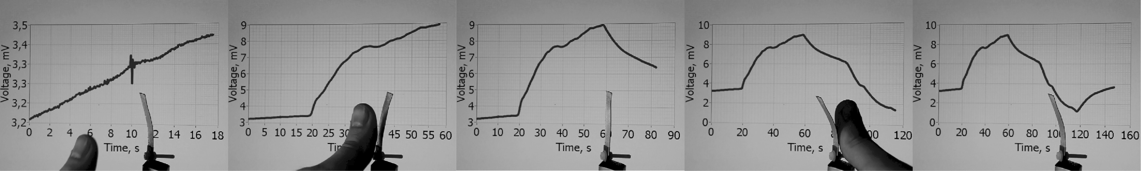
Figure 2

- Experimental

Material fabrication:
A Nafion 117 ionomer membrane was first boiled in 1 M hydrochloric acid, washed by boiling in deionized water, and then ion-exchanged by boiling in LiClO₄ solution. After drying under vacuum, the membrane was immersed in EMImTFS ionic liquid. The electrode material was prepared by dispersing carbide-derived carbon powder with LIQUION® solution LQ-1115 1100EW 15% wt (Ion Power, Inc) using ultrasonic probe. The dispersion was painted layer-by-layer directly on the both sides of ionic-liquid impregnated membrane using an airbrush. After application of each layer, solvents were evaporated under infrared lamp. Finally, the membrane was sandwiched between gold foils and fused together by hot-pressing. Extra Nafion solution was used to promote gold foil adhesion. The manufacturing method is described in more detail in {{50 Palmre, Viljar 2009}}.
Voltage and current measurement:
The sensor output was measured using Burr-Brown INA116 low bias current instrumentation amplifier as a preamplifier and National Instruments PCI-6036E DAQ device as an analog-digital converter. In case of long experiments, the high bias current of conventional operational amplifiers causes the capacitor-like test object to eventually charge to considerable voltages and this can result in inaccurate sensor measurements. Current was measured as a voltage drop over a low-ohm (10 Ω) shunt resistor connected between the electrodes. The same amplifier set-up functioned as volt- or ammeter, depending on if the shunt resistor was connected. The resistor value was chosen so that maximum electric power is dissipated on it.
Humidity generation:
The humidity sensing properties were measured by exposing the opposite sides of the laminate to air chambers with different humidity. Saturated salt solutions were used to generate fixed humidity points. All measurements were performed at 25±1 degrees Celsius. Dry (0⁺⁵ % RH) environment was created using dehydrated calcium chloride (CaCl₃) as absorbent. Saturated solutions of potassium acetate, magnesium nitrate and sodium chloride were used to generate fixed relative humidity points 23±3 %, 53±3 % and 75±3 %, respectively; and distilled water was used to generate 100₋₅ % RH. An air agitator was used to accelerate achievement of equilibrium humidity over the solution before and in the course of the experiments. The laminate under test was clamped between two epoxy laminates. Gold terminals were attached on the epoxy plates for electric connection. The board with laminate under test was placed between two chambers with known humidity. The size of the laminate was xx x xx mm, but XX % of it was exposed directly to humidity chamber, while the rest was fixed between the epoxy boards. First, both sides of the laminate were exposed to equal humidity and held electrically shorted until equilibrium was reached in about 1000 seconds. Then, one side of the laminate was exposed to the chamber with different humidity and current or voltage was measured between the terminals.
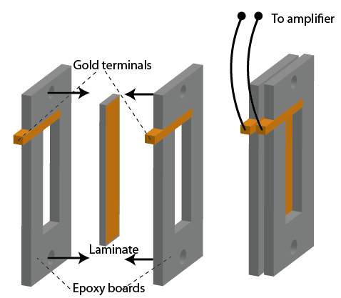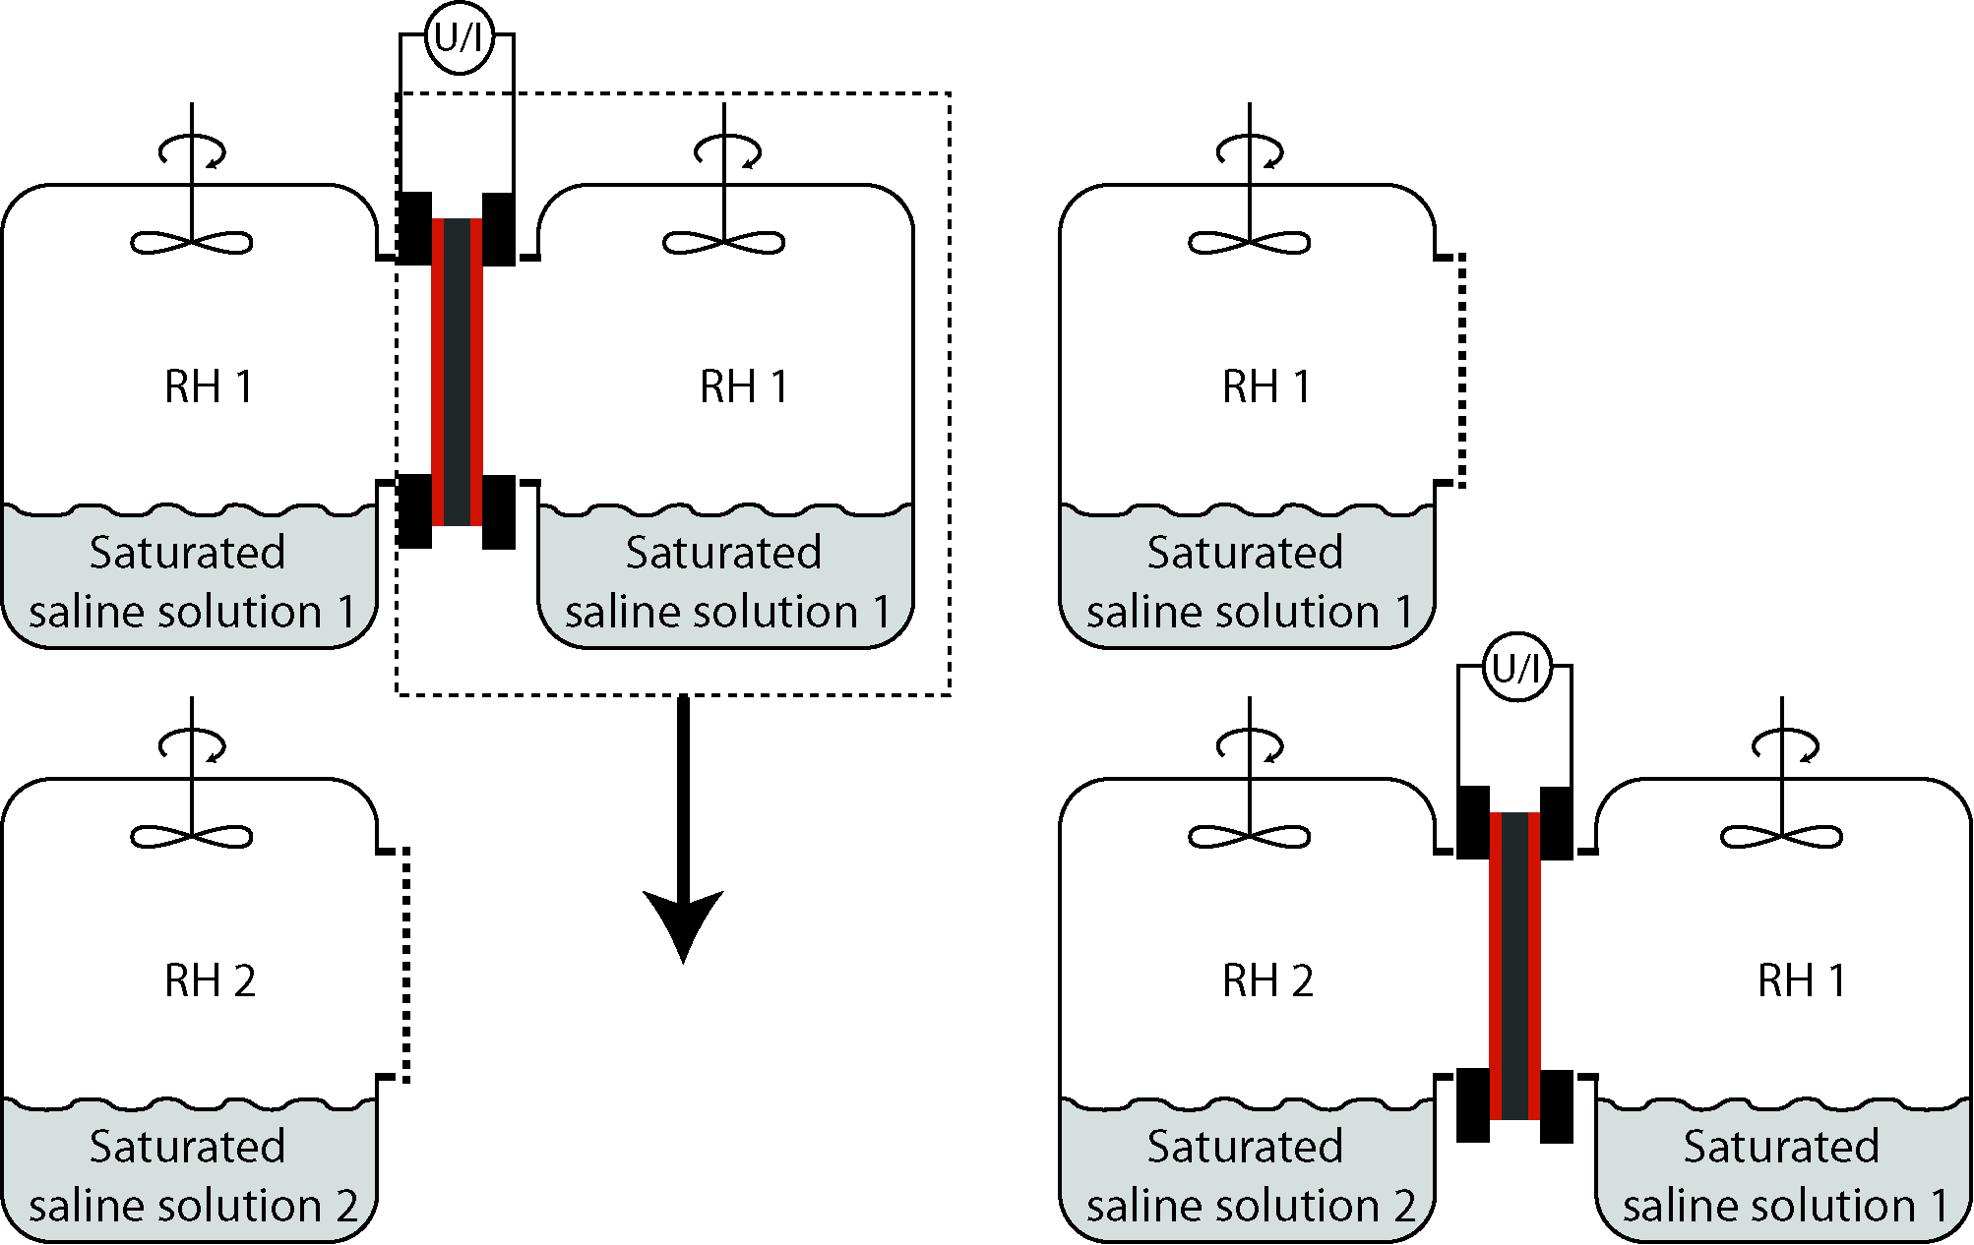
Figure 3

- Results and discussion

  - Open-circuit voltage
Experiments were conducted by exposing one side of an initially equilibrated laminate to a different humidity environment. The voltage between the electrodes increases rapidly, whereas negative voltage can be registered on more dampened electrode. Two distinguishable processes can be observed from the results of open-circuit voltage measurements. After an instant change in humidity, there is a first peak after 100-500 seconds (depicted as an inset in Figure 4). When the laminate is exposed to a humidity gradient for a longer time, the voltage increases for 8000 seconds and can reach voltages up to 160 mV after this time period (Figure 4). Some combinations of the initial humidity and humidity changes do not form a voltage peak after 100 seconds, because the peak is overlapped with the one from consecutive process with longer time constant.
The peak voltage registered after 100-500 seconds corresponds to the reorientation of ions, which is caused by water sorption and diffusion in this electrode, above which air humidity content was changed. The reorientations induce also polarization in the carbon electrode, which can be registered as voltage. The second peak corresponds to both achievement of uniform water diffusion across the laminate, and achievement of balance between the accrual of ions capable of forming double-layer at the carbon-electrolyte boundary, and electrostatic repulsion between like-charged ions at both electrodes.
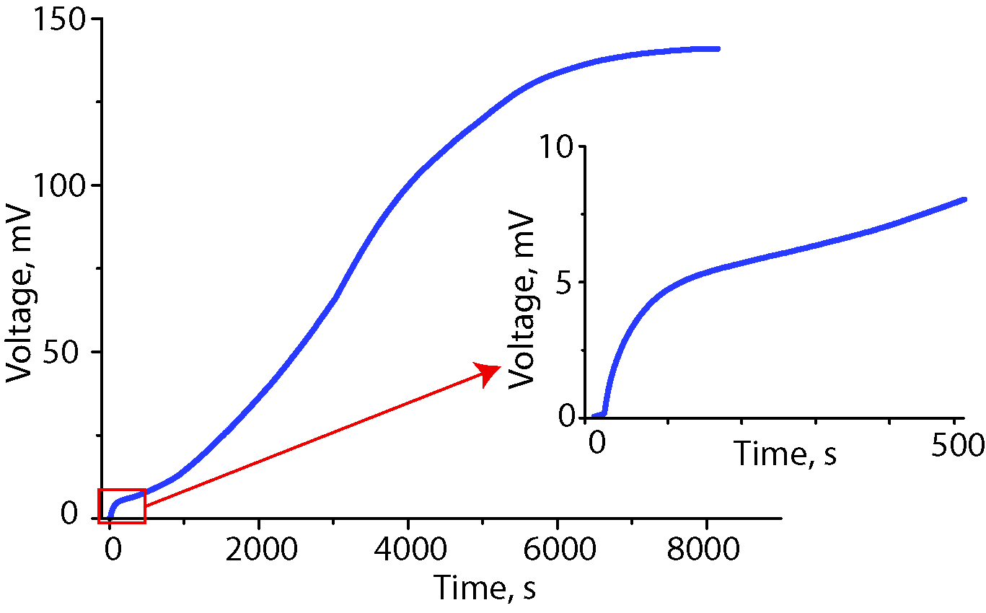
Figure 4

Figure 5A depicts voltage peak values for all combinations of initial humidity and humidity change. The combinations, in which the peak of the faster process is overlapped, the voltage measured after 500 seconds is plotted. For example, in Figure 5C, there is no peak formed when the humidity changes from 0 to 23 %.
The transient voltage in Figure 5C caused by the humidity difference depicted on Figure 5B indicates that the higher change in humidity results in a higher peak value (up to 50 mV), but it also decreases more rapidly. The peak voltages of Figure 5C correspond to the curve on Figure 5A with 0 % initial humidity. After 600 s, the signal with the highest peak value (change from 0 to 100 % RH) is now the lowest in magnitude. As illustrated on Figure 4, this humidity change also does not result in eventual achievement of a high voltage magnitude, but the change from dry to 25 % yields an increase of voltage in several hours’ time. (The relation between the long-term peak values to the voltage magnitudes needs an additional study. )
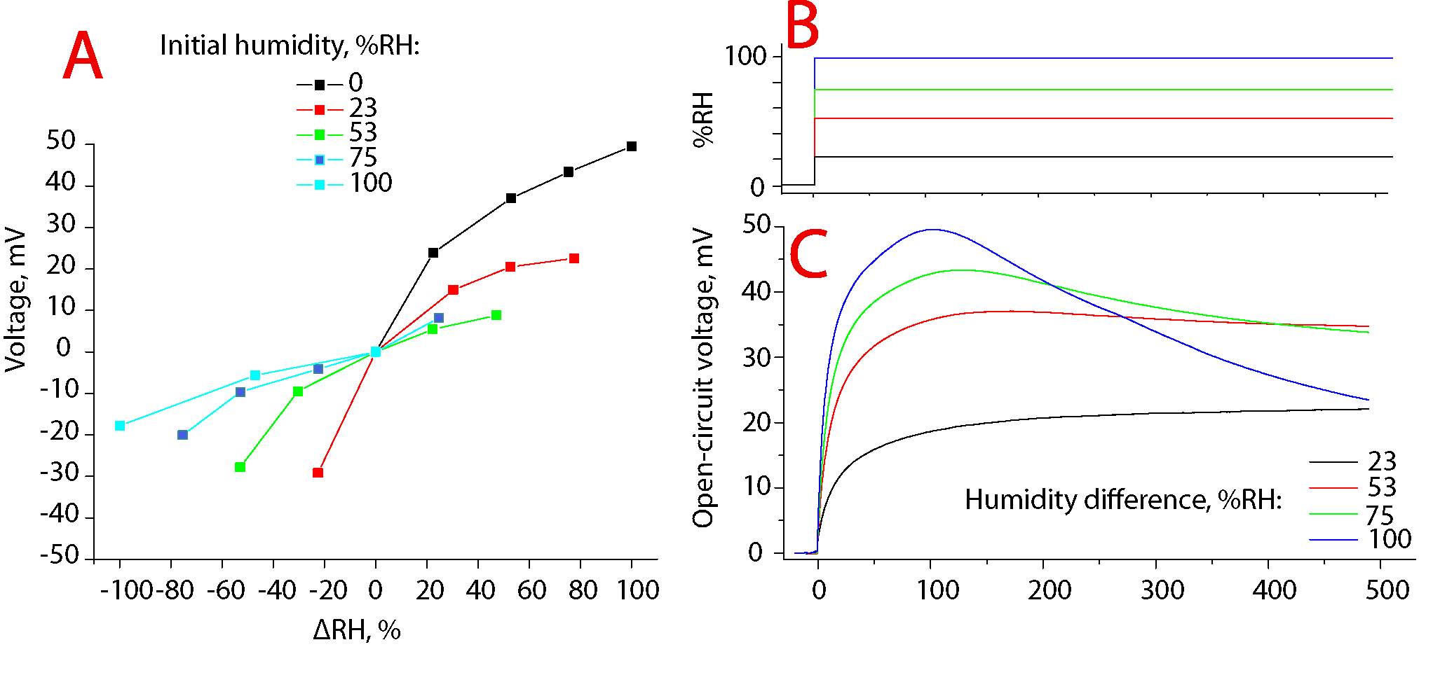
Figure 5

As it can be seen on Figure 5A, the peak voltage is not proportional to change in the RH content. As a rule, the increase in humidity content yields a larger peak value, because the absorption is generally faster process than desorption. In case of absorption, the slope between humidity change and peak voltage is decreasing with larger humidity difference, while in case of desorption it is, instead, increasing.
The slower process depicted on Fig XX is a result of dislocation of ionic liquid ions as a result of water diffusion. The flux of ionic liquid induces changes in double layer, which results in the rise of voltage between the electrodes. The voltage caused by the ion flux is in the order of magnitude greater than the quick reorientation after change of humidity and the resulting diffusive water flux.
While the course in voltage corresponding to the faster process is reversible, the slower process caused by ion flux is semi-irreversible. The reversal of direction of water diffusion gradient does not result in the immediate reversal of the voltage, but many cycles are needed to achieve the same voltage with opposite polarity. This observation bears a strong analogy to EDLCs. The supercapacitors are in principle non-polar devices, i.e. they can be charged with either polarity, but the real EDLC devices are operated only by charging them with the same polarity, which is defined by the first charging cycle [??]. This is explained by the trapping of certain ions in the smallest range of micropores. If the ions are introduced in the micropores with the sizes close to the ion size, the ion gets fixed in the pore and a large potential barrier has to be overcome to release the ion, but this causes decrease in energy storage efficiency.
  - Current and charge generation
The current was measured as a voltage drop over low-ohm (10 Ω) resistor. The transient course of current (Figure 6D) after change of humidity Figure 6C results in a sharp peak with magnitude up to 280 µA. Initially, both sides of the laminate were held at the same ambient humidity conditions (in Figure 6C-D, it was 0 %). One side of laminate was then exposed to different humidity for 300 s, as depicted on Figure 6C. The Figure 6D shows a transient course of current in case of zero initial humidity. A sharp peak value nearly proportional to the change magnitude in current was registered in approximately 10 seconds time. After return to initial conditions, another current peak with opposite polarity was registered, but the peak value was not in proportion with the humidity change. The highest increase in humidity (wetting out) results in the highest peak value, but also corresponds to the lowest current peak value after return to initial humidity.
The peak values of current are depicted as a function of initial humidity and humidity difference on Figure 6A for the disturbance of the equilibrium, and on Figure 6B for the return to initial humidity. The current peak value after the disturbance of the equilibrium shows the same trend as in the case of open-circuit voltage – faster absorption results in higher peak value. The transient course of voltage depicted on Figure 6D
As expected, if the laminate is initially held at 100 % humidity and then one side is dried out (cyan line at Figure 6A-B), the current peak value that corresponds to drying out is much lower than that resulting from wetting out.
The transient course of generated charge depicted on Figure 6E was calculated by integrating the current values depicted on Figure 6D. It can be noticed that the highest humidity change does not yield the highest charge value, but, instead, starts to decrease after 100 seconds. The decrease in charge corresponds to the negative current.
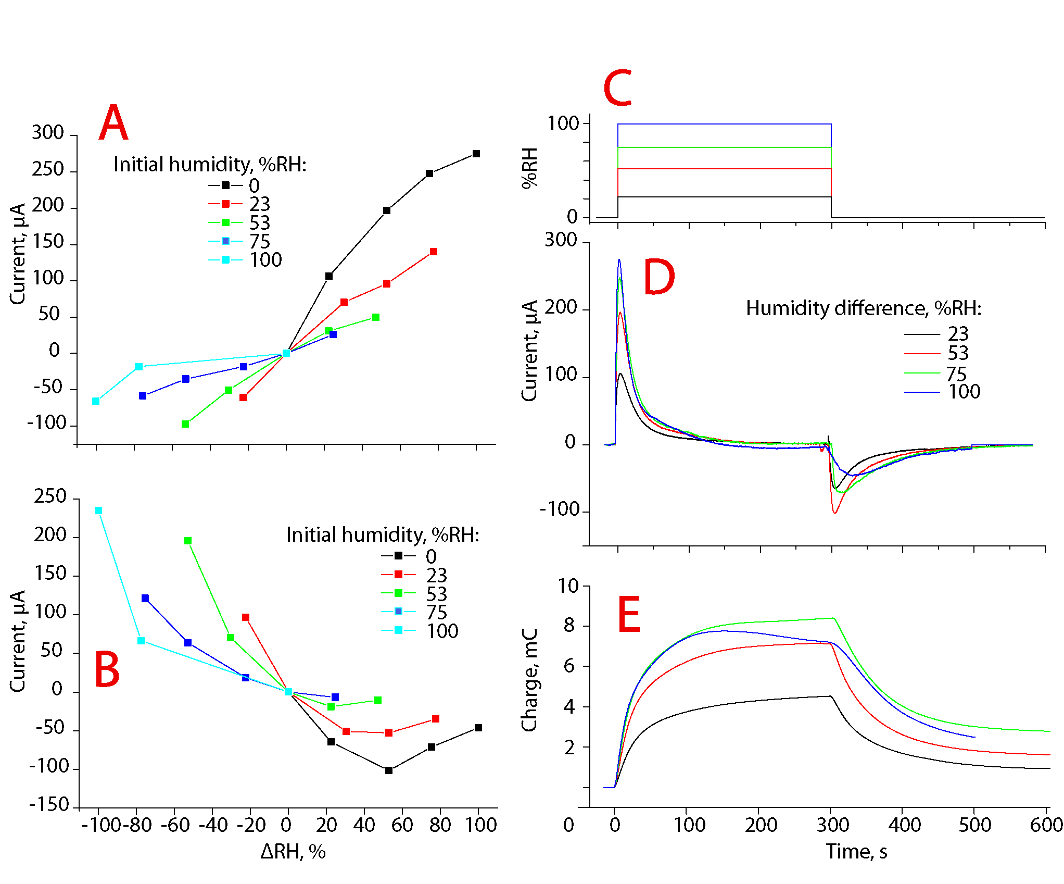
Figure 6

  - Strain
The IEAP laminate responds to the change in humidity not only with voltage and current, but also with the formation of strain difference between the electrodes, which can be observed as bending of the laminate. Figure 7 illustrates the transient response to introduced humidity with both voltage and displacement. The displacement was measured at 20 mm distance from the point, where the laminate was fixed as a cantilever between the voltage measurement terminals. It can be observed that both deflection and potential difference are evoked instantly after humidity change, but the voltage shows a much steeper change at the beginning of the humidity change, while the deflection increases with nearly constant rate. However, the accurate characterization of the strain and humidity relation is to be done in the future work.
The increase of weight was measured between the driest and maximally hydrated sample was 6.0 % as measured by weighing using an analytical scale.
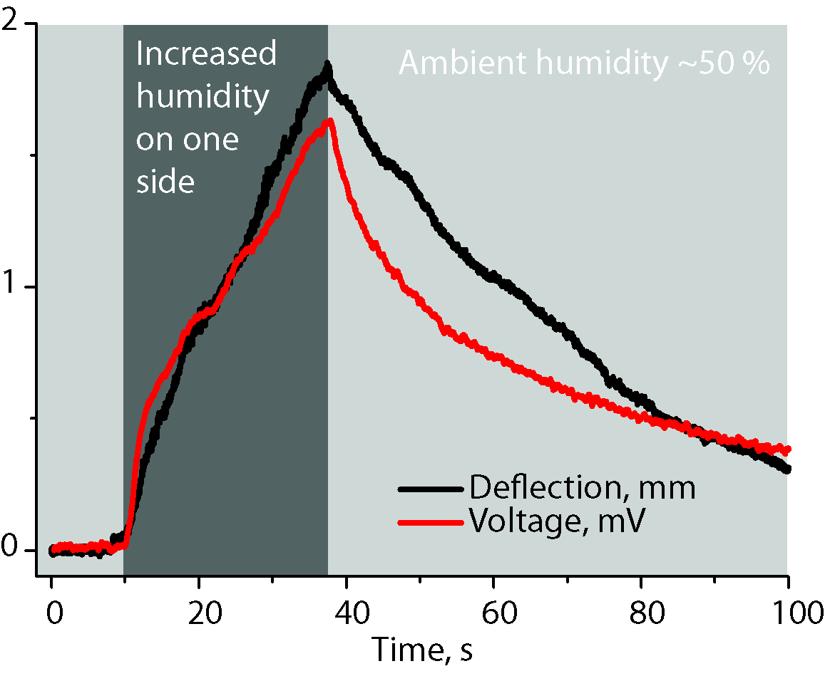
Figure 7

  - Energy harvesting
The IEAP laminate generates a considerable amount of charge when moisture gradient is applied. The output is relatively high in current and charge, but the collection of charge with a purpose of powering electronic devices is limited with the low magnitude of generated voltage. The maximum power output is achieved when the internal resistance of the power source matches with the resistance of the consumer device. The internal resistance of the laminate under investigation was 30 Ω*cm² at 50 % RH and at room temperature. Around 0 % RH, the internal resistance increased up to 160 Ω*cm². In the current research, a 3 cm² piece with an internal resistance of 10 Ω was used and a 10 Ω resistor was chosen as a power consumer. The current measured in a continuous regime did not exceed 250 µA, as it can be seen on Figure 6A-B, which corresponds to 2.5 mV in potential. Voltage as low could not be directly used to power electronic devices. Moreover, the currently available step-up converters, which can raise the voltage to usable level for the electronics, require higher voltages.
To overcome this problem, a periodic discharge cycle depicted on Figure 8 is proposed. As it was described in the introduction, the IEAP laminate is in its nature a supercapacitor. The streaming current generated as the result of water diffusion is stored in the high surface area carbon electrodes. In this way, the capacitor can be used not only as an energy storage element, but also as a voltage amplifier. Moreover, because a part of the laminate was rigidly clamped between the epoxy plates and was not exposed to the humidity chamber, it acted only as an energy storage element.
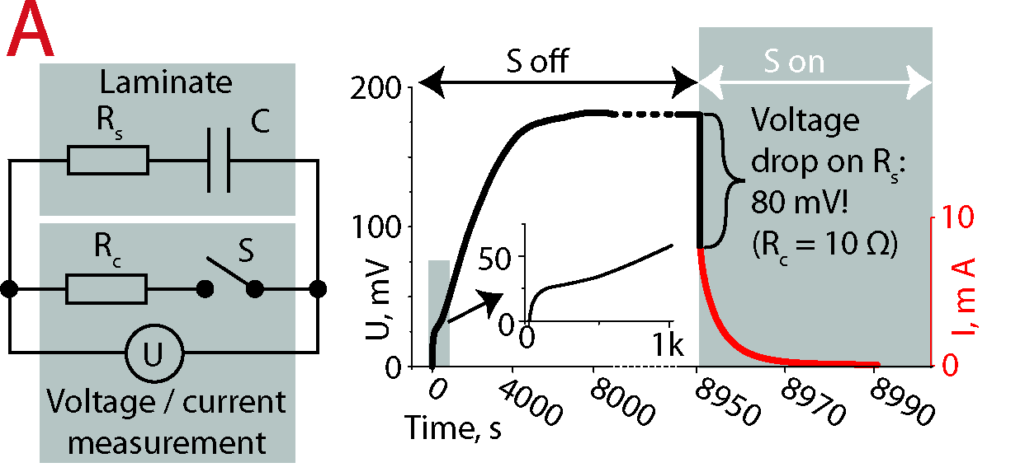
Figure 8

In the energy harvesting experiment, one side of the initially dry laminate was exposed to 50 % humidity, while the other side was continuously dried. After 2.2 hours, the voltage stabilized at 180 mV, as depicted on Figure 8B. Subsequently, a load R_{c} of 10 Ω was connected between the electrodes (Figure 8B), and the generated and stored charge of 20.4 mC was consumed. Doing so, the laminate acted as a 100 mF supercapacitor charged to 180 mV.
After connecting the laminate to the 10 Ω load, an instant voltage drop of 80 mV was registered as a result of large internal resistance of the laminate, R_{s}.

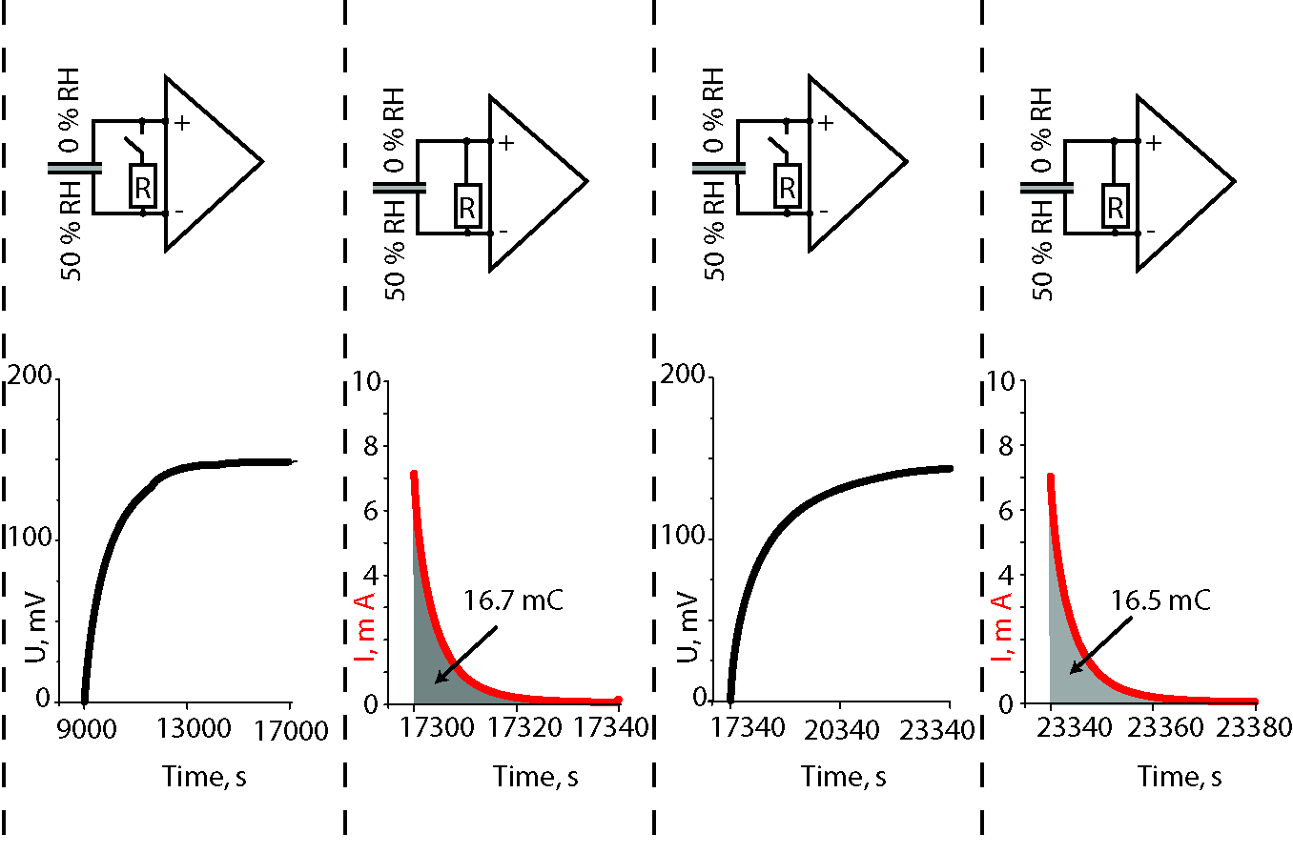
Figure 9
After disconnecting the load, the voltage rose back to around 160 mV (Figure 9A) and the charge of 16.7 mC was again available for consuming (Figure 9B). The consequtive cycles resulted in an equal generated charge (Figure 9C-D). It is interesting to note that in case of conservation of the constant water diffusion gradient, there is no extra peak visible in the transient voltage. This confirms that the extra peak that can be seen on Figure 4 is caused by the sorption of water in a single electrode.
Commercially available step-up converters, for example, LTC3108 from Ambient Sensors, can boost the voltage from the voltage sources as low as 20 mV. Before the decrease of the voltage below that level, up to 14 mC of charge could be collected from the unstacked device.

  - Working principle

Electro-osmosis is one of the mechanisms responsible for generation of volumetric effects between oppositely charged electrodes in actuators. The charging of carbonaceous electrodes with external current results in separation of electrolyte ions with opposite charges. In the humidity sensor, however, there is no external voltage source. The diffusion of water in the cluster channels of Nafion induces streaming current. However, standard streaming current theory is not easily applicable in such system. The streaming current generated in response to the humidity gradient results from the reorientation and dislocation of ionic liquid, which induces charge at the carbon electrodes.
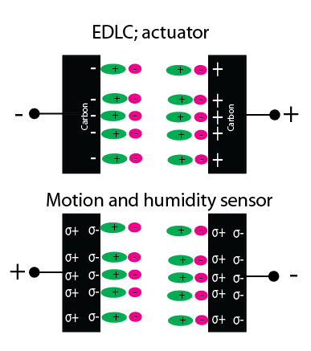
The (hypothetical) explanation of the generation of charge is based on a result of the following concurring processes – the absorption of water by IL, the hydration of Nafion, and double layer formation on carbon.
Nafion consists of a hydrophobic tetrafluoroethylene backbone with perfluorovinyl ether side chains, which are terminated by hydrophilic ionic sulfonate groups. In the process of the preparation of the laminate, Nafion (which has initially Li⁺ cations as counter-ions at ionic sulfonate groups) is swelled in an ionic liquid. During the immersion in an IL, ion exchange occurs, where Li⁺ cations change place with EMI⁺ cations (LiTFS is left in the solution – concentration gradient).
In low humidity conditions, the Nafion membrane consists of EMI⁺ cations bound to the sulphonic acid groups attached to the hydrophobic perfluorocarbon backbone. The ionomer cluster channels formed during the swelling stage of manufacturing process are filled with mobile EMI⁺ cations and TFS⁻ anions of ionic liquid. The sulphonic acid groups make the cluster channels of Nafion strongly hydrophilic. The water molecules are attracted by sulphonic acid groups; dry (without being soaked in an IL) Nafion can absorb water 22 % of its weight and each sulphonic acid group can coordinate up to 15 water molecules {{92 James,P.J. 2000}}.
EMITFS contained in hydrophilic channel network is classified as a hydrophilic IL. The increase in ambient humidity level results first in a fast sorption of water by the sulphonic acid groups of Nafion. The sulphonic acid group makes Nafion extremely hydrophilic. The sulphonate group of TFS⁻ anion makes it the next potent attractor of water molecules.
The 1-ethyl-3-methylimidasolium has hydrophobic character due to its hydrocarbon chain and the imidazolium group, which suggests that at high water concentrations they even act as simple surfactants {{90 Varela,L.M. 2009}}. The hydrophobicity increases with the increase of hydrocarbon chain length. Still, EMI⁺ is reported to be the most hydrophilic ionic liquid cation {{91 Ranke,Johannes 2009}}, which suggests that the EMI⁺ cation can also collect water molecules to its coordination sphere (?). Moreover, the anisotropic distribution of charge over the cation causes the IL cation to have preferential adsorbation orientation {{93 Zhang,Xiaoning 2012}}. Also, a strong orientation of the cation is presumed over the surface with large dipole. This suggests that the orientation of cation could be significantly altered with the introduction of water molecules, or just by mechanical strain on the material, which creates locally in the pores of carbon hydrostatic pressure on IL. The alteration of orientation induces dipole in the adsorbate (CDC carbon), which could be instantly registered as voltage between differently strained electrodes.
From the all species of IL-water mixtures – cations, anions, and neutral water molecules, as a rule, the organic cations are the most hydrophobic species and tend to adsorb positively, while the main function for the anion is the preservation of both global and local electroneutrality, and the effect of anions on adsorption is minimal {{90 Varela,L.M. 2009}}. This is in good accordance with our observations in case of application of both pressure and water gradient that cations are the more mobile than anions, and the formation of double layer due to the pressure change is dominated by the relatively hydrophobic cation.
When the ambient humidity conditions change, the pressure gradient is induced by water sorption and diffusion. The ambient humidity change causes water diffusion along the Nafion cluster network. The lateral dimension of EMI⁺ is 0.53–0.95 nm and of TFS⁻ is 0.XX nm. The diameter of a water molecule is 0.2 nm, this indicates that it can easily diffuse in the ionic liquid. In dry state, the EMI⁺ cations are strongly bonded to sulphonic acid groups. As a result of hydration, the sulphonic acid group gets coordinated by more water and the bond length between sulphonic acid group and EMI⁺ cation significantly increases. Consquently, the EMI⁺ cation can now relocate more easily and even get carried along with water flux caused by diffusion.
The charged surface of the cluster network of Nafion also represents of itself an obstruction to the ionic groups trying to diffuse through the pores.
The CDC particles are covered with and connected to each other by the Nafion network. Although CDC itself is also strongly hydrophilic and the small dimension (0.2 nm) of water molecule allows it to easily reach the carbon surface, the water has to first pass through the Nafion network. The change in ambient humidity causes water molecules to compete towards adsorption with ionic liquid. The water diffusion induces polarization of an IL from reorientation and entrainment of cations from ionic polymer. As previously suggested {{64 Must,Indrek 2012}}, the smaller anions are fixed in the smaller micropore range, while the larger cations are more mobile. Therefore, the ionic liquid at the carbon boundary orientates itself as a result of diffusing particles. It has been shown {{94 Wu,Peng 2012}} that the mechanism of charge storage at low voltages is swapping the co-ions in the pore with the counterions from the free IL. The processes at carbon – ionic liquid interface have been divided also to slow and fast processes. The slow process is suggested to be related to charge redistribution in the innermost layer {{95 Roling,Bernhard 2012}}, the slow kinetics of this process has even suggested an analogy to faradaic reaction between the carbonaceous electrode and IL {{96 Giménez,Pablo 2012}}.
The specific orientation causes the polarization of the carbon. The electrode exposed to higher humidity acquires a negative electric potential. This indicates the predominance of anions at the double layer of more hydrated electrode. This suggests the hypothesis of cations being more mobile ions.

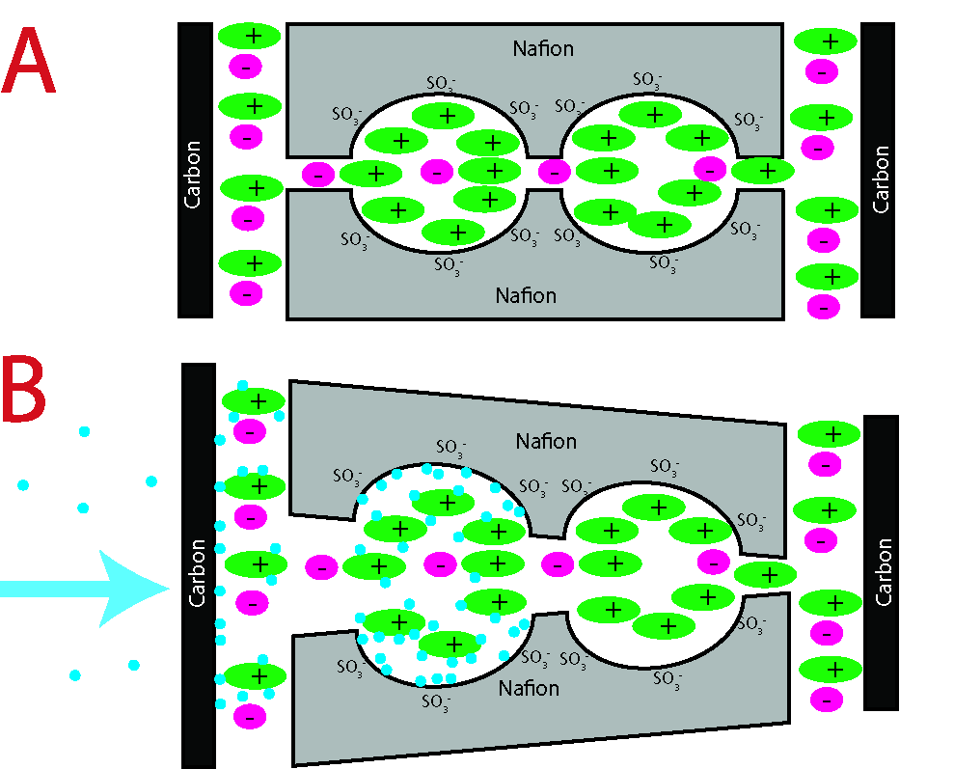
Figure 10
The components that are chosen for manufacture of this laminate are currently from theoretical viewpoint the best available. The carbide-derived carbon has an exceptional surface area and tunable porosity distribution, which is well matched with the used ionic liquid. The ionic liquid is amongst the most hydrophilic ionic liquids currently available. The imidasolium-based cations with short ligands are the most hydrophilic cations published to date []. The superhigh hydrophilicity is one of the assets of Nafion which has favored it to be used, for example, in fuel cell applications [].
The humidity sensing capability of a supercapacitor-like technology has previously been investigated in case of potassium hydroxide electrolyte []. The hydration of the salt increases ionic conductivity approximately 10 times, which also proportionally increases the device capacitance.
The effect of humidity change related dimensional changes has been researched in case of polypyrrole actuators {{98 Okuzaki,Hidenori 2000}} where the contraction is achieved by water desorption by Joule heating.
The bending actuation caused by water sorption has been investigated in case of self-assembled rodlike nanostructures {{97 Ciszek,Jacob.W. 2010}}.
In case of an electrochemical cell with conductive polymer (polypyrrole) electrodes, the ability of transportation of (ambient) water has been demonstrated{{100 Xu,Han 2006}}. This suggests that at least the diffusion constant should be different in the case of short- or open-circuited electrodes.
Cationic conduction
{{channel, it becomes attracted to and repelled by different interactions, such as the dispersion energy, repulsion energy, polarization energy, field dipole energy, field gradient quadrupole, adsorbate–adsorbate interactions, and the acid–base interactions with the active site if the zeolite contains hydroxyl bridge groups [20]. This transport can be pictured as an activated molecular hopping between fixed sites [12,20,88]. Therefore,}}

Conclusions
Purely water diffusion gradient can charge the capacitor to 160 mV and produce 30 C*m⁻²*h⁻¹ of charge.
The formation of electric double layer in the three-layer laminate due to mechanical deformation offers new possibilities for feedback sensors in soft robotics. However, it is possible to evolve the idea of charge generation from the pressure gradient even further. In the current research, the pressure gradient has been applied in the form of humidified air. Merely the water diffusion due to concentration gradient, without applying any extra pressure, can generate substantial amount of electric power.
- Wet actuators and sensors are more effective
- Capacitance does not vary much, resistance decreases with humidity

