Optimization of electrochemically active material utilization in 3D microbattery by finite element modeling

Abstract:
Method for modeling ionic transport in 3D microbattery (3D-MB) has been presented. In 3D-MB performance of battery depends critically from homogeneous charge transfer between electrodes. Unlike in conventional battery, where homogeneous charge transfer between electrodes is independent from material parameters, in 3D-MB material properties and geometry must be carefully engineered to ensure charge transfer between electrodes to be as homogeneous as possible. Mathematical model describing conventional Li-Ion battery has been extended to describe ionic transport in 3D microbattery and FEA has been used to optimize electrochemically active surface area utilization by studying effects of changing electrode and conductivity, diffusion coefficient and length. As a result of simulations, it is clear, that optimization of electrochemically active surface area usage can be primarily done by manipulating with electrode conductivity and diffusion coefficient. As the range of manipulating with material properties is limited, changing electrode length can be used to fine-tune surface-area usage. Simulation results also points out some principal differences between conventional Li-Ion battery and 3D microbattery architectures. Extensions for basic model are presented to overcome those differences.

Introduction
Portable microbattery supply is critical factor in many developing technologies – miniaturization of microelectronics has far outpaced advances in small scale power supplies. Lack of suitable portable power supplies is stopping development progress in many technology branches, like microelectromechanical devices (MEMS) and biomedical micro machines. An example from MEMS based device is autonomous device that is powered by battery and consists of one or more sensors, computation and communication circuit with dimensions about 1 mm. By using such kind of configuration, problems with existing lithium-ion batteries, which are from nature 2D, are revealing themselves – in so small volumes, it is not possible to achieve sufficient energy densities. This problem can be solved by implementing batteries which are three-dimensional (3D) in their architecture. In current work, architecture of a battery is considered to be its geometrical design material properties. A conventional 2D-battery architecture can be represented as a sandwich, consisting of current collector, positive electrode, electrolyte (separator), negative electrode and current collector in a layer-by-layer configuration (Fig. 1). 3D-micro-batteries (3D-MBs) consist of same components, but with a more complex spatial distribution. The increased area-gain achieved by designing the battery in the third dimension can theoretically expand the energy density within an order of magnitude or more. Examples of possible 3D-MB architectures are presented in Fig. 2: 3D-interdigitated (a), 3D-trench (b), 3D-concentric (c) and aperiodic (d) architectures. It should be pointed out, however, that so far no one has yet completed synthezing a full micro-battery system (only half-cells) based on these architectures. This field of science is still emerging, but emerging fast. New materials are being introduced, and advanced micro-structures being synthesized at a growing pace. The number of presentations on micro-battery systems are growing fast today on international conferences on energy storage.
Modeling processes taking place in Li-ion batteries is generally carried out using approach proposed in [1] and [2]. In these works, 1D mathematical model is presented, where porous electrode theory is used to model electrodes, and it is assumed, that electrodes are porous and form superposition of active material, binder and electrolyte. To model electrolyte, concentrated solution theory is used. Ionic transport in active material particles is modeled by diffusion. Model presented in these works is very general and is applicable to wide range of Li-ion systems. Presented model is validated in [3]. Other works [danilov], [mesocale approac], are using Nernst-Plank equation approach and eventually coincide with [2], or are based on equivalent electronic network [notten] or molecular dynamics simulations [Anti?, Endel?]. Although, having good agreement between simulations and experimental results, equivalent electronic network model lack ability to describe local processes taking place in battery, necessary to analyse processes in 3D-MB. Molecular dynamics simulations can not be used in whole battery modeling, as it's not possible to simulate systems large enough, to describe whole battery.
Experimental work about electrode materials and geometry?
Building half cells of nanopillars, nanotrences, etc. is complicated task. Even more complicated or even impossible is optimizing 3D-MB systems based by experimental work.

All presented models are dedicated to study conventional Li-ion batteries, that are from nature, 2D. Moreover, to study those batteies, mathematical models can be spatially 1D. In current work, mathematical model presented in [2] is extended to 3D battery systems to make it possible to model 3D-MB systems. Aim of this study is to understand basic features of different 3D-MB architectures and at same time, point out ways to optimize battery architectures and test theoretical limits of different geometries.

Materials and methods

Mathematical model
In current work, we are modeling battery with non-porous electrodes, made from mixture of active material particles and binder. To set up mathematical model, we are using previously published and validated approac[2] as basis. It is modified to take into account that electrodes are made only from active material. According to [book], where porous electrode theory extension is presented, to model thin film batteries made from nonporous active material.
During constructing mathematical model, describing processes taking place in battery, that is basing on [newman things], we made following assumptions:
- Diffusion constants and conductivities are considered constant within a region in the battery.
- Active material particles and binder forming electrodes are assumed to form one solid elecrode, where movement of Li ions is described by diffusion.
- Side reactions are neglected in whole cell
- Volume changes in electrodes are neglected
- Charge transfer processes are assumed to be described by Butler-Volmer type kinetic expression:
(1)
- To model open circuit potential in electrodes, piecewise polynomials are used [U_oc].
- Constant values for transference number are assumed at all times and all points in battery.
- Electroneutrality is assumed in electrolyte.
- Ions are transported by diffusion in active material and by diffusion and migration in electrolyte.

Charge and material balance
Materials, from witch 3D-MB is constructed are still under study it is not clear yet, what sort of materials to use. As there is in literature lots of materials about LiCoO2 anode and C6 graphite cathode, we are using in our simulations right now these materials as starting point.
Chemical reactions taking place in battery electrodes are:
(2)
(3)
In our model, we are describing reactions taking place in battery by Li ion concentrations. When battery is fully discarged, then in anode, Li+ concentration is maximal and Li+ concentration in cathode (C6) is minimal. When battery is fully charged, then Li+ concentration in anode is minimal and in cathode maximal.
It is not yet known what sort of electrode material to use for 3D-MB – porous or nonporous. Recent experimental works show, that nonporous electrode material approach is good starting point [Gabi's experiments ...]. Also, geometrical dimensions of a battery electrodes are in same range as typical active material particles in porous electrodes. Thus we are setting up our battery model for nonporous electrodes. As we are modeling nonporous electrodes, electrochemical reactions take place only on surface between electrode and electrolyte. Thus, source term in equations presented in [Newman] disappears and insertion of lithium ions is controlled by boundary conditions [Advances in Li-ion batteries]. To obtain potential distribution in battery, Ohm's law is used in electrode and modified Ohm's law, taking into account concentrated solution theory, is used for electrolyte.
(4)
(5)
Potential in electrode is calculated by
(6)
(7)
Equations to describe mass transport in electrolyte are
(8)
(9)
where D is diffusivity of electrolyte. Material balance in electrode is described by equation:
(10)
(11)

Geometrical model
Basic architectures proposed for 3D-MB are presented in [Dunn's review article] and pointed out on Fig. 2. To simulate processes taking place in whole whole battery, it is necessary to model all battery architectures, based on these geometries, in 3D, with exception of trench model. By using trench model, it is possible to reduce simulations to 2D and expand results from calculations to 3D. Also, by placing a slice through one symmetry axis of a interdigitated model, it we get a 2D approximation, that coincides with tench model. It is desirable to reduce spatial dimensions as low as possible to reduce necessary computer resources during simulations. Thus, in calculations, 2D approximation of trench model is used, as it is possible to extend obtained results to several different geometries without any loss of accuracy.
Basic model for simulations – trench model is constructed with electrode pillar length about 100e-6m and diameter 10e-6m. Distance between electrodes is 10e-6m. Length of plate is varied during different calculations.
Electrodes in trench model are made completely from active material. Anode consists of LiCoO2 and cathode from C6. Electrolyte is chosen to be 1.5 molar LiPF6. Current collectors on top of electrodes are simulated by boundary conditions. To Current collector on anode is applied charging/discharging current. Current collector on cathode is grounded.
As Making geometrical model to simulate whole battery is too demanding for computer time and memory. To describe whole battery with optimal usage of computer resources, small cell consisting of one anode and one cathode plate is selected and periodic boundary conditions for concentration and potentials in electrodes and electrolyte on cell sides are applied. Thus, in calculations infinitely large battery is simulated.

Material and geometry properties and initial values
Everithing according to table 1.

Electrochemically active surface area studies
To achieve maximum capacity, maximum material usage and peak current of a 3D-MB – which is equivalent of optimizing its energy density – we must utilize the surface area of the electrode to a maximum. This is achieved automatically in a 2D-battery, where electrodes are flat. The current distribution in the electrodes and electrolyte is then homogeneous, and does not depend on the conductivity. In a 3D-battery, however, where the shape of the electrodes is more complicated, we must carefully engineer the shape of the electrodes, their conductivity and ionic diffusivity, in order to achieve a situation where the electrochemical activity on electrode surface – and thus also the current distribution in the electrolyte – is as uniform as possible. This task is more or less impossible to complete systematically with conventional experimental methods, but computer modelling and simulations can give significant insights.
Current distribution in 3D-MB battery depends from many factors – diffusion coefficient, conductivities, processes taking place on solid-electrolyte interface (SEI), temperature, side reactions in battery, shape of electrodes etc. In current work, we are studying what effects of changing electrode geometry and material properties on current distribution in battery.
To study electrochemically active surface area in battery, concentration gradient is used. According to equations (5, 7, 9, 11), it is proportional to diffusion and migration of species in electrolyte.
We are looking for a electrode configuration, where differences in concentration gradient are minimal on surface between electrolyte and electrode. Simulations are carried out by varying electrode conductivities, length and thickness. Initial material properties and electrode measurements are presented in table 1 .
Calculations to study effects of changing different parameters of a 3D-MB architecture were divided into two sections. In first section, dependence of electrochemical activity from electronic conductivity of the electrode was studied, while geometrical parameters of battery were fixed. In second section, dependence of electrochemical activity from electrode dimensions was studied, while physical parameters of electrode were fixed. Calculations were carried out by using trench model and modified trench model, where plate, forming electrode also included current collector (some figure to describe.).
In first section, during calculations, geometry of the electrodes and conductivity of the anode was fixed according to table .... . Conductivity of the cathode was varied by decreasing it by 25% steps from initial conductivity, in every sequential calculation. In last calculation, conductivity of the electrode was set to 5% of initial conductivity. Initial conductivity in cathode was set equal to the conductivity of the anode.
In second section of simulations, we studied effects of changing electrode geometry, presented on Fig. 5. During calculations, length L of a pillar/plate was varied by decreasing it, compared to initial length, by 25% steps in every sequential calculation, with length of pillar at 5% of initial value, in last calculation. Distance D between electrodes is held at constant value and material properties in all calculations were fixed according to table 1. In calculations, only length of a plate is changed. Changing it from maximum to minimum value, leads from 3D battery to 2D battery. As well, as changing plate thickness from it's minimum value to maximum value, leads again from 3D battery to 2D battery. Also, by decreasing length of a plate and holding distance D between electrodes constant leads to a situation, where relative thickness of a electrode is incerasing. Thus during simulations, only electrode lenght L is changed.

Results
Concentration and concentration gradient profiles for different simulations, where concentration profile dependence from electrode lenght are presented on figures ...... . Results are presented after 10, 50, 100, 150 and 250 seconds after start of charging/discharging process.
Typical concentration gradient profiles, as modules of concentration gradient vectors, during charging/discharging, obtained for electrolyte are presented on Fig. 6 and Fig. 7.

Discussion & Conclusions
Mathematical model has been proposed to simulate processes taking place in 3D-MB. Calculations carried out to optimize electrochemically active electrode surface area in battery showed, that primary means to optimize electrode surface area utilization are manipulating with electrode conductivity and measurements.
From simulations with variable electrode conductivity, we can conclude, that surface area usage is maximal, when both electrodes have equal conductivities. Surface area utilization is in tolerable limits, when electrode conductivities are differing up to one magnitude. This situation is hard to achieve in experimental work as minimum difference between conductivities achievable for electrode materials today is about two magnitudes.
From simulations with manipulating with electrode measurements we can see, that changing electrode length or radius tends to lead 3D-MB architecture to limits, where it acts like an ordinary Li-Ion battery.
By comparing results from simulations with different electrode dimensions and conductivities, we can see, it is possible to fine tune electrode surface area usage by changing simultaneously electrode measurements and conductivity. Such- kind of fine tuning must be done carefully, as from one hand, we are winning in battery performance, but from other hand, we are losing in capacity.
In our model, processes taking place on solid-electrolyte interface are not modeled. Also, side reactions taking place in electrolyte are not modeled. Introducing these factors to model would be aim for further studies.
In present study, the parameters varied in our model have been length, thickness and electronic conductivity of the electrodes (different for anode and cathode) and ionic diffusion of the electrolyte. We have here used parameter values taken from well-known Li-ion battery materials which are possible to synthesize as nano-materials. In order to optimize the micro-battery performance (with respect to both electrode length, thickness, conductivity, porosity, etc.), we need to go beyond our present one-parameter approach, i.e., where these parameters are studied separately. By using a one-parameter approach, we are only receiving a general picture about the nature of parameter changes – e.g., that decreasing length of the electrode also result in a decreasing differences in electrochemical activity on the electrode/electrolyte interface. It is therefore necessary to analyse more complex situations, where more than one parameter is changed at the time, for example, length, thickness and shape of the electrode, to find the optimal combination of these parameters. Since we would like to study how the electrochemical activity on electrode/electrolyte solid interface depends on changing these four variables, we achieve a non-linear and thus mathematically complicated optimization problem, where we need to divide the planned studies into several tasks:
- Optimizing length, thickness and shape of the electrodes, based on what can be achieved experimentally.
- Choosing material combinations for anode, cathode and electrolyte with optimal conductivities of electrodes to generate a uniform current distribution for a specific surface area.
- The global optimization problem, where the variable parameters are conductivities, length and thickness of electrodes.
Validation of the mathematical model
Experimental validation of mathematical model, is not necessary, as our representation and modification of model presented in [2] does not introduce any principal mathematical changes. Our model coincides with model in [2], in terms of describing electrolyte and active material. Differences are coming in from battery architecture, as battery with porous electrodes, studied in [2] is rejected and replaced with nonporus electrode battery. Thus, Li ion sources, presented as source terms, in equations (......), in paper[2] are now introduced as boundary conditions (eq. ....). Experimental validation for model, used to study 2D porous electrode battery [2] is experimentally validated in [3] .

References
- Doyle, M.; Fuller, T. & Newman, J. Modeling of galvanostatic charge and discharge of the lithium/polymer/insertion cell, Journal of the Electrochemical Society, 1993, 140, 1526 - 33
- Fuller,T.;Doyle,M.&Newman,J., Simulation and optimization of the dual lithium ion insertion cell, Journal of the Electrochemical Society, 1994, 141, 1 - 10
- Doyle, M.; Newman, J.; Gozdz, A.; Schmutz, C. & Tarascon, J.-M. Comparison of modeling predictions with experimental data from plastic lithium ion cells,Journal of the Electrochemical Society, 1996, 143, 1890 - 903
- Hart, R. W.; White, H. S.; Dunn, B. & Rolison, D. R. 3-D Microbatteries Electrochemistry Communications, 2003, 5, 120 – 123
- Danilov, D. & Notten, P. Mathematical modelling of ionic transport in the electrolyte of Li-ion batteries Electrochimica Acta, 2008, 53, 5569 – 5578
- Advances in Lithium-Ion Batteries ... book
- Open circuit potential by piecevise polynomials
- Mesoscale modeling of a Li-ion polymer cell Journal of the Electrochemical Society, 2007, 154, 1035 - 47

Tables

Symbol | Quantity | Value
 | Diffusion constant of Li ions in electrode
D | Diffusion constant of electrolyte
 | Electronic conductivity of anode
 | Ionic conductivity in electrolyte
 | Electronic conductivity of cathode
C_0 | Salt concentration
 | Initial Li+ concentration in anode
 | Initial Li+ concentration in cathode
J_0 | Charging/discharging current
H | Distance between electrode bases
L | Lenght of a plate/pillar
d | Distance between plate/pillar centres
h | Thickness of plate/pillar base
r | Thickness of plate / radius of pillar
D=H-L | Distance between electrodes
 | Distance between electrodes
j_o | Exchange current density
Table 1. Material parameters in model.

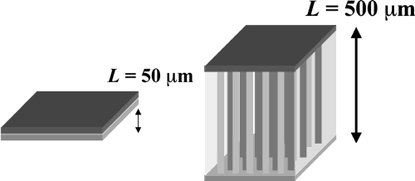Fig. 1 Difference between 2D and 3D battery.
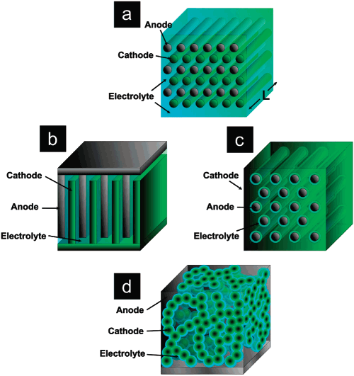Fig. 2 Possible 3D-MB architectures
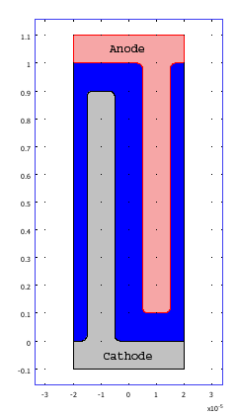Fig. 3 Trench model geometry used in calculations
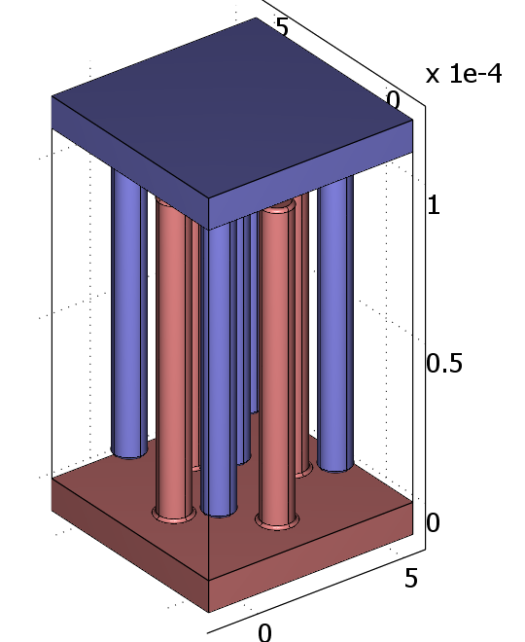Fig. 4: 3D-interdigitated battery architecture

Fig. 5 Varied geometrical parameters in simulations
L_{cc}
L_{a}
H_{c}
h_{a}
h_{c}
d

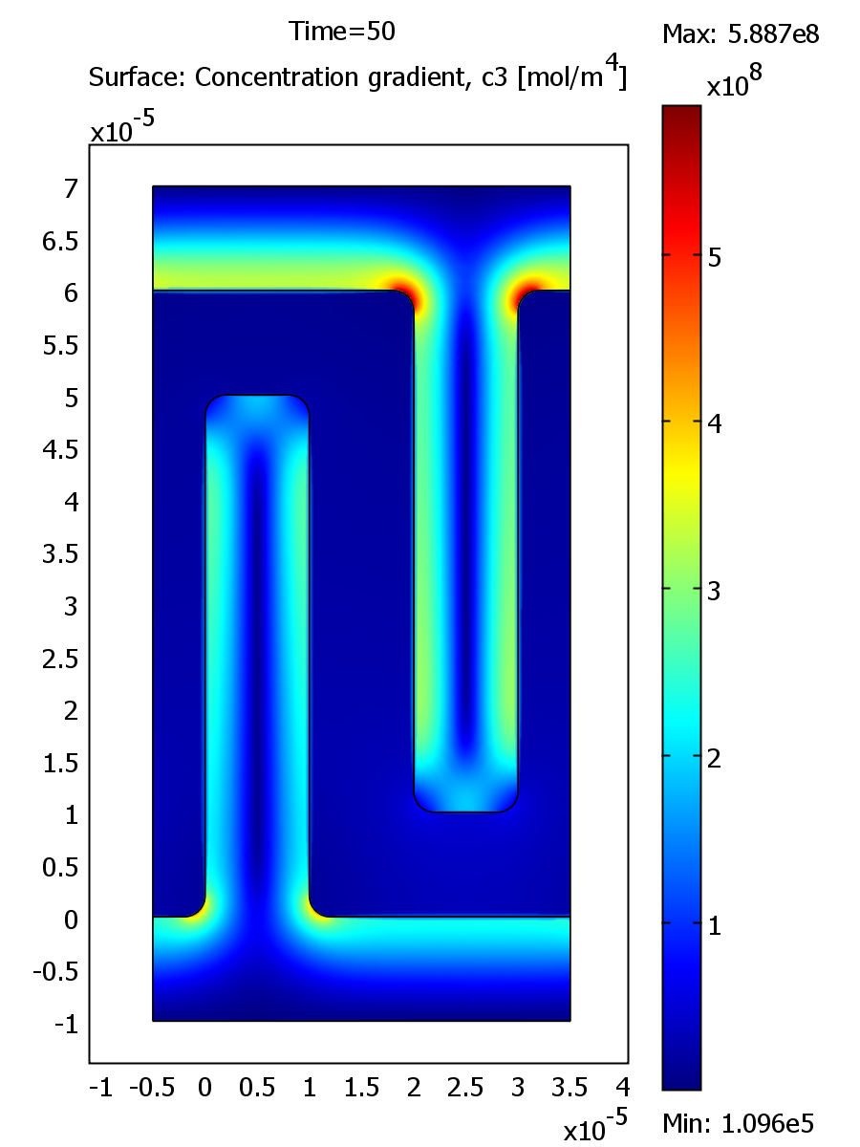

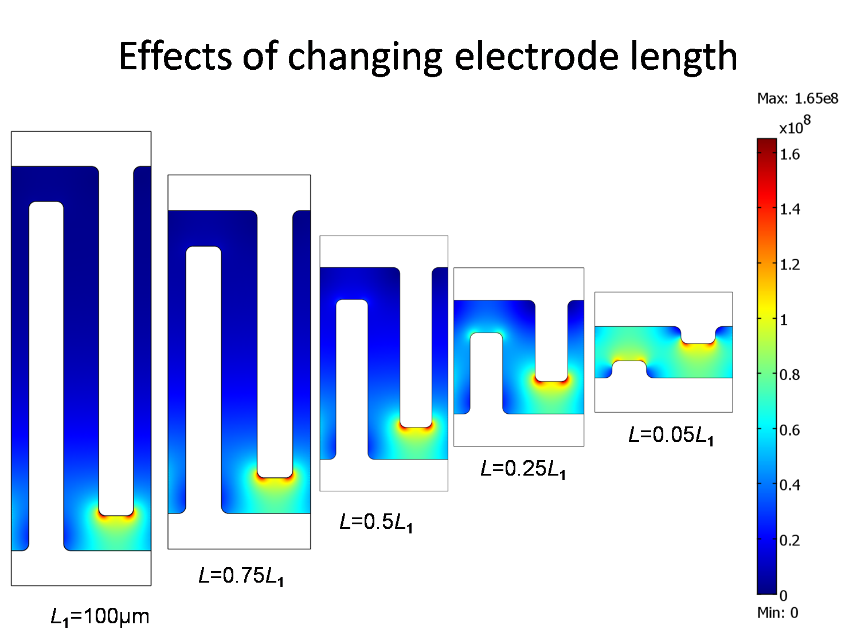Fig. 6 Effects of changing electrode lenght
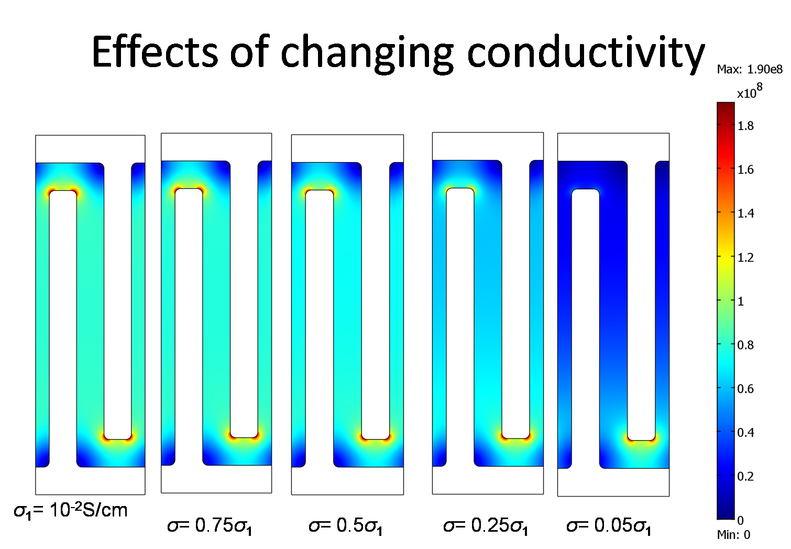Fig. 7 Effects of changing electrode conductivity

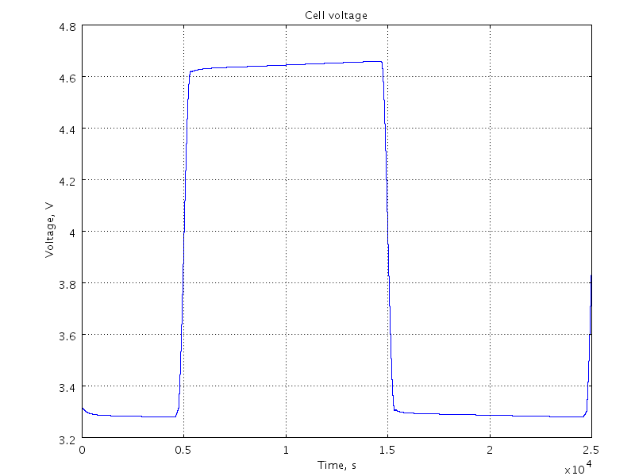Fig. 8 Cell voltage during discharge/charge

